Introduction
Mail Merge is a useful tool that allows you to produce multiple letters, labels, envelopes, name tags, and more using information stored in a list, database, or spreadsheet. When performing a Mail Merge, you will need a Word document (you can start with an existing one or create a new one) and a recipient list, which is typically an Excel workbook.
https://edu.gcfglobal.org/en/word/mail-merge/1/

To use Mail Merge:
Open an existing Word document or create a new one.
From the Mailings tab, click the Start Mail Merge command and select Step-by-Step Mail Merge Wizard from the drop-down menu.
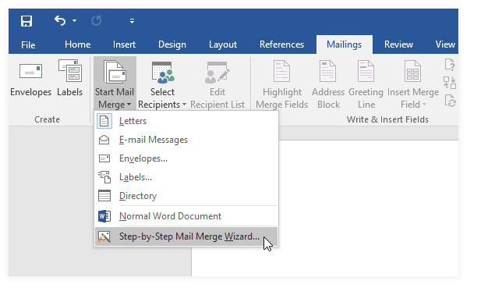

The Mail Merge pane will appear and guide you through the six main steps to complete a merge. The following example demonstrates how to create a form letter and merge the letter with a recipient list.

Step 1:
- From the Mail Merge task pane on the right side of the Word window, choose the type of document you want to create. In our example, we'll select Letters. Then click Next: Starting document to move to Step 2.
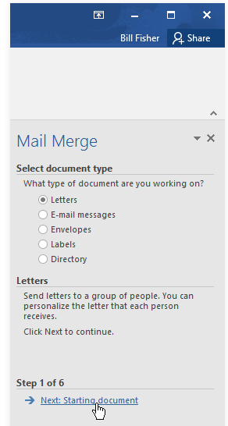

Step 2:
- Select Use the current document, then click Next: Select recipients to move to Step 3.
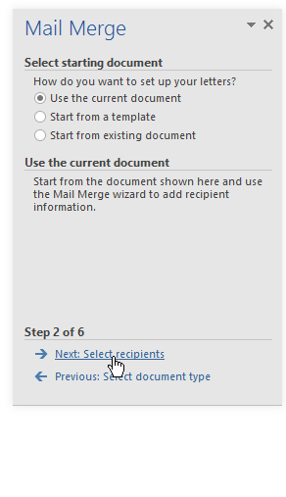

Step 3:
Now you'll need an address list so Word can automatically place each address into the document. The list can be in an existing file, such as an Excel workbook, or you can type a new address list from within the Mail Merge Wizard.
Select Use an existing list, then click Browse to select the file.
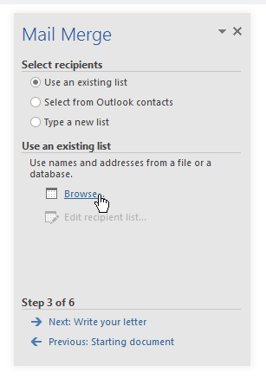

Locate your file, then click Open.
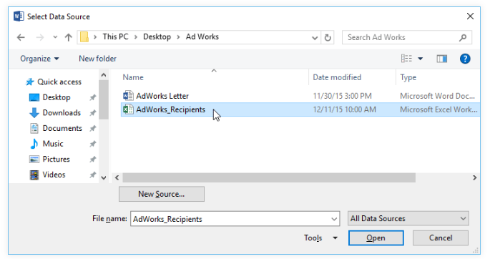

If the address list is in an Excel workbook, select the worksheet that contains the list, then click OK.
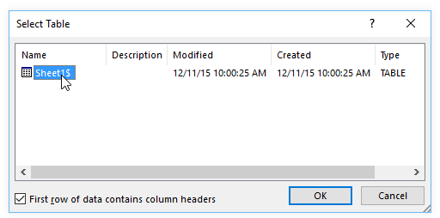

In the Mail Merge Recipients dialog box, you can check or uncheck each box to control which recipients are included in the merge. By default, all recipients should be selected. When you're done, click OK.
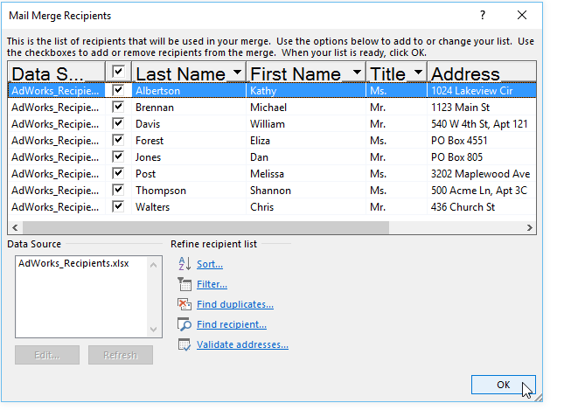

Click Next: Write your letter to move to Step 4.
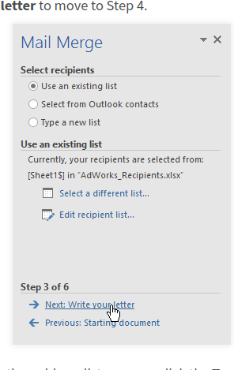

If you don't have an existing address list, you can click the Type a new list button and click Create, then type your address list manually.

Step 4:
Now you're ready to write your letter. When it's printed, each copy of the letter will basically be the same; only the recipient data (such as the name and address) will be different. You'll need to add placeholders for the recipient data so Mail Merge knows exactly where to add the data.

To insert recipient data:

Place the insertion point in the document where you want the information to appear.
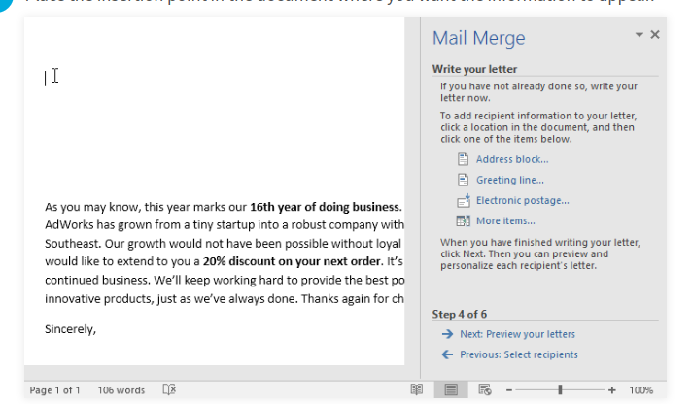
Choose one of the placeholder options. In our example, we'll select Address block.
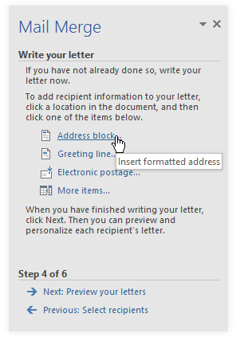

Depending on your selection, a dialog box may appear with various customization options. Select the desired options, then click OK.
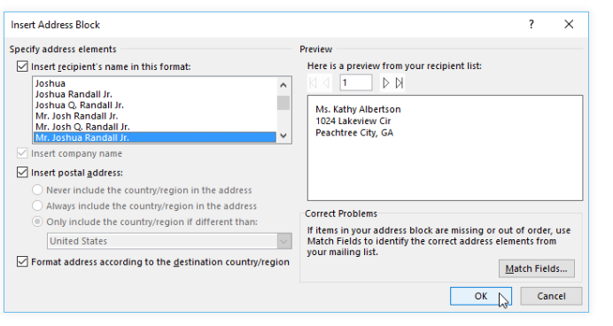

A placeholder will appear in your document (for example, «AddressBlock»).
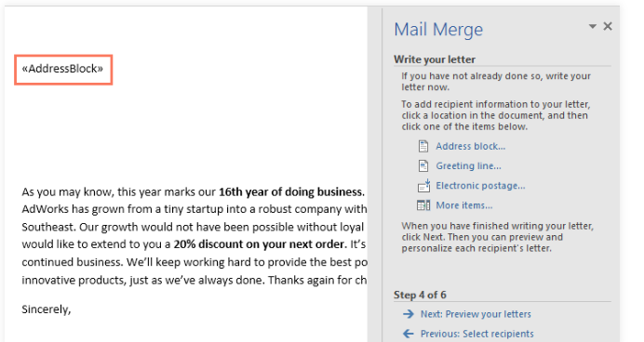

Add any other placeholders you want. In our example, we'll add a Greeting line placeholder just above the body of the letter.
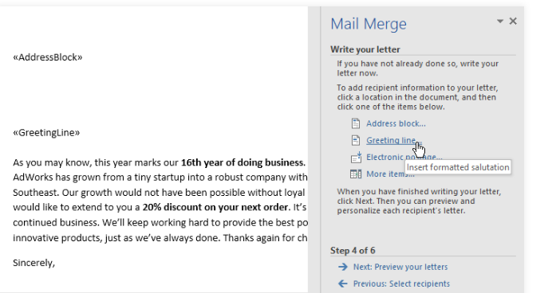

When you're done, click Next: Preview your letters to move to Step 5.
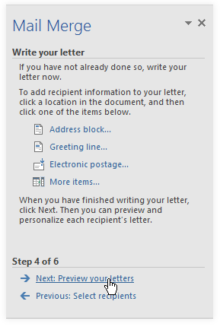

For some letters, you'll only need to add an Address block and Greeting line. But you can also add more placeholders (such as recipients' names or addresses) in the body of the letter to personalize it even further.

Step 5:
Preview the letters to make sure the information from the recipient list appears correctly in the letter. You can use the left and right scroll arrows to view each version of the document.
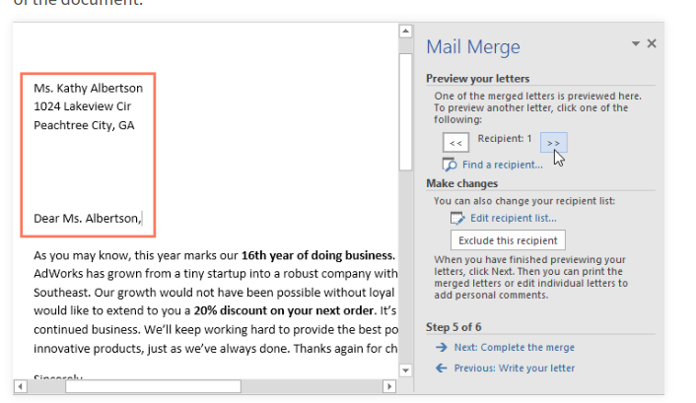

If everything looks correct, click Next: Complete the merge to move to Step 6.
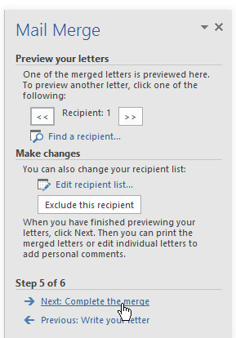

Step 6:
Click Print to print the letters.
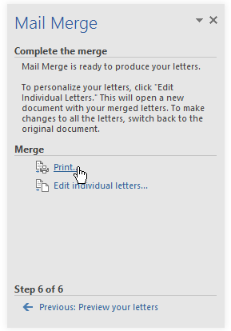

A dialog box will appear. Decide if you want to print All of the letters, the current document (record), or only a select group, then click OK. In our example, we'll print all of the letters.
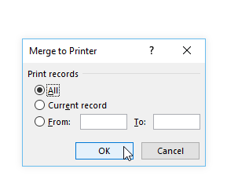
The Print dialog box will appear. Adjust the print settings if needed, then click OK. The letters will be printed.
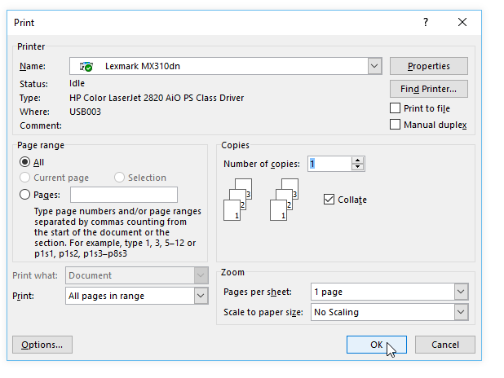

What Is VLOOKUP?
The VLOOKUP function is used when we have a set of vertical data. It allows us to search a range of data references with columns, and retrieves the right information we are looking for.

VLOOKUP Formula
The syntax of the VLOOKUP formula is,

The arguments of the VLOOKUP formula are,
- lookup_value: The value for which we are trying to retrieve the result from the table_array (2nd argument). It is a mandatory argument.
- table_array: It will be either range or table_array where we search for the lookup_value. It is a mandatory argument.
- col_index_num: In a given table_array, it is the column we are looking for the result. It is a mandatory argument.
- : In this optional argument, we need to specify the kind of match we need:
  - 0 or FALSE – It will search for the exact match of the lookup_value in the table_array. If nothing is specified, 1 or TRUE will be the default mode.
  - 1 or TRUE – It will search for the approximate match of the lookup_value in the table_array.

What Is HLOOKUP?
The HLOOKUP function is used when we have a set of horizontal data. It allows us to search a range of data references with rows, and retrieves the right information we are looking for.

HLOOKUP Formula

The arguments of the HLOOKUP formula are,
- lookup_value: The value for which we are trying to retrieve the result from the table_array (2nd argument). It is a mandatory argument.
- table_array: It will be either range or table_array where we search for the lookup_value. It is a mandatory argument.
- row_index_num: In a given table_array, it isthe row we are looking for the result. It is a mandatory argument.
- : In this optional argument, we need to specify the kind of match we need:
  - 0 or FALSE – It will search for the exact match of the lookup_value in the table_array. If nothing is specified, 1 or TRUE will be the default mode.
  - 1 or TRUE – It will search for the approximate match of the lookup_value in the table_array.

Example Of VLOOKUP And HLOOKUP
Let us take an example to illustrate VLOOKUP vs HLOOKUP. In the below image, we have a table with the “Employee ID”, “Employee Name”, and “Performance Grade by HR”.
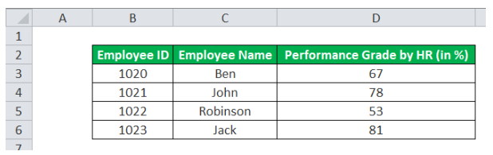
With just the employee ID, we will retrieve the employee’s name and the performance grade given by HR using the VLOOKUP and the HLOOKUP formula.
The output using the VLOOKUP formula is,
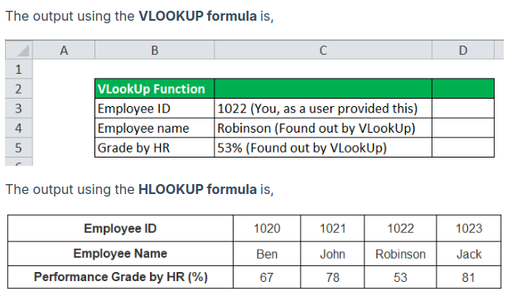
Output Interpretation:
- VLOOKUP works when the table is vertically set up, i.e., a column-wise table.
- HLOOKUP works when the table setup is horizontal, i.e., a row-wise table.
Therefore, the functions VLOOKUP and HLOOKUP retrieved the same result, but the table is arranged differently.
HLOOKUP
Description
Searches for a value in the top row of a table or an array of values, and then returns a value in the same column from a row you specify in the table or array. Use HLOOKUP when your comparison values are located in a row across the top of a table of data, and you want to look down a specified number of rows. Use VLOOKUP when your comparison values are located in a column to the left of the data you want to find.
The H in HLOOKUP stands for "Horizontal."
Syntax
HLOOKUP(lookup_value, table_array, row_index_num, [range_lookup])

The HLOOKUP function syntax has the following arguments:

Lookup_value Required. The value to be found in the first row of the table. Lookup_value can be a value, a reference, or a text string.

Table_array Required. A table of information in which data is looked up. Use a reference to a range or a range name.

The values in the first row of table_array can be text, numbers, or logical values.

If range_lookup is TRUE, the values in the first row of table_array must be placed in ascending order: ...-2, -1, 0, 1, 2,... , A-Z, FALSE, TRUE; otherwise, HLOOKUP may not give the correct value. If range_lookup is FALSE, table_array does not need to be sorted.

Uppercase and lowercase text are equivalent.
Sort the values in ascending order, left to right. For more information, see Sort data in a range or table.

Row_index_num Required. The row number in table_array from which the matching value will be returned. A row_index_num of 1 returns the first row value in table_array, a row_index_num of 2 returns the second row value in table_array, and so on. If row_index_num is less than 1, HLOOKUP returns the #VALUE! error value; if row_index_num is greater than the number of rows on table_array, HLOOKUP returns the #REF! error value.

Range_lookup Optional. A logical value that specifies whether you want HLOOKUP to find an exact match or an approximate match. If TRUE or omitted, an approximate match is returned. In other words, if an exact match is not found, the next largest value that is less than lookup_value is returned. If FALSE, HLOOKUP will find an exact match. If one is not found, the error value #N/A is returned.

Remark
If HLOOKUP can't find lookup_value, and range_lookup is TRUE, it uses the largest value that is less than lookup_value.

If lookup_value is smaller than the smallest value in the first row of table_array, HLOOKUP returns the #N/A error value.

If range_lookup is FALSE and lookup_value is text, you can use the wildcard characters, question mark (?) and asterisk (*), in lookup_value. A question mark matches any single character; an asterisk matches any sequence of characters. If you want to find an actual question mark or asterisk, type a tilde (~) before the character.

Example
Copy the example data in the following table, and paste it in cell A1 of a new Excel worksheet. For formulas to show results, select them, press F2, and then press Enter. If you need to, you can adjust the column widths to see all the data.
Axles | Bearings | Bolts
4 | 4 | 9
5 | 7 | 10
6 | 8 | 11
Formula | Description | Result
=HLOOKUP("Axles", A1:C4, 2, TRUE) | Looks up "Axles" in row 1, and returns the value from row 2 that's in the same column (column A). | 4
=HLOOKUP("Bearings", A1:C4, 3, FALSE) | Looks up "Bearings" in row 1, and returns the value from row 3 that's in the same column (column B). | 7
=HLOOKUP("B", A1:C4, 3, TRUE) | Looks up "B" in row 1, and returns the value from row 3 that's in the same column. Because an exact match for "B" is not found, the largest value in row 1 that is less than "B" is used: "Axles," in column A. | 5
=HLOOKUP("Bolts", A1:C4, 4) | Looks up "Bolts" in row 1, and returns the value from row 4 that's in the same column (column C). | 11
=HLOOKUP(3, {1,2,3;"a","b","c";"d","e","f"}, 2, TRUE) | Looks up the number 3 in the three-row array constant, and returns the value from row 2 in the same (in this case, third) column. There are three rows of values in the array constant, each row separated by a semicolon (;). Because "c" is found in row 2 and in the same column as 3, "c" is returned.

Pivot Table
What it is: A Pivot Table is a powerful Excel tool used to summarize large datasets. It allows you to extract meaningful information by organizing data into rows and columns, providing summaries such as totals, averages, or counts.
Use Cases
  - Summarizing sales data by category, region, or date.
  - Analyzing employee performance by department.
  - Grouping and filtering large datasets to focus on specific aspects.

How to Create a Pivot Table:
  - Select your data range.
  - Go to the Insert tab and choose Pivot Table.
  - In the PivotTable Field List, drag fields to the Rows, Columns, and Values areas.
  - Use Rows to categorize your data (e.g., products), and Values to summarize (e.g., total sales).

Example: Imagine you have a dataset with sales information for various products, broken down by month and region. You can use a Pivot Table to quickly answer questions like:
  - What are the total sales for each region?
  - Which product sold the most in the last quarter?
By dragging Region to Rows and Sales to Values, the Pivot Table will show a summary of sales by region.

2. Use of E-mail Clients (MS Outlook)
What it is: An email client like Microsoft Outlook helps you manage your email accounts, organize communication, and integrate calendars, tasks, and contacts in one place. It’s widely used in business for its professional email features and integration with Microsoft Office.

Features of MS Outlook:
  - Email Management:
    - Create, send, and receive emails.
    - Organize emails into folders and use filters to prioritize important messages.
  - Calendaring:
    - Schedule meetings and appointments.
    - Set reminders for important events.
  - Task Management:
    - Create task lists and set due dates.
    - Track progress on projects.
  - Contacts:
    - Store contact information for colleagues, clients, or vendors.
    - Use contact groups to easily send mass emails.

Example: Imagine you are managing a team project. You can use Outlook to:
  - Email your team about updates and progress.
  - Use the calendar feature to schedule team meetings and set deadlines.
  - Assign tasks and set reminders for team members to complete their work.
You can also create rules to automatically sort incoming emails from specific team members into designated folders.
--------------------------------------------------------------------
Mozilla Thunderbird is a popular, open-source email client that allows users to manage multiple email accounts, organize messages, and integrate with calendars and other tools. Below is a step-by-step guide on how to install and configure Thunderbird.

Mozilla Thunderbird: Installation and Configuration

Step 1: Downloading Thunderbird
- Go to the official Mozilla Thunderbird website: https://www.thunderbird.net.
- Click on the "Free Download" button.
- Once the download completes, open the installer file.
  - For Windows: Run the .exe file.
  - For Mac: Open the .dmg file.
  - For Linux: Follow the distribution-specific installation instructions (e.g., using a package manager like apt or yum).

Step 2: Installing Thunderbird
• Windows/Mac:
- Follow the installation wizard prompts.
- Agree to the license agreement and choose the installation location if prompted.
- Click Install and wait for the process to complete.
• Linux:
- Use the terminal to install Thunderbird (for example, on Ubuntu):
bash
sudo apt install thunderbird
Follow any additional instructions specific to your Linux distribution.

Step 3: Launching Thunderbird
- Once the installation is complete, launch Thunderbird.
  - You can find it in your Applications folder or Start menu.
- Upon first launch, you’ll be prompted to set up your email account.

Step 4: Configuring an Email Account
- Set Up Your Email Address:
  - Thunderbird will automatically prompt you to set up your first email account.
  - Enter your name, email address, and password.
- Manual Configuration (if needed):
  - If Thunderbird cannot automatically configure your account, click Manual Config.
  - You will need to know your email provider’s incoming and outgoing server settings.
    - IMAP (for syncing email across devices) or POP3 (for downloading emails to a single device).
    - SMTP (for sending email).
    - Example settings for popular providers:
      - Gmail IMAP: imap.gmail.com (Port 993), SMTP: smtp.gmail.com (Port 587)
      - Outlook IMAP: outlook.office365.com (Port 993), SMTP: smtp.office365.com (Port 587)
  - Enter the appropriate settings for your email provider and click Done.

Step 5: Customize Thunderbird
- Add More Accounts:
  - Go to Tools > Account Settings > Add Mail Account to add multiple email accounts.
- Themes and Extensions:
  - Customize the look and functionality of Thunderbird by adding themes and extensions.
  - Go to Tools > Add-ons and search for available extensions to enhance your experience.

Step 6: Syncing and Using Thunderbird
- Managing Emails:
  - Once your email is set up, Thunderbird will sync your messages.
  - You can organize your inbox with folders, tags, and filters.
- Calendar Integration:
  - You can integrate calendars using the Lightning extension, which is built into Thunderbird.
  - Go to Events and Tasks > Calendar to start managing events and tasks.
- Contacts:
  - Import contacts from other email clients or manually add them to Thunderbird’s address book.

