**Fake news Detection using NLP Project**

**Design and Innovation**

| **Date** | **10-10-2023** |
| --- | --- |
| **Team ID** | **3916** |
| **Project Name** | **Fake news detection using NLP** |

**Table of Contents**

| 1 | Introduction |
| --- | --- |
| 2 | Problem Statement |
| 3 | Design and Innovation Strategies |
| 3.1 | Data Collection and Pre- processing |
| 3.2 | Feature Engineering |
| 3.3 | Model development and Training |
| 3.4 | Fake new detection metrics |
| 3.5 | User Interface and Explainability |
| 3.6 | Ethical Considerations Innovation |
| 3.7 | Continuous Improvement |
| 4 | Conclusion |

**1. Introduction**



Our project aims to develop an AI system that distinguishes real news from fake news, especially when it originates from untrustworthy sources. By training the AI model with a mix of real and fake news data, we strive to promote trustworthy and accurate news consumption in the era of online misinformation.

**2. Problem Statement**

We're addressing the issue of fake news, false or misleading information posing as real news, prevalent on the internet, especially on social media platforms due to its attention-grabbing nature. Our objective is to develop an AI model capable of discerning real from fake news, particularly when from unreliable sources. We'll use a combination of real and fake news to train the AI model, ultimately striving to guarantee the trustworthiness and accuracy of the news we consume.

**3. Design and Innovation Strategies**

**3.1. Data Collection and Pre -processing:**

Innovation: Comprehensive Data Gathering

Utilizing advanced web scraping techniques to collect diverse datasets encompassing news articles from various sources.

Incorporating social media APIs to retrieve related data such as shares, likes, and comments. Including metadata like publication date, title, text, subject and source credibility scores.

**Innovation: Text Data Pre-processing**

Employing Natural Language Processing (NLP) techniques for text cleaning, tokenization, and removing stop words.

Implementing sentiment analysis to gauge the emotional tone of news articles.

Detecting named entities and their relationships within the text using Named Entity Recognition (NER).

**3.2. Feature Engineering Innovation:**

Feature Extraction Extracting linguistic features such as word frequency, sentence length, and readability scores.

Generating context-based features, including the presence of specific keywords associated with fake news.

Utilizing topic modeling techniques like Latent Dirichlet Allocation (LDA) to unveil the underlying themes in news articles.

**3.3. Model Development and Training**

Innovation: NLP-based Models

Leveraging NLP models like Recurrent Neural Networks (RNNs) or Transformer-based models (e.g., BERT) for text classification.

Constructing an ensemble of models by amalgamating NLP models with traditional machine learning algorithms like Random Forest or Support Vector Machines.

Innovation: Advanced Model Exploration Exploring advanced techniques such as deep learning architectures (e.g., LSTM) and pre-trained language models (e.g., BERT) to improve fake news detection accuracy.

Employing ensemble methods to enhance the robustness and reliability of the prediction system.

**3.4. Fake News Detection Metrics**

Innovation: Performance Evaluation

Defining custom metrics for fake news detection, including precision, recall, and F1-score.

Implementing cross-validation techniques to assess model generalization.

Continuous monitoring and fine-tuning of the model to adapt to evolving fake news tactics.

**3.5. User Interface and Explainability**

Innovation: User-Friendly Interface

Developing an intuitive web application enabling users to submit news articles for analysis.

Providing real-time feedback on the likelihood of news articles being fake or real.

Incorporating explanations for model predictions, highlighting key features influencing the decision.

**3.6. Ethical Considerations Innovation:**

Ethical Framework Creating guidelines for responsible AI usage, ensuring fairness and minimizing biases. Implementing mechanisms to prevent inadvertent promotion of censorship by the system. Promoting transparency in the fake news detection process while safeguarding user privacy.

**3.7. Continuous Improvement**

Innovation: Model Enhancement

Establishing a feedback loop for users to report false positives and negatives.

regularly updating the model with new labeled data and incorporating user feedback to enhance accuracy.

Implementing automated data ingestion and model retraining for real-time effectiveness.

**This diagram provides a simplified overview of our solution architecture, highlighting key components and innovations from sections 3.1 to 3.7:**

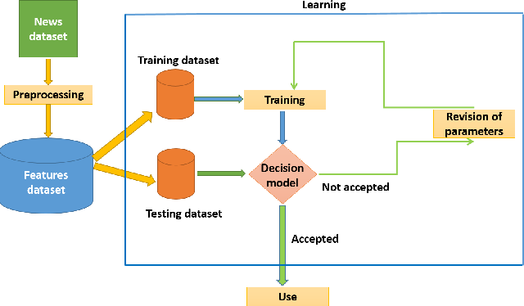

**4. Conclusion**

In conclusion, our innovative NLP-based fake news detection project combines advanced data gathering, text processing, and model development. By leveraging deep learning and ensemble techniques, we improve accuracy. Custom metrics and a user-friendly interface ensure responsible AI usage. Continuous enhancement and ethical considerations underscore our commitment to combating misinformation.