Minimum Requirements:
Supported Operating System:
- Windows 10/11 (64 bit)
- macOS: 10.15 Catalina or later
Hardware Prerequisites:
- Processor: 1.6 GHz or faster
- RAM - Minimum 4 GB [8 GB or higher is recommended]
- Storage - Minimum 20+ GB of free disk space (additional space required for extensions and projects)
Software Prerequisites for VScode:
- .NET Framework 4.5.2 or later (automatically installed if not present)
- Visual C++ Re-distributable (usually comes with Windows updates)
Software Prerequisites for node.js:
- Windows Build Tools [It will be installed while the node.js installation]
- Python 3.x or later
- Visual Studio Build Tools
- Microsoft Visual C++ Build Tools
- PowerShell 5.1
- .NET Framework 4.5.2 or later (automatically installed if not present)
- Visual C++ Re-distributable (usually comes with Windows updates)

Installation - Visual Studio code(version 1.97.0):
Step 1:
Download Visual Studio: https://code.visualstudio.com/updates/v1_97

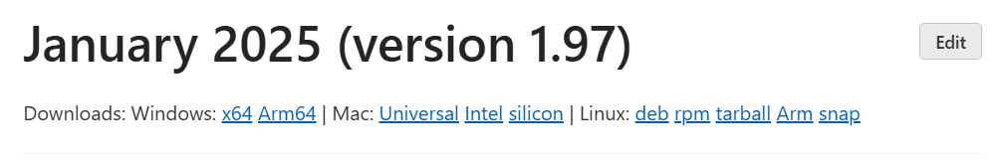
Click Windows: x64 link.

Step 2:
Install the downloaded .exe file

Step 3:
In the Setup Popup - Click “I accept the agreement” radio button and click NEXT and install.

Step 4:
Click Finish button.

Step 5:
To Verify installation:
Open command prompt and run the below command
- code --version [Result should be v1.97.0]

Installation - node.js (version 22.13.1):
Step 1:
Download Node.js: https://nodejs.org/en/download

Make sure the below option is selected.
Click Windows installer(.msi) button

Step 2:
Run the installer [downloaded .msi file].

Setup wizard will open.

Step 3:
Click NEXT and click the check box - “I accept the terms in the License Agreement” and click Next till it reaches the Tools for Native Modules page.

Step 4:
Click the check box- “Automatically install the necessary tools” and click NEXT and install.

Step 5:
After installation, Command prompt will appear. Press any key from keyboard to continue. It will ask you to install PowerShell. Click ok. And wait till it runs completely.

[Wait till the command displayed - “Type Enter to Exit”]. Click Enter button

Step 6:
To Verify installation:
Open command prompt and run the below commands one by one.
- node -v [Result should be v22.13.1]
- npm -v [Result should be v10.9.2]

MSSQL Server (2019 Express):
Step 1:
Go to the Link - https://www.microsoft.com/en-ca/download/details.aspx?id=101064

Step 2:
Click Download

Step 3:
Run the downloaded (.exe) file and click Yes in the Prompt. It will open the installation page

Step 4:
Select Basic option and Accept the License terms

Step 5: Click Install Button.
Wait till Installation complete. It will open the installer and show the credentials

Step6:
From the SQL Server Installer page, Click Connect Now button. It will open command prompt.

Step 7:
Copy the command from 2nd line in the prompt and paste it and run the command.
(keep a note of it) - sqlcmd -S DESKTOP-DDBC6NE\SQLEXPRESS -E

Step 8:
Come back to SQL Server Installer page.
Step 9:
Click Customize button

Step 8:
Click NEXT button and again NEXT button.

Step 9:
Allow the install rules progress bar to run. Click Next.

Step 10:
Click Next. Agree the License terms and click Next.

Step 11:
Click NEXT and wait.

Step 12:
Choose Names instances radio button. Enter the Name and Instance Id as “ERP_Dev_2025”. Click Next

Step 13:
Change Startup type for SQL Service Browser to Automatic in the drop-down. Click Next

Step 14:
Switch to Mixed mode radio button. Enter the password Admindev@123. Click Next.
Wait till installation complete.
Once the Install successful message is shown, click close.

Step 15:
Come back to SQL Server Installer page.

Step 16:
Click Install SSMS button. It will open the browser. https://learn.microsoft.com/en-us/sql/ssms/download-sql-server-management-studio-ssms?view=sql-server-ver15&redirectedfrom=MSDN

Step 17:
Click the download link (version 20.2).


It will download the SSMS executable file(.exe). Run it

Step 18:
Click Install. And Click Yes in the User Account Control.
[Wait till the progress is complete].

Step 19:
Click Close button.

Step 20:
Click Close button in the SQL Server installer.

Git Installation:
Step 1:
Click https://git-scm.com/downloads

Step 2:
Click Windows link
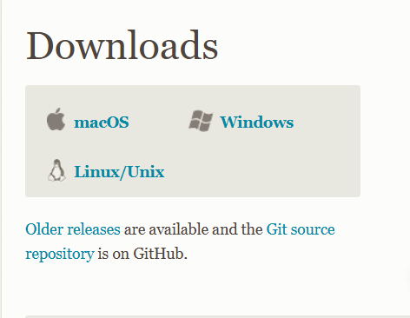

Step 3:
Click 64-bit Git for Windows Setup link.
It will download the .exe file. Run it

Step 4:
Click Yes in the User Account Control

Step 5:
Click Next until Install and click Install button

Step 6:
Click Finish button.

Step 7:
Search for Edit the system environment variables start menu and click Yes.

Step 8:
In the System Properties window, click "Environment Variables".

Step 9:
Under System variables, scroll down and find the Path variable. Select it and click "Edit".

Step 10:
In the new window, click "New" and check for Git's bin and cmd folders. If not present add the path.

Example:
C:\Program Files\Git\bin
C:\Program Files\Git\cmd

Step 11:
Click OK on all windows to save the changes.

Step 12:
Open/Restart Command Prompt and type the command: git --version
It should display the Git version

GitHub Desktop Application:
Step 1:
Click GitHub Desktop | Simple collaboration from your desktop · GitHub

Step 2:
Click Download Now button, Click Download for windows 64 bit button
[It will download the exe file]. Run it

Step 3:
Click Sign in to Github.com button

Step 4:
Click Continue button. Click Authorize Desktop button.

Step 5:
In the prompt, Click Open GitHubDesktop.exe button

Step 6:
Click Finish

GitHub Desktop Application Setup:
Step 1:
Open the GitHub Desktop Application, Click the Create a New Repository on your local drive button.

Step 2:
Enter the repository Name for your local drive.
Choose the path to save the project in local drive
Click Create Repository button.

Step 3:
Click Open in Visual Studio code button

Step 4:
File > Clone Repository > choose ProphecyTech2k14/erp-platform and click clone.

