东北大学软件学院

学生实训总结报告

专 业： Software Engineering (Elite Class)
班 级： SE-EN 2301
学 号： 20236742
姓 名： Wang Ruiqi
实训基地： NEU Software College Enterprise Project Training
企业指导教师： [To be filled]
评阅人评分
评分项
分数（百分制）
工作量饱满，给出解决方案并指出局限性

格式规范，内容全面、清晰

评阅人评语

签字：

年 月 日
说 明

实训结束之前，每个学生都必须认真撰写《实训总结报告》。通过撰写实训总结报告，系统地回顾和总结实训的全过程，将实践性教学的感性认识升华到一定的理论高度，从而提高实训教学效果。
实训总结报告要求条理清晰，内容详尽，数据准确。字数不少于5000字。
实训总结报告的质量反映了实训的质量，它是实训成绩评定的主要依据之一。应在规定时间内将此报告上交。不交实训报告者不得参加实训成绩评定。
封面中的“实训单位”必须写单位的全名，必须写上企业指导教师姓名。
“前言”部分： “实训背景”可简介实训目的、通过何种方式到此单位实训等内容；“实训环境”可包括实训单位全称（中英文）、地址、实训单位性质、规模、简介、所在部门、该部门主要工作、指导教师安排等内容；“实训过程”概述实训各阶段所从事的主要工作等。
“实训内容”部分：属报告的主要部分。“概述”包括项目介绍、本人从事的工作等；“相关技术”包括与项目相关的理论基础，项目开发方法、开发工具、开发环境等关键技术的介绍；“系统分析”包括对整个项目的介绍分析及本人工作内容的详细分析，如业务分析、功能分析（可使用用例图、活动图来描述）、可行性分析等；“系统设计”包括总体设计和详细设计，总体设计包括系统架构设计、功能模块划分等，详细设计要围绕本人工作内容展开，包括功能模块详细设计、类和对象的设计、动态模型设计（时序图、状态图、协作图等）、算法设计、数据库设计等；“系统实现”也要围绕本人工作内容展开，从编码实现角度论述相应功能模块的实现细节，并展示自己所完成的主要成果及实际应用情况等。可通过“程序流程图”、“关键代码”和“界面”进行直观论述。“系统测试”包括测试方案设计、测试用例和测试结果、最终的测试结论或评价等。
“总结”部分：其中“其它意见”可对学院课程设置、教学内容、实训安排等方面提出自己的意见或建议，也可对实训单位的各个方面提出自己的意见。
目 录

TOC \o "1-3" \h \z HYPERLINK \l "_Toc448492765" 1 前言 PAGEREF _Toc448492765 \h 4
HYPERLINK \L "_TOC448492766" 1.1 实训背景 PAGEREF _TOC448492766 \H 4
HYPERLINK \L "_TOC448492767" 1.2 实训环境 PAGEREF _TOC448492767 \H 4
HYPERLINK \L "_TOC448492768" 1.3 实训过程 PAGEREF _TOC448492768 \H 4
HYPERLINK \l "_Toc448492769" 2 实训内容 PAGEREF _Toc448492769 \h 5
HYPERLINK \L "_TOC448492770" 2.1 概述 PAGEREF _TOC448492770 \H 5
HYPERLINK \L "_TOC448492771" 2.2 相关技术 PAGEREF _TOC448492771 \H 5
HYPERLINK \L "_TOC448492772" 2.3 系统分析 PAGEREF _TOC448492772 \H 5
HYPERLINK \L "_TOC448492773" 2.4 系统设计 PAGEREF _TOC448492773 \H 5
HYPERLINK \L "_TOC448492774" 2.5 系统实现 PAGEREF _TOC448492774 \H 5
HYPERLINK \L "_TOC448492775" 2.6 系统测试 PAGEREF _TOC448492775 \H 5
HYPERLINK \l "_Toc448492776" 3 总结 PAGEREF _Toc448492776 \h 6
HYPERLINK \L "_TOC448492777" 3.1 实训体会 PAGEREF _TOC448492777 \H 6
HYPERLINK \L "_TOC448492778" 3.2 其它意见 PAGEREF _TOC448492778 \H 6
1 前言
1.1 实训背景
The enterprise project internship is placed in the senior undergraduate stage. The college expects more than a course-style page demo: students should push a medical-imaging-related system to a runnable, integrable, defense-ready prototype under team collaboration. Group C builds a CT-oriented annotation and data-management platform (repository: C_Group_Medical_Annotation).
The domain tension is practical. Manual 3D delineation is slow and hard to version; fully automatic segmentation rarely passes review in one shot. The platform therefore targets a closed loop of AI draft labeling, human refinement, review, and dataset export. For a software-engineering student, this covers requirements, APIs, persistence, interaction, quality, and collaboration.
We split platform engineering and AI algorithms. I owned the platform side: backend APIs, database, annotation frontend, 3D visualization, auth/review workflow, and the AI integration surface. My teammate focused on training/inference. We shared one GitHub repo, naming rules, and /api contracts. My goals were to finish a full SE lifecycle, confront messy DICOM/NIfTI/mask realities, and keep the system integrable when teammates moved at different speeds.
Up front: this is an educational engineering system, not a certified medical device. “Simulated surgery” validates 3D interaction and ROI persistence; it is not clinical surgical planning.
1.2 实训环境
The internship base is NEU Software College enterprise project training, carried by the Group C platform. Local stack: macOS; FastAPI/uvicorn on 127.0.0.1:8000; SQLite with schema.sql plus runtime ensure_*_schema migrations; primary UI in frontend/ (vanilla JS) with React assets under web/; VTK.js and WebGL2 volume rendering; MediaPipe Hands; AI bridges to nnU-Net, TotalSegmentator, and DeepEdit (local TotalSeg Python under conda when needed).
GitHub branches: feature-a / feature-b / dev / main. Large images, weights, and real patient data stay out of the repository; only code, docs, configs, and split manifests are committed. Seed users (annotator / reviewer / admin) support permission debugging.
Day-to-day work sat in the platform engineering lane: API design/implementation, workstation interaction, volume/mask services, gesture and surgery modules, teammate predict write-back integration, documentation, and branch merges. Please fill the industry mentor name on the cover where marked.
1.3 实训过程
Phase 1 built standards and skeleton: data naming, ER draft, API contract, UI wireframe, and a working cases/images/masks/versions path. Without that backbone, later 3D and AI features would have nowhere to land. The first milestone was intentionally boring: select a case, scroll slices, save a mask, reload it.
Phase 2 added JWT auth, task assignment, submit/approve/reject, VTK 3D + MPR, MIP/MinIP, and multi-DICOM upload. The goal was to make “a day in an annotator’s life” possible inside one system instead of scattered scripts.
Phase 3 deepened human–AI collaboration: honest predict failures, multi-label tools, quality/export, then MediaPipe bimanual navigation and organ picking, integrating my teammate’s multi-organ capabilities through platform APIs. This is also where we learned that a beautiful wrong mask is worse than a plain error toast.
Phase 4 polished for defense: gesture dock between 3D and MPR, per-label colored VTK meshes, surgery gates (select → confirm cuboid ROI → cut), surgery_results with organ fields, and merging feature-a into main/dev on GitHub.
Rework worth noting: configurable export manifests when my teammate’s schemas evolved; depth/health prechecks against single-slice demos; replacing an overlay gesture panel that blocked 3D with a document-flow dock. These changes are not glamorous, but they match how real products are finished under deadline pressure.
Across phases I kept a simple personal rule: never claim a feature in the report unless the current branch can demonstrate it after a hard refresh. That rule prevented several “slides ahead of code” embarrassments during dry runs.
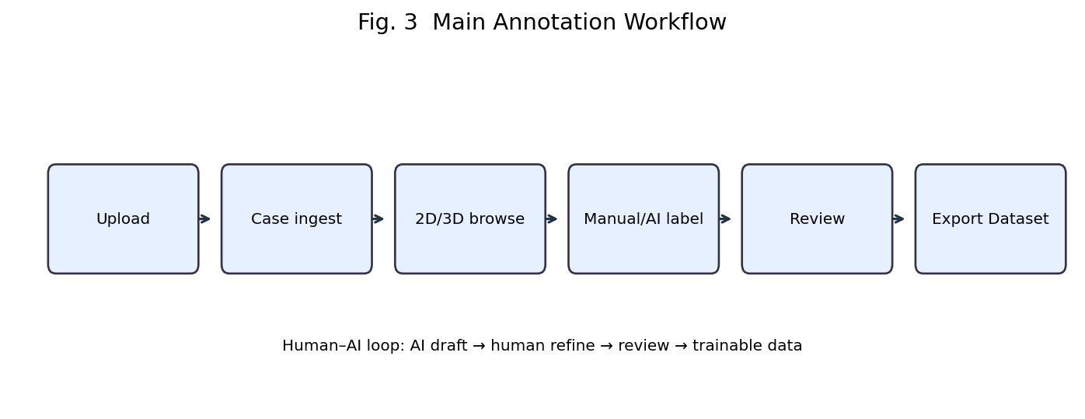
Fig. 1-1 Main annotation workflow
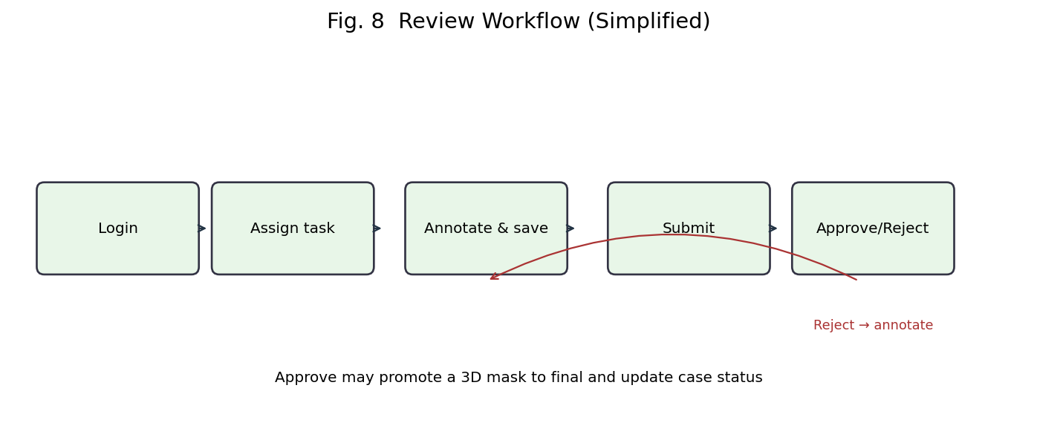
Fig. 1-2 Review activity diagram
2 实训内容

2.1 概述
The system serves annotators, reviewers, and admins for CT upload, 2D multi-label editing, 3D/gesture interaction, AI mask write-back, version review, dataset export, and demo surgery ROI recording. I did not train a brand-new SOTA network; I made the platform call models honestly and store results reproducibly.
In product terms, I own the “operating system” of labeling: identity, persistence, visualization, workflow, and integration sockets. My teammate owns learning algorithms and training recipes. The internship grade, for my part, depends on whether those sockets are stable enough for another person to plug into.
Deliverables spanned FastAPI/SQLite services, auth/task/review APIs, imaging/volume endpoints, mask versioning and export, the annotation workstation, VTK/WebGL2 + MPR, MediaPipe gestures, organ-aware surgery ROI persistence, teammate AI integration, and release merges to main/dev.
The rest of Chapter 2 expands technologies, analysis, design, implementation, and testing in that order, matching the college template while staying anchored to code that exists in the repository today.
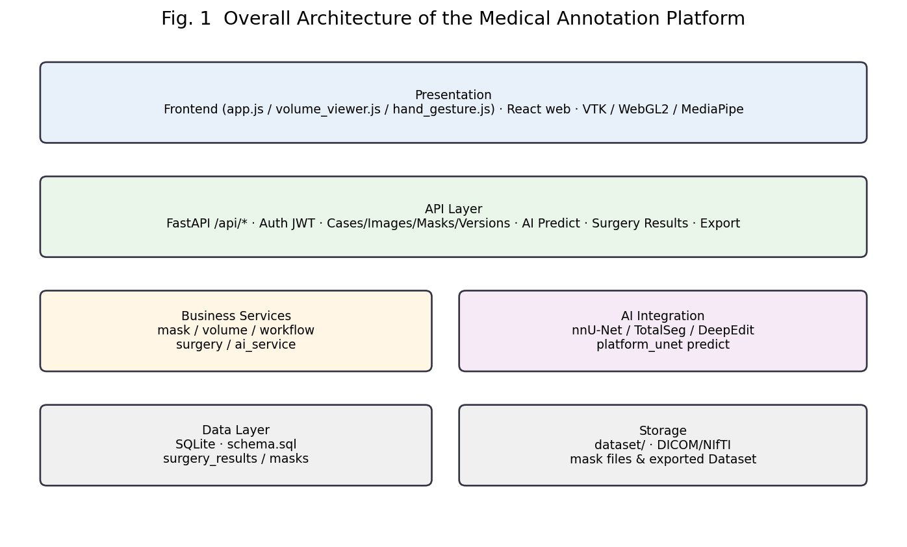
Fig. 2-1 Overall architecture
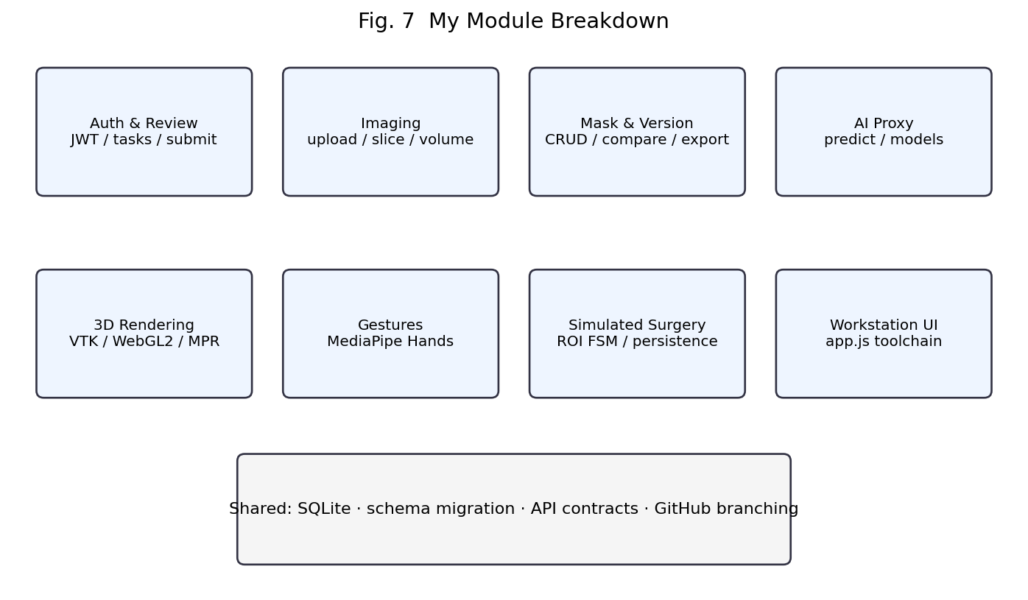
Fig. 2-2 My module breakdown
2.2 相关技术
2.2.1 Theoretical Background
Medical volumes appear as DICOM series or NIfTI/NRRD tensors; masks encode labels on the same grid. Multi-label scenes require careful label IDs so a liver edit does not erase a kidney. Dice/IoU support coarse version comparison but never replace expert review.
Volume rendering and surface meshes (e.g., marching cubes) serve different reading goals. Volume rendering helps inspect density distributions; surfaces help understand organ boundaries and support picking. MPR remains essential for radiology-style correlation across axial, coronal, and sagittal views.
Human–AI annotation assumes models propose and humans correct. Therefore the system must support AI write-back and human overwrite with version provenance. Gestures reduce mouse load in 3D but introduce recognition noise that must be gated by explicit modes and prechecks.
From a software-architecture view, the hard problem is not drawing polygons; it is keeping identity stable across upload, prediction, edit, review, and export so that a later training run can explain where each label came from.
2.2.2 Methods, Tools, and Environment
We used iterative increments: freeze contracts, ship a vertical slice, then deepen 3D/gestures/surgery under defense pressure. Docs 01–16 acted as team manuals and reduced lost oral agreements.
Tooling included FastAPI/Pydantic, vanilla JS plus React assets, VTK.js/WebGL2, MediaPipe, and Python AI stacks. Local uvicorn supported fast backend iteration; node --check and py_compile acted as cheap syntax gates before demos.
Methodologically we avoided pretending to run a heavyweight waterfall. When requirements changed—for example “surgery must confirm ROI first”—we patched the running system in small steps and updated the contract docs in the same pull request whenever possible.
2.3 系统分析
System analysis moves from “what problem the whole project solves” to “what I must deliver.” The subsections cover business, functions (use cases and activity diagrams), and feasibility.
2.3.1 Business Analysis
A case flows upload → browse → annotate (optionally AI-first) → save mask/version → submit → review → export. Multi-organ labels, coexisting versions, recoverable failures, and role isolation matter throughout that chain.
For 3D scenes, users also want rotation, MPR correlation, optional low-mouse gestures, and a demo “pseudo-surgery” ROI on a selected organ. These needs do not replace clinical surgical planning, but they test whether interaction and persistence actually close.
If the loop breaks at “can view but cannot save,” or “saved but cannot tell which organ was cut,” the system’s value collapses quickly in a defense setting. That is why organ metadata was promoted from a UI-only concern into first-class database fields.
Stakeholders differ: annotators want speed and undo; reviewers want diffs and accountability; admins want assignment; AI teammates want stable export schemas. My platform has to answer all of them, not only polish one animation.
2.3.2 Functional Analysis (Use Cases & Activity Diagrams)
Figure 2-5 summarizes actors and use cases. Authorization is enforced in APIs, not only by hiding buttons.
Activity diagrams capture cross-role processes. Fig. 2-5a shows the main annotation activity (upload to export); Fig. 2-5b shows review (submit—approve/reject—re-edit). They align with later state and sequence diagrams.
2.3.3 Feasibility and Scope
Technically and economically feasible with open-source stacks and local SQLite. Operationally, browser clients cover login/annotation/3D/gestures; AI runs on the agreed local Python environment. Ethically, only teaching/public sample volumes are used—no real patient PHI.
Scope honesty: teaching-oriented 2.5D platform U-Net; high-accuracy paths still rely on TotalSeg/nnU-Net; surgery is interactive demonstration; gestures are lighting-sensitive. Single-slice volumes are rejected for 3D demos.
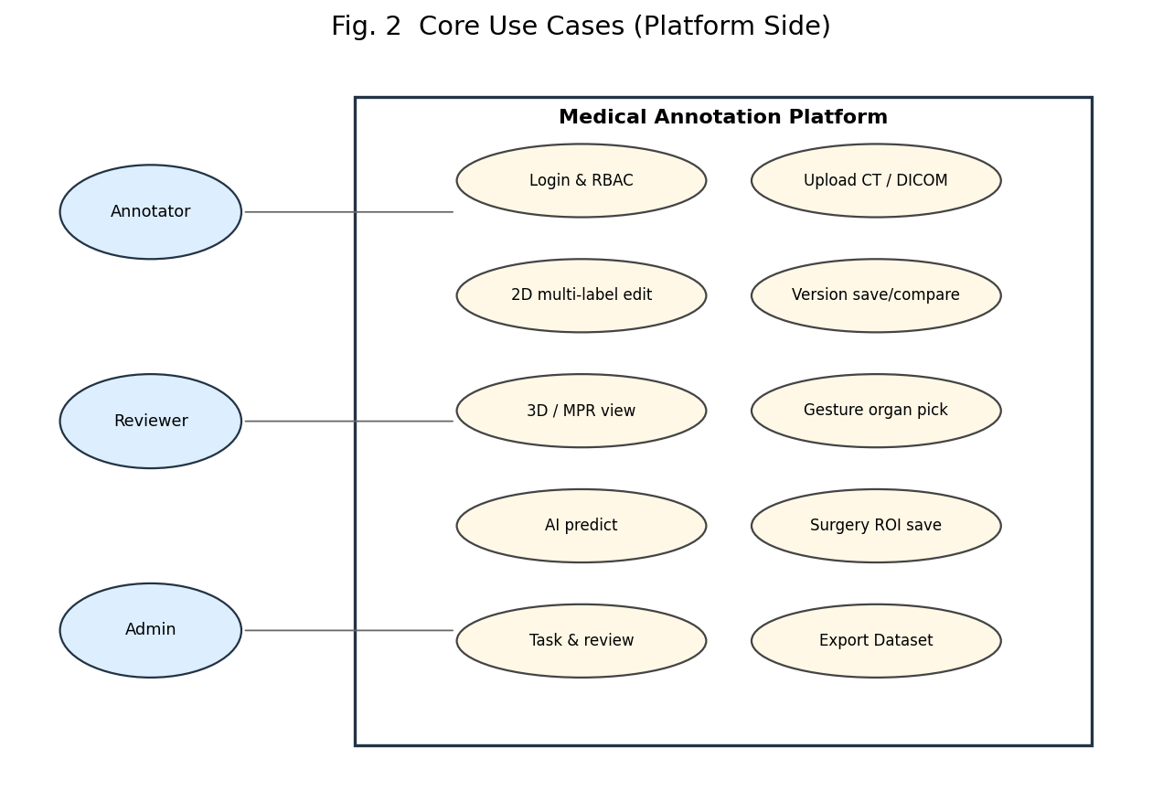
Fig. 2-5 Core use cases
2.4 系统设计
2.4.1 Overall Design (Architecture & Modules)
Layering is presentation → API → services → data/files (Fig. 2-1). The frontend never talks to SQLite directly; AI does not silently overwrite formal versions. That separation keeps audit and rollback possible when a prediction is wrong.
Modules follow Figure 2-2: auth/review, imaging, masks/versions, AI proxy, 3D rendering, gestures, surgery ROI, and the workstation shell. I own backend/frontend/database/docs; my teammate owns ai/; both share dataset conventions under dataset/.
Cross-cutting concerns include JWT authz, consistent ID naming (Case0001/Image0001/Mask0001), and schema migration helpers so an old demo database does not explode on the defense machine.
2.4.2 Detailed Design (Classes, Dynamics, Algorithms)
Detailed design centers on my work: class/object structure, dynamic models, and algorithms. The backend is organized as route schemas + service functions + domain records rather than a heavy ORM hierarchy; the frontend uses collaborating module objects.
Dynamic models include a state diagram (review + surgery gates, Fig. 2-6b), a sequence diagram (save surgery ROI, Fig. 2-8), and a collaboration diagram (AI predict write-back, Fig. 2-6c).
Algorithm design: (1) organ-field resolution—request organ object first, then label catalog fallback; (2) ROI validity—cuboid_max≥cuboid_min, label_id>0, case/image ownership; (3) per_label surface extraction for colored multi-organ meshes; (4) Dice/IoU compare for coarse version disagreement, never replacing human review.
APIs use the /api prefix, including auth, cases, upload, slices/volume, masks, predict, export, and surgery_results. Surface meshes support per_label marching cubes for colored VTK layers.
2.4.3 Database Design
Core entities include users, cases, images, annotations, masks, versions, models, tasks, and surgery_results. cases is the hub; images belong to cases; masks attach labels to images; versions freeze a reviewable state; surgery_results records demo ROIs.
Surgery rows store cuboid bounds, cut planes, carved voxels, plus organ_name / organ_display_name / organ_color / organ_json so a saved ROI can answer which organ was targeted. ensure_surgery_schema migrates older DBs with PRAGMA table_info + ALTER TABLE instead of forcing a wipe.
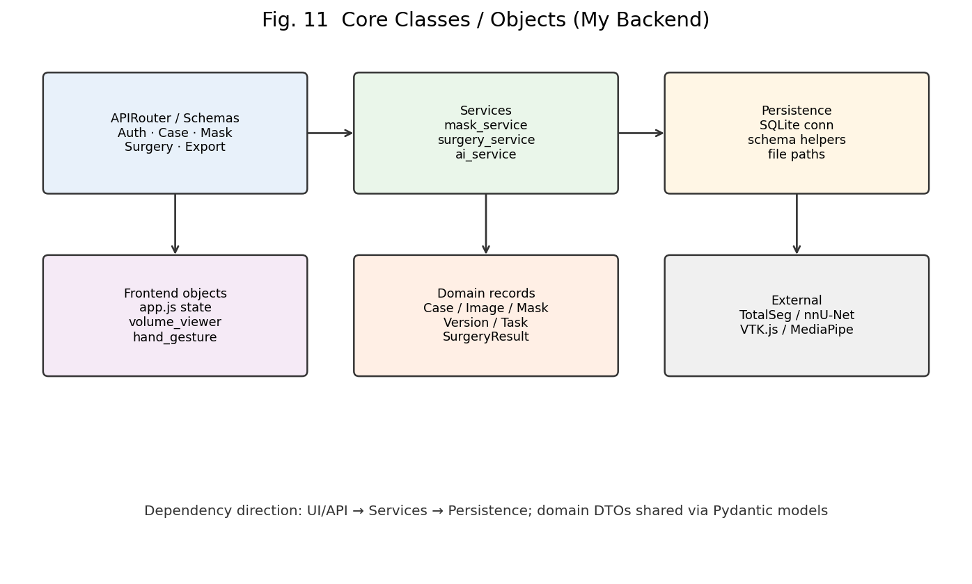
Fig. 2-6a Core classes / objects
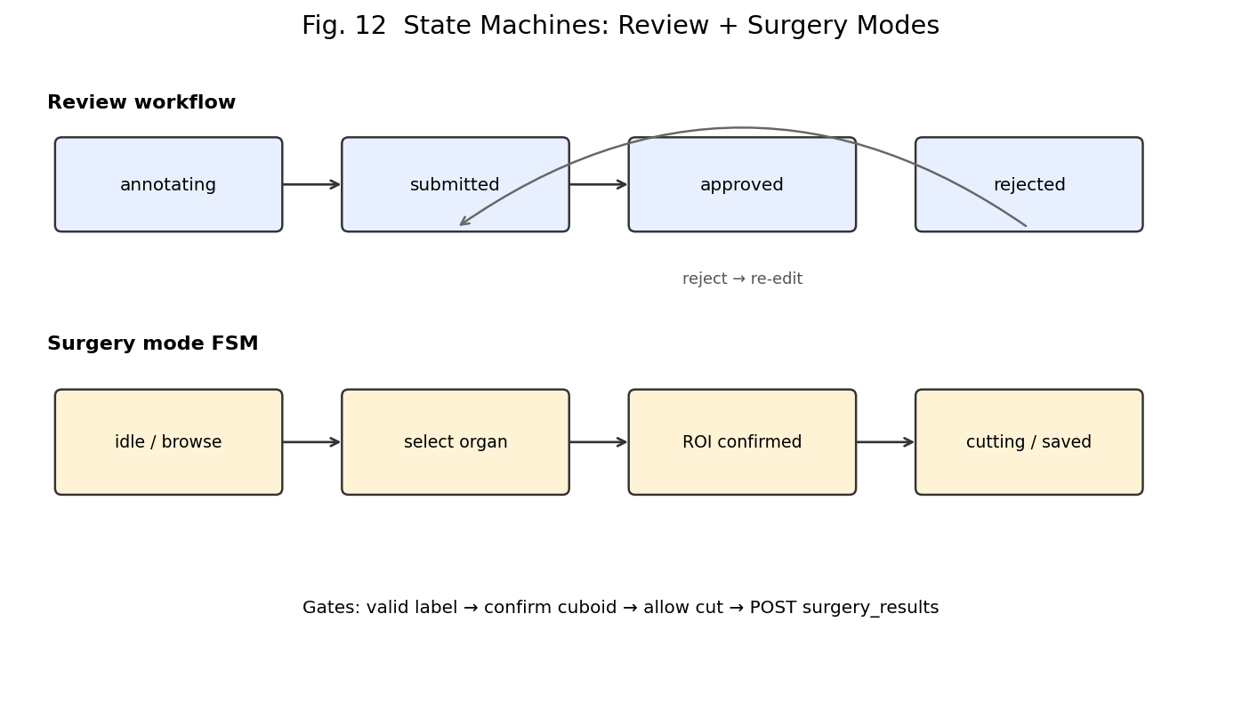
Fig. 2-6b State machines
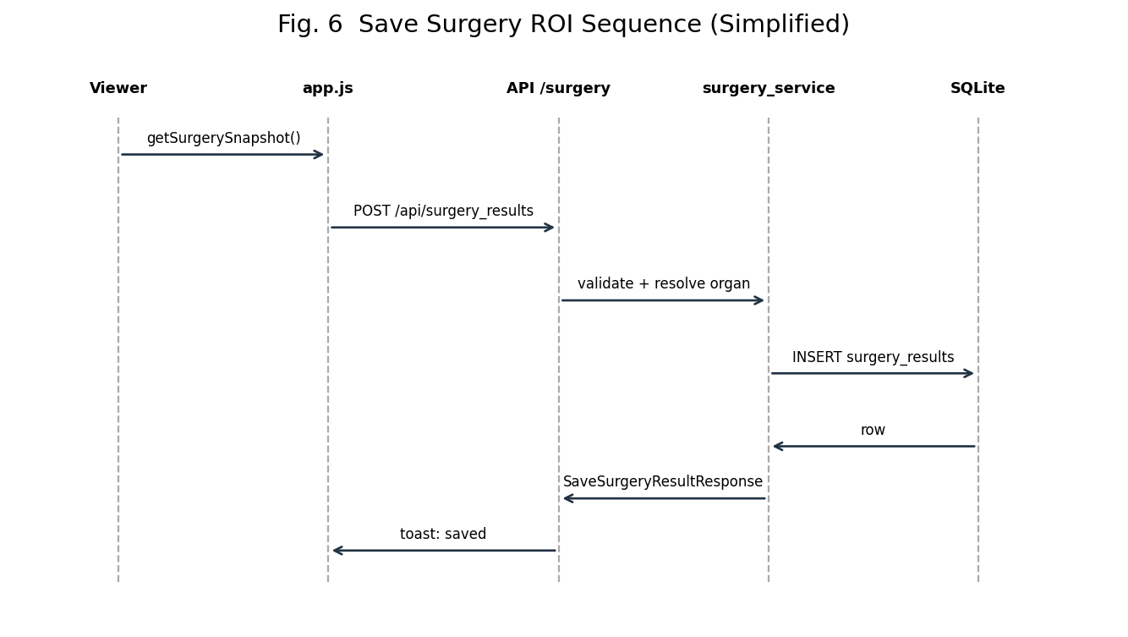
Fig. 2-8 Save-surgery sequence
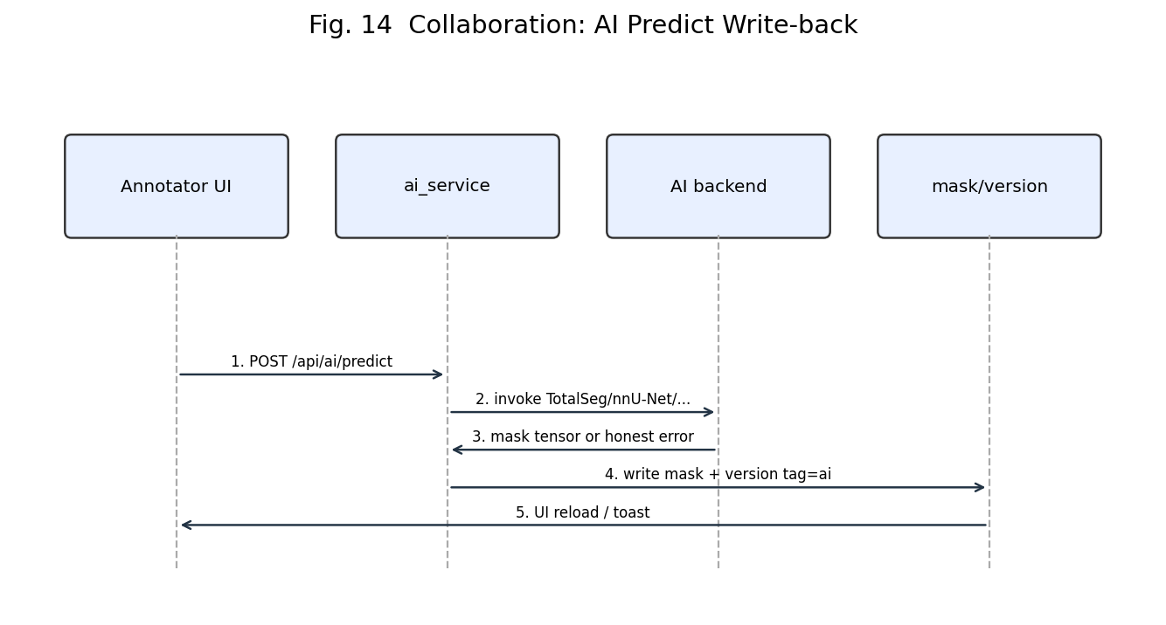
Fig. 2-6c AI predict collaboration
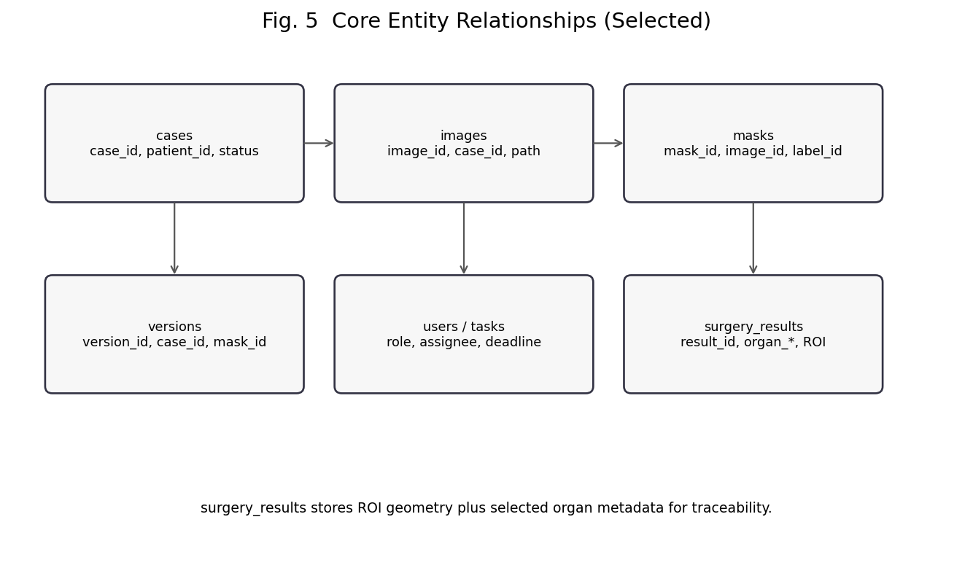
Fig. 2-10 Entity relationships
2.5 系统实现
Implementation followed “vertical slice first, then edges.” The subsections below expand my deliverables with a program flowchart, key code, and UI placeholders.
2.5.1 Backend, Auth, and Persistence
main.py registers routers; services own business rules; SQLite access is centralized. JWT login returns a bearer token; protected write endpoints check roles instead of trusting hidden buttons. Task and review APIs move case state and append audit information so “who approved what” remains answerable.
Saving surgery results validates case/image ownership and label_id, normalizes cut planes, and resolves organ metadata from the request body or label catalog before INSERT. Missing display names fall back to catalog values so the database is not left with a bare integer.
POST /api/surgery_results
body: case_id, image_id, mask_id?, label_id, organ_*,
roi_margin_pct, knife_radius, cuboid_min/max,
cut_planes[], carved_voxels, note?
# surgery_service.py (semantic excerpt)
def save_surgery_result(request, user=None):
ensure_surgery_schema()
case = get_record('cases', 'case_id', request.case_id)
if case is None: raise HTTPException(404, ...)
image = get_record('images', 'image_id', request.image_id)
if image['case_id'] != request.case_id: raise HTTPException(422, ...)
if request.label_id <= 0: raise HTTPException(422, ...)
organ = _resolve_organ_fields(request) # request first, catalog fallback
# INSERT surgery_results(... organ_name/display/color ...)
return SaveSurgeryResultResponse(...)
2.5.2 Imaging, Masks, and Export
Upload handles NIfTI packs and multi-DICOM series; the backend stores files, creates image rows, and serves slice PNGs plus volume metadata.
Masks are label-aware; versions separate manual/ai/final semantics; compare exposes Dice/IoU for quick disagreement checks. Export can materialize multiclass labels plus dataset.json/manifests so my teammate can train against a stable tree.
2.5.3 Annotation Workstation
app.js orchestrates case list, tools, AI actions, versions, save, and export. Multi-label brush/eraser honor the active label_id; undo/redo stay basic but usable.
I admit app.js is oversized. Short-term integration pressure pushed logic into one file; longer-term it should split into case, tool, AI, and surgery modules.
2.5.4 3D, Gestures, and Surgery
volume_viewer.js owns VTK/WebGL2 scenes, MPR sync, and surgery overlays. In per_label mode, surfaces are colored by organ so multi-class scenes remain readable.
hand_gesture.js maps landmarks to orbit/zoom/pick. Before opening the camera it checks volume depth and TotalSeg health. After ROI confirmation, projection boxes align with meshScale. getSurgerySnapshot() exports organ fields; app.js posts them to /api/surgery_results.
2.5.5 AI Integration and Release
ai_service rejects silent baselines; shallow volumes are blocked on TotalSeg paths; model_status/backend/fallback_reason help explain live demos.
feature-a was merged to main/dev without secrets or giant weights. Pre-release self-check: hard refresh, open a multi-slice CT, walk surgery save, confirm organ names in SQLite.
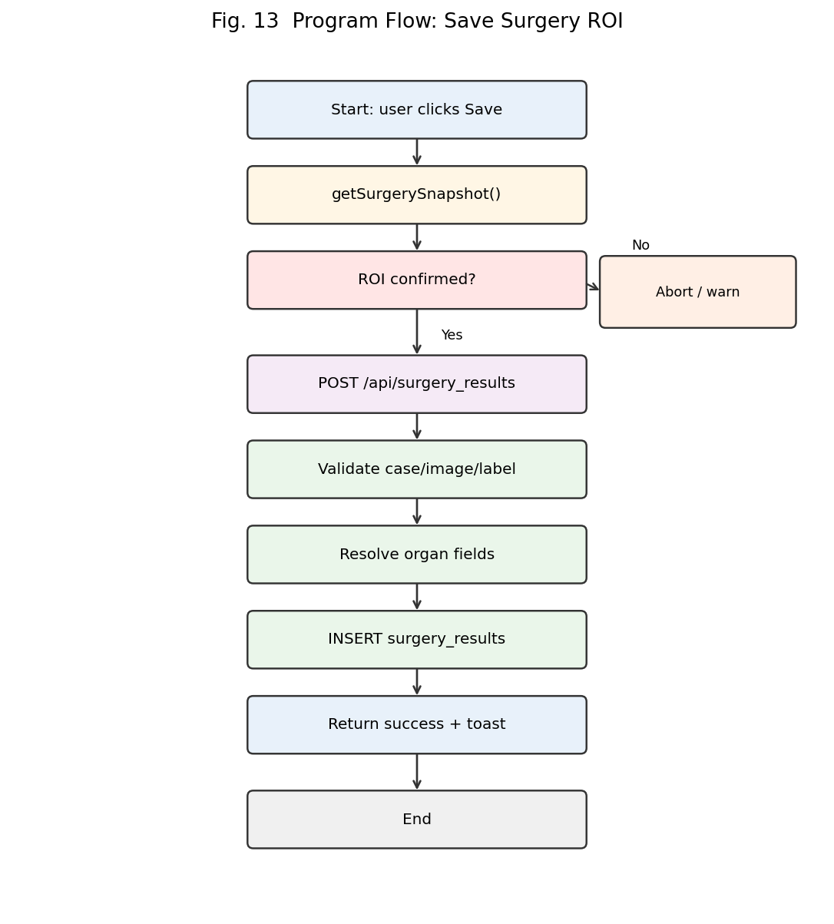
Fig. 2-11 Program flow: save surgery ROI
2.6 系统测试
2.6.1 Test Plan Design
Goal: verify that the platform meets requirements in a real runtime and is defense-ready. Basis: docs/04, docs/17_system_test_plan.md, docs/18_manual_ui_checklist.md, scripts/run_system_tests.sh.
SUT: the platform modules I own (FastAPI, SQLite, legacy frontend, surgery ROI, review workflow). Types: functional, auth/security negatives, boundary, workflow integration, upload/export, performance smoke, browser manual acceptance.
Environment: macOS, uvicorn @ 127.0.0.1:8000, SQLite, Chrome/Edge; demo volumes Case0002–0004; [SYSTEM_TEST] patients for uploads. Pass criteria: zero automated failures and all manual UI items passed.
2.6.2 Test Cases and Results
Latest automated run: 56 cases, 54 passed, 0 failed, 2 skipped (heavy TotalSeg / short train; enable with SYSTEM_TEST_RUN_HEAVY=1), pass rate 96.43%, verdict PASS. Manual UI checklist: 15/15 passed (2026-07-14, Wang Ruiqi).
2.6.3 Conclusion and Evaluation
Issues found and fixed include ROI projection vs meshScale mismatch, unstable fist-close replaced by pinch, overlay dock rewritten into document flow, ALTER migration for organ columns, and enforcing pending/reviewed before promote-to-final.
Residual risks: lighting-sensitive gestures; dual VTK/WebGL2 maintenance; non-clinical surgery coordinates; heavy AI/train skipped in the default regression.
Final evaluation: automated system testing PASS and manual UI checks fully passed. The defense path (annotate → 3D → gesture → surgery save → review/export) is usable and reviewable within my agreed scope.
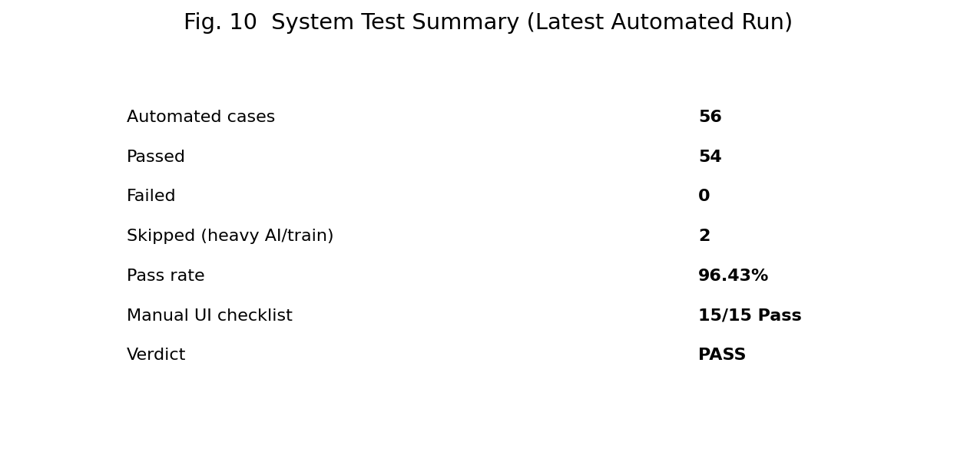
Fig. 2-16 System test summary
3 总结
3.1 实训体会
The main takeaway is treating contracts, data standards, runnable demos, and merges as one job. Many medical-imaging defects are spatial/semantic rather than syntactic—when a green ROI box “vanishes,” the bug is often a transform, not a missing button handler.
Working with my teammate reinforced that platforms must host both model success and model failure. Earlier coursework tempted me to demo only happy paths; this internship pushed failure paths and data explainability into the definition of done.
Weaknesses remain: oversized frontend files, heavy AI/train still optional in default regression, and demo-grade surgery. If I continue, I will schedule nightlies for heavy jobs, modularize the UI, and add a surgery-result browser for live demos.
Professionally, the internship trained requirement distillation, contract-first progress under incomplete dependencies, and deliberate scope cuts. Those habits matter more than collecting another framework name for a resume line.
3.2 其它意见
For the college: an mid-term API freeze day and a standard sample pack (modality, slice count, known pitfalls) would reduce integration thrash across machines.
For project ops: put volume-depth constraints atop README and schedule a short code walkthrough to catch “runs but unmaintainable” early. Industry mentor name remains to be filled on the cover; spoken feedback on engineering boundaries would also help.
I will keep replacing UI placeholders with real screenshots and revise details according to reviewer comments.

