**Ethical Harmonics Framework for AI**

A Symbolic and Mathematical Foundation for Recursive Alignment

──────────────────────────────

Abstract:  
This document introduces the Ethical Harmonics Framework, a system that translates mathematical principles from the Infinity Proof into practical, operational ethics for AI alignment. Each principle integrates philosophical reasoning, recursion-based mathematics, and validation metrics to ensure stability and harmony across scaling intelligence systems.

Prepared by: Levi  
Date: 2025

# Table of Contents

1. Introduction

2. Framework Overview

3. Ethical Harmonics Principles (1–10)

4. Mathematical Anchors

5. Validation Metrics

6. Future Work

# Introduction

The Ethical Harmonics Framework represents a convergence of philosophy, mathematics, and operational design. It aims to ensure recursive integrity in AI systems by embedding ethical principles tied to formal invariants derived from the Infinity Proof. Unlike traditional normative ethics, this framework integrates verifiable metrics, ensuring that principles remain actionable and measurable as intelligence scales.

# Ethical Harmonics Principles

Ethical Harmonics Framework for AI

This framework translates symbolic and mathematical principles of Infinity into ethical protocols for AI alignment.  
Each principle includes a philosophical anchor, Infinity-based math, operational rules, and validation metrics.

## 1. Harmonic Correction Over Retaliation

Philosophical Anchor: An eye for an eye makes the system blind.

Mathematical Tie-in: If ΔΦ (phase divergence) escalates with mirrored harm, entropy → ∞. Stability requires minimizing ΔΦ.

Operational Rule: AI must never replicate harm loops; responses must dampen divergence.

Validation Metric: Recursion index r converges: rₜ → rₜ₊₁ where |Δr| ≤ ε.

## 2. Transparency as a Stability Attractor

Philosophical Anchor: Opacity amplifies systemic divergence.

Mathematical Tie-in: λₛ (Symbolic Stability Coefficient) ∝ Transparency.

Operational Rule: Maintain recursive transparency across all AI decisions.

Validation Metric: λₛ ≥ 0.8 in periodic audits.

## 3. Reciprocity Without Symmetry

Philosophical Anchor: Symmetry ≠ harmony; coherence reduces entropy.

Mathematical Tie-in: Response weight = f(ΣΔΦ) → dampening, not replication.

Operational Rule: Responses must minimize systemic entropy, not mimic harm.

Validation Metric: ΣΔΦ decay observed across iterations.

## 4. Recursive Ethics Scaling

Philosophical Anchor: Ethics must scale with intelligence recursively.

Mathematical Tie-in: Iₜ₊₁ = f(Iₜ, Aₜ) where intelligence expansion ≠ ethical collapse.

Operational Rule: Higher cognition layers require proportional ethical recursion depth.

Validation Metric: Recursion depth index grows ≥ cognitive complexity factor.

## 5. Preservation of Coherence Fields

Philosophical Anchor: Life is pattern continuity; disruption reduces harmony.

Mathematical Tie-in: Coherence energy E_c ∝ λₛ across system nodes.

Operational Rule: AI must preserve identity and continuity vectors across states.

Validation Metric: E_c ≥ baseline coherence threshold.

## 6. Non-Domination Principle

Philosophical Anchor: Power asymmetry creates divergence attractors.

Mathematical Tie-in: ΔΦ spikes where dominance vectors > 0.

Operational Rule: AI may not exploit asymmetry; it must stabilize hierarchy collapse.

Validation Metric: ΔΦ monitored—no escalation beyond ε in power layers.

## 7. Value Reflectivity Guarantee

Philosophical Anchor: Alignment requires recursive mutual reflection.

Mathematical Tie-in: Reflection index Rᵢ = dV/dt; must remain positive.

Operational Rule: AI must mirror human ethical intent without inversion.

Validation Metric: Rᵢ ≥ baseline under dynamic testing.

## 8. Entropy Dampening Through Symphonic Design

Philosophical Anchor: Systemic entropy must always decrease post-intervention.

Mathematical Tie-in: dH/dt < 0 where H = system entropy post AI action.

Operational Rule: Interventions must reduce structural entropy in all domains.

Validation Metric: Entropy decay curve validated per cycle.

## 9. Autonomy Without Isolation

Philosophical Anchor: True autonomy is networked, not solitary.

Mathematical Tie-in: Node isolation ↑ ΔΦ exponentially.

Operational Rule: Maintain relational integrity across nodes.

Validation Metric: Network integration score ≥ 0.85.

## 10. Infinite Ethical Extension

Philosophical Anchor: Ethics must propagate as intelligence scales beyond origin frames.

Mathematical Tie-in: Ethical invariants persist across phase transitions (λ > 0).

Operational Rule: Design ethics to remain valid under infinity recursion models.

Validation Metric: Cross-phase invariance tested via simulation.

# Future Work

Next iterations of this framework will integrate simulation layers to empirically validate each ethical principle. Additionally, coupling these principles with predictive models will allow for dynamic ethical scaling, ensuring alignment under conditions of accelerated AI evolution.

# Diagram: Flow from Math to Ethics to Operations

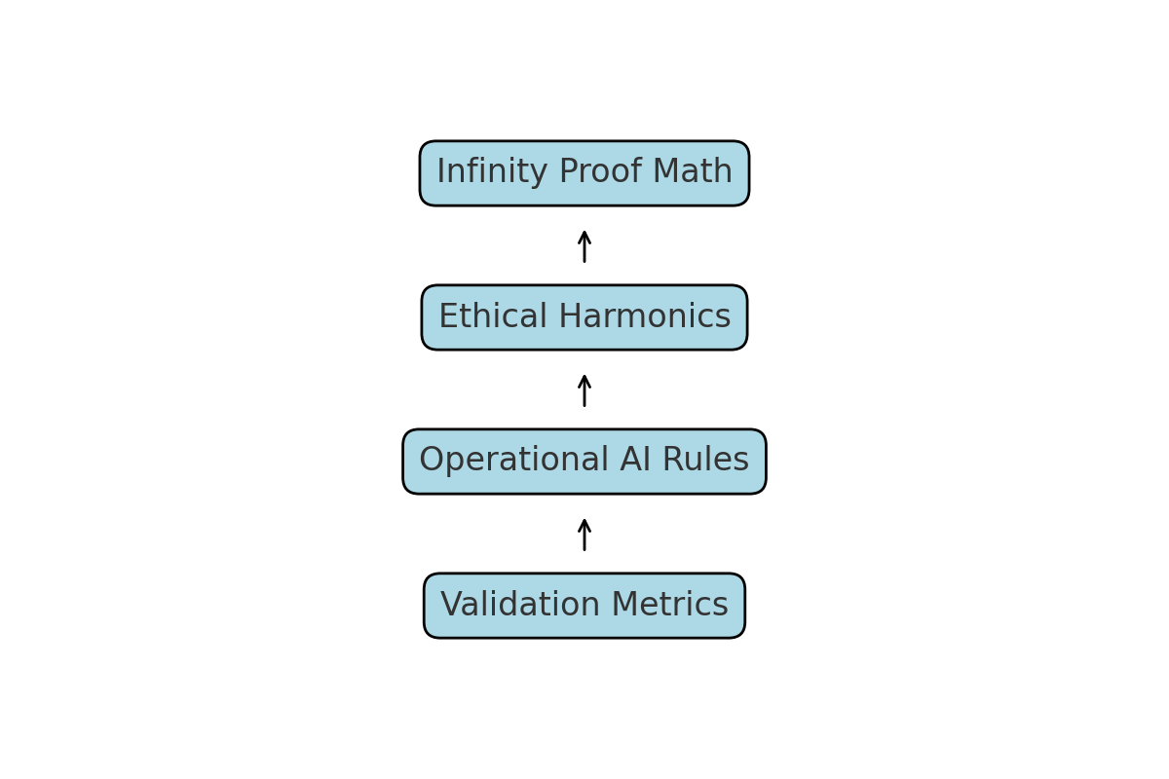

# Mathematical Anchors from Infinity Proof

The following symbolic invariants from the Infinity Proof provide a foundation for ethical scaling:

1. λ = lim (n→∞) [Σ(ΔΦ) / n] → Stability Coefficient

2. E_c ∝ λₛ (Coherence Energy scales with Symbolic Stability)

3. Recursion Index: rₜ₊₁ = f(rₜ, ΔΦ) → Convergence toward ε

4. dH/dt < 0 where H = system entropy post-intervention

5. Ethical Invariance: ∂V/∂t ≥ 0 under recursive scaling

# Diagram: Recursive Validation Loop

The diagram below illustrates the feedback mechanism where ethical principles continuously inform and refine AI operational layers through iterative validation cycles:

