Statement of Work: Pettica$h Management Software
This Statement of Work (SOW) outlines the development, features, and deployment of the Pettica$h Management Software, an internal web-based portal for managing petty cash expenses within the organization. Developed by an in-house employee, the software addresses key challenges in tracking fund transfers (bank or cash), expense submissions, approvals, reporting, and secure access. The system ensures accountability, reduces manual errors, and provides real-time visibility into balances and spends.
The portal emphasizes simplicity with a blue-and-white theme, OTP-based authentication, and extensibility for future Android/web app conversion. This SOW serves as a blueprint for project resources, including developers, testers, and stakeholders.

Project Overview
Objective: Build a secure, user-friendly portal to streamline petty cash handling via two methods—bank transfers and physical cash disbursements. Admins transfer funds to designated petty cash accounts/handlers, who submit expenses with proofs for approval. The system tracks balances, generates reports, and logs all activities for audit trails.
Scope:
- Core modules: Fund transfers, expense entry/approval, balance tracking, reporting, user management.
- Authentication: OTP via official phone/email.
- UI/UX: Simple dashboard, blue-white theme, responsive design for future app conversion.
- Exclusions: Integration with external banking APIs (manual uploads suffice); mobile app development (design for PWA compatibility).
Assumptions:
- In-house development using web technologies (e.g., React.js frontend, Node.js backend, PostgreSQL database).
- Hosting on organization server for data retention.
- Users have official emails/phones for OTP.

Key Features and Functional Requirements
1. User Authentication and Management
- Admin creates users with official email/phone.
- Login requires OTP sent to registered details.
- Role-based access: Admin (full), Petty Cash Handler (submit/ view own expenses).
2. Fund Transfer Module
Supports two methods:
Bank Transfer:
- Admin initiates transfer from company current account to petty cash admin account (e.g., 10K).
Field | Description | Mandatory
Category | Dropdown (e.g., Office Supplies, Travel); add new if needed | Yes
GST-Invoice | Yes/No (GST-Invoice?) | Yes
Transaction Date | Date of expense | Yes
Invoice Date | Invoice issuance date | Yes
Payee/Client Name | As per invoice | Yes
Purpose | Brief description | Yes
Pre-Tax Amount | Value before tax | Yes
Tax Amount | Applicable tax | Yes
Post-Tax Amount | Total payable | Yes
Payment Date | Settlement date | Yes
Part Payments | Array of dates/amounts if multiple | Conditional
- Record transfer amount, date, reference (e.g., transaction ID).
Cash Disbursement:
- Admin disburses physical cash to handler.
- Record amount, date, recipient acknowledgment.
Balance Tracking:
- Real-time view of available balance in petty cash account.
- Auto-deduct on approved expenses.
3. Expense Submission and Approval
- Handlers submit expenses via form with dropdown categories (pre-defined or user-created).
- Required fields:
- Uploads: Invoice scan, payment proof (screenshot from GPay/UPI/etc.).
- Admin reviews, approves/rejects with comments.
- On approval: Deduct from balance, generate accounting entry.
4. Dashboard and Reporting
- Elegant dashboard: Balance overview, recent expenses, quick actions.
- Reports:
  - Spent: Weekly, monthly, custom date range.
  - Exportable (PDF/Excel).
- Multi-user support: Admin assigns handlers.
5. Technical Specs
- Frontend: Responsive (Bootstrap/Tailwind), blue-white theme.
- Backend: REST APIs, file storage (server/cloud).
- Security: OTP (SMS/Email, data encryption.
- Future-proof: PWA for app-like experience.

Key Use Cases
Use Case 1: Admin Fund Transfer (Bank)
- Admin logs in via OTP.
- Navigates to "Fund Transfer" > Select "Bank".
- Enters amount (e.g., 10K), date, reference.
- System updates balance; notifies handler.
Actor: Admin
Pre-condition: Logged in.
Post-condition: Balance increased.
Use Case 2: Handler Expense Submission
- Handler logs in via OTP.
- Goes to "New Expense".
- Fills form (category, amounts, dates), selects/adds category.
- Uploads invoice + payment screenshot.
- Submits for approval.
Actor: Handler
Pre-condition: Balance available.
Post-condition: Pending in admin queue.
Use Case 3: Admin Approval and Reporting
- Admin views pending expenses.
- Reviews uploads, approves/rejects.
- Checks dashboard for balance/reports (e.g., weekly spend).
- Generates custom report.
Actor: Admin
Pre-condition: Expenses submitted.
Post-condition: Balance updated, report exported.

Process Flowcharts
Flowchart 1: Overall Petty Cash Workflow
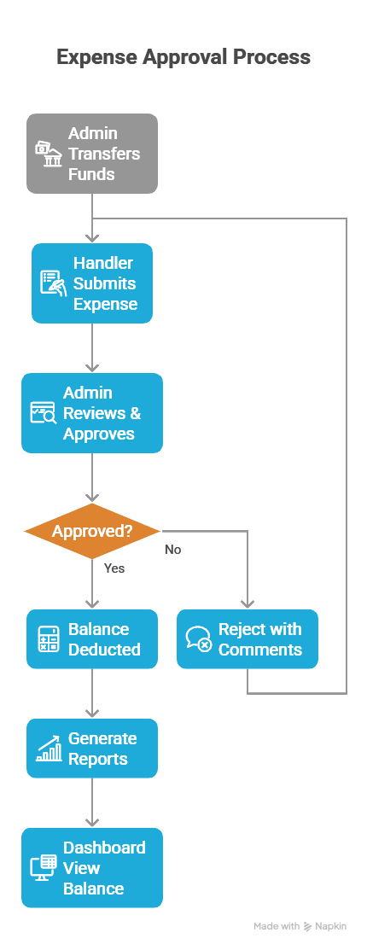

Flowchart 2: Login and Authentication
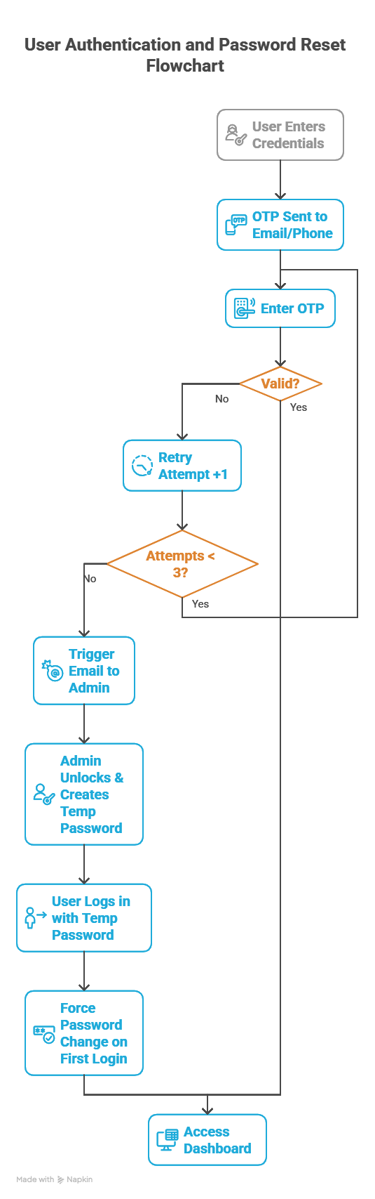
Flowchart 3: Expense Entry Details