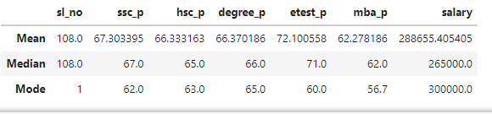

Mean and median is more over same for the all the columns except salary , from this there is no outliers for those columns , but salary difference is higher, for that salary column alone have outliers.

Mode is repated value , so in above table more students have got 62 in ssc and 63 in hsc, 65 in degree, 60 in etest, 56 in MBA and they have got 3Laks as salary.

This is information which we got from the table.