
Active Systems PTY

User Interface Testing
Project Name: |  | Vehicle Registration Management
Type of Test: |  | White Box testing
Test Case No | Test Case Name | Test steps | Input Evidence | Result Evidence | Pass / Fail
1 | Enter test | 1. Click the text box  2. Type the Rego plate  3. Click enter button | 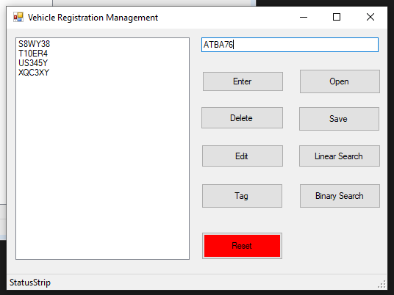 | 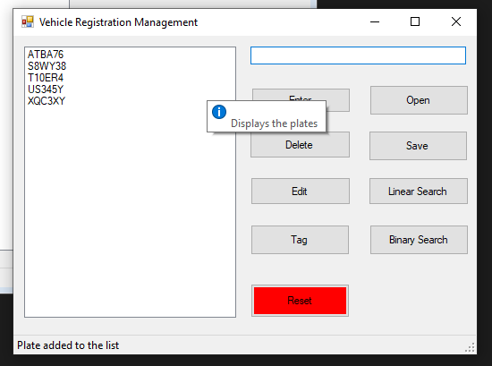 | PASS
2 | Delete test | 1. Select a rego plate from list  2. Click Delete button | 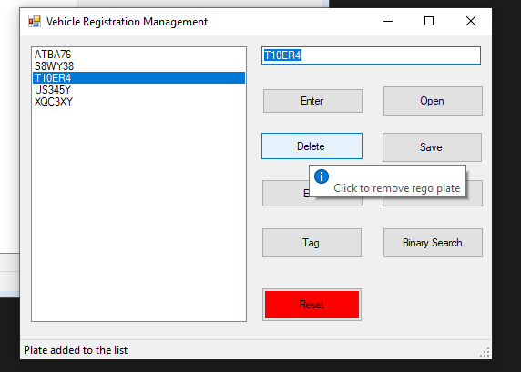 | 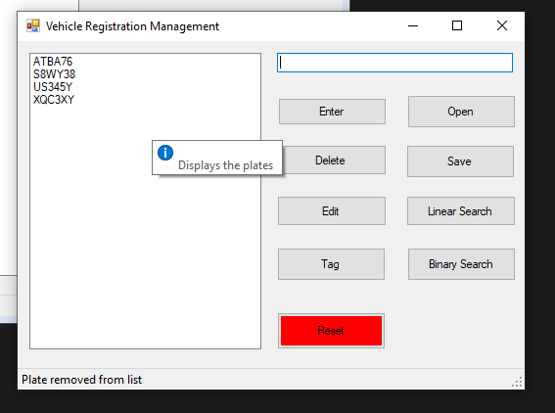 | PASS
3 | Edit test | 1. Select a rego plate from list  2. Edit the rego plate in text box  3. Click Edit button | 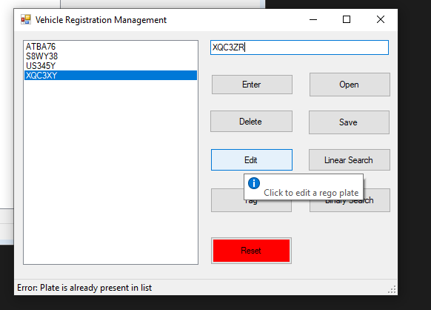 | 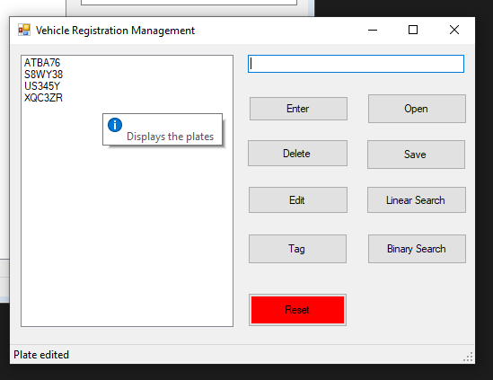 | PASS
4 | Tag test | 1. Select a rego plate from list  2. Click Tag button | 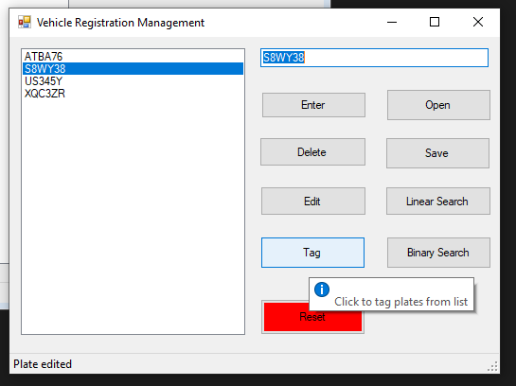 | 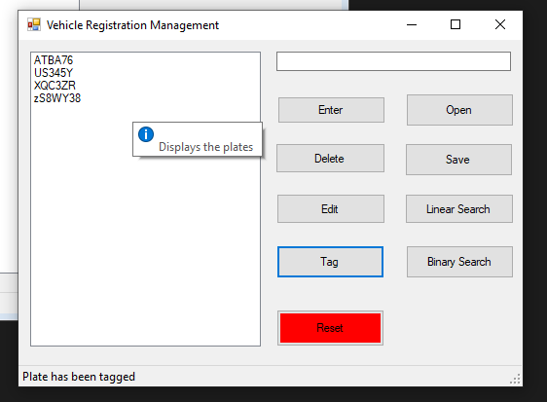 | PASS
5 | Open test | 1. Click Open button  2. Select the text file  3. Click open | 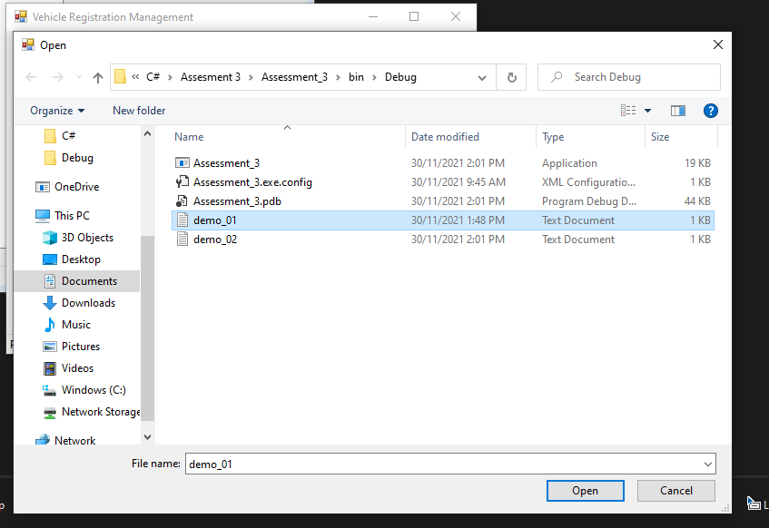 | 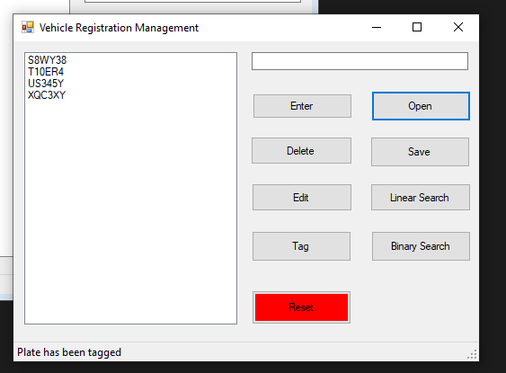 | PASS
6 | Save text | 1. Click Save button  2. Name the file  3. Click save | 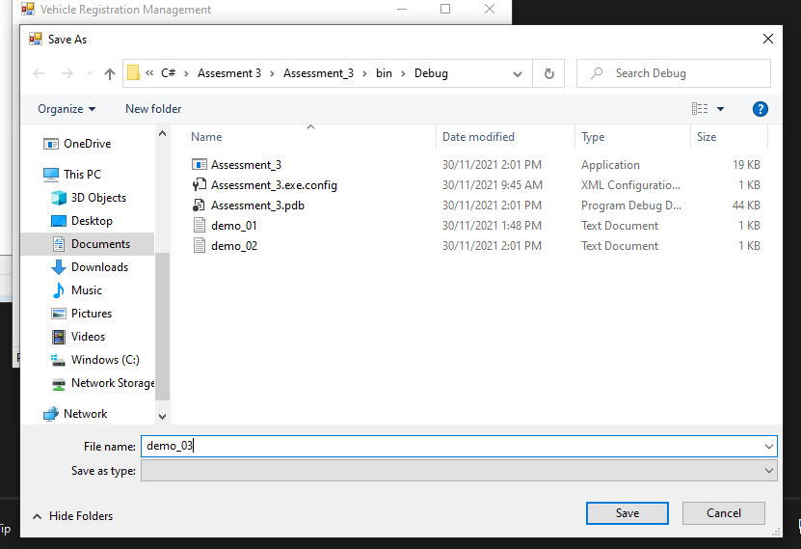 | 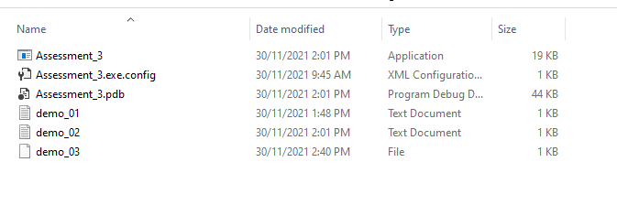 | PASS
7 | Binary search test | 1. Type the plate number in text box  2. Click binary search button | 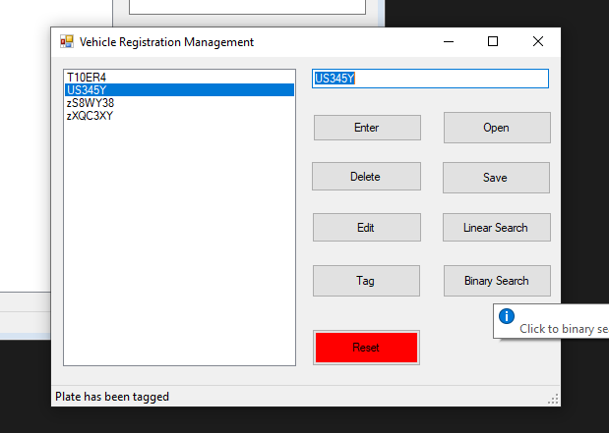 | 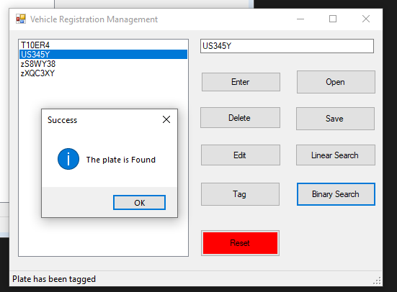 | PASS
8 | Linear search test | 1. Type the plate number in text box  2. Click sequential search button | 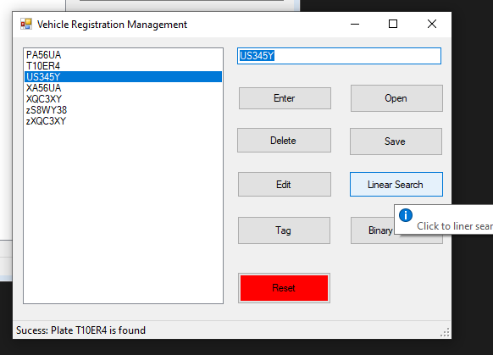 | 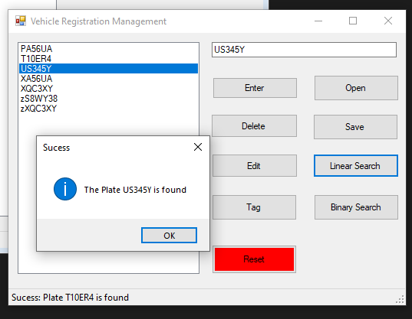 | PASS

