Questions
- Under what conditions is MLP equivalent to Logistic Regression?
Answer:
Logistic Regression Recap: Logistic regression is a linear model for binary classification. It takes input features and computes a weighted sum, then applies a sigmoid activation to get a probability.
MLP (Multilayer Perceptron) recap: An MLP is a neural network with an input layer, optional hidden layers with non-linear activations (like ReLU, tanh), and an output layer. For binary classification, the output layer usually uses a sigmoid activation.
MLP can be equivalent to Logistic Regression under these conditions:
- No hidden layers: The MLP consists only of the input and output layers.
- Linear transformation only: No non-linear activations are used in any hidden layers (if present), meaning the network remains a linear model.
- Sigmoid in the output layer: The output layer uses a sigmoid activation for binary classification.
- No complex regularization or feature transformations: The model does not use additional techniques (like L1/L2 regularization or feature engineering) that go beyond logistic regression.
- Linear Separability of Data: If the given data is linearly separable, both logistic regression and a simple MLP will arrive at similar decision boundaries.

- Suppose you have a CNN that begins by taking an input image of size 28 × 28 × 3 and passing it through a convolution layer that convolves the image using 3 filters of dimensions 2 × 2 × 3 with valid padding.
  - How many learnable parameters does this convolution layer have?
Answer:
Each filter in the convolution layer has dimensions 2 × 2 × 3, which means it has 2 × 2 × 3 = 12 weights. Additionally, each filter has 1 bias parameter.
Since there are 3 filters, the total number of learnable parameters is:
(12 weights + 1 bias) × 3 filters = 39

  - Suppose that you instead decided to use a fully connected layer to replicate the behavior of this convolutional layer. How many parameters would that fully connected layer have
Answer:
To replicate the behavior of the convolution layer using a fully connected layer, we would need to fully connect every pixel in the input image (which is 28 × 28 × 3 = 2352 values) to the same number of output neurons as in the convolution operation.
Each filter produces one output per 2 × 2 patch in the input, without padding. The number of patches the filter moves over can be computed as:
Output height = 28 - 2 + 1 =27
Output width = 28 - 2 + 1 =27
So, each filter produces a 27 × 27 feature map.
Since there are 3 filters, the total output shape is:
27 × 27 × 3 = 2187 values
The number of parameters in a fully connected layer is:
input size×output size+bias terms
Each neuron in a dense layer connects to all inputs from the previous layer (all 2352 input values) and has one weight per input, plus one bias.
We have: 2187 output neurons, each has 2352 weights + 1 bias = 2353 parameters
So:
Total parameters = 2187 × 2353 + 2187 = 5146011
​

- Explain mathematically the vanishing gradient problem in Recurrent Neural Networks (RNNs). Then, analyze how changing the lookback window size impacts the severity of this phenomenon.
Answer:
RNN structure recap:
In an RNN, the model processes sequences step-by-step. At each time step t, it takes the current input $x_{t}$and the hidden state from the previous time step $h_{t}-1$​ to compute a new hidden state:
$h_{t}=tanh(W_{h}​h_{t-1}−1​+W_{x}​x_{t}​+b)$
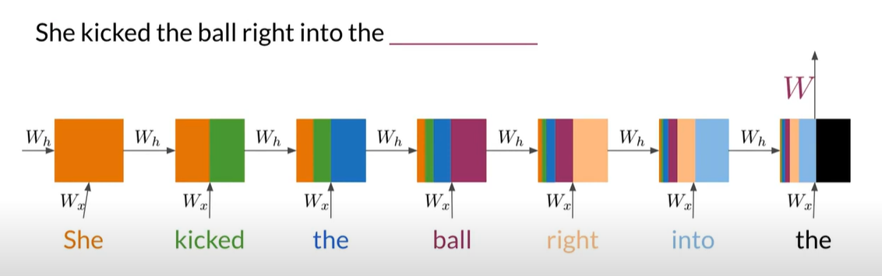

To update weights, we compute gradients of this loss with respect to weights like 𝑊. However, since the hidden state depends on all previous hidden states, gradients must be backpropagated through all time steps, not just layers. (Backpropagation through time)
The key gradient expression is:
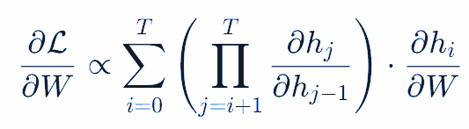
Each term $\frac{∂h_{j}}{∂h_{j-1}}$ involves the derivative of the activation function (like tanh):
${\left|\left|\frac{∂h_{j}}{∂h_{j-1}}\right|\right|}_{2}<1$
When this is multiplied across many time steps, the product shrinks exponentially toward zero:
${\left|\left|\prod_{j=i+1}^{T}{}\frac{∂h_{j}}{∂h_{j-1}}\right|\right|}_{2}→0$
This is the vanishing problem, gradients become so small that earlier time steps receive no effective learning signal.

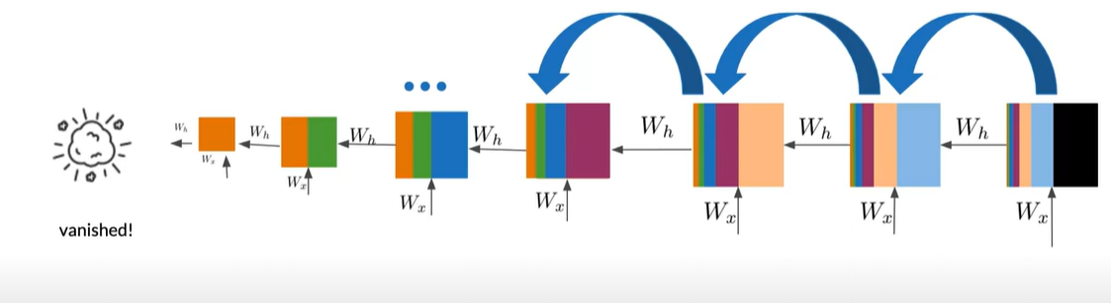
Here we can see that early words (which may be important) can't influence training because the gradients died out before reaching them.

The lookback window defines how many steps back the RNN unrolls during training.
When we use longer lookback, we will have more time steps in the gradient chain.
- More multiplications → greater chance of vanishing
- Model fails to learn long-range dependencies

When we use shorter lookback, we will have fewer steps so the gradients preserved. But the model can't capture long-term context

So Increasing the lookback window makes vanishing gradients worse.

