Horizon Bikes Manufacturing (HBM)-Cloud Transformation Plan

Name: Poorna Chandra Dinesh, Cloud Transformation SME
Course Title: Cloud Administration and Digital Workspaces
Clarku.edu: pdinesh@clarku.edu

Architecture Diagram

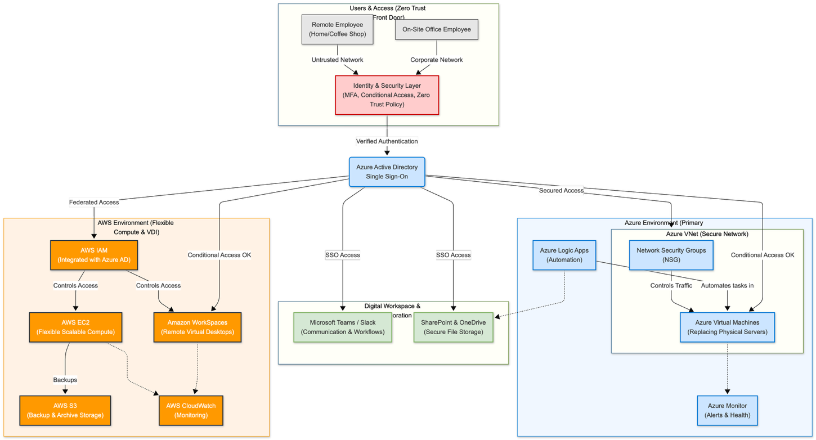

1. Introduction

This paper explains how Horizon Bikes Manufacturing (HBM) can move from old, unreliable systems to a modern cloud setup. HBM has 450 employees and makes bikes and scooters, but their current technology is slow, risky, and hard to manage.

My role as Cloud Transformation SME is to plan the move using cloud tools like Azure and AWS. This includes secure logins, cloud storage, virtual servers, automation, monitoring, and modern communication tools. The goal is a cloud environment that is safe, easy to manage, and ready for the company to grow.

2. Current State of Horizon Bikes (Outdated Systems & Problems)
Why This Environment Is Inefficient, Insecure, and Costly
- Systems crash often, stopping work.
- No real security (no MFA, no Zero Trust).
- No backups, so data can be lost.
- Communication is scattered (emails, papers).
- Most tasks are manual, slowing everything down.
- Old systems are expensive to maintain.
Bottom line: The current setup is slow, risky, and too costly. It can’t support growth.

3. Azure Administration Improvements

- Servers: Replace old physical servers with Azure Virtual Machines. They are more stable and can handle more work when needed.
- Network: Use VNets, subnets, and NSGs to separate systems and control network access safely.
- Logins: Switch from personal emails to Azure Active Directory so everyone has one secure login for all tools.
- Security: Add Conditional Access to block logins from untrusted devices or locations.
- Monitoring: Azure Monitor keeps an eye on servers and sends alerts if something fails.
- File Storage: Move files from USB drives and shared folders to OneDrive and SharePoint, where they are safe, backed up, and easy to share.
In short: Azure makes HBM’s servers, network, logins, and files more secure, reliable, and easier to manage.

4. AWS Foundations Improvements
AWS will give HBM flexible computing, safe storage, and support for remote work.
- EC2: Cloud servers that can be added or removed quickly when more processing is needed.
- S3: A secure place to keep backups and data that isn’t used every day.
- IAM: Controls who can access which parts of the system to keep things safe.
- CloudWatch: Keeps an eye on servers and services and notifies IT if something goes wrong.
- WorkSpaces: Lets employees log into virtual desktops from home or anywhere else.
In short: AWS makes computing, storage, access control, monitoring, and remote work simple, safe, and flexible for HBM.

5. Automation & Monitoring Modernization
Automation will help HBM reduce repetitive work and catch problems early.
- Slack or Teams: Let employees communicate quickly and share updates in real time.
- Slack workflows: Automatically manage approvals, requests, and check-ins so teams don’t have to do them by hand.
- Azure Logic Apps: Handle routine tasks like moving files, sending notifications, or updating records without manual effort.
- Monitoring Alerts: Keep track of CPU, network, disk usage, and logins to detect issues before they cause downtime.
- iperf3: Simulate network traffic to test performance and identify bottlenecks.
Bottom line: Using automation and monitoring makes work faster, reduces mistakes, and keeps systems running smoothly.

6. Identity & Security Modernization
This plan will make HBM’s systems much safer and easier to manage.
- Multi-Factor Authentication (MFA): Everyone confirms their identity with a second step, like a phone or app, to prevent unauthorized access.
- Zero Trust: The network does not assume anyone or any device is safe; everything is checked before access is allowed.
- Least Privilege: Employees get only the access they need to do their jobs.
- Regular Access Reviews: Permissions are checked regularly to remove anything unnecessary.
- No Shared Passwords: Every employee has a unique login to avoid security risks.
- Conditional Access: Logins are controlled based on device, location, or risk to block unsafe access.
Bottom line: These measures protect HBM’s accounts, data, and systems while keeping it simple for employees to work securely.

7. Digital Workspace Transformation
This plan updates how HBM employees work and communicate.
- Agile approach: Teams complete work in small, flexible steps and can adjust quickly to new needs.
- DevOps mindset: IT and development teams collaborate to deliver updates and tools faster and more reliably.
- Modern communication tools: Replace emails and paper notes with Teams and Slack for fast, clear messaging.
- Cloud-based collaboration: Use OneDrive and SharePoint so files are safe, backed up, and accessible from anywhere.
- Hybrid/remote work model: Employees can work securely from home or on-site.
- Improved workflows: Simple processes and regular check-ins make communication easier and reduce confusion.
Bottom line: HBM will have a modern, flexible workspace where teams can work together efficiently, whether in the office or remotely.

8. Cloud Operations (Long-Term Sustainability)
To keep HBM’s cloud environment working well over time, we will focus on these areas:
- Cost management: Track cloud usage and remove resources that aren’t needed to avoid unnecessary spending.
- Incident response: Have a clear plan for handling outages, security issues, or failures quickly.
- Documentation and runbooks: Maintain easy-to-follow guides for common tasks and troubleshooting.
- Resource lifecycle management: Regularly review servers, storage, and applications, and retire or update them as needed.
- Access reviews and audits: Check permissions regularly to make sure everyone has only the access they need.
- Cloud architecture best practices: Use proven cloud designs to keep systems secure, scalable, and high-performing.
Bottom line: These steps ensure HBM’s cloud is secure, cost-effective, and ready to support growth over the long term.

9. Conclusion
This plan updates HBM’s IT in several key ways:
- Servers and storage move to Azure and AWS, making systems more reliable and able to scale as the company grows.
- Security is strengthened with MFA, Zero Trust, conditional access, and proper user management.
- Automation and monitoring reduce manual work and detect issues before they impact employees.
- Collaboration tools like Teams, Slack, and OneDrive make communication and file sharing easier.
- Work culture improves with Agile practices, DevOps teamwork, and support for hybrid or remote work.
- Cloud operations follow best practices to stay efficient and cost-effective over time.
Why it matters: Modernizing IT makes HBM’s systems safer, faster, and easier to manage. Employees can work more efficiently, and data is better protected.
Future-ready: The new cloud environment prepares HBM for growth, supports flexible work, and makes adopting new technologies easier without being held back by old, outdated systems.

References
- Microsoft Azure documentation on deploying and managing Virtual Machines. Accessed from: Here
- Overview of Azure Active Directory (Azure AD) features and fundamentals, Microsoft Docs. Available at: Here
- Introduction to Azure Monitor for performance and diagnostics monitoring in cloud environments. Microsoft Docs. Here
- Documentation on building workflows and automating processes using Azure Logic Apps. Microsoft Docs. Here
- Amazon EC2 User Guide: Instructions for configuring and managing Elastic Compute Cloud instances. AWS Documentation. Here
- Amazon S3 Documentation: Guidelines on object storage, buckets, and security management in AWS. AWS Documentation. Here
- Amazon Web Services Identity and Access Management (IAM) guide for permission management. AWS Documentation. Here
- Guide to using Amazon CloudWatch for monitoring resources and applications in AWS. AWS Documentation. Here
- Microsoft’s Zero Trust Deployment Guide: Security principles for cloud and enterprise systems. Here
- Microsoft documentation on Conditional Access policies within Azure Active Directory. Available at: Here
- Best practices for designing and implementing cloud architecture in Microsoft Azure. Microsoft Docs. Here
Note: The architecture diagram at the top was created using Mermaid.

