User details
• Full Name: Poorna Chandra Dinesh
• VM username: pdinesh
• VM Public IP Address: 52.159.237.183

Part 1: Create Resource Group.

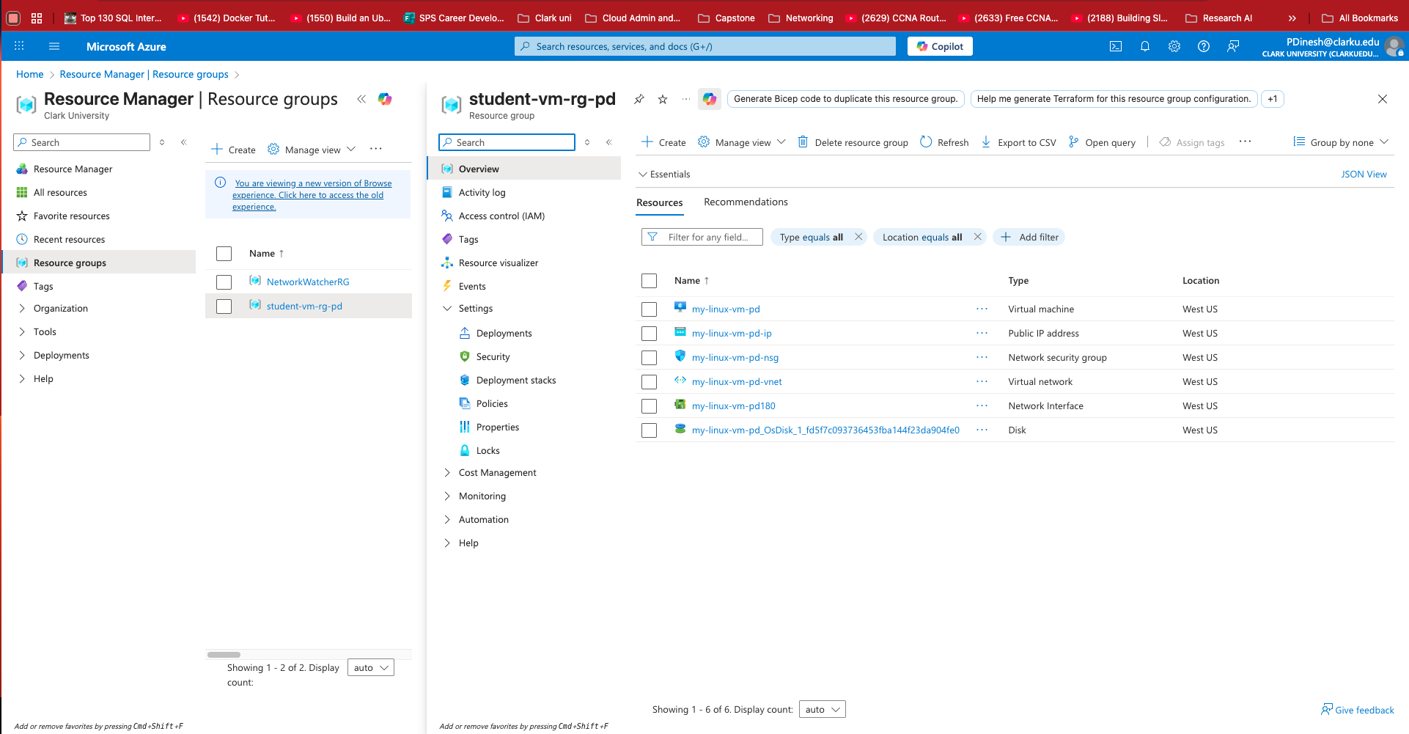

Task completed: Resource group student-vm-rg-pd was successfully created. Since the Azure for Students subscription restricts deployments to the East US region, I’m choosing West US for the next deployment.

Part 2: Create Virtual Machine

I have successfully created the Azure virtual machine name my-linux-vm-pd with the specified configurations, including Ubuntu Server 24.04 LTS (latest) , SSH access, and Standard B1s size. The VM is now running, and the public IP is visible in the overview, confirming it is accessible.

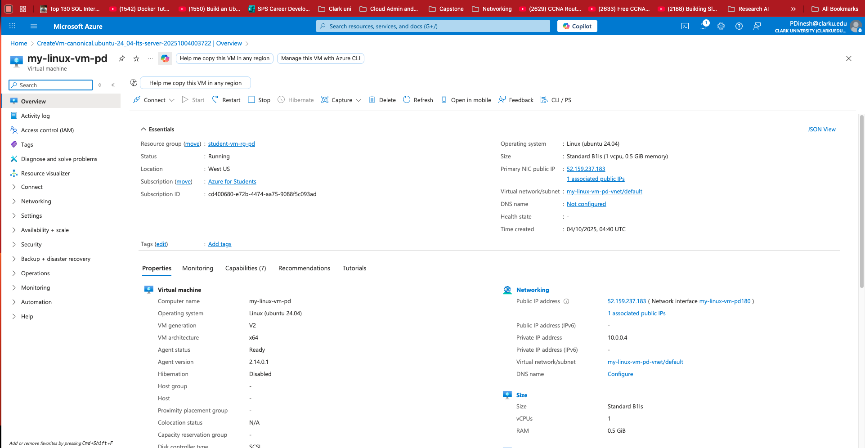

Part 3: Connect to VM with PuTTY

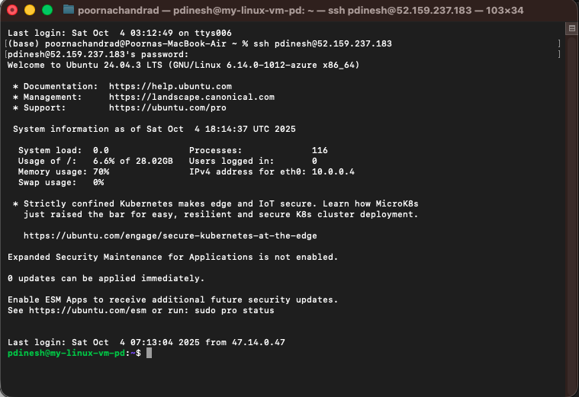
Task completed successfully — PuTTY was installed and configured using the provided public IP. I was able to connect to the VM via SSH and confirm a successful login to the terminal.

Part 4: Linux Practice

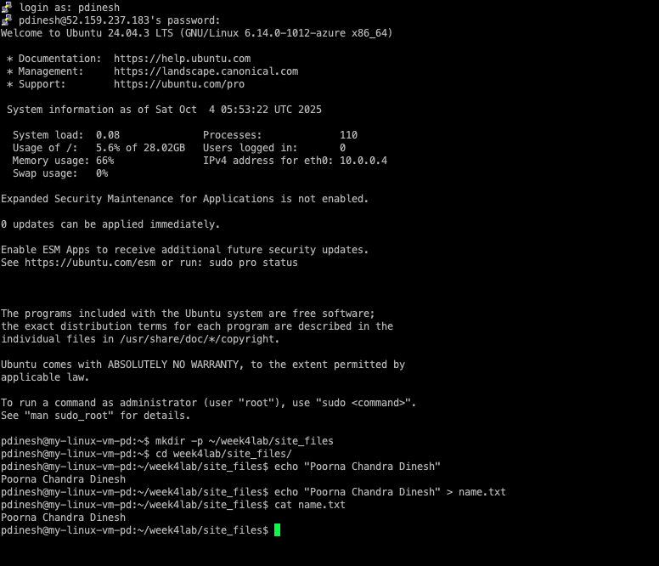
Task completed successfully — I logged in to the server using PuTTY and executed all the required commands. The name.txt file was created and displayed correctly, confirming that the setup worked as expected.

Part 5: Install Apache

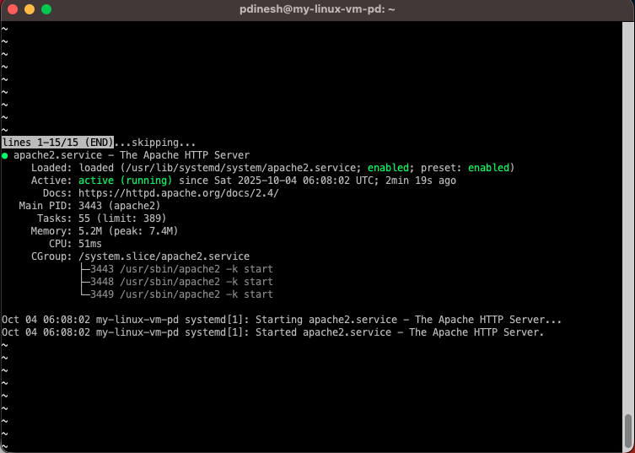

Task completed: Apache web server successfully installed and is active (running).

Part 6: Open Port 80 in Azure

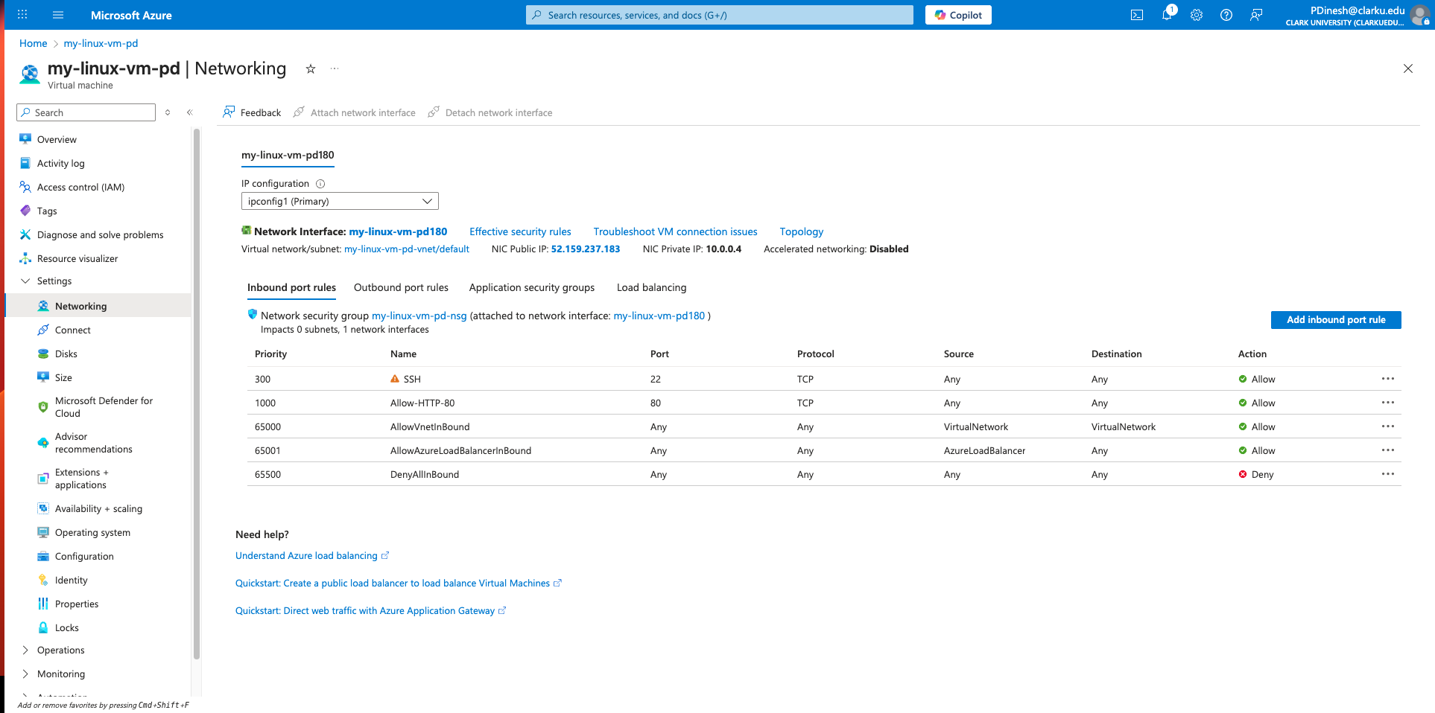

Task completed: Successfully added the inbound port rule for HTTP (port 80) in the VM’s Network Security Group. The NSG inbound rules list now shows both SSH (22) and HTTP (80) entries as required.

Part 7: Website Folder and Sample HTML

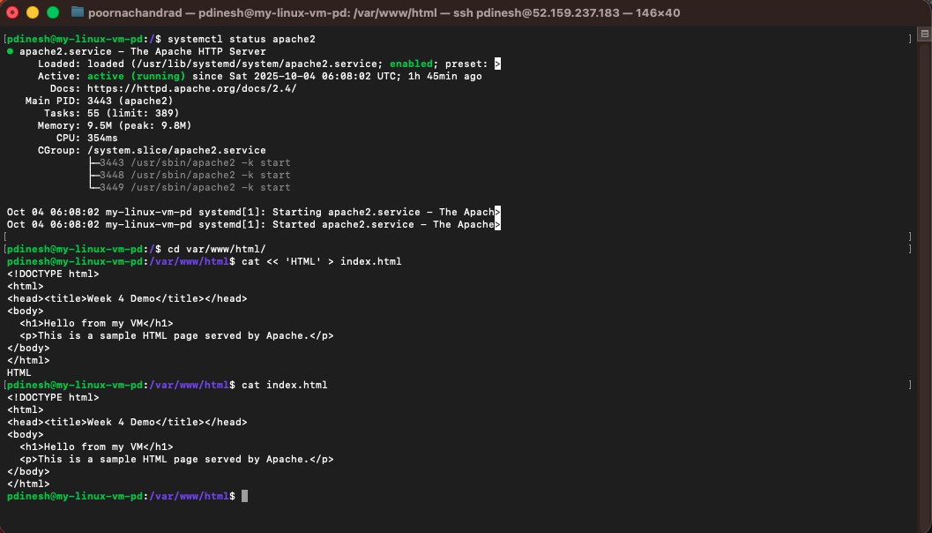

Task completed successfully — the sample HTML file was created and saved in the /var/www/html/webpage directory. The cat index.html command confirms that the file content displays correctly as intended.

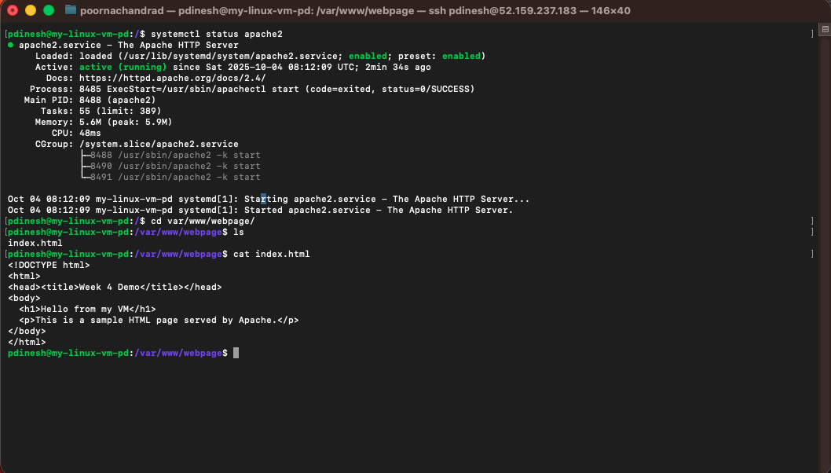

The DocumentRoot was updated from /var/www/html to /var/www/webpage to serve files from the new project directory.

HTTP 200 OK.

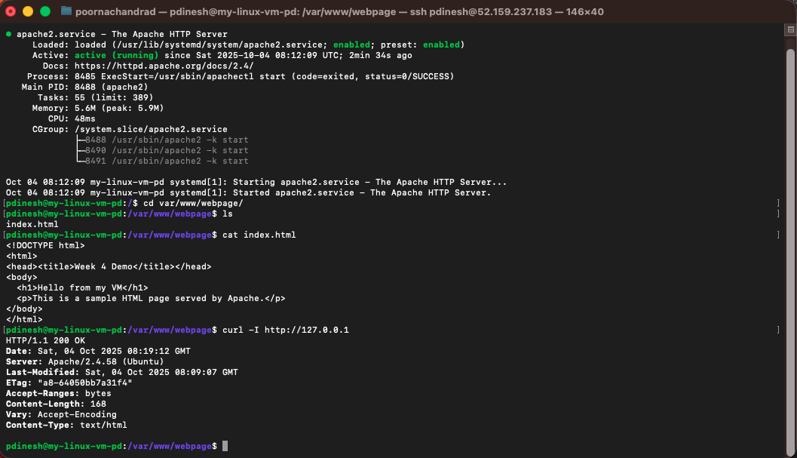

Sample HTML page in browser.

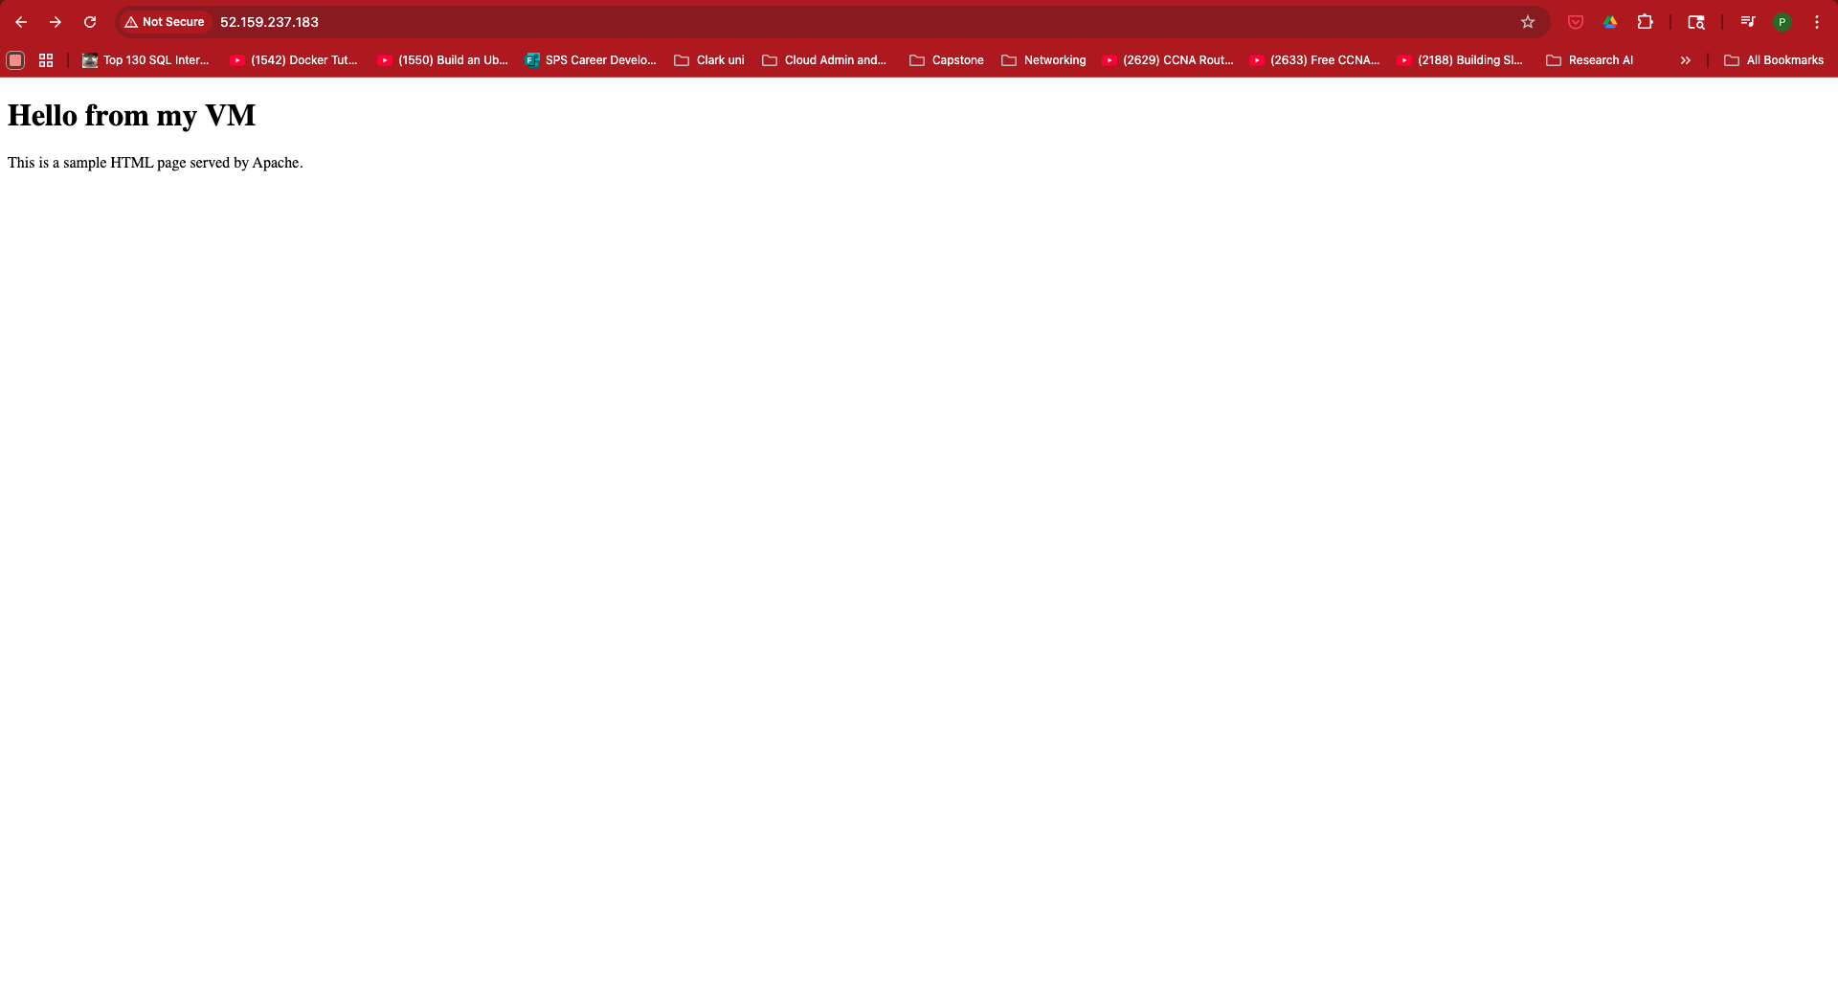

Part 8: Build Your Own Website

Multi-page Static To-Do App:

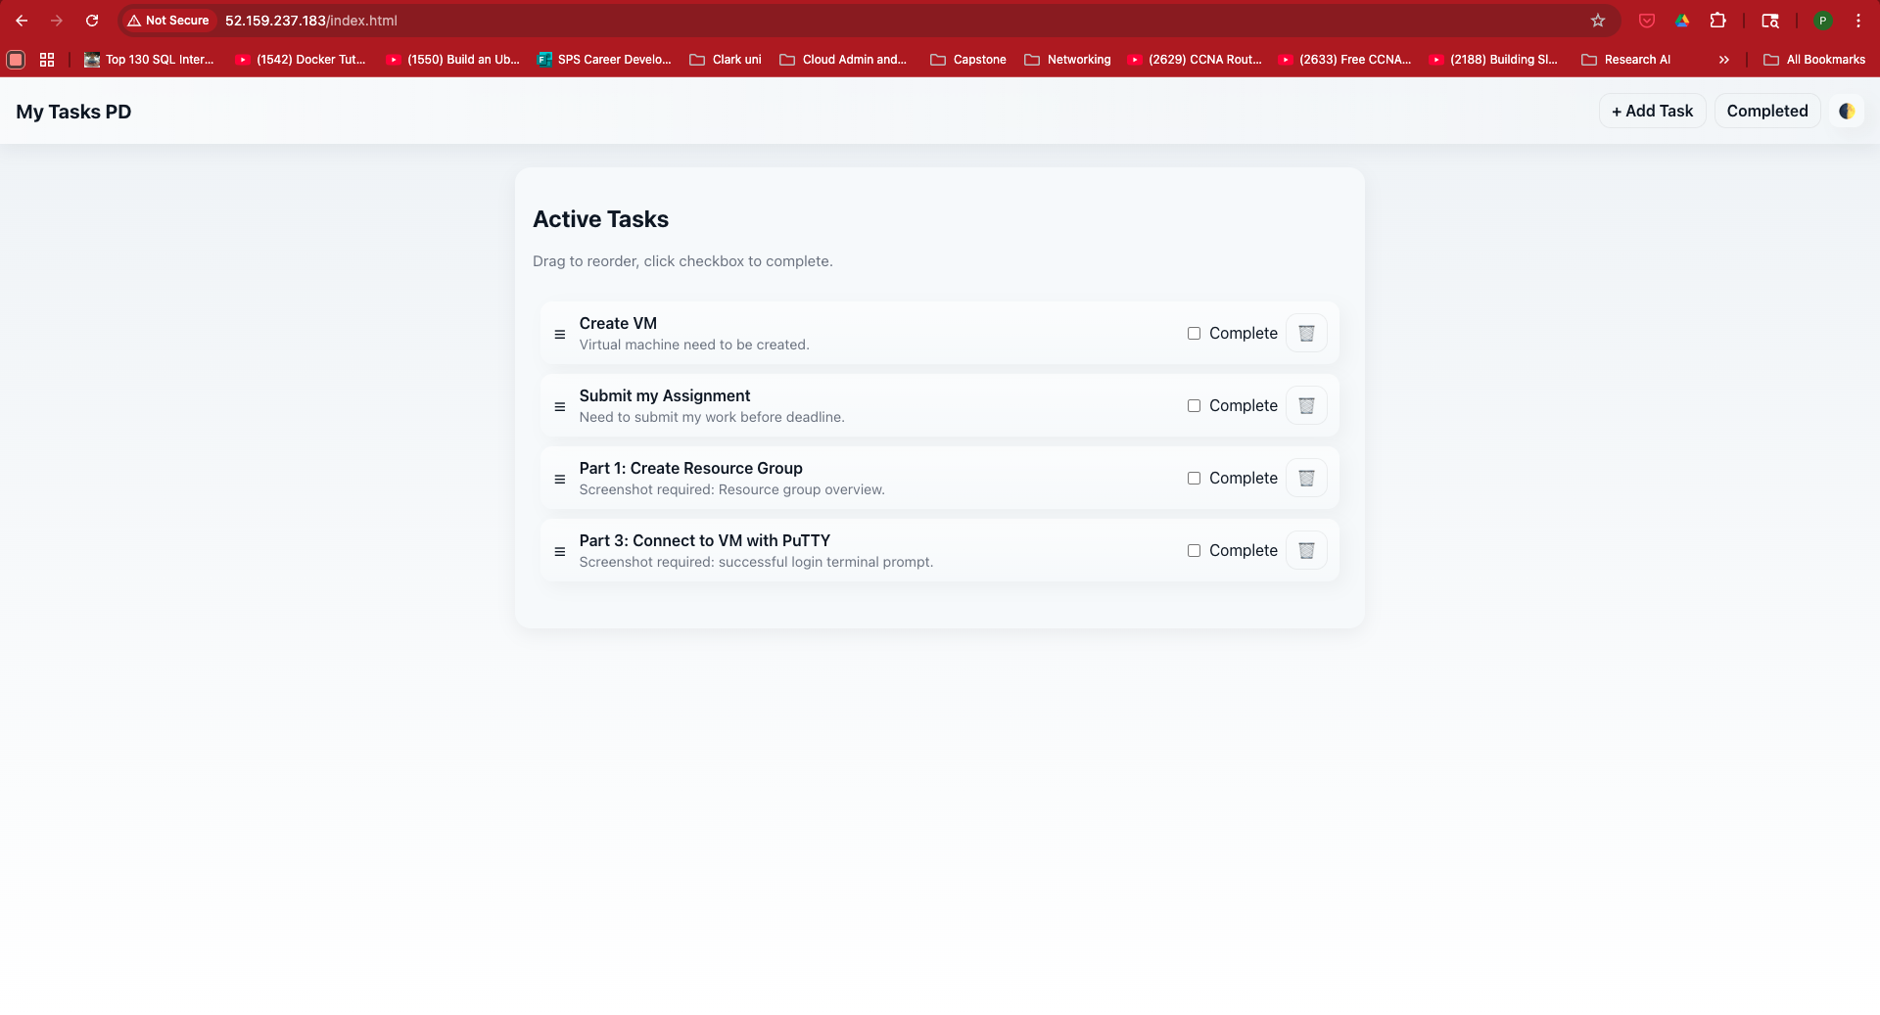

Multi-page app: Added separate pages for home, adding tasks, and viewing completed tasks.
Drag-and-drop reordering: Enabled intuitive drag-and-drop functionality to reorder tasks easily.

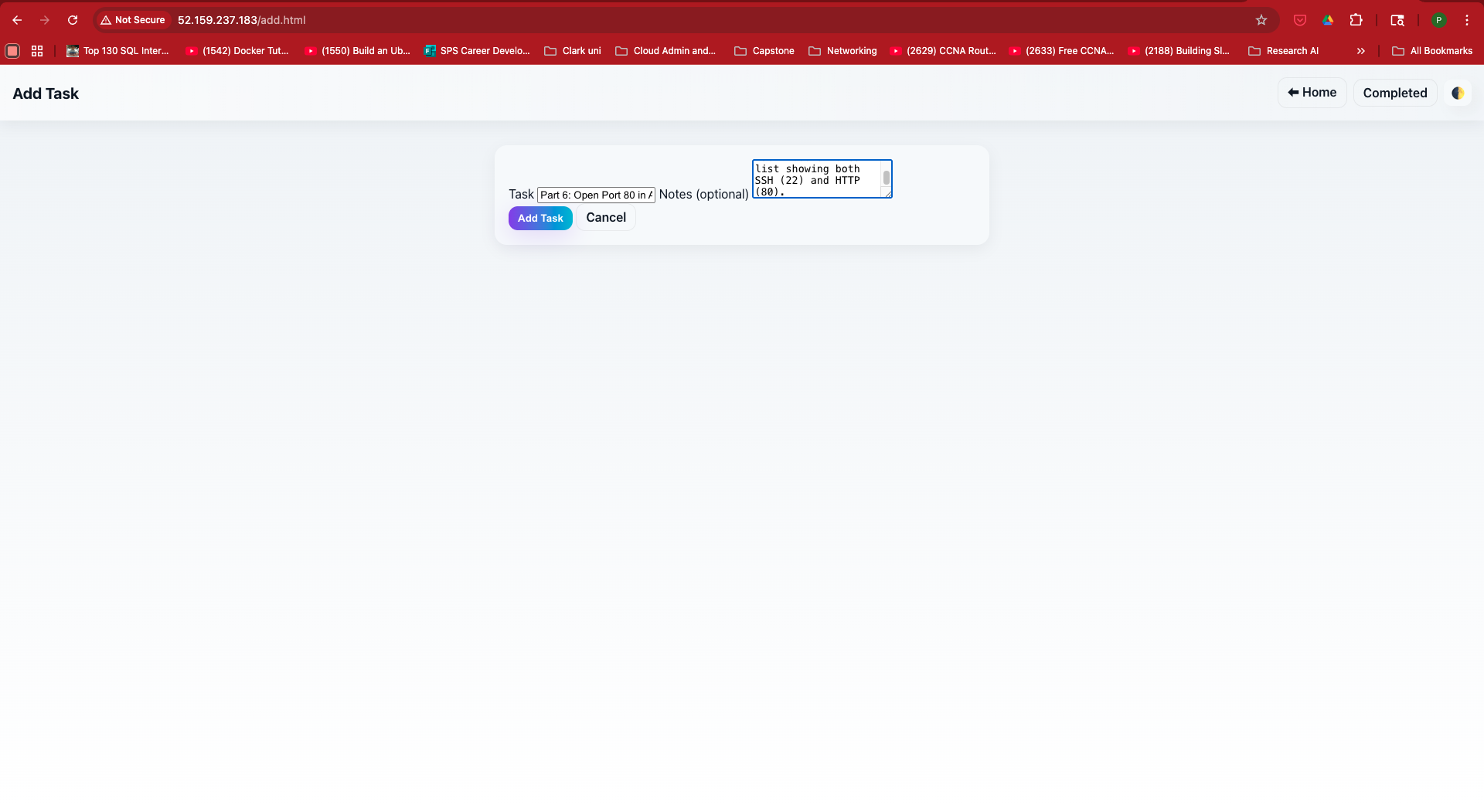

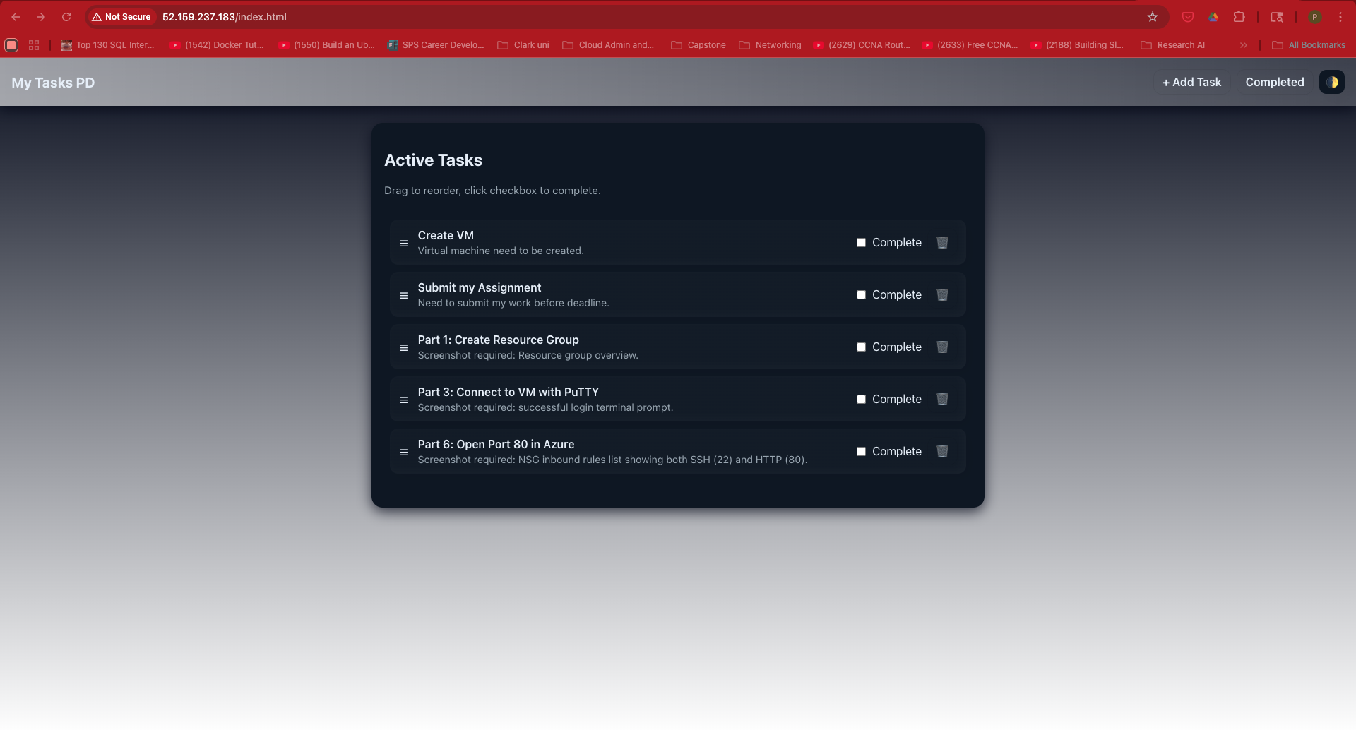
Dark/Light mode toggle: Implemented a theme switch for seamless dark and light mode transitions.
Modern UI: Designed with gradient buttons, neumorphic cards, shadows, and smooth hover effects for a polished look.

