Cloud Automation + Security Lab - Network Alert to Teams

Name: Poorna Chandra Dinesh

Course Title: Cloud Administration and Digital Workspaces

Clarku mail: pdinesh@clarku.edu

Deliverable and Step-by-step lab

One-line objective:

Create an Azure test setup where an attacker VM generates high network traffic to a target VM, triggering an automated Azure metric alert that sends a plain-text notification to Microsoft Teams through a Logic App for real-time security visibility.

List of resources and IPs used:
- Resource Group: AutomationDemoRG
- Virtual Network: DemoVNet (10.2.0.0/16)
- Subnet: DemoSubnet (10.2.1.0/24)
- Network Security Group: DemoNSG
- Rules:
- Allow-SSH-MyIP → 47.14.0.47/32
- Allow-5201-IntraVNet → intra-VNet traffic on port 5201
- Attacker VM: attacker-vm (public IP: 20.245.94.4 ; Ubuntu 24.04 LTS)
- Target VM: target-vm (private IP: 10.2.1.5; Ubuntu 22.04)
- Logic App: AlertToTeamsLogicApp (HTTP POST URL: https://prod-189.westus.logic.azure.com:443/workflows/0697f205bf59432eac0039afaa7b44d0/triggers/When_an_HTTP_request_is_received/paths/invoke?api-version=2016-10-01&sp=%2Ftriggers%2FWhen_an_HTTP_request_is_received%2Frun&sv=1.0&sig=AL2G_514onKSw_fr-LmcVMVLCVLniYf61LhQk_poSLE )
- Action Group: AlertToTeamsAG
- Alert Rule: HighNetworkIn-100b-1min
- Metric: Network In Total (Virtual Machine Host)
- Aggregation: Sum, Period: 1 min, Threshold: 100 bytes
- Test Port: 5201 (iperf3 default)

Preliminaries
Logged into Azure Portal, verified resource creation access, retrieved my laptop’s public IP, and prepared it with /32 for the NSG rule.
My Pubic Ip: 47.14.0.47/32

Screenshot: Resource group AutomationDemoRG shows created resources.

Create resource group
I created the AutomationDemoRG resource group successfully in West US. Since I have a policy restriction rule for East US, I will be using West US for my lab environment.
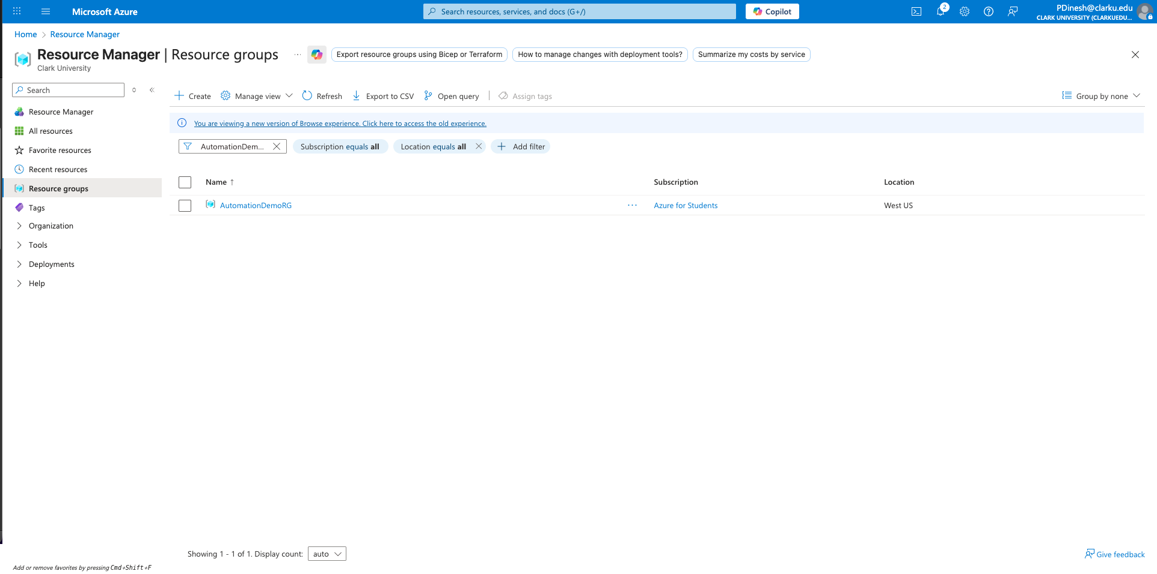

Screenshot: DemoVNet overviewwith 10.2.0.0/16 and DemoSubnet 10.2.1.0/24

Create VNet + Subnet
Created DemoVNet with address space 10.2.0.0/16 and subnet DemoSubnet 10.2.1.0/24 in AutomationDemoRG successfully.

Address space:
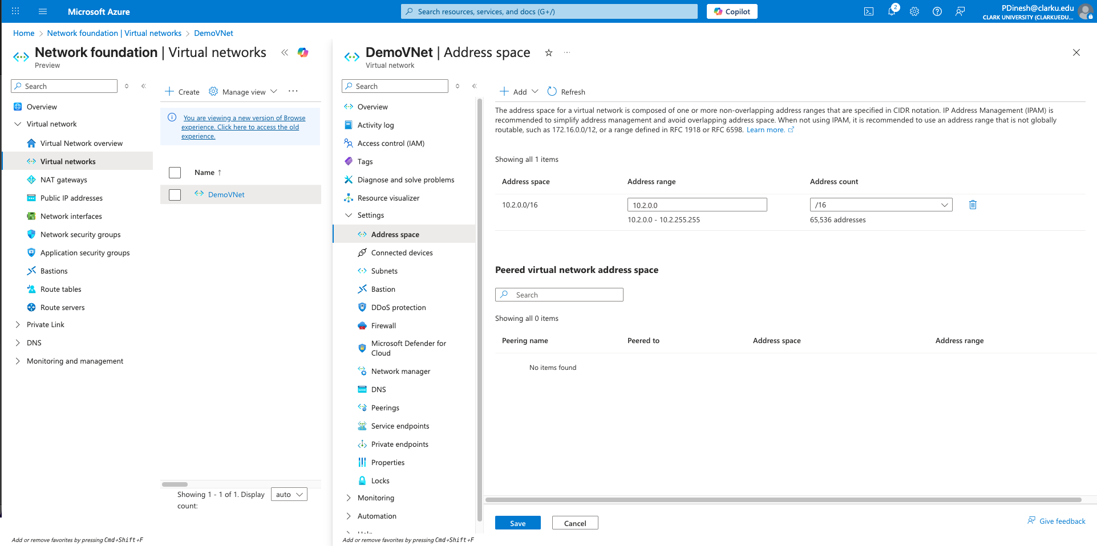

DemoSubnet:
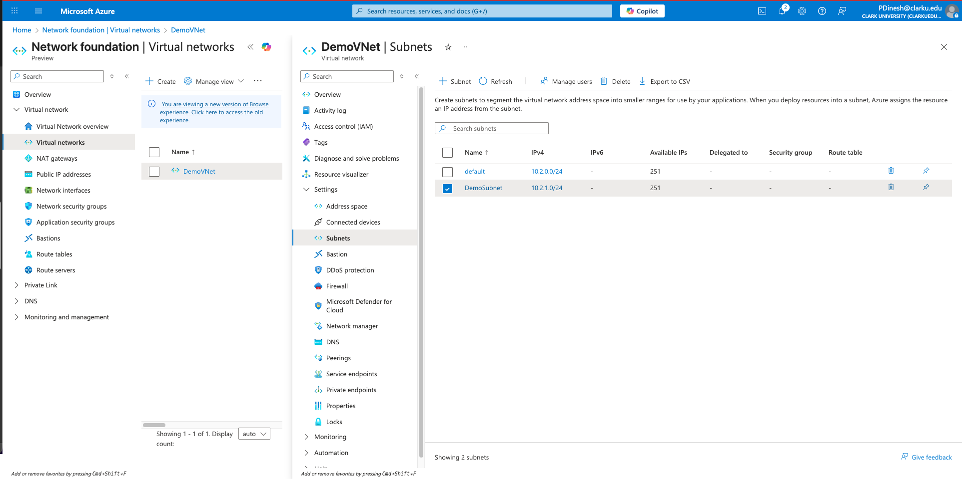

Create NSG
Created Network Security Group DemoNSG in AutomationDemoRG (West US) successfully.
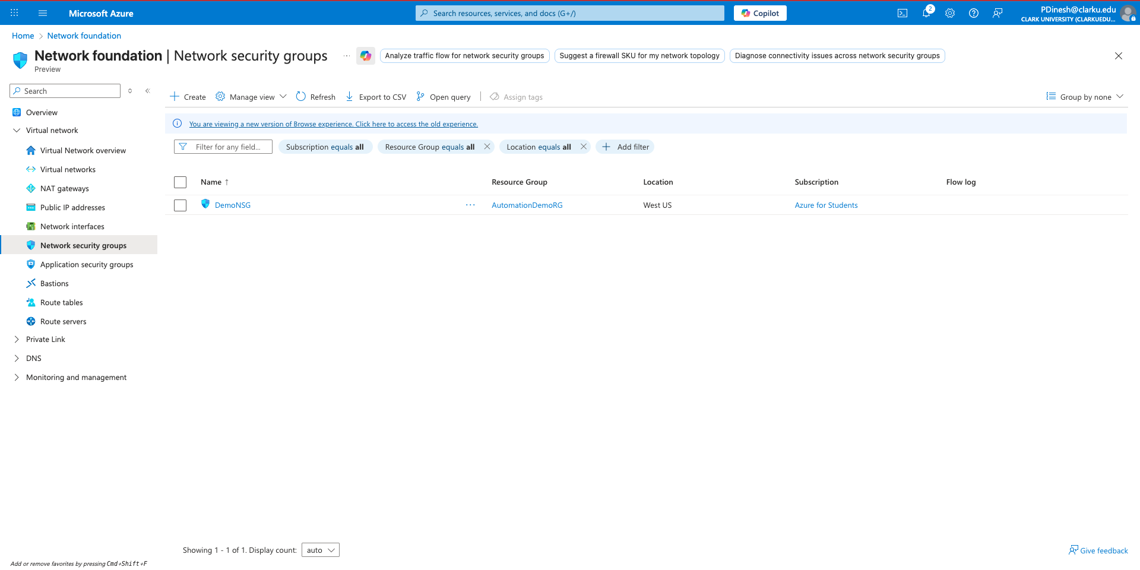

Screenshot: DemoNSG inbound rules showing your public IP in Allow-SSH-MyIP.

Add inbound rules to NSG
Added inbound rules to DemoNSG: Allow-SSH-MyIP from my public IP /32 and Allow-5201-IntraVNet for intra-VNet iperf traffic; both rules confirmed in the list.
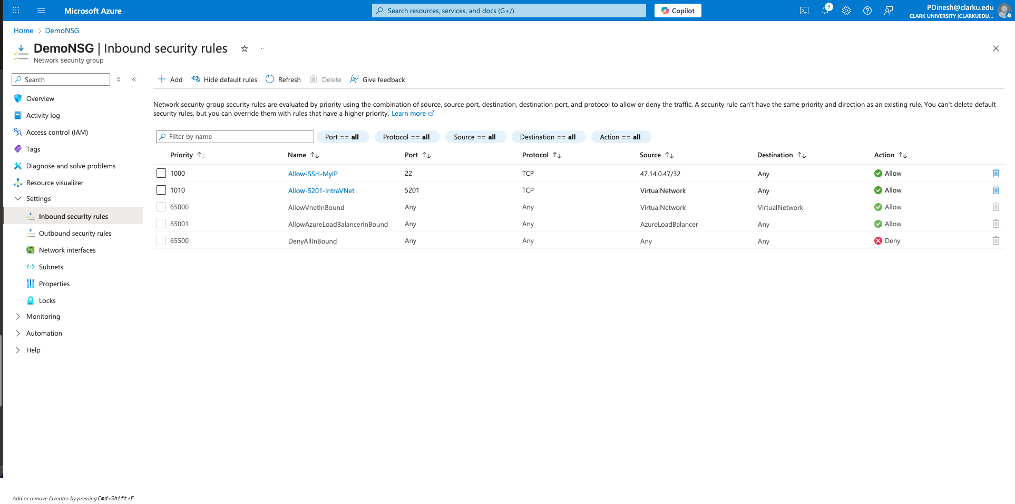

Screenshot: DemoNSG → Subnets showing DemoSubnet associated.

Associate NSG to Subnet
Associated DemoNSG with DemoSubnet in DemoVNet successfully; confirmed under NSG’s Subnets tab.
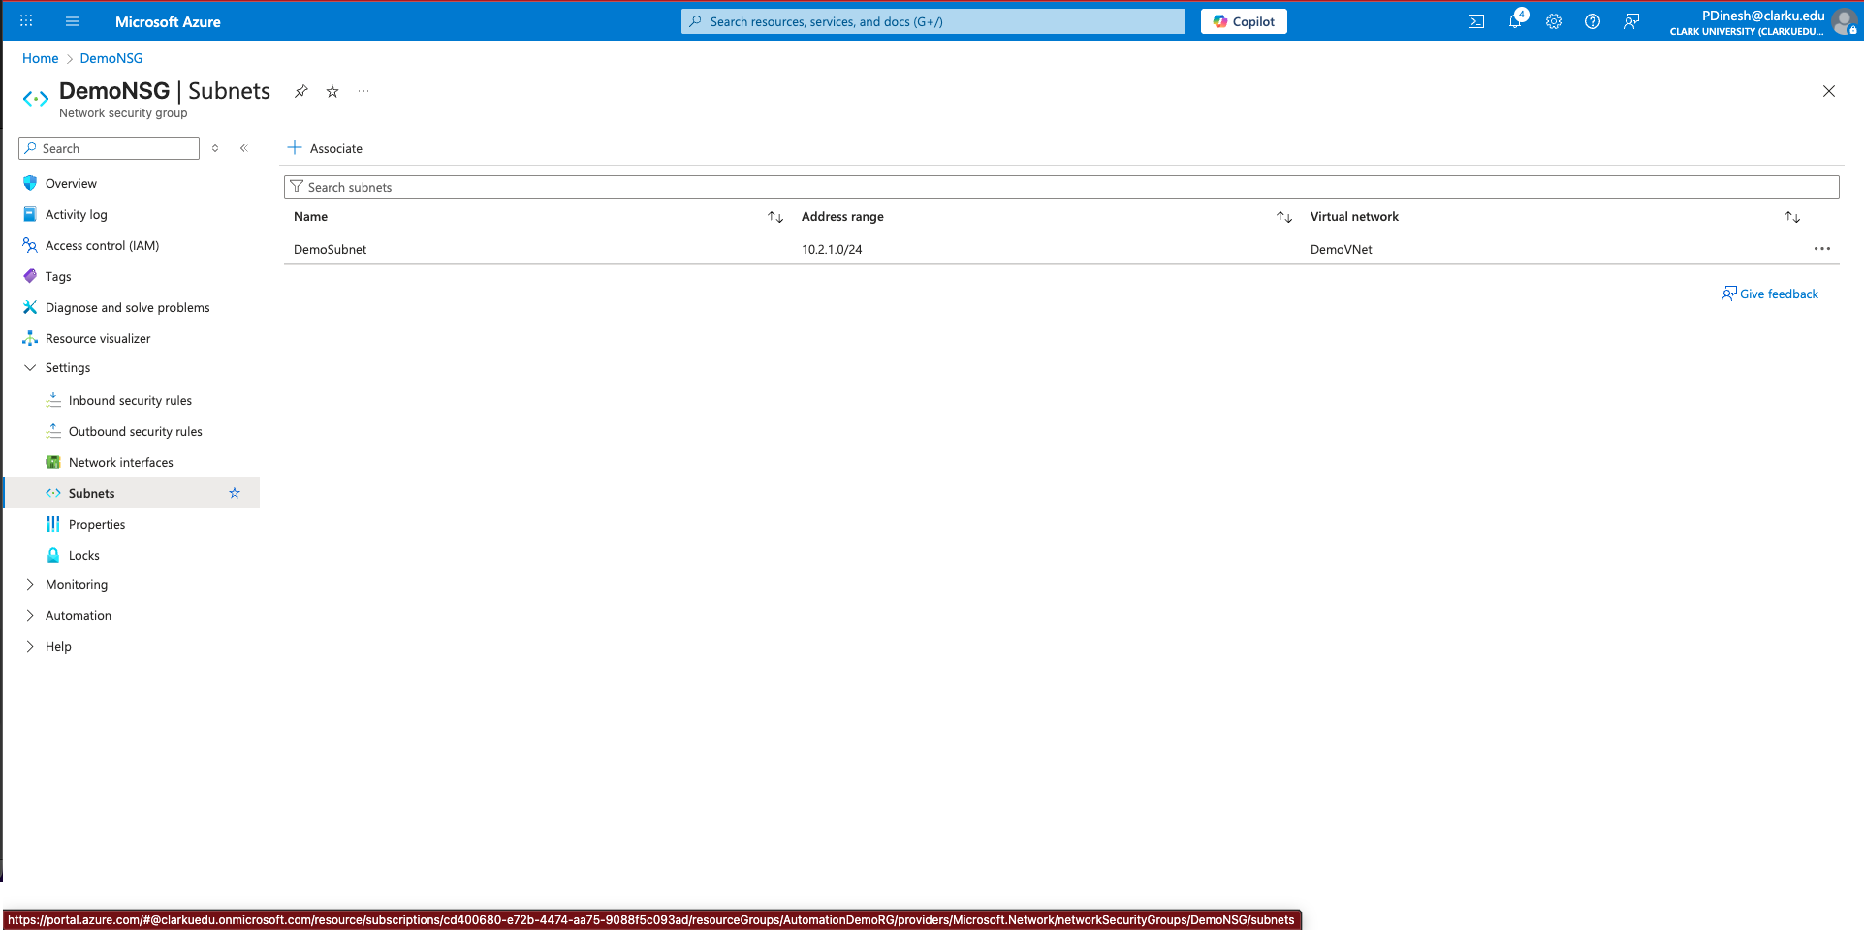

Screenshot: attacker-vm Overview with Public IP visible.

Create attacker and target VMs

Attacker VM (public):
Created attacker-vm in AutomationDemoRG with Ubuntu 24.04, public IP, and attached it to DemoVNet/DemoSubnet successfully.
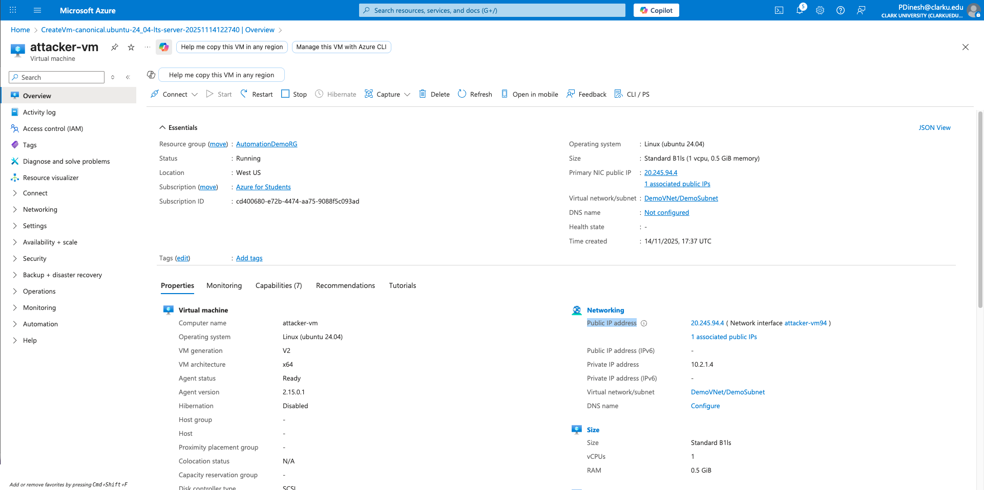

Screenshot: target-vm Overview with Private IP visible.

Target VM (private):
Created target-vm in AutomationDemoRG with no public IP and joined it to DemoVNet/DemoSubnet successfully.
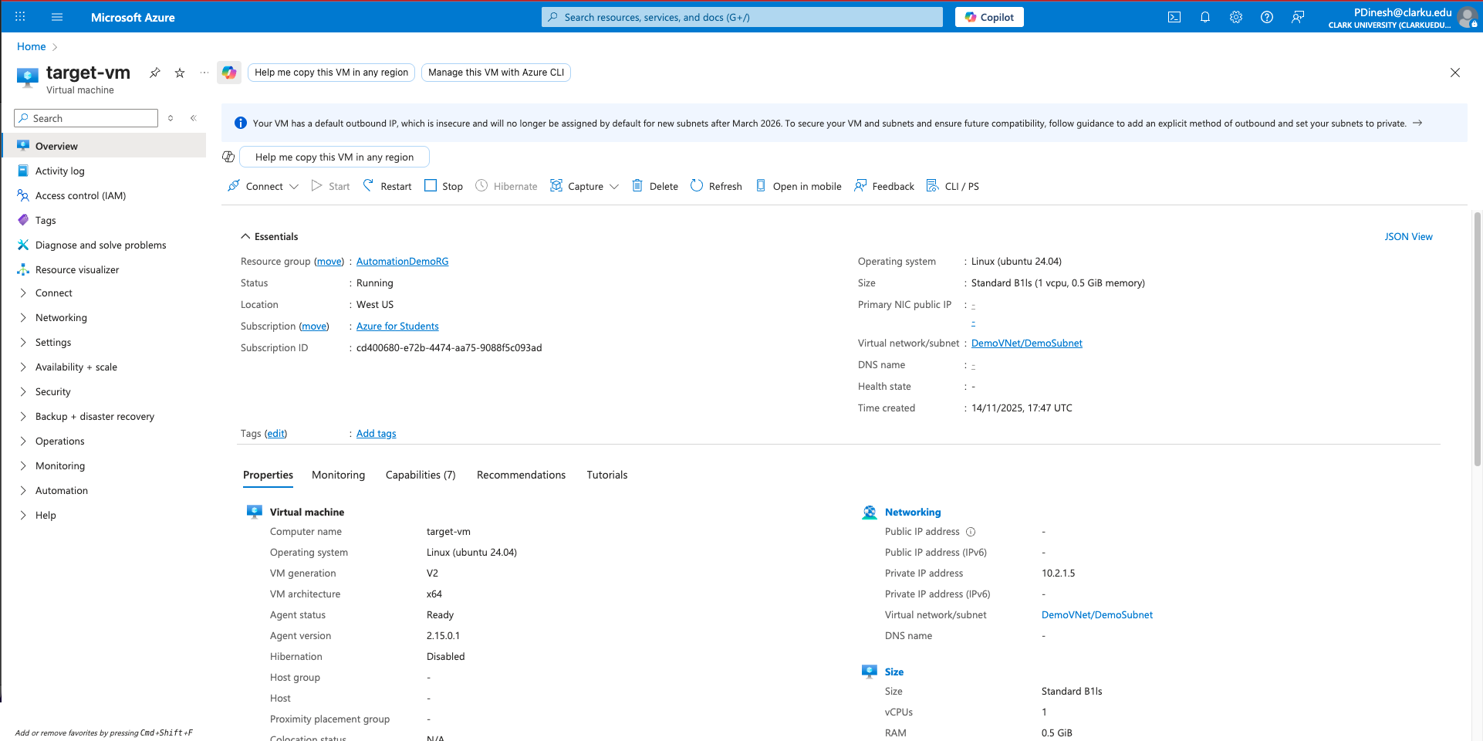

RunCommand output (terminal text and screenshot) from target-vm showing iperf3 server listening. Paste the output text.

Start iperf3 server on target (portal Run Command)
Installed iperf3 on target-vm and successfully started the iperf3 server on port 5201 via Run Command; verified listener using ss output.
Enable succeeded:
[stdout]
LISTEN 0 4096 *:5201 *:* users:(("iperf3",pid=5720,fd=3))

[stderr]

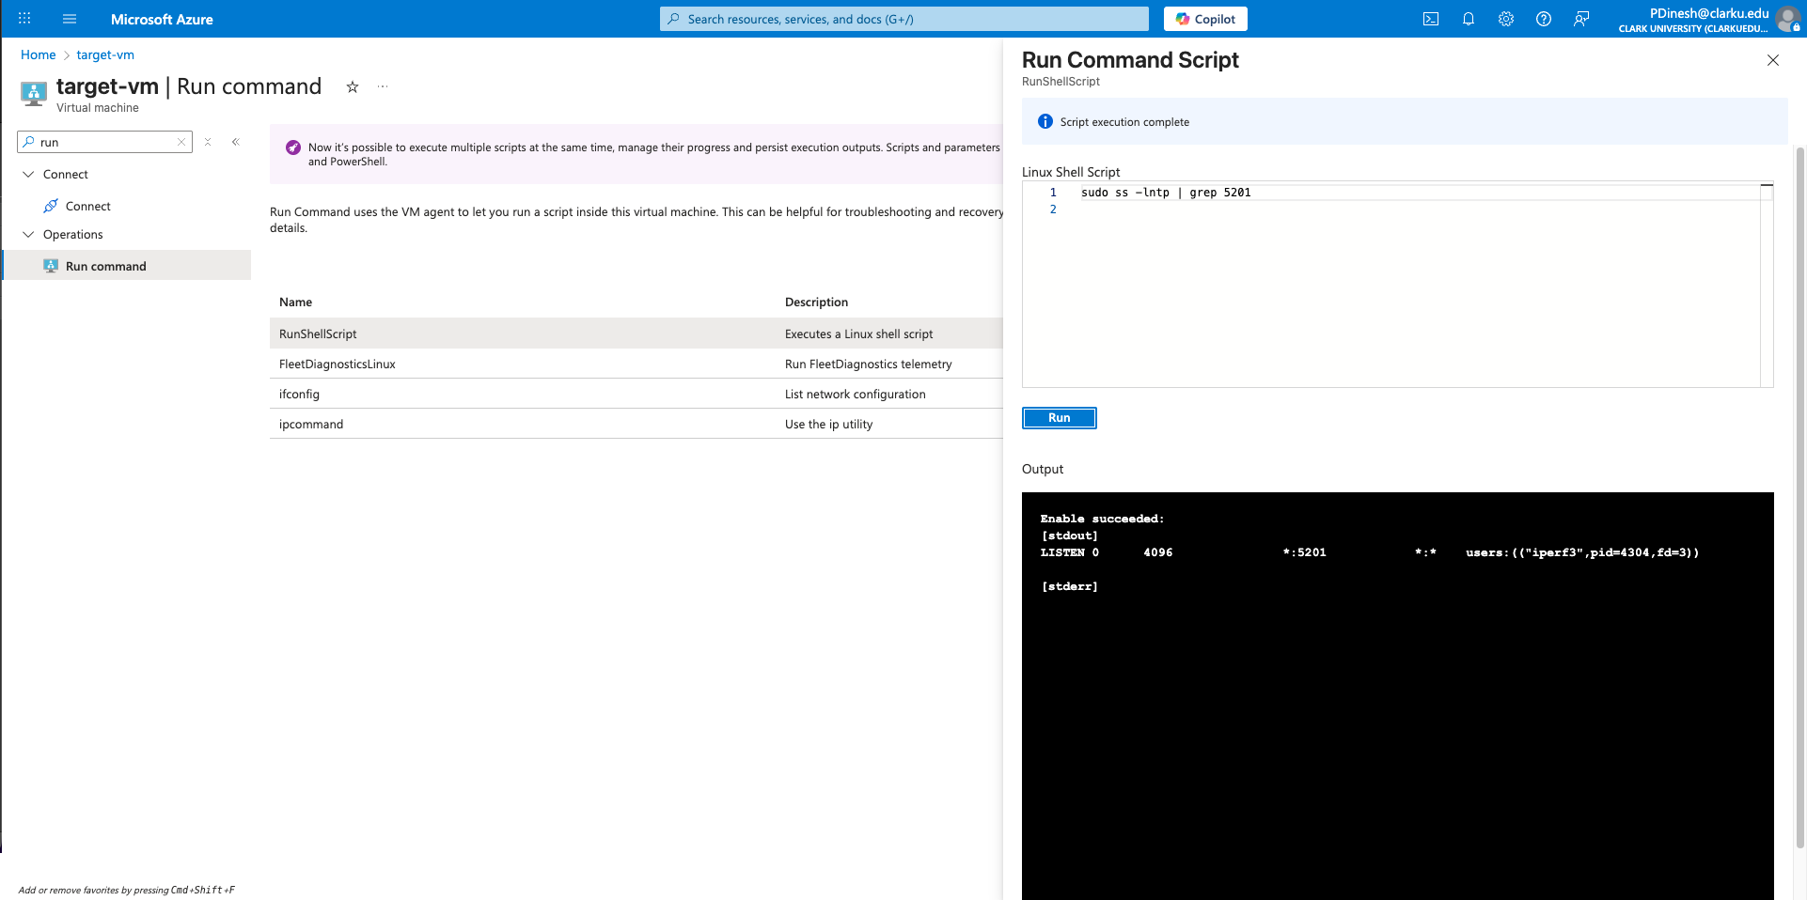

SSH into attacker VM
Connected to attacker-vm successfully via SSH using its public IP.
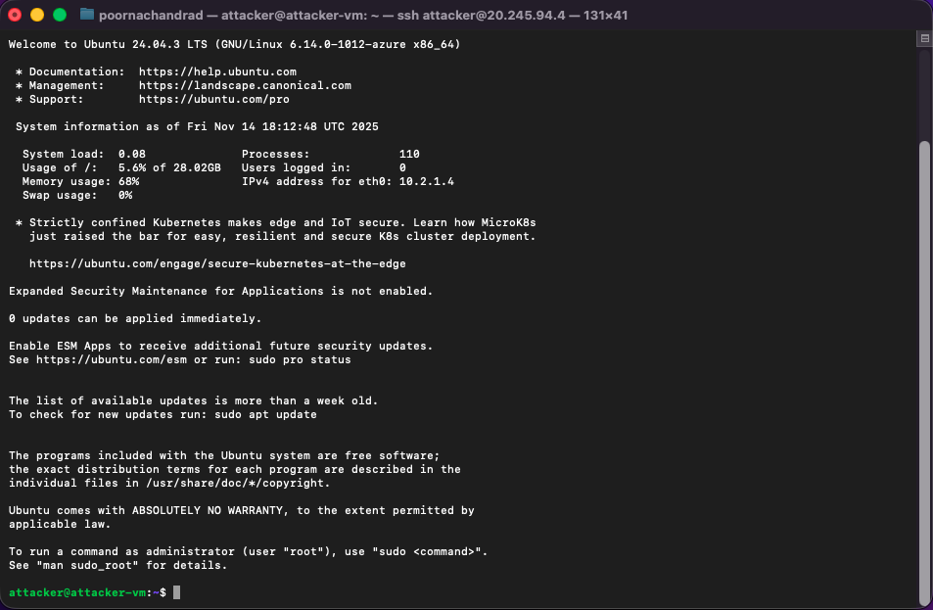

10. Attacker terminal screenshot showing iperf3 client running and saved client output file. Paste the file contents.

Install iperf3 on attacker and run client test
Ran iperf3 client on attacker-vm targeting target-vm private IP on port 5201 for 300 seconds at 50 Mbps; saved output to ~/iperf3_client_output.txt and verified traffic flow successfully.

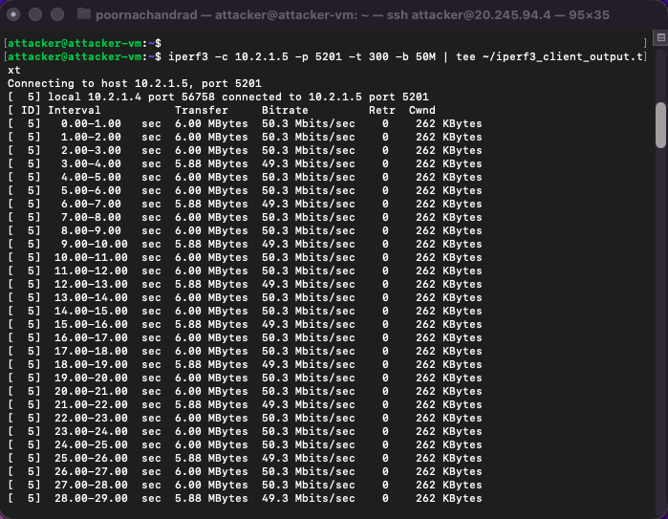

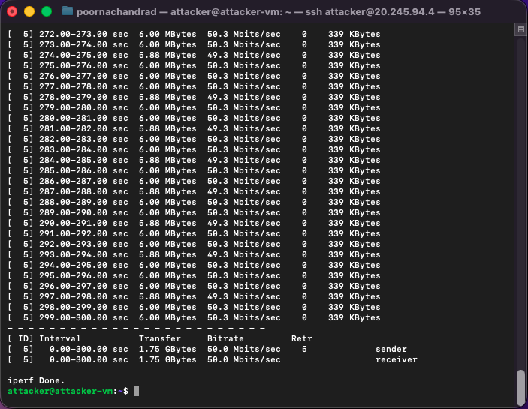

Saved client output file:

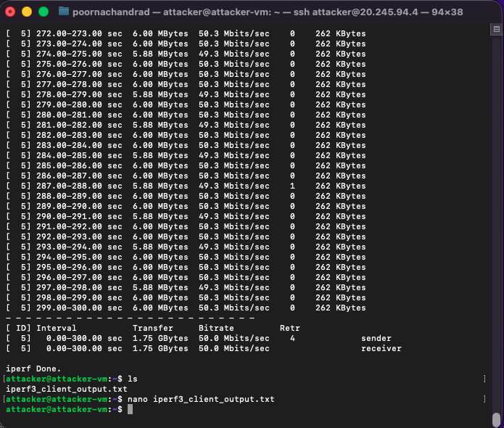

File Contents
Connecting to host 10.2.1.5, port 5201
[ 5] local 10.2.1.4 port 56758 connected to 10.2.1.5 port 5201
[ ID] Interval Transfer Bitrate Retr Cwnd
[ 5] 0.00-1.00 sec 6.00 MBytes 50.3 Mbits/sec 0 262 KBytes
[ 5] 1.00-2.00 sec 6.00 MBytes 50.3 Mbits/sec 0 262 KBytes
[ 5] 2.00-3.00 sec 6.00 MBytes 50.3 Mbits/sec 0 262 KBytes
[ 5] 3.00-4.00 sec 5.88 MBytes 49.3 Mbits/sec 0 262 KBytes
[ 5] 4.00-5.00 sec 6.00 MBytes 50.3 Mbits/sec 0 262 KBytes
[ 5] 5.00-6.00 sec 6.00 MBytes 50.3 Mbits/sec 0 262 KBytes
[ 5] 6.00-7.00 sec 5.88 MBytes 49.3 Mbits/sec 0 262 KBytes
[ 5] 7.00-8.00 sec 6.00 MBytes 50.3 Mbits/sec 0 262 KBytes
[ 5] 8.00-9.00 sec 6.00 MBytes 50.3 Mbits/sec 0 262 KBytes
[ 5] 9.00-10.00 sec 5.88 MBytes 49.3 Mbits/sec 0 262 KBytes
[ 5] 10.00-11.00 sec 6.00 MBytes 50.3 Mbits/sec 0 262 KBytes
[ 5] 11.00-12.00 sec 6.00 MBytes 50.3 Mbits/sec 0 262 KBytes
[ 5] 12.00-13.00 sec 5.88 MBytes 49.3 Mbits/sec 0 262 KBytes
[ 5] 13.00-14.00 sec 6.00 MBytes 50.3 Mbits/sec 0 262 KBytes
[ 5] 14.00-15.00 sec 6.00 MBytes 50.3 Mbits/sec 0 262 KBytes
[ 5] 15.00-16.00 sec 5.88 MBytes 49.3 Mbits/sec 0 262 KBytes
[ 5] 16.00-17.00 sec 6.00 MBytes 50.3 Mbits/sec 0 262 KBytes
[ 5] 17.00-18.00 sec 6.00 MBytes 50.3 Mbits/sec 0 262 KBytes
[ 5] 18.00-19.00 sec 5.88 MBytes 49.3 Mbits/sec 0 262 KBytes
[ 5] 19.00-20.00 sec 6.00 MBytes 50.3 Mbits/sec 0 262 KBytes
[ 5] 20.00-21.00 sec 6.00 MBytes 50.3 Mbits/sec 0 262 KBytes
[ 5] 21.00-22.00 sec 5.88 MBytes 49.3 Mbits/sec 0 262 KBytes
[ 5] 22.00-23.00 sec 6.00 MBytes 50.3 Mbits/sec 0 262 KBytes
[ 5] 23.00-24.00 sec 6.00 MBytes 50.3 Mbits/sec 0 262 KBytes
[ 5] 24.00-25.00 sec 6.00 MBytes 50.3 Mbits/sec 0 262 KBytes
[ 5] 25.00-26.00 sec 5.88 MBytes 49.3 Mbits/sec 0 262 KBytes
[ 5] 26.00-27.00 sec 6.00 MBytes 50.3 Mbits/sec 0 262 KBytes
[ 5] 27.00-28.00 sec 6.00 MBytes 50.3 Mbits/sec 0 262 KBytes
[ 5] 28.00-29.00 sec 5.88 MBytes 49.3 Mbits/sec 0 262 KBytes
[ 5] 29.00-30.00 sec 6.00 MBytes 50.3 Mbits/sec 0 262 KBytes
[ 5] 30.00-31.00 sec 6.00 MBytes 50.3 Mbits/sec 0 262 KBytes
[ 5] 31.00-32.00 sec 5.88 MBytes 49.3 Mbits/sec 0 262 KBytes
[ 5] 32.00-33.00 sec 6.00 MBytes 50.3 Mbits/sec 0 262 KBytes
[ 5] 33.00-34.00 sec 6.00 MBytes 50.3 Mbits/sec 0 262 KBytes
[ 5] 34.00-35.00 sec 5.88 MBytes 49.3 Mbits/sec 0 262 KBytes
[ 5] 35.00-36.00 sec 6.00 MBytes 50.3 Mbits/sec 0 262 KBytes
[ 5] 36.00-37.00 sec 6.00 MBytes 50.3 Mbits/sec 0 262 KBytes
[ 5] 37.00-38.00 sec 5.88 MBytes 49.3 Mbits/sec 0 262 KBytes
[ 5] 38.00-39.00 sec 6.00 MBytes 50.3 Mbits/sec 0 262 KBytes
[ 5] 39.00-40.00 sec 6.00 MBytes 50.3 Mbits/sec 0 262 KBytes
[ 5] 40.00-41.00 sec 5.88 MBytes 49.3 Mbits/sec 0 262 KBytes
[ 5] 41.00-42.00 sec 6.00 MBytes 50.3 Mbits/sec 0 262 KBytes
[ 5] 42.00-43.00 sec 6.00 MBytes 50.3 Mbits/sec 0 262 KBytes
[ 5] 43.00-44.00 sec 6.00 MBytes 50.3 Mbits/sec 0 262 KBytes
[ 5] 44.00-45.00 sec 5.88 MBytes 49.3 Mbits/sec 0 262 KBytes
[ 5] 45.00-46.00 sec 6.00 MBytes 50.3 Mbits/sec 0 262 KBytes
[ 5] 46.00-47.00 sec 6.00 MBytes 50.3 Mbits/sec 0 262 KBytes
[ 5] 47.00-48.00 sec 5.88 MBytes 49.3 Mbits/sec 0 262 KBytes
[ 5] 48.00-49.00 sec 6.00 MBytes 50.3 Mbits/sec 0 262 KBytes
[ 5] 49.00-50.00 sec 6.00 MBytes 50.3 Mbits/sec 0 262 KBytes
[ 5] 50.00-51.00 sec 5.88 MBytes 49.3 Mbits/sec 0 262 KBytes
[ 5] 51.00-52.00 sec 6.00 MBytes 50.3 Mbits/sec 0 262 KBytes
[ 5] 52.00-53.00 sec 6.00 MBytes 50.3 Mbits/sec 0 262 KBytes
[ 5] 53.00-54.00 sec 5.88 MBytes 49.3 Mbits/sec 0 262 KBytes
[ 5] 54.00-55.00 sec 6.00 MBytes 50.3 Mbits/sec 0 262 KBytes
[ 5] 55.00-56.00 sec 6.00 MBytes 50.3 Mbits/sec 0 262 KBytes
[ 5] 56.00-57.00 sec 5.88 MBytes 49.3 Mbits/sec 0 262 KBytes
[ 5] 57.00-58.00 sec 6.00 MBytes 50.3 Mbits/sec 0 262 KBytes
[ 5] 58.00-59.00 sec 6.00 MBytes 50.3 Mbits/sec 0 262 KBytes
[ 5] 59.00-60.00 sec 5.88 MBytes 49.3 Mbits/sec 0 262 KBytes
[ 5] 60.00-61.00 sec 6.00 MBytes 50.3 Mbits/sec 0 262 KBytes
[ 5] 61.00-62.00 sec 6.00 MBytes 50.3 Mbits/sec 0 262 KBytes
[ 5] 62.00-63.00 sec 6.00 MBytes 50.3 Mbits/sec 0 262 KBytes
[ 5] 63.00-64.00 sec 5.88 MBytes 49.3 Mbits/sec 0 262 KBytes
[ 5] 64.00-65.00 sec 6.00 MBytes 50.3 Mbits/sec 0 262 KBytes
[ 5] 65.00-66.00 sec 6.00 MBytes 50.3 Mbits/sec 0 262 KBytes
[ 5] 66.00-67.00 sec 5.88 MBytes 49.3 Mbits/sec 0 262 KBytes
[ 5] 67.00-68.00 sec 6.00 MBytes 50.3 Mbits/sec 0 262 KBytes
[ 5] 68.00-69.00 sec 6.00 MBytes 50.3 Mbits/sec 0 262 KBytes
[ 5] 69.00-70.00 sec 5.88 MBytes 49.3 Mbits/sec 0 262 KBytes
[ 5] 70.00-71.00 sec 6.00 MBytes 50.3 Mbits/sec 0 262 KBytes
[ 5] 71.00-72.00 sec 6.00 MBytes 50.3 Mbits/sec 0 262 KBytes
[ 5] 72.00-73.00 sec 5.88 MBytes 49.3 Mbits/sec 0 262 KBytes
[ 5] 73.00-74.00 sec 6.00 MBytes 50.3 Mbits/sec 0 262 KBytes
[ 5] 74.00-75.00 sec 6.00 MBytes 50.3 Mbits/sec 0 262 KBytes
[ 5] 75.00-76.00 sec 5.88 MBytes 49.3 Mbits/sec 0 262 KBytes
[ 5] 76.00-77.00 sec 6.00 MBytes 50.3 Mbits/sec 0 262 KBytes
[ 5] 77.00-78.00 sec 6.00 MBytes 50.3 Mbits/sec 0 262 KBytes
[ 5] 78.00-79.00 sec 5.88 MBytes 49.3 Mbits/sec 0 262 KBytes
[ 5] 79.00-80.00 sec 6.00 MBytes 50.3 Mbits/sec 1 262 KBytes
[ 5] 80.00-81.00 sec 6.00 MBytes 50.3 Mbits/sec 0 262 KBytes
[ 5] 81.00-82.00 sec 6.00 MBytes 50.3 Mbits/sec 0 262 KBytes
[ 5] 82.00-83.00 sec 5.88 MBytes 49.3 Mbits/sec 0 262 KBytes
[ 5] 83.00-84.00 sec 6.00 MBytes 50.3 Mbits/sec 0 262 KBytes
[ 5] 84.00-85.00 sec 6.00 MBytes 50.3 Mbits/sec 0 262 KBytes
[ 5] 85.00-86.00 sec 5.88 MBytes 49.3 Mbits/sec 0 262 KBytes
[ 5] 86.00-87.00 sec 6.00 MBytes 50.3 Mbits/sec 0 262 KBytes
[ 5] 87.00-88.00 sec 6.00 MBytes 50.3 Mbits/sec 0 262 KBytes
[ 5] 88.00-89.00 sec 5.88 MBytes 49.3 Mbits/sec 0 262 KBytes
[ 5] 89.00-90.00 sec 6.00 MBytes 50.3 Mbits/sec 0 262 KBytes
[ 5] 90.00-91.00 sec 6.00 MBytes 50.3 Mbits/sec 0 262 KBytes
[ 5] 91.00-92.00 sec 5.88 MBytes 49.3 Mbits/sec 0 262 KBytes
[ 5] 92.00-93.00 sec 6.00 MBytes 50.3 Mbits/sec 0 262 KBytes
[ 5] 93.00-94.00 sec 6.00 MBytes 50.3 Mbits/sec 0 262 KBytes
[ 5] 94.00-95.00 sec 5.88 MBytes 49.3 Mbits/sec 0 262 KBytes
[ 5] 95.00-96.00 sec 6.00 MBytes 50.3 Mbits/sec 0 262 KBytes
[ 5] 96.00-97.00 sec 6.00 MBytes 50.3 Mbits/sec 0 262 KBytes
[ 5] 97.00-98.00 sec 5.88 MBytes 49.3 Mbits/sec 0 262 KBytes
[ 5] 98.00-99.00 sec 6.00 MBytes 50.3 Mbits/sec 0 262 KBytes
[ 5] 99.00-100.00 sec 6.00 MBytes 50.3 Mbits/sec 0 262 KBytes
[ 5] 100.00-101.00 sec 6.00 MBytes 50.3 Mbits/sec 0 262 KBytes
[ 5] 101.00-102.00 sec 5.88 MBytes 49.2 Mbits/sec 0 262 KBytes
[ 5] 102.00-103.00 sec 6.00 MBytes 50.4 Mbits/sec 0 262 KBytes
[ 5] 103.00-104.00 sec 6.00 MBytes 50.3 Mbits/sec 0 262 KBytes
[ 5] 104.00-105.00 sec 5.88 MBytes 49.3 Mbits/sec 0 262 KBytes
[ 5] 105.00-106.00 sec 6.00 MBytes 50.3 Mbits/sec 0 262 KBytes
[ 5] 106.00-107.00 sec 6.00 MBytes 50.3 Mbits/sec 0 262 KBytes
[ 5] 107.00-108.00 sec 5.88 MBytes 49.3 Mbits/sec 0 262 KBytes
[ 5] 108.00-109.00 sec 6.00 MBytes 50.3 Mbits/sec 0 262 KBytes
[ 5] 109.00-110.00 sec 6.00 MBytes 50.2 Mbits/sec 0 262 KBytes
[ 5] 110.00-111.00 sec 5.88 MBytes 49.4 Mbits/sec 0 262 KBytes
[ 5] 111.00-112.00 sec 6.00 MBytes 50.3 Mbits/sec 0 262 KBytes
[ 5] 112.00-113.00 sec 6.00 MBytes 50.3 Mbits/sec 0 262 KBytes
[ 5] 113.00-114.00 sec 5.88 MBytes 49.3 Mbits/sec 0 262 KBytes
[ 5] 114.00-115.00 sec 6.00 MBytes 50.3 Mbits/sec 0 262 KBytes
[ 5] 115.00-116.00 sec 6.00 MBytes 50.3 Mbits/sec 0 262 KBytes
[ 5] 116.00-117.00 sec 5.88 MBytes 49.3 Mbits/sec 0 262 KBytes
[ 5] 117.00-118.00 sec 6.00 MBytes 50.3 Mbits/sec 0 262 KBytes
[ 5] 118.00-119.00 sec 6.00 MBytes 50.3 Mbits/sec 0 262 KBytes
[ 5] 119.00-120.00 sec 6.00 MBytes 50.3 Mbits/sec 0 262 KBytes
[ 5] 120.00-121.00 sec 5.88 MBytes 49.3 Mbits/sec 0 262 KBytes
[ 5] 121.00-122.00 sec 6.00 MBytes 50.3 Mbits/sec 0 262 KBytes
[ 5] 122.00-123.00 sec 6.00 MBytes 50.3 Mbits/sec 0 262 KBytes
[ 5] 123.00-124.00 sec 5.88 MBytes 49.3 Mbits/sec 0 262 KBytes
[ 5] 124.00-125.00 sec 6.00 MBytes 50.3 Mbits/sec 0 262 KBytes
[ 5] 125.00-126.00 sec 6.00 MBytes 50.3 Mbits/sec 0 262 KBytes
[ 5] 126.00-127.00 sec 5.88 MBytes 49.2 Mbits/sec 0 262 KBytes
[ 5] 127.00-128.00 sec 6.00 MBytes 50.4 Mbits/sec 0 262 KBytes
[ 5] 128.00-129.00 sec 6.00 MBytes 50.3 Mbits/sec 0 262 KBytes
[ 5] 129.00-130.00 sec 5.88 MBytes 49.3 Mbits/sec 0 262 KBytes
[ 5] 130.00-131.00 sec 6.00 MBytes 50.3 Mbits/sec 0 262 KBytes
[ 5] 131.00-132.00 sec 6.00 MBytes 50.3 Mbits/sec 0 262 KBytes
[ 5] 132.00-133.00 sec 5.88 MBytes 49.3 Mbits/sec 0 262 KBytes
[ 5] 133.00-134.00 sec 6.00 MBytes 50.3 Mbits/sec 0 262 KBytes
[ 5] 134.00-135.00 sec 6.00 MBytes 50.3 Mbits/sec 0 262 KBytes
[ 5] 135.00-136.00 sec 5.88 MBytes 49.3 Mbits/sec 0 262 KBytes
[ 5] 136.00-137.00 sec 6.00 MBytes 50.3 Mbits/sec 0 262 KBytes
[ 5] 137.00-138.00 sec 6.00 MBytes 50.3 Mbits/sec 0 262 KBytes
[ 5] 138.00-139.00 sec 5.88 MBytes 49.3 Mbits/sec 0 262 KBytes
[ 5] 139.00-140.00 sec 6.00 MBytes 50.3 Mbits/sec 0 262 KBytes
[ 5] 140.00-141.00 sec 6.00 MBytes 50.3 Mbits/sec 0 262 KBytes
[ 5] 141.00-142.00 sec 6.00 MBytes 50.3 Mbits/sec 0 262 KBytes
[ 5] 142.00-143.00 sec 5.88 MBytes 49.3 Mbits/sec 0 262 KBytes
[ 5] 143.00-144.00 sec 6.00 MBytes 50.3 Mbits/sec 0 262 KBytes
[ 5] 144.00-145.00 sec 6.00 MBytes 50.3 Mbits/sec 0 262 KBytes
[ 5] 145.00-146.00 sec 5.88 MBytes 49.3 Mbits/sec 0 262 KBytes
[ 5] 146.00-147.00 sec 6.00 MBytes 50.3 Mbits/sec 0 262 KBytes
[ 5] 147.00-148.00 sec 6.00 MBytes 50.3 Mbits/sec 0 262 KBytes
[ 5] 148.00-149.00 sec 5.88 MBytes 49.3 Mbits/sec 0 262 KBytes
[ 5] 149.00-150.00 sec 6.00 MBytes 50.3 Mbits/sec 0 262 KBytes
[ 5] 150.00-151.00 sec 6.00 MBytes 50.2 Mbits/sec 0 262 KBytes
[ 5] 151.00-152.00 sec 5.88 MBytes 49.4 Mbits/sec 0 262 KBytes
[ 5] 152.00-153.00 sec 6.00 MBytes 50.3 Mbits/sec 0 262 KBytes
[ 5] 153.00-154.00 sec 6.00 MBytes 50.3 Mbits/sec 0 262 KBytes
[ 5] 154.00-155.00 sec 5.88 MBytes 49.3 Mbits/sec 0 262 KBytes
[ 5] 155.00-156.00 sec 6.00 MBytes 50.3 Mbits/sec 0 262 KBytes
[ 5] 156.00-157.00 sec 6.00 MBytes 50.3 Mbits/sec 0 262 KBytes
[ 5] 157.00-158.00 sec 5.88 MBytes 49.2 Mbits/sec 0 262 KBytes
[ 5] 158.00-159.00 sec 6.00 MBytes 50.4 Mbits/sec 0 262 KBytes
[ 5] 159.00-160.00 sec 6.00 MBytes 50.3 Mbits/sec 0 262 KBytes
[ 5] 160.00-161.00 sec 6.00 MBytes 50.3 Mbits/sec 0 262 KBytes
[ 5] 161.00-162.00 sec 5.88 MBytes 49.3 Mbits/sec 0 262 KBytes
[ 5] 162.00-163.00 sec 6.00 MBytes 50.3 Mbits/sec 0 262 KBytes
[ 5] 163.00-164.00 sec 6.00 MBytes 50.3 Mbits/sec 0 262 KBytes
[ 5] 164.00-165.00 sec 5.88 MBytes 49.3 Mbits/sec 0 262 KBytes
[ 5] 165.00-166.00 sec 6.00 MBytes 50.3 Mbits/sec 0 262 KBytes
[ 5] 166.00-167.00 sec 6.00 MBytes 50.3 Mbits/sec 0 262 KBytes
[ 5] 167.00-168.00 sec 5.88 MBytes 49.3 Mbits/sec 0 262 KBytes
[ 5] 168.00-169.00 sec 6.00 MBytes 50.3 Mbits/sec 0 262 KBytes
[ 5] 169.00-170.00 sec 6.00 MBytes 50.3 Mbits/sec 0 262 KBytes
[ 5] 170.00-171.00 sec 5.88 MBytes 49.3 Mbits/sec 0 262 KBytes
[ 5] 171.00-172.00 sec 6.00 MBytes 50.3 Mbits/sec 0 262 KBytes
[ 5] 172.00-173.00 sec 6.00 MBytes 50.3 Mbits/sec 0 262 KBytes
[ 5] 173.00-174.00 sec 5.88 MBytes 49.3 Mbits/sec 0 262 KBytes
[ 5] 174.00-175.00 sec 6.00 MBytes 50.3 Mbits/sec 2 262 KBytes
[ 5] 175.00-176.00 sec 6.00 MBytes 50.3 Mbits/sec 1 339 KBytes
[ 5] 176.00-177.00 sec 5.88 MBytes 49.3 Mbits/sec 0 339 KBytes
[ 5] 177.00-178.00 sec 6.00 MBytes 50.3 Mbits/sec 0 339 KBytes
[ 5] 178.00-179.00 sec 6.00 MBytes 50.3 Mbits/sec 0 339 KBytes
[ 5] 179.00-180.00 sec 6.00 MBytes 50.3 Mbits/sec 0 339 KBytes
[ 5] 180.00-181.00 sec 5.88 MBytes 49.3 Mbits/sec 0 339 KBytes
[ 5] 181.00-182.00 sec 6.00 MBytes 50.3 Mbits/sec 0 339 KBytes
[ 5] 182.00-183.00 sec 6.00 MBytes 50.3 Mbits/sec 0 339 KBytes
[ 5] 183.00-184.00 sec 5.88 MBytes 49.3 Mbits/sec 0 339 KBytes
[ 5] 184.00-185.00 sec 6.00 MBytes 50.3 Mbits/sec 0 339 KBytes
[ 5] 185.00-186.00 sec 6.00 MBytes 50.3 Mbits/sec 0 339 KBytes
[ 5] 186.00-187.00 sec 5.88 MBytes 49.3 Mbits/sec 0 339 KBytes
[ 5] 187.00-188.00 sec 6.00 MBytes 50.3 Mbits/sec 0 339 KBytes
[ 5] 188.00-189.00 sec 6.00 MBytes 50.3 Mbits/sec 0 339 KBytes
[ 5] 189.00-190.00 sec 5.88 MBytes 49.3 Mbits/sec 0 339 KBytes
[ 5] 190.00-191.00 sec 6.00 MBytes 50.3 Mbits/sec 0 339 KBytes
[ 5] 191.00-192.00 sec 6.00 MBytes 50.3 Mbits/sec 0 339 KBytes
[ 5] 192.00-193.00 sec 5.88 MBytes 49.3 Mbits/sec 0 339 KBytes
[ 5] 193.00-194.00 sec 6.00 MBytes 50.3 Mbits/sec 0 339 KBytes
[ 5] 194.00-195.00 sec 6.00 MBytes 50.3 Mbits/sec 0 339 KBytes
[ 5] 195.00-196.00 sec 5.88 MBytes 49.3 Mbits/sec 0 339 KBytes
[ 5] 196.00-197.00 sec 6.00 MBytes 50.3 Mbits/sec 0 339 KBytes
[ 5] 197.00-198.00 sec 6.00 MBytes 50.3 Mbits/sec 0 339 KBytes
[ 5] 198.00-199.00 sec 6.00 MBytes 50.3 Mbits/sec 0 339 KBytes
[ 5] 199.00-200.00 sec 5.88 MBytes 49.3 Mbits/sec 0 339 KBytes
[ 5] 200.00-201.00 sec 6.00 MBytes 50.3 Mbits/sec 0 339 KBytes
[ 5] 201.00-202.00 sec 6.00 MBytes 50.3 Mbits/sec 0 339 KBytes
[ 5] 202.00-203.00 sec 5.88 MBytes 49.3 Mbits/sec 0 339 KBytes
[ 5] 203.00-204.00 sec 6.00 MBytes 50.3 Mbits/sec 0 339 KBytes
[ 5] 204.00-205.00 sec 6.00 MBytes 50.3 Mbits/sec 0 339 KBytes
[ 5] 205.00-206.00 sec 5.88 MBytes 49.3 Mbits/sec 0 339 KBytes
[ 5] 206.00-207.00 sec 6.00 MBytes 50.3 Mbits/sec 0 339 KBytes
[ 5] 207.00-208.00 sec 6.00 MBytes 50.3 Mbits/sec 0 339 KBytes
[ 5] 208.00-209.00 sec 5.88 MBytes 49.3 Mbits/sec 0 339 KBytes
[ 5] 209.00-210.00 sec 6.00 MBytes 50.3 Mbits/sec 0 339 KBytes
[ 5] 210.00-211.00 sec 6.00 MBytes 50.3 Mbits/sec 0 339 KBytes
[ 5] 211.00-212.00 sec 5.88 MBytes 49.3 Mbits/sec 0 339 KBytes
[ 5] 212.00-213.00 sec 6.00 MBytes 50.3 Mbits/sec 0 339 KBytes
[ 5] 213.00-214.00 sec 6.00 MBytes 50.3 Mbits/sec 0 339 KBytes
[ 5] 214.00-215.00 sec 5.88 MBytes 49.3 Mbits/sec 0 339 KBytes
[ 5] 215.00-216.00 sec 6.00 MBytes 50.3 Mbits/sec 0 339 KBytes
[ 5] 216.00-217.00 sec 6.00 MBytes 50.3 Mbits/sec 0 339 KBytes
[ 5] 217.00-218.00 sec 6.00 MBytes 50.3 Mbits/sec 0 339 KBytes
[ 5] 218.00-219.00 sec 5.88 MBytes 49.3 Mbits/sec 0 339 KBytes
[ 5] 219.00-220.00 sec 6.00 MBytes 50.3 Mbits/sec 0 339 KBytes
[ 5] 220.00-221.00 sec 6.00 MBytes 50.3 Mbits/sec 0 339 KBytes
[ 5] 221.00-222.00 sec 5.88 MBytes 49.3 Mbits/sec 0 339 KBytes
[ 5] 222.00-223.00 sec 6.00 MBytes 50.3 Mbits/sec 0 339 KBytes
[ 5] 223.00-224.00 sec 6.00 MBytes 50.3 Mbits/sec 0 339 KBytes
[ 5] 224.00-225.00 sec 5.88 MBytes 49.3 Mbits/sec 0 339 KBytes
[ 5] 225.00-226.00 sec 6.00 MBytes 50.3 Mbits/sec 0 339 KBytes
[ 5] 226.00-227.00 sec 6.00 MBytes 50.3 Mbits/sec 0 339 KBytes
[ 5] 227.00-228.00 sec 5.88 MBytes 49.3 Mbits/sec 0 339 KBytes
[ 5] 228.00-229.00 sec 6.00 MBytes 50.3 Mbits/sec 0 339 KBytes
[ 5] 229.00-230.00 sec 6.00 MBytes 50.3 Mbits/sec 0 339 KBytes
[ 5] 230.00-231.00 sec 5.88 MBytes 49.3 Mbits/sec 0 339 KBytes
[ 5] 231.00-232.00 sec 6.00 MBytes 50.3 Mbits/sec 0 339 KBytes
[ 5] 232.00-233.00 sec 6.00 MBytes 50.3 Mbits/sec 0 339 KBytes
[ 5] 233.00-234.00 sec 5.88 MBytes 49.3 Mbits/sec 0 339 KBytes
[ 5] 234.00-235.00 sec 6.00 MBytes 50.3 Mbits/sec 0 339 KBytes
[ 5] 235.00-236.00 sec 6.00 MBytes 50.3 Mbits/sec 0 339 KBytes
[ 5] 236.00-237.00 sec 5.88 MBytes 49.3 Mbits/sec 0 339 KBytes
[ 5] 237.00-238.00 sec 6.00 MBytes 50.3 Mbits/sec 0 339 KBytes
[ 5] 238.00-239.00 sec 6.00 MBytes 50.3 Mbits/sec 0 339 KBytes
[ 5] 239.00-240.00 sec 6.00 MBytes 50.3 Mbits/sec 0 339 KBytes
[ 5] 240.00-241.00 sec 5.88 MBytes 49.3 Mbits/sec 0 339 KBytes
[ 5] 241.00-242.00 sec 6.00 MBytes 50.3 Mbits/sec 0 339 KBytes
[ 5] 242.00-243.00 sec 6.00 MBytes 50.3 Mbits/sec 0 339 KBytes
[ 5] 243.00-244.00 sec 5.88 MBytes 49.3 Mbits/sec 0 339 KBytes
[ 5] 244.00-245.00 sec 6.00 MBytes 50.3 Mbits/sec 0 339 KBytes
[ 5] 245.00-246.00 sec 6.00 MBytes 50.3 Mbits/sec 0 339 KBytes
[ 5] 246.00-247.00 sec 5.88 MBytes 49.3 Mbits/sec 0 339 KBytes
[ 5] 247.00-248.00 sec 6.00 MBytes 50.3 Mbits/sec 0 339 KBytes
[ 5] 248.00-249.00 sec 6.00 MBytes 50.3 Mbits/sec 0 339 KBytes
[ 5] 249.00-250.00 sec 5.88 MBytes 49.3 Mbits/sec 0 339 KBytes
[ 5] 250.00-251.00 sec 6.00 MBytes 50.3 Mbits/sec 0 339 KBytes
[ 5] 251.00-252.00 sec 6.00 MBytes 50.3 Mbits/sec 0 339 KBytes
[ 5] 252.00-253.00 sec 5.88 MBytes 49.3 Mbits/sec 0 339 KBytes
[ 5] 253.00-254.00 sec 6.00 MBytes 50.3 Mbits/sec 0 339 KBytes
[ 5] 254.00-255.00 sec 6.00 MBytes 50.3 Mbits/sec 0 339 KBytes
[ 5] 255.00-256.00 sec 5.88 MBytes 49.3 Mbits/sec 0 339 KBytes
[ 5] 256.00-257.00 sec 6.00 MBytes 50.3 Mbits/sec 0 339 KBytes
[ 5] 257.00-258.00 sec 6.00 MBytes 50.3 Mbits/sec 0 339 KBytes
[ 5] 258.00-259.00 sec 6.00 MBytes 50.3 Mbits/sec 0 339 KBytes
[ 5] 259.00-260.00 sec 5.88 MBytes 49.3 Mbits/sec 0 339 KBytes
[ 5] 260.00-261.00 sec 6.00 MBytes 50.3 Mbits/sec 0 339 KBytes
[ 5] 261.00-262.00 sec 6.00 MBytes 50.3 Mbits/sec 0 339 KBytes
[ 5] 262.00-263.00 sec 5.88 MBytes 49.3 Mbits/sec 0 339 KBytes
[ 5] 263.00-264.00 sec 6.00 MBytes 50.3 Mbits/sec 1 339 KBytes
[ 5] 264.00-265.00 sec 6.00 MBytes 50.3 Mbits/sec 0 339 KBytes
[ 5] 265.00-266.00 sec 5.88 MBytes 49.3 Mbits/sec 0 339 KBytes
[ 5] 266.00-267.00 sec 6.00 MBytes 50.3 Mbits/sec 0 339 KBytes
[ 5] 267.00-268.00 sec 6.00 MBytes 50.3 Mbits/sec 0 339 KBytes
[ 5] 268.00-269.00 sec 5.88 MBytes 49.3 Mbits/sec 0 339 KBytes
[ 5] 269.00-270.00 sec 6.00 MBytes 50.3 Mbits/sec 0 339 KBytes
[ 5] 270.00-271.00 sec 6.00 MBytes 50.3 Mbits/sec 0 339 KBytes
[ 5] 271.00-272.00 sec 5.88 MBytes 49.3 Mbits/sec 0 339 KBytes
[ 5] 272.00-273.00 sec 6.00 MBytes 50.3 Mbits/sec 0 339 KBytes
[ 5] 273.00-274.00 sec 6.00 MBytes 50.3 Mbits/sec 0 339 KBytes
[ 5] 274.00-275.00 sec 5.88 MBytes 49.3 Mbits/sec 0 339 KBytes
[ 5] 275.00-276.00 sec 6.00 MBytes 50.3 Mbits/sec 0 339 KBytes
[ 5] 276.00-277.00 sec 6.00 MBytes 50.3 Mbits/sec 0 339 KBytes
[ 5] 277.00-278.00 sec 6.00 MBytes 50.3 Mbits/sec 0 339 KBytes
[ 5] 278.00-279.00 sec 5.88 MBytes 49.3 Mbits/sec 0 339 KBytes
[ 5] 279.00-280.00 sec 6.00 MBytes 50.3 Mbits/sec 0 339 KBytes
[ 5] 280.00-281.00 sec 6.00 MBytes 50.3 Mbits/sec 0 339 KBytes
[ 5] 281.00-282.00 sec 5.88 MBytes 49.3 Mbits/sec 0 339 KBytes
[ 5] 282.00-283.00 sec 6.00 MBytes 50.3 Mbits/sec 0 339 KBytes
[ 5] 283.00-284.00 sec 6.00 MBytes 50.3 Mbits/sec 0 339 KBytes
[ 5] 284.00-285.00 sec 5.88 MBytes 49.3 Mbits/sec 0 339 KBytes
[ 5] 285.00-286.00 sec 6.00 MBytes 50.3 Mbits/sec 0 339 KBytes
[ 5] 286.00-287.00 sec 6.00 MBytes 50.3 Mbits/sec 0 339 KBytes
[ 5] 287.00-288.00 sec 5.88 MBytes 49.3 Mbits/sec 0 339 KBytes
[ 5] 288.00-289.00 sec 6.00 MBytes 50.3 Mbits/sec 0 339 KBytes
[ 5] 289.00-290.00 sec 6.00 MBytes 50.3 Mbits/sec 0 339 KBytes
[ 5] 290.00-291.00 sec 5.88 MBytes 49.3 Mbits/sec 0 339 KBytes
[ 5] 291.00-292.00 sec 6.00 MBytes 50.3 Mbits/sec 0 339 KBytes
[ 5] 292.00-293.00 sec 6.00 MBytes 50.3 Mbits/sec 0 339 KBytes
[ 5] 293.00-294.00 sec 5.88 MBytes 49.3 Mbits/sec 0 339 KBytes
[ 5] 294.00-295.00 sec 6.00 MBytes 50.3 Mbits/sec 0 339 KBytes
[ 5] 295.00-296.00 sec 6.00 MBytes 50.3 Mbits/sec 0 339 KBytes
[ 5] 296.00-297.00 sec 6.00 MBytes 50.3 Mbits/sec 0 339 KBytes
[ 5] 297.00-298.00 sec 5.88 MBytes 49.3 Mbits/sec 0 339 KBytes
[ 5] 298.00-299.00 sec 6.00 MBytes 50.3 Mbits/sec 0 339 KBytes
[ 5] 299.00-300.00 sec 6.00 MBytes 50.3 Mbits/sec 0 339 KBytes
- - - - - - - - - - - - - - - - - - - - - - - - -
[ ID] Interval Transfer Bitrate Retr
[ 5] 0.00-300.00 sec 1.75 GBytes 50.0 Mbits/sec 5 sender
[ 5] 0.00-300.00 sec 1.75 GBytes 50.0 Mbits/sec receiver

iperf Done.

Create Logic App to post plain-text message to Teams
Created AlertToTeamsLogicApp, added HTTP trigger and Teams action, configured fixed alert message, saved the workflow, and captured the generated POST URL.
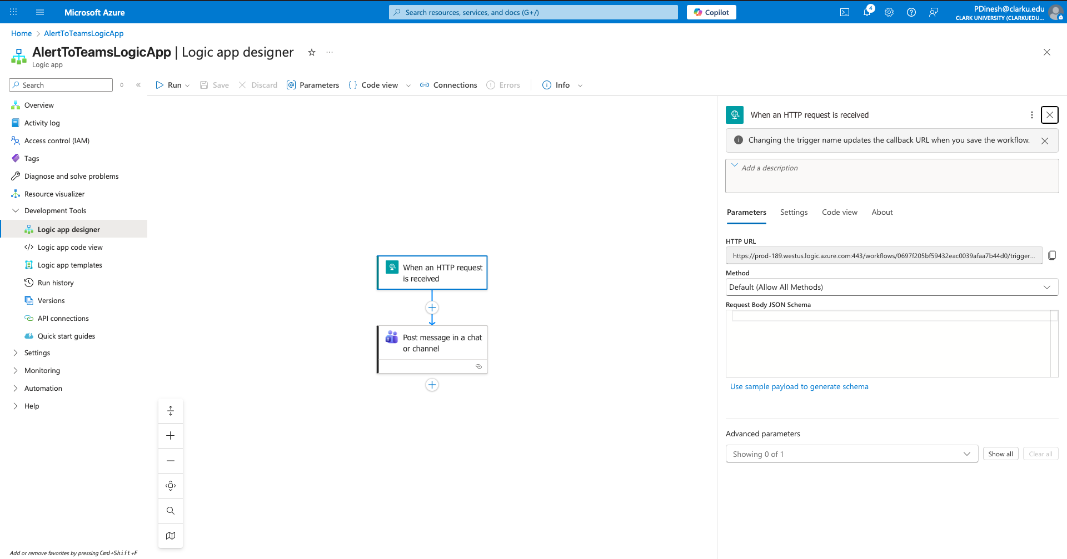
HTTP POST URL:

https://prod189.westus.logic.azure.com:443/workflows/0697f205bf59432eac0039afaa7b44d0/triggers/When_an_HTTP_request_is_received/paths/invoke?api-version=2016-10-01&sp=%2Ftriggers%2FWhen_an_HTTP_request_is_received%2Frun&sv=1.0&sig=AL2G_514onKSw_fr-LmcVMVLCVLniYf61LhQk_poSLE

Create Action Group that invokes Logic App
Created Action Group AlertToTeamsAG with Logic App action PostToTeams linked to AlertToTeamsLogicApp successfully.
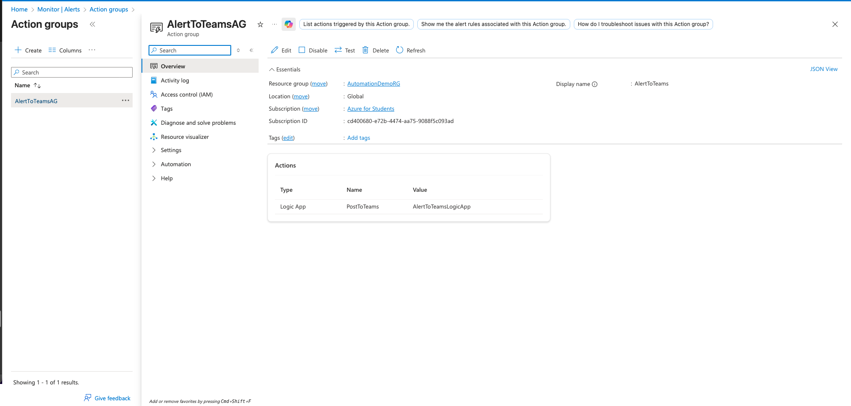

Create metric alert rule
Created alert rule HighNetworkIn-100b-1min on target-vm with Network In Total > 100 bytes over 1 minute, linked to AlertToTeamsAG successfully.
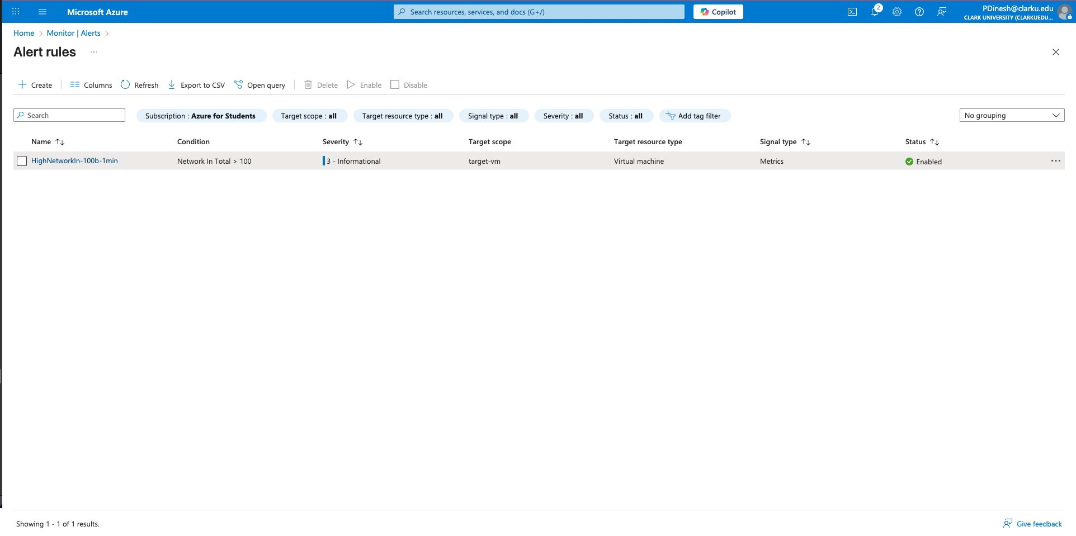

11. Metrics chart screenshot (1-minute Sum, time grain 1 min, Y axis max set to 200 MiB or smaller to show spike). Show the Y max setting on the screenshot.

Metric chart settings to see spikes
Configured Metrics on target-vm with Network In Total (Sum, 1-minute grain), 1-hour range, and manual Y-axis max to visualize the traffic spike successfully.

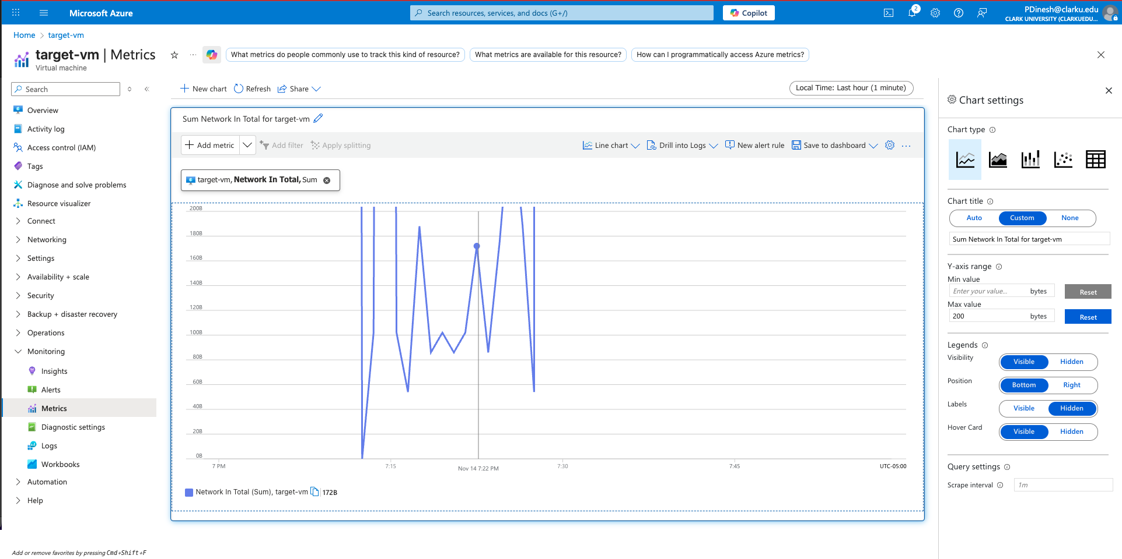

12.Alerts page screenshot showing rule Fired (or Fired + Resolved).

Test end-to-end and evidence collection
1. Metrics Spike Screenshot:
Observed and captured the visible Network In Total spike on target-vm while the iperf3 client was running.
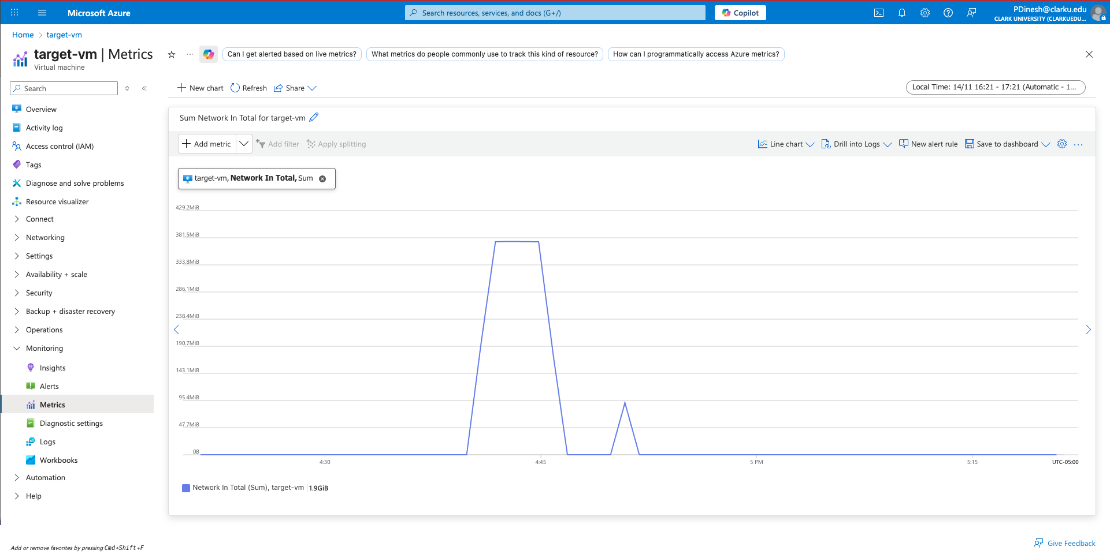
2. Alert Fired Screenshot:
Verified and documented that the HighNetworkIn-100b-1min alert triggered and appeared in the Fired state on target-vm.
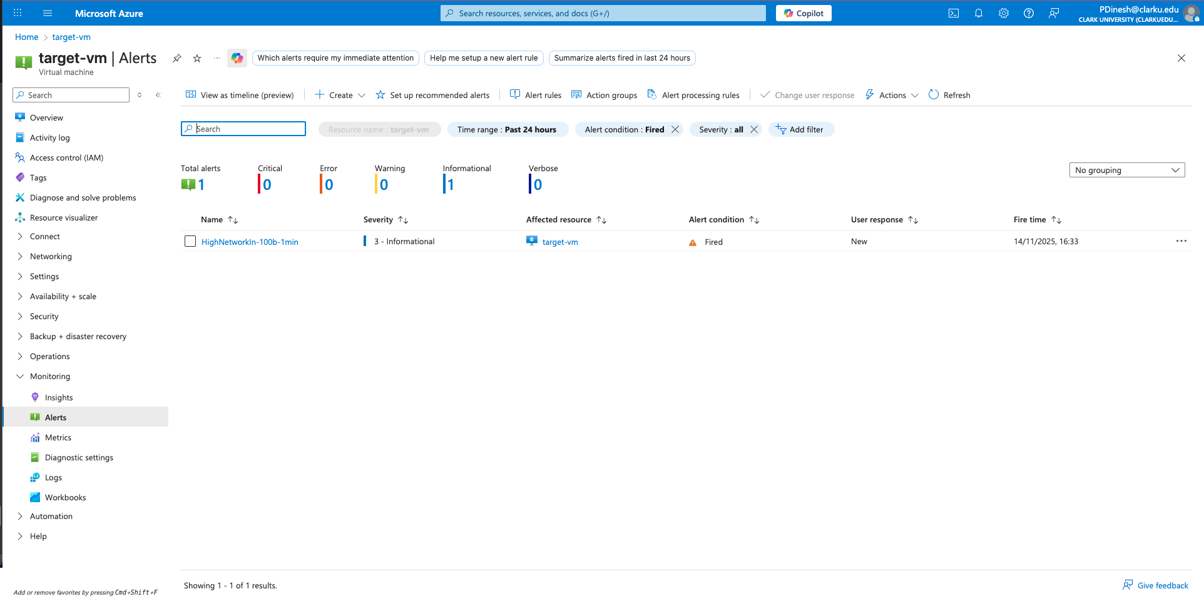

13.Teams screenshot showing the plain-text alert message.

3. Teams Notification Screenshot:

Confirmed that the Teams channel received the alert message ‘ALERT: High network activity detected on target-vm’ and captured the notification.

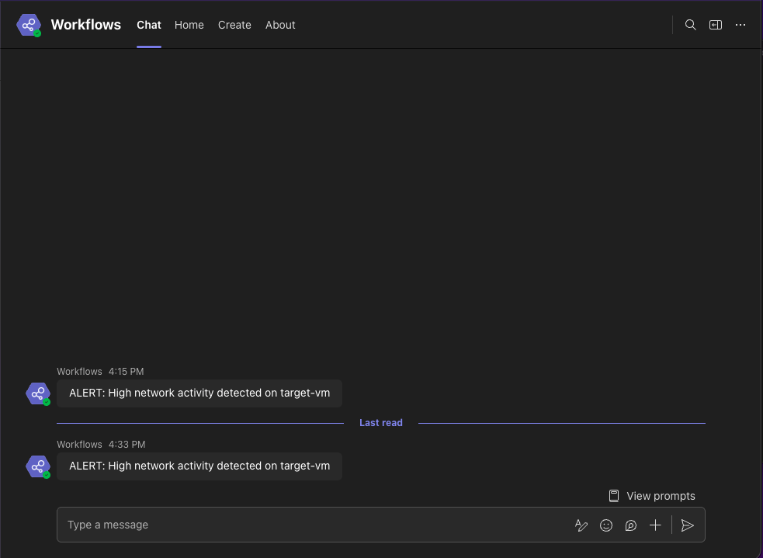

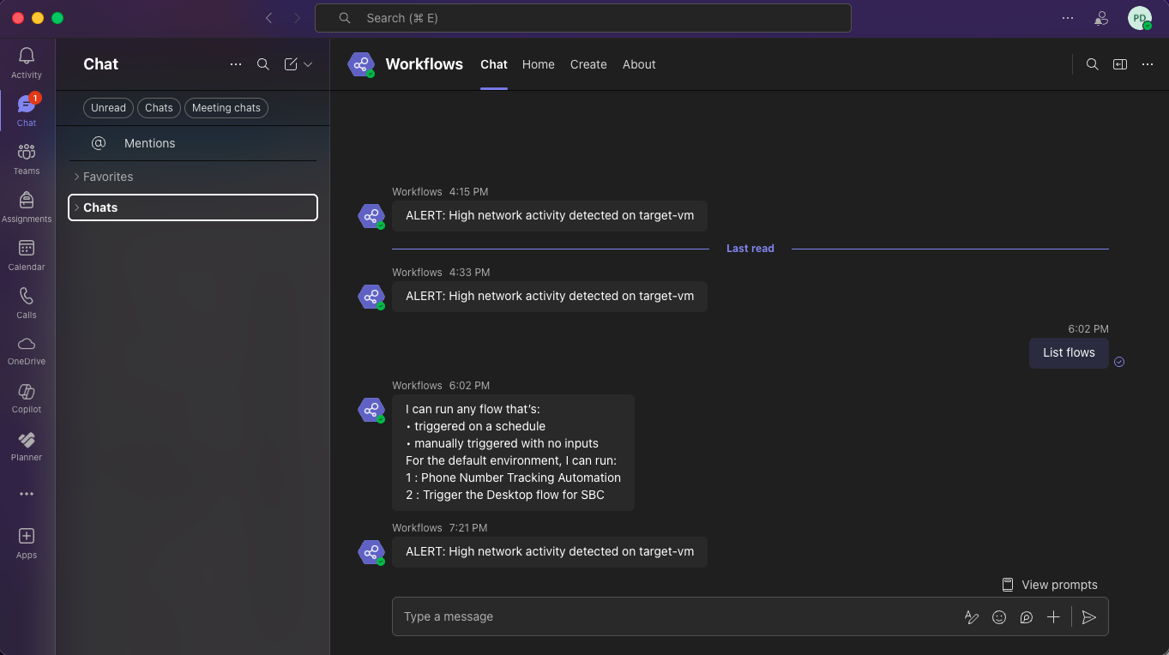

14.Short troubleshooting log (if any).

Troubleshooting checklist
This troubleshooting section was helpful for identifying where issues might occur whether restarting the iperf3 server, correcting metric settings, checking Logic App run failures, or updating the NSG rule for dynamic IP changes and made it clear what the main causes could be.
I confirm that all steps were successfully completed without encountering any issues.

Clean up
Deleted the AutomationDemoRG resource group successfully and captured the deletion confirmation screenshot.

15. Short conclusion
In simple terms, choosing the right metric granularity is important because it makes sure even short bursts of network traffic are seen, so alerts go off when they should and we don’t miss any issues. At the same time, correctly associating the NSG keeps the network secure by letting only the traffic we want like SSH from our computer or iperf3 between VM while blocking everything else. Together, these settings make sure we can monitor the network properly, get alerts on time, and keep communication between resources safe and controlled.

