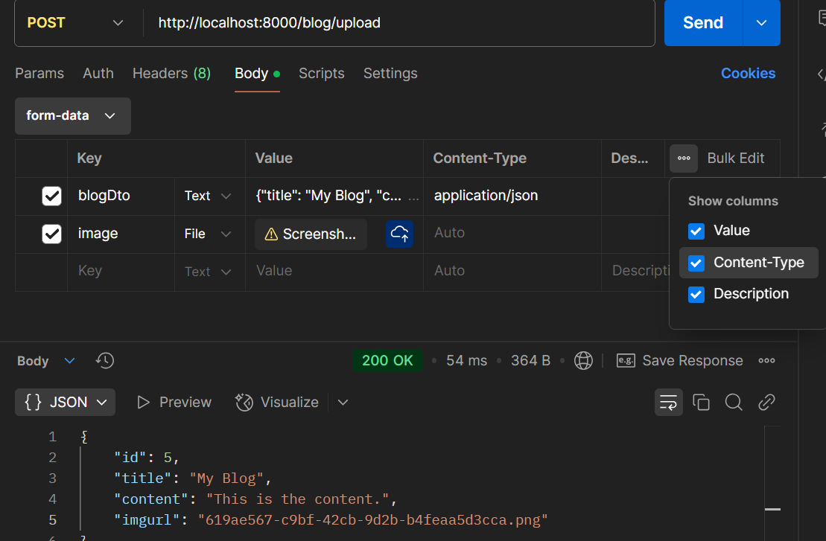

Key must be blog dto

And value must be Jason and contenttype application.json