UseContext

Create a separate file by any name

We need reateContext and passing state is compulsory

As in the image wrap the children with ContextName.Provider value={{ send the states or anything that you wanna pass}}

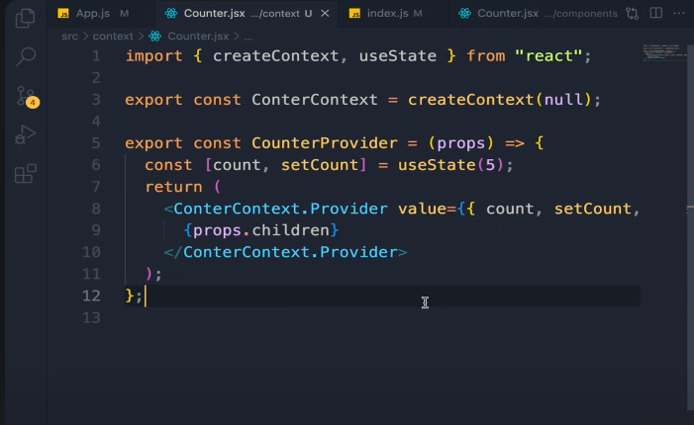



If using vite react

Then wrap the whole app with this CounterProvider not the file name but provider function



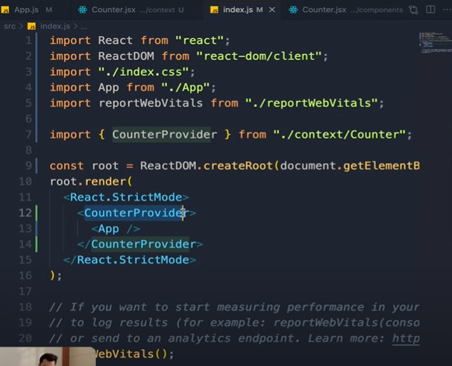



Now use Contextname to get everything from provider,for that you need to import first and u need use context

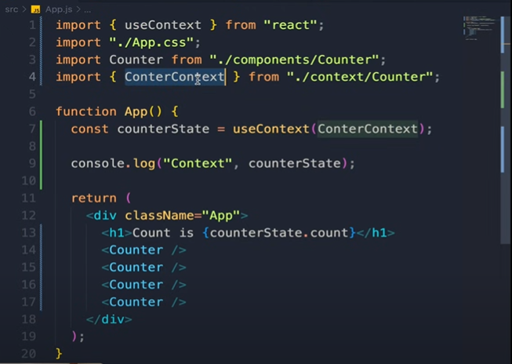



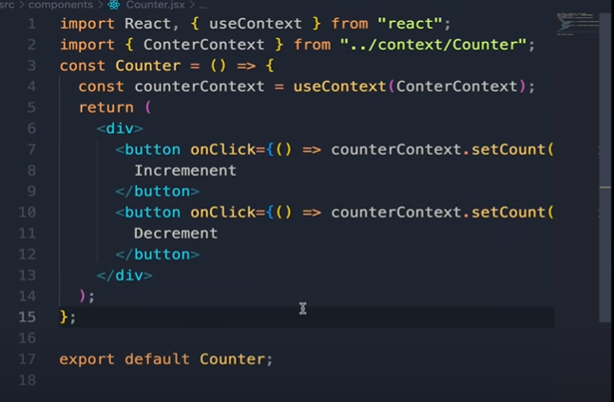



# Custom Context hook(industry standards)

In the main context file,just create your own hook by calling usecontext() and club it,now

You no need import use context again and again in child components

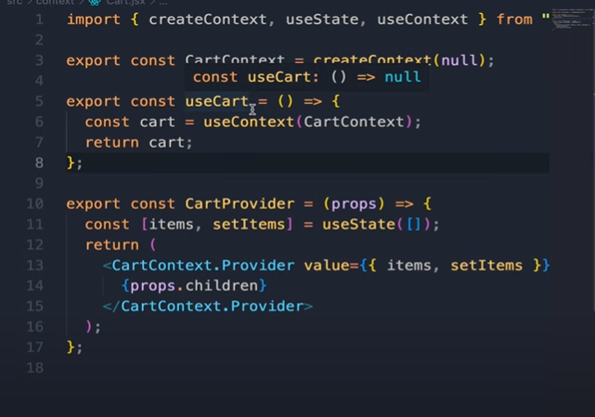



2:now just import that hook directly in child components and use it

