Tansatck query/React query and Devtools

Step 1:For mocking apis fake will create our own

# Install npm i json server to mock the api

We need data for that we need lightweight Jason server

Install it…only for dev purpose and practice

**>npm i json-server**

# Create Database file in the parent directory

Db.json

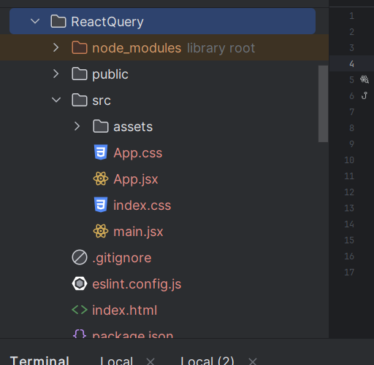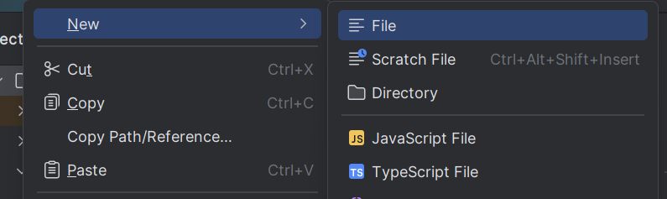



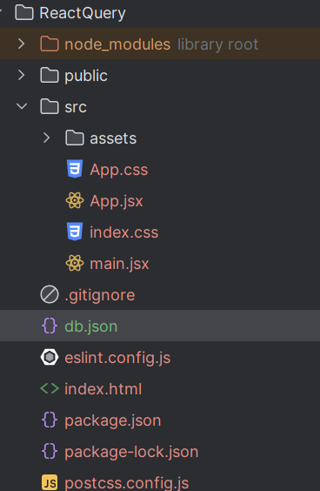



# Add data in db.json

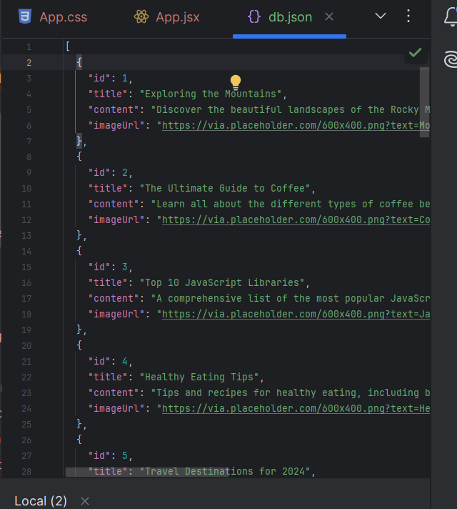

# Setup server to run and it port on package.json

Uder scripts

And yes you can give any port

"server-json": "json-server --watch db.json --port 4000"

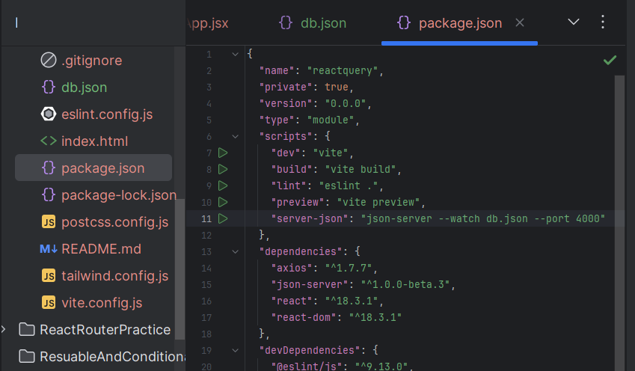



Command to start the server

>npm run server-json

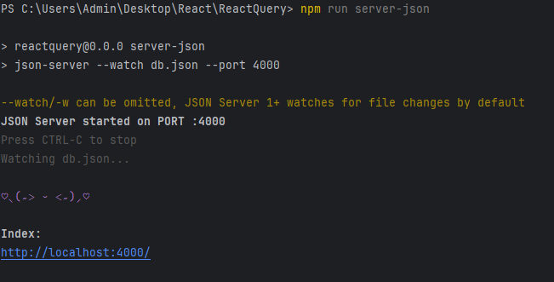



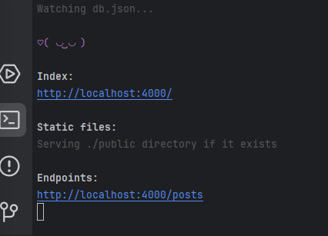



If you click on index link

This also provides docks to do all opertations

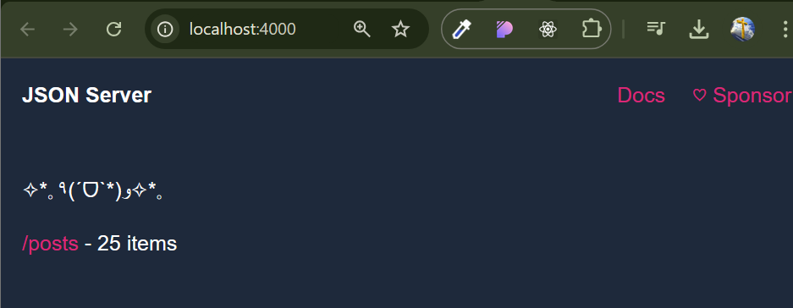



Docks on handling api

* **json-server**

Important

Viewing beta v1 documentation – usable but expect breaking changes. For stable version, see [here](https://github.com/typicode/json-server/tree/v0)

👋 *Hey! Using React, Vue or Astro? Check my new project [MistCSS](https://github.com/typicode/mistcss) to write 50% less code.*

* **Install**

npm install json-server

* **Usage**

Create a db.json or db.json5 file

{

"posts": [

{ "id": "1", "title": "a title", "views": 100 },

{ "id": "2", "title": "another title", "views": 200 }

],

"comments": [

{ "id": "1", "text": "a comment about post 1", "postId": "1" },

{ "id": "2", "text": "another comment about post 1", "postId": "1" }

],

"profile": {

"name": "typicode"

}

}

View db.json5 example

Pass it to JSON Server CLI

$ npx json-server db.json

Get a REST API

$ curl http://localhost:3000/posts/1

{

"id": "1",

"title": "a title",

"views": 100

}

Run json-server --help for a list of options

* **Sponsors ✨**

| **Sponsors** |
| --- |
|  |
|  |

| **Sponsors** |
| --- |
|  |

| **Sponsors** |  |
| --- | --- |
|  |  |
| [Delivery Routing Software and Route Optimization Software](https://route4me.com/) |  |

[Become a sponsor and have your company logo here](https://github.com/users/typicode/sponsorship)

* **Sponsorware**

Note

This project uses the [Fair Source License](https://fair.io/). Only organizations with 3+ users are kindly asked to contribute a small amount through sponsorship [sponsor](https://github.com/sponsors/typicode) for usage. **This license helps keep the project sustainable and healthy, benefiting everyone.**

For more information, FAQs, and the rationale behind this, visit <https://fair.io/>.

* **Routes**

Based on the example db.json, you'll get the following routes:

GET /posts

GET /posts/:id

POST /posts

PUT /posts/:id

PATCH /posts/:id

DELETE /posts/:id

# Same for comments

GET /profile

PUT /profile

PATCH /profile

* **Params**
* **Conditions**
* → ==
* lt → <
* lte → <=
* gt → >
* gte → >=
* ne → !=

GET /posts?views_gt=9000

* **Range**
* start
* end
* limit

GET /posts?_start=10&_end=20

GET /posts?_start=10&_limit=10

* **Paginate**
* page
* per_page (default = 10)

GET /posts?_page=1&_per_page=25

* **Sort**
* _sort=f1,f2

GET /posts?_sort=id,-views

* **Nested and array fields**
* x.y.z...
* x.y.z[i]...

GET /foo?a.b=bar

GET /foo?x.y_lt=100

GET /foo?arr[0]=bar

* **Embed**

GET /posts?_embed=comments

GET /comments?_embed=post

* **Delete**

DELETE /posts/1

DELETE /posts/1?_dependent=comments

* **Serving static files**

If you create a ./public directory, JSON Server will serve its content in addition to the REST API.

You can also add custom directories using -s/--static option.

json-server -s ./static

json-server -s ./static -s ./node_modules

* **Notable differences with v0.17**
* id is always a string and will be generated for you if missing
* use _per_page with _page instead of _limitfor pagination
* use Chrome's Network tab > throtling to delay requests instead of --delay CLI option