**Design or describe a method to convert an input sine wave signal into an output square wave signal**

**Circuit diagram:**

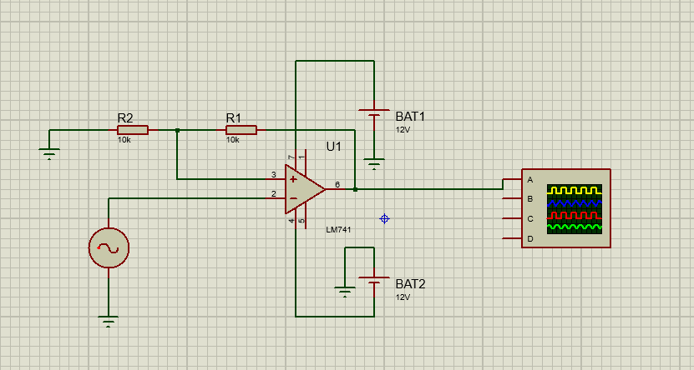

**Fig: Inverting Schmitt trigger**

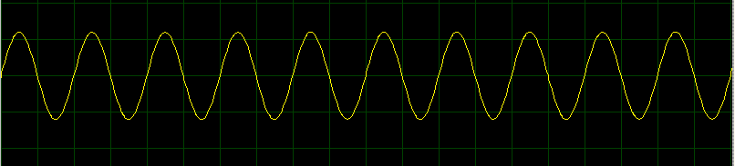

**Fig: Input sine wave :5V, 50Hz**

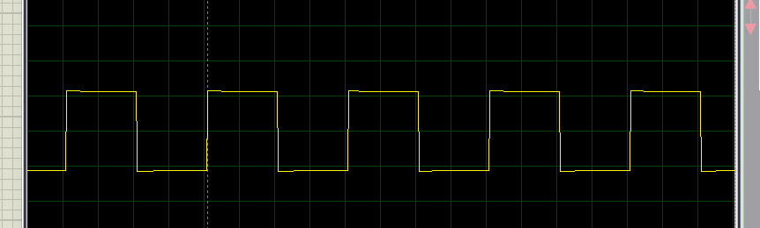

**Fig: Inverting Schmitt trigger output**

**Schmitt trigger:**

Schmitt trigger circuit is a type of comparator circuit with hysteresis. This hysteresis means it has two distinct threshold voltages—upper threshold voltage (VUT) and lower threshold voltage (VLT). The output of the Schmitt trigger changes states only when the input voltage crosses these thresholds, making it highly resistant to noise.

* **Upper Threshold (V_UT)**: The input voltage at which the output switches from low to high.
* **Lower Threshold (V_LT)**: The input voltage at which the output switches from high to low.

**Upper Threshold Voltage (VUT):**

* VUT = (R1 / (R1 + Rf)) Vsat

**Lower Threshold Voltage (VLT):**

* VLT = – (R1 / (R1 + Rf)) Vsat

**Method 2**

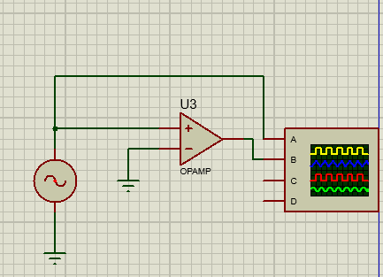

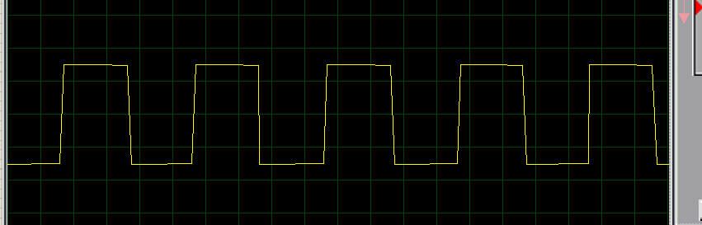

**Fig: output of Method 2**