**Regulators**

**Definition:** A regulator is a device or circuit that maintains a stable output voltage or current, even when the input voltage or load current changes

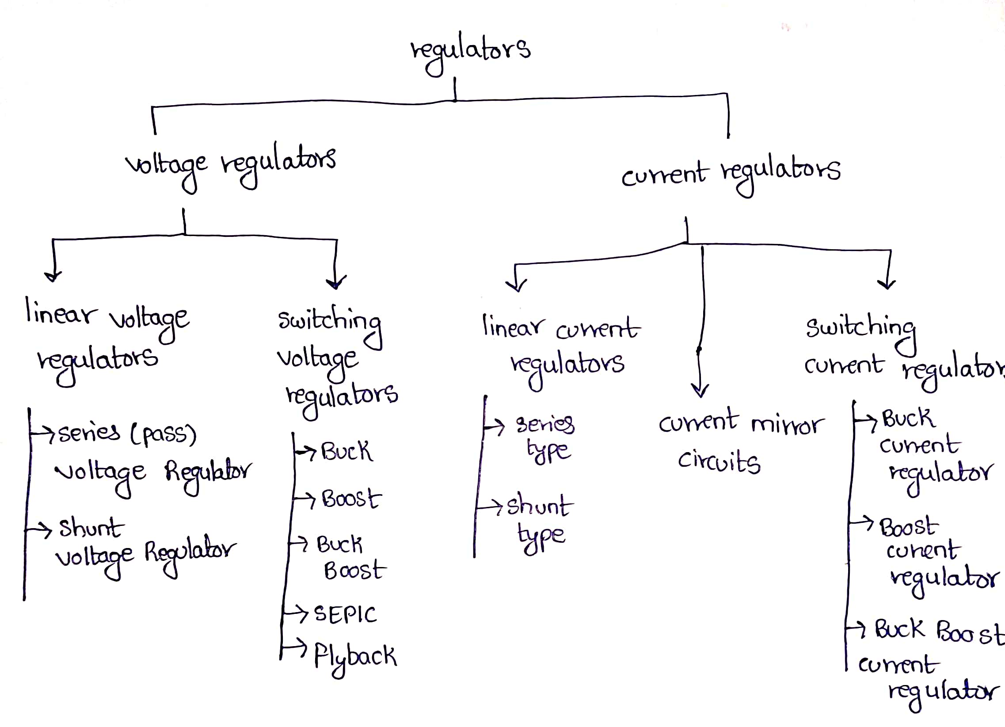

**Linear Voltage Regulator:**

**Series Voltage Regulator:**

It keeps the output Voltage constant by adjusting the resistance of a series pass element placed in series with the load

Pass element (BJT or MOSFET)

Vout = Vz - Vbe

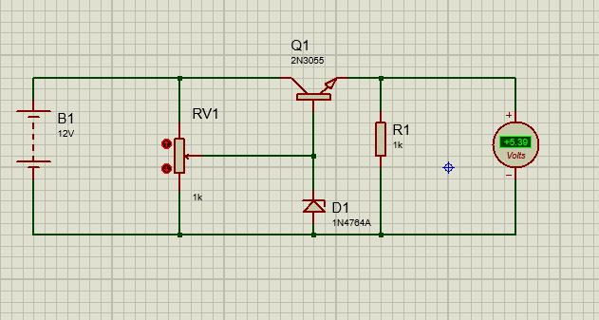

**Shunt Voltage Regulator**

A shunt voltage regulator is a simple type of voltage regulator that maintains a constant output voltage by diverting (shunting) excess current away from the load through a regulating element connected in parallel with the load

If **voltage increases**, the regulator shunts more current to ground to drop the voltage back to normal.

If **voltage decreases**, the regulator shunts less current, allowing more to go to the load.

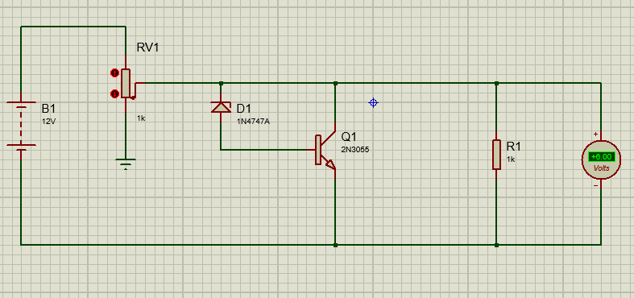

**Switching Voltage Regulator**

Switching regulators are voltage regulators that maintain a constant output voltage by rapidly switching an energy storage element (inductor, capacitor, or transformer) on and off, and then smoothing the output.

**Buck Converter:**

A buck converter works by rapidly switching a transistor on and off, using an inductor and capacitor to smooth the output.

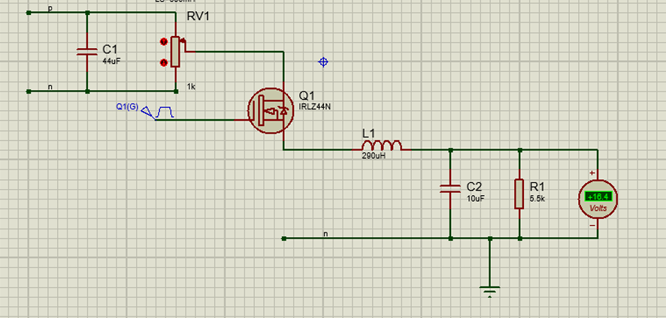

**Boost Converter:**

The boost converter works by storing energy in an inductor when the switch is on, and then releasing it to the load at a higher voltage when the switch is off.

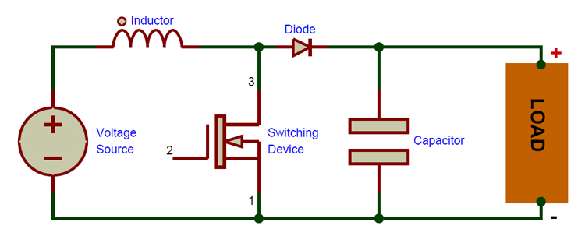

**why switching regulators are generally more efficient than linear regulators.**

Switching regulators are generally more efficient than linear regulators because of how they handle excess energy.

* A linear regulator works like a variable resistor in series with the load.
* It drops the excess voltage as heat.
* A **switching regulator** rapidly turns a transistor **fully ON** (low resistance) or **fully OFF** (no current).
* When fully ON, voltage drop across the transistor is very small → low power loss.
* When fully OFF, no current flows → almost no power loss.
* Energy is stored in an **inductor** or **capacitor** and then transferred to the load, instead of being burned as heat.

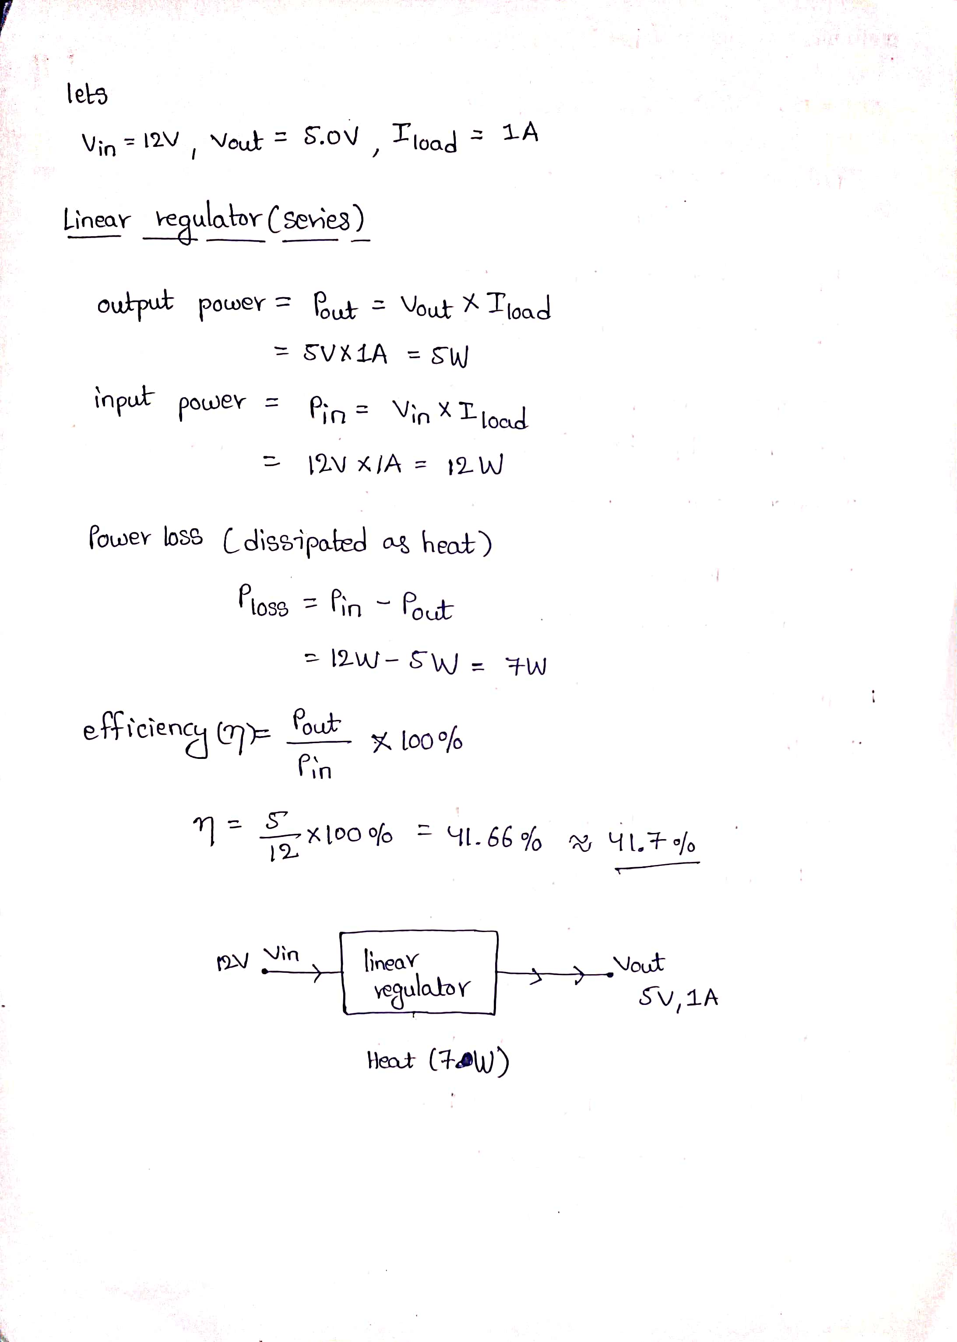

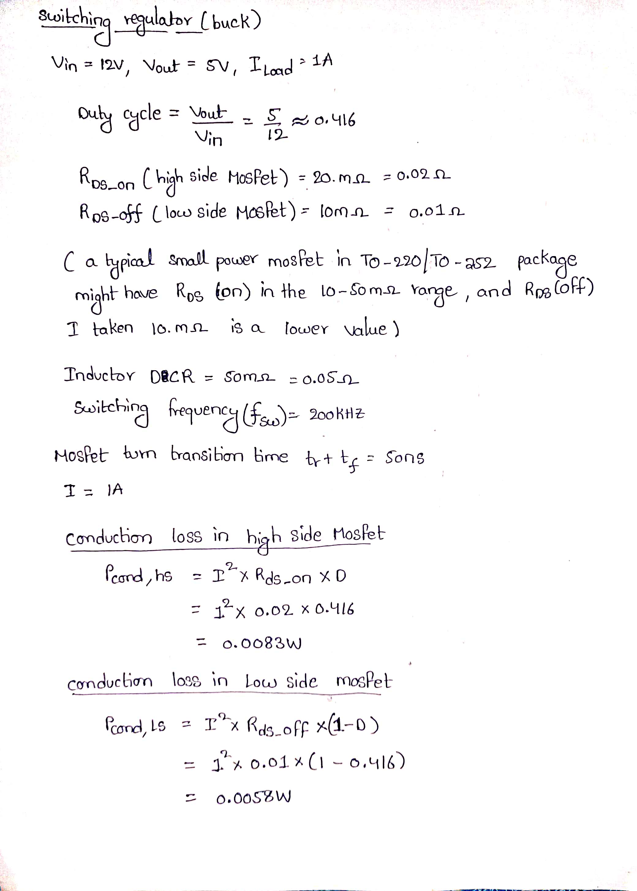

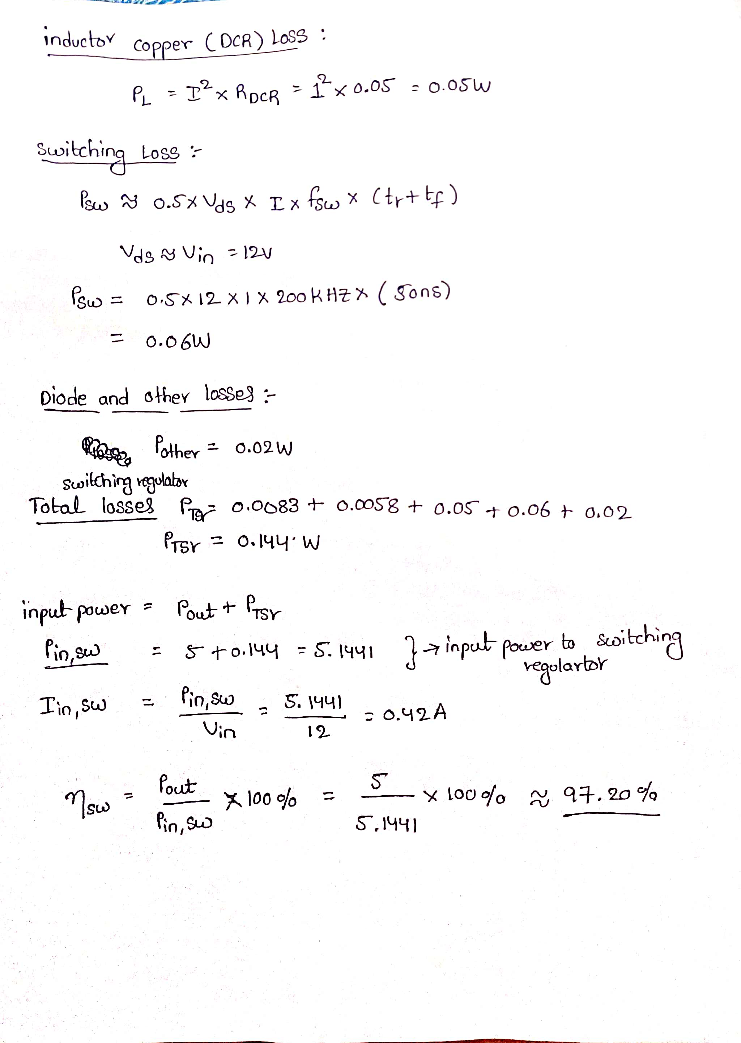

The Switching regulators are very efficient than Linear regulator