**RS-232 Vs RS-422**

**RS-232:**

* RS-232 (Recommended Standard 232) is a serial communication standard defined by EIA (Electronic Industries Association) in the 1960s.
* It’s used for point-to-point communication between Data Terminal Equipment (DTE) and Data Communication Equipment (DCE).

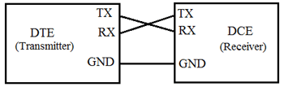

Universal Asynchronous Data Receiver &Transmitter (UART) used in connection with RS232 for transferring data between printer and computer. The microcontrollers are not able to handle such kind of voltage levels, connectors are connected between RS232 signals. These connectors are known as the DB-9 Connector as a serial port and they are of two type’s Male connector (DTE) & Female connector (DCE).

The most commonly used type of serial cable connectors is 9-pin connectors DB9 and 25-pin connector DB-25. Each of them may be a male or female type. Nowadays most of the computers use the DB9 connector for asynchronous data exchange. The maximum length of the RS-232 cable is 50ft.

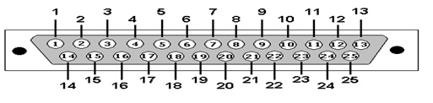

|  |  |
| --- | --- |
| **pin** | **usage** |
| Pin-1  Pin-2  Pin-3  Pin-4  Pin-5  Pin-6  Pin-7  Pin-8  Pin-9  Pin-10  Pin-11  Pin-12  Pin-13  Pin-14  Pin-15  Pin-16  Pin-17  Pin-18  Pin-19  Pin-20  Pin-21  Pin-22  Pin-23 | It is a ground Pin.  Transmit Data.  Receive Data.  Request to send.  Clear to send.  Data Set Ready.  common reference for all signals  received line signal detector carrier detect  DTE serial connector  Test Pin.  standby select.  Data Carrier Detect.  Clear to send.  Transmit data.  Transmit clock.  Receive data  Receive clock.  Test Pin  Request to send.  Data terminal Ready.  Signal Quality Detector  Ring Indicator  Data Signal Rate Detector |

**Interfacing RS232 to Microcontrollers using Max 232:**

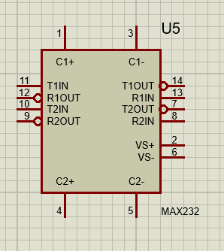

It is used for serial communication by converting TTL/CMOS logic levels (0V–5V) to RS-232 voltage levels (±3V to ±15V) and vice versa.

* Input supply voltage of 5V.
* Input voltage levels compatible with the TTL standard.
* Output voltage levels compatible with RS 232 standard.
* The low input current of 0.1microAmpere and output current of 24mA.

**TTL Logic (microcontroller):**

Logic 0 = 0V, Logic 1 = +5V (or +3.3V in some systems).

**RS232 Standard:**

Logic 0 = +3V to +15V, Logic 1 = -3V to -15V.

**How it Works:**

* External capacitors connected to the IC help generate ±10V internally.
* TTL signals from microcontroller → pass through T1IN/T2IN → converted to RS232 signals at T1OUT/T2OUT.
* RS232 signals from PC → enter via R1IN/R2IN → converted to TTL levels at R1OUT/R2OUT.

**RS-422:**

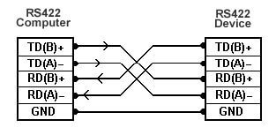

* RS-422 stands for Recommended Standard 422 (officially: *EIA-422*).
* It is a serial communication standard that defines electrical signal levels (not protocols).
* It improves on RS-232 by using differential signalling instead of single-ended, which makes it faster and more noise-resistant, especially over long distances.
* **RS-422** = One driver, multiple receivers (simplex or half-duplex).

**Differential Signalling:**

* Data is sent using a pair of wires (A and B).
* Receiver looks at the voltage difference between the pair, not absolute voltage.
* This cancels out noise picked up equally on both wires (common-mode rejection).

**Voltage Levels:**

* Logic “1” (Mark) = A < B (differential ≈ −2 V to −6 V)
* Logic “0” (Space) = A > B (differential ≈ +2 V to +6 V)
* Noise margin = ±200 mV minimum (receiver threshold).

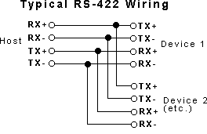

**Circuit-Level Comparison of RS-232 and RS-422 Communication Standards**

**1.Signalling Method:**

**RS-232** 🡪 Single-ended (one wire per signal referenced to ground).

**RS-422** 🡪Differential (two wires per signal, A & B, voltage difference used).

**2.Receiver Type:**

**RS-232** 🡪 Single-ended comparator to ground

**RS-422** 🡪 Differential comparator (measures V(A) − V(B))

**3.Max Cable Length:**

**RS-232** 🡪 approximately 15 m (50 ft).

**RS-422** 🡪approximately 1200 m (4000 ft).

**4.Multi-Driver Support:**

**RS-232** 🡪 No (only one active driver).

**RS-422 🡪** No (only one driver active), but multi-receiver is allowed.

**5.Max Baud Rate:**

* Baud rate = number of symbols per second transmitted.
* The maximum baud rate is the highest reliable speed at which data can be transmitted without errors, given the circuit design, cable, and environment.

**RS-232** 🡪 approximately 20 kbps practical (at short distance).

**RS-422 🡪** Up to 10 Mbps (short distances).

**6.Connector Standard:**

**RS-232** 🡪 Commonly DB9/DB25 connectors.

**RS-422 🡪** No fixed connector; often terminal blocks or RJ45 in industrial use.

**5.Crosstalk Immunity:**

* Crosstalk is unwanted interference caused when a signal transmitted in one wire induces a signal in a nearby wire.
* It happens because of electromagnetic coupling (electric + magnetic fields) between adjacent conductors.
* Example: In a long cable with multiple wires, when one wire carries a fast digital signal, nearby wires may pick up a “ghost” signal.

**Crosstalk Immunity** means the ability of a communication system (circuit or cable) to resist crosstalk and prevent unwanted signal coupling.

|  |
| --- |
|  |

**RS-232** 🡪 Poor (signal wire picks up noise easily).

**RS-422 🡪** Excellent (differential signalling cancels noise).

**6. Termination Resistors:**

A termination resistor is a resistor placed at the end of a transmission line to match the line’s characteristic impedance.

* Purpose: To absorb signal energy and prevent reflections of signals traveling along the line.
* Common in high-speed serial communication (RS-422, RS-485, CAN, Ethernet).
* If the end of the line is left open, the signal bounces back (reflection).
* These reflections can distort the signal, cause ringing, or even be interpreted as false bits.

A termination resistor equal to the characteristic impedance (Z₀) of the cable “absorbs” the signal, preventing reflections.

**RS-232** 🡪 No need for termination resistors

**RS-422 🡪** Requires 120 Ω termination resistor across A & B lines at the receiving end(s).

**7. Slew Rate Control:**

Slew rate control refers to limiting how fast the output signal voltage changes (dV/dt) over time in a communication system, usually measured in V/µs (volts per microsecond).

**RS-232** 🡪 Usually has a natural slew rate limit due to capacitive loading and drivers.

**RS-422 🡪** Many transceivers include slew-rate limited drivers.

**8. EMI susceptibility:**

EMI susceptibility refers to how sensitive an electronic communication system (like RS-232, RS-422, RS-485, or microcontroller circuits) is to external electromagnetic interference (EMI). EMI is unwanted noise generated by sources like switching power supplies, motors, radio transmitters, Wi-Fi devices, or even nearby cables carrying high-frequency signals.

If a system is highly susceptible, the interference can corrupt data, cause communication errors, or even reset devices.

**RS-232** 🡪 Uses single-ended signalling (one signal referenced to ground). It is more susceptible to EMI, especially over long distances.

**RS-422 🡪** Use differential signalling. This provides excellent EMI immunity because external noise tends to affect both wires equally, and the receiver only cares about the difference.

**9. Cable Capacitance Effect:**

Every cable act like a distributed capacitor due to the conductor and shielding/ground separated by insulation (dielectric).

50–100 pF/m (picofarads per meter) for twisted pair cables.

**RS-232** 🡪 More affected by cable capacitance because it uses single-ended signals with relatively weak drivers.

**RS-422 🡪** Less affected because they use differential signalling and stronger drivers.

**10.Error Rate in Noisy Environment:**

**RS-232🡪** High BER

**RS-422🡪** Low BER due to differential noise rejection

|  |
| --- |
|  |

**11.Hot-Swap Support:**

Hot-Swap Support refers to the ability of a device to connect or disconnect from a communication bus while the system is powered on, without causing errors, data corruption, or hardware damage.

Hot-swap support means you can plug or unplug a device while the power is on and the communication link is active.

The interface remains stable, and no reset or reboot of the system is required.

**RS-232🡪** Limited hot-swap ability. Connecting/disconnecting while active can cause glitches, but many modern ICs add protection.

**RS-422🡪** Designed with multi-drop bus structures and biasing, so hot-swap is more practical.

**12.ESD Susceptibility:**

* ESD (Electrostatic Discharge) occurs when a sudden flow of electricity is released between two electrically charged objects.
* In communication systems, this can happen when someone touches a connector pin or plugs/unplugs a cable.
* ESD Susceptibility means how vulnerable a communication standard or IC is to these sudden discharges.

**RS-232🡪** Signal levels are ±12V typically → higher voltage swing. Direct exposure of TX/RX pins to connectors increases susceptibility

**RS-422🡪** Signal levels are ±2V to ±6V. Differential pair reduces the likelihood of ESD-induced bit errors