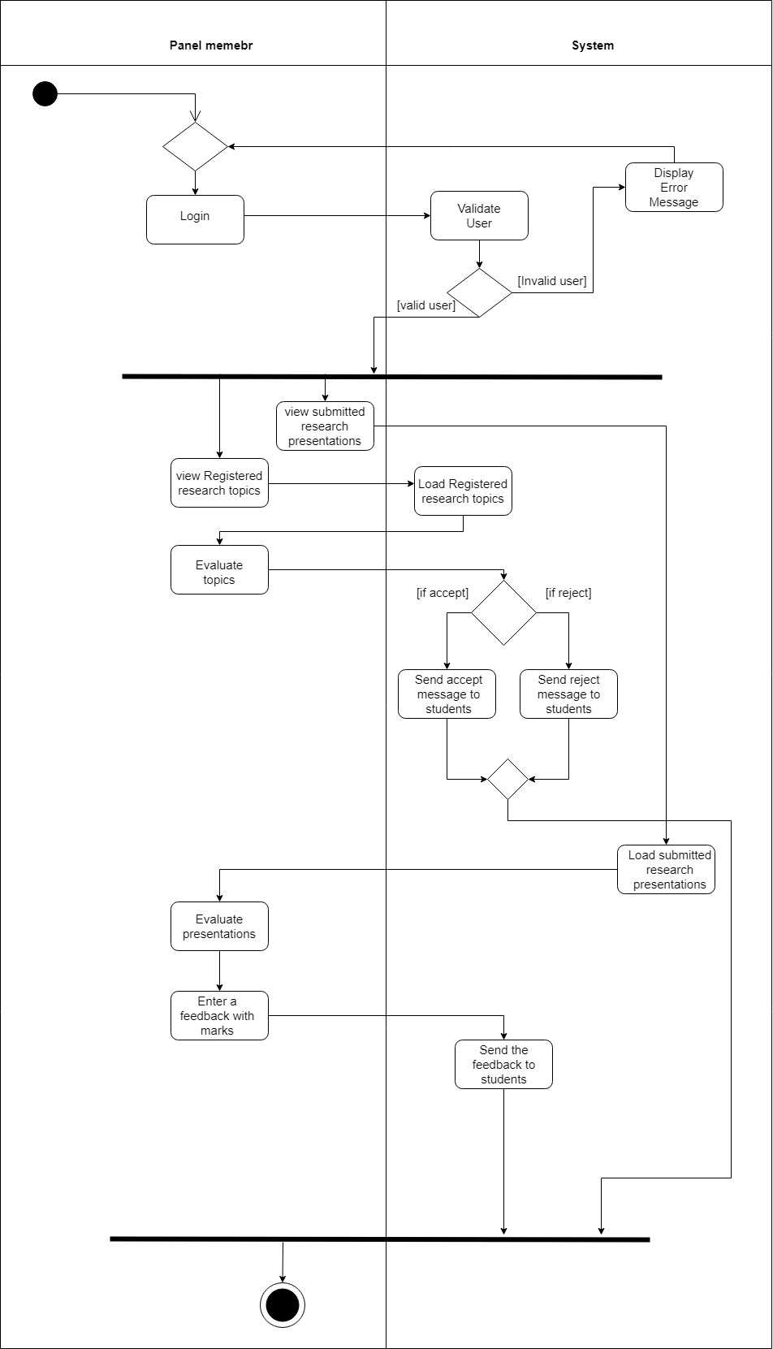

|  |  |
| --- | --- |
| Scenario number | 3 |
| Scenario name | Evaluate research topics. |
| Primary actor | Panel member |
| Pre-condition | 1. Panel member should already log in to the system |
| Main success scenario | 1. Panel member should navigate to the submitted research topics section.  2. System loads the submitted research topics.  3. Panel member evaluate research topics.  4. Panel member can accept a research topic.  5. System sends accept message to students. |
| Extensions | 4.A. Panel member can reject a research topic.  4.A.1. System sends accept message to students. |

|  |  |
| --- | --- |
| Scenario number | 4 |
| Scenario name | Evaluates research presentations. |
| Primary actor | Panel member |
| Pre-condition | 1. Panel member should already log in to the system |
| Main success scenario | 1. Panel member should navigate to the submitted research presentations section.  2. System loads the submitted research presentations.  3. Panel member evaluates research presentations.  4. Panel member enters feedback with marks.  5. System sends the feedback to the students. |
| assumptions | 1.In this system Students can pre-record their presentation and they can upload it into the system. |

Using this system supervisors / Co-supervisors can accept registered research topics, chat with the groups, and evaluate research documents submitted by groups using the provided marking scheme. Once the supervisor login into the system he or she can navigate to the registered research topic section. There supervisor can see the research topics that were previously submitted into the system by groups. Here supervisor can select one of these topics and accept or reject it. If the supervisor accepts the topic, then the system will send an accept message to that group. If the supervisor rejects the topic, then the system will send a reject message to that group. Also, supervisor can evaluate the submitted research documents. For that supervisor must navigate to the submitted research documents section. There supervisor can find the submitted research documents. Supervisor can pick one and evaluate it. After evaluating the document, the supervisor can give feedback with the marks for that document. Also, supervisors can chat with groups through the chat window provided by the system.