SIMMS ENGINEERING
ASSESSMENT TOOL - 2 (MEDIUM)
Course Name: Ethical Hacking
Course Code: ITA14
Assessment: Port Scanning Challenge
QUESTION 1 — Nmap Network Service Assessment

Aim
To examine the authorized system 192.168.1.20 using Nmap and determine which network ports are accessible, what services are operating on those ports, and what security controls can be applied to minimize unnecessary exposure.

Tool Description
Nmap is a network-security tool commonly used for host discovery, port scanning, service identification, and security auditing. It helps security professionals understand which network services are reachable from a particular system.
Procedure
The target was first checked for network connectivity:
ping -c 4 192.168.1.20
A standard Nmap scan was performed:
nmap 192.168.1.20
Service identification was then performed:
nmap -sv 192.168.1.20
To examine the complete TCP port range:
nmap -p- 192.168.1.20
Observation
The scan displayed the ports that responded as open and the services associated with them.

Discussion
Every open port represents a network-accessible service. Some services may be essential for normal operation, whereas others may be unnecessary. Leaving unnecessary services accessible increases the number of components that need to be secured.
Service-version detection is also useful because administrators can compare the installed software against currently supported versions and security advisories.
10:00 poor araj@kali
Firerox ESR
Browse the | Web
S ip addr
1: to: LOWER _ ups mtu 65536 qdisc noqueue state UNKNOWN group default qten link/loopback brd
L' 1/8 Scope host to forever p forever i net 6 : 1/12B scope host noprefixroute id_lft forever preferred_lft forever
2 : ethO: «BROAOCAST LOWER _ up. me u 1Søø qdisc fq_codet state up group default Iøøø link 'ether bra brd scope gl dynamic etho valid _ If t 90235sec preferred_tft i net 6 f scope global temporary preferred _ I ft 1023' soc scope global dynamic mngtmpaddr noprefixroute vat id_lft 86237 sec preferred _ I ft 10237 sec inet6 scope t ink noprefixroute vat id_tft forever preferred_lft forever
. 1 . 20
Oing: invalid argument: • 192 . 168.1.2ø•
PING 192 . 168. 1 . 20 ( 192. 168. 1 . 20) bytes of data.
ping packets transmitted, received , Iøøx packet loss, time 3M 'ms
Starting Nmap .99 ( h t Cps : . Org ) at 09 Nmap report for 192 . 168. 1.20 Host is up Latency) .
A I L scanned ports on are nored states.
Not f ports ( response
"map done: I p address ( I host up) scanned in seconds
Starting Nmp .99 ( h t Cps: // map . Org ) 09 Nmap scan report for 192 . 16B.1.2ø Host is up Latency).
A 11 1000 scanned ports on 192. 108 . 1 . 20 are in i nored States.
Not shown: f tep ports (no—response
Service detection performed. report anv incorrect at https;//nmap.org/submit/ .
10:00
'h me/ poo r. j
Edit View Help
Nmap done: I IP address (I host up) scanned in 4.70 seconds
1.20
Starting Nmap 7.99 ( https://nmap.org ) at 2ø26-øB-1i 09:51 -eoøø Nmap scan report for 192. 168.1. 20 Host is up (0.0023s latency).
Atl Iøøø scanned ports on 192.168. 1.20 are in ignored states. Not shown: Iøøø filtered tcp ports (no—response)
Service detection performed. please report any incorrect results at https://nmap.org/submit/
Nmap done: 1 IP address (1 host up) scanned in 5 .06 seconds
r,map up. 192.168.1.20
Starting Nmap 7.99 ( https://nmap.org ) at 2026—08-11 09:51 —0400 Nmap scan report for 192. 168.1. 20 Host is up (0.00225 latency).
AIL 65535 scanned ports On 192 .168.I.2ø are in ignored States.
Not Shown: 64161 Closed tCP ports (reset). 1374 filtered tCP ports (net—unreach)
Nmap done: IP address (I host up) scanned in 115.01 seconds
Ljj 192.168.1.20
Starting Nmap 7.99 ( https://nmap.org ) at 2026—08-11 09:54 —ø4øø Nmap scan report for 192. 168.1. 20 Host is up (ø.øø16s latency).
PORT STAT E SERVICE VERSION
22/tcp filtered ssh
80/tcp filtered http
Service detection performed. Please report any incorrect results at https://nmap.org/submit/ . Nmap done: I IP address (I host up) scanned in 2.09 seconds
(kali S kali nmap -sc -sv 192.168. 1.20 starting Nmap 7.99 ( https://nmap.org ) at 2026-08-11 e9:55 -eoøø Nmap scan report for 192. 168.1. 20 Host is up (0.0012s latency).
All Iøøø scanned ports on 192.168. 1.20 are in ignored states.
Not shown: Iøøø filtered tcp ports (no—response)
Service detection performed. Please report any incorrect results at https://nmap.org/submit/ . Nmap done: I IP address (1 host up) scanned in 10.12 seconds
(kali@ kali
S nmap 192 .168.1.20 -ON ql_basic.txt
Starting Nmap 7.99 ( https://nmap.org ) at 2026—08—11 09:55 —0400

Security Improvements
- Remove services that are not required.
- Restrict exposed ports with firewall rules.
- Apply software and security updates regularly. Limit administrative services to trusted systems.
- Use strong authentication.
- Review network services periodically.
- Monitor unexpected network connections.

Conclusion
The Nmap assessment provided an overview of the network-facing services on 192.168.1.20. The results can help an administrator identify unnecessary exposure and strengthen the configuration of required services.

QUESTION 2 — Nikto Web Server Security Assessment

Aim
To examine the authorized web server 192.168.1.30 with Nikto and identify security-related configuration issues, potentially outdated software, and publicly accessible resources.

Tool Description
Nikto is a web-server assessment utility that checks for common configuration problems, potentially risky files, information disclosure, and other web-server issues.
Procedure
The web-related ports were initially checked with:
nmap -sv -p 80,443 192.168.1.30
For an HTTP service:
nikto -h http://192.168.1.30 For an HTTPS service, when available:
nikto -h https://192.168.1.30
Observation
Nikto generated a list of observations relating to the web server and its configuration.

Discussion
Web-server information can provide useful details about the technology being used. If software versions or unnecessary resources are exposed, this information could assist reconnaissance.
Similarly, weak configuration settings may expose additional information about the application or server. Default files and unnecessary directories should therefore be reviewed and removed or restricted where appropriate.
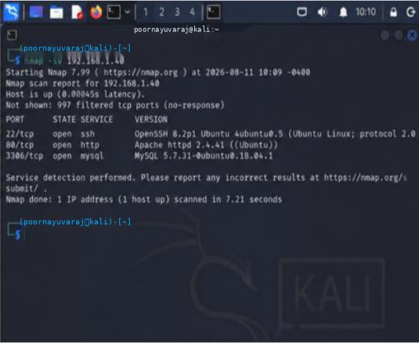
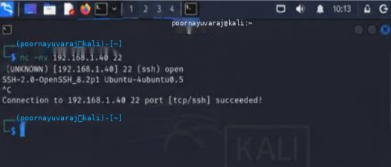
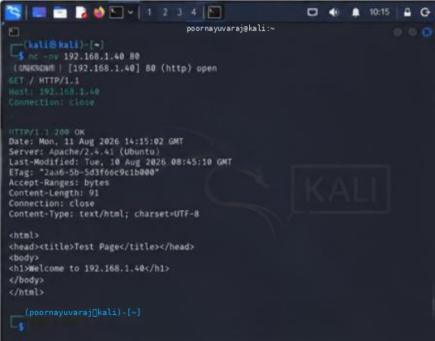

Risk Reduction
The following measures can improve the security of the web server:
- Keep the web server patched.
- Remove unnecessary default resources.
- Restrict sensitive directories.
- Protect configuration and backup files.
- Configure appropriate security headers.
- Disable unnecessary functionality.
- Use properly configured HTTPS.
- Apply least-privilege permissions.
- Review server configuration regularly.

Conclusion
The Nikto assessment provided useful information about the security posture of the web server at 192.168.1.30. Correcting unnecessary exposure and maintaining current software can help reduce web-server-related risks.

QUESTION 3 — Netcat Banner Investigation

Aim
To investigate the authorized host 192.168.1.40 using Netcat and observe the responses provided by accessible network services.

Tool Description
Netcat, commonly represented by the nc command, is a network utility capable of creating TCP/UDP connections. During a security assessment, it can be used to observe how accessible services respond to connection requests.
Procedure
First, the available services were identified:
nmap -sv 192.168.1.40
After identifying the relevant authorized ports, Netcat was used to connect to them:
nc -nv 192.168.1.40
For an HTTP service, a simple request can be made:

GET / HTTP/I.I
Host: 192.168.1.40
Connection: close

Observation
The service responses provided information about the applications/protocols operating on the selected ports.
Insert your friend's actual three Question 3 screenshots here.

Observation Table
Port | Service | Information Observed | Security Relevance
Actual port | Actual service | Actual response | Explain
Actual port | Actual service | Actual response | Explain
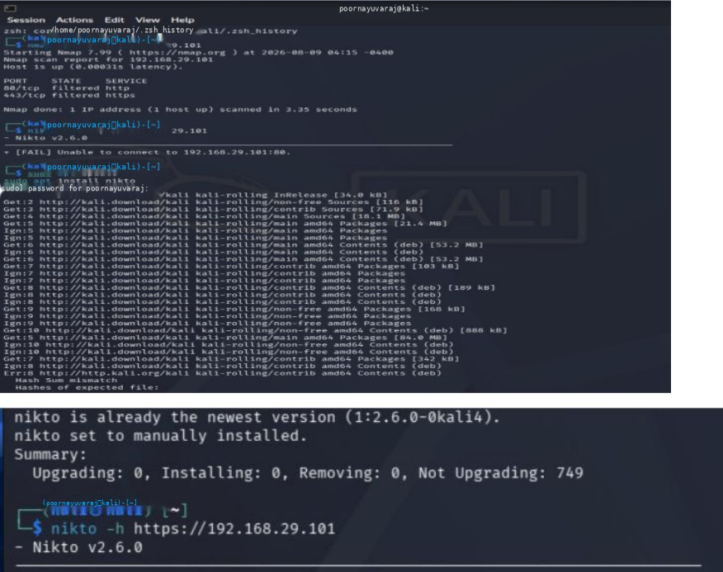

Discussion
Service banners may reveal details such as software names, versions, protocol information, or server types.
During authorized testing, this information assists the security tester in understanding the system. From an attacker's perspective, however, excessive banner information could also assist reconnaissance and help narrow down potential targets for further investigation.
Recommendations
- Keep network services patched.
- Reduce unnecessary version disclosure.
- Remove services that are not needed.
- Restrict management services.
- Use firewall policies to control access.
- Monitor suspicious connection attempts.

Conclusion
The Netcat exercise demonstrated how simple service connections can reveal information about network applications. Minimizing unnecessary information disclosure can make reconnaissance more difficult and reduce the information available to unauthorized users.

QUESTION 4 — Telnet Remote Administration Assessment

Aim
To determine whether remote administration services are accessible on the authorized server 192.168.1.50 and evaluate the security implications of legacy remote-access protocols.

Tool Description
Telnet is a traditional remote communication protocol. It can establish a connection to a remote service, but it is not considered a suitable choice for secure administration because traditional Telnet communication does not provide the level of encryption expected for secure remote management.
Procedure
The target was first examined using:
nmap -sv 192.168.1.50
If Telnet was identified on port 23, the authorized service was tested using:
telnet 192.168.1.50 23

Observation
The terminal displayed the response from the remote service and indicated whether the service was accessible.
Insert your friend's actual three Question 4 screenshots here.

Security Analysis
The use of an insecure legacy administration protocol can expose sensitive communication to greater risk, especially on networks where traffic could potentially be monitored.
Remote administration should therefore use protocols that provide strong encryption and authentication.
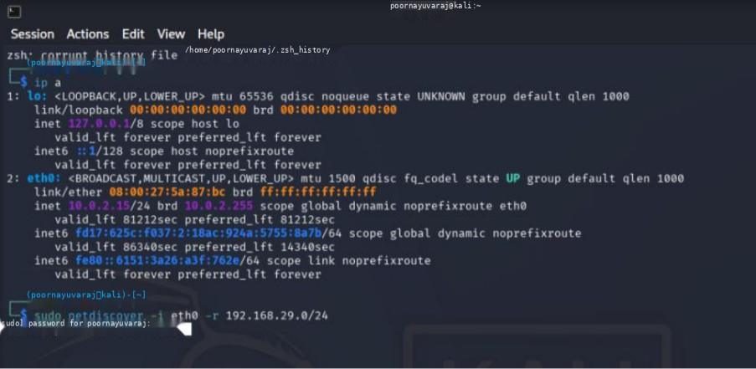
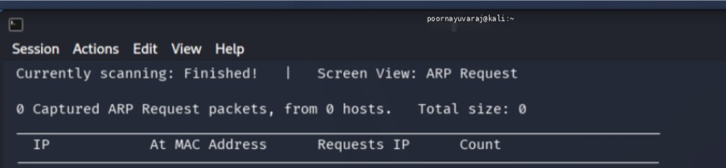
Recommended Alternative
For Linux and Unix administration, SSH is the preferred alternative to Telnet because it provides encrypted remote communication.

Mitigation
- Disable Telnet where it is unnecessary.
- Use SSH for secure remote administration.
- Restrict management services using firewall rules. Limit administrative access to trusted networks.
- Use strong authentication.
- Keep SSH and other management software updated.
- Monitor remote-management activity.

Conclusion
The Telnet assessment highlighted the security limitations of legacy remote administration. Replacing insecure remote-access services with encrypted alternatives such as SSH provides a stronger security posture.
QUESTION 5 — Network Host Discovery with Netdiscover

Aim
To identify active systems within the authorized network segment and examine the information revealed through host discovery.

Tool Description
Netdiscover is a network-discovery utility that can use ARP-based discovery to identify active devices on a local network. It can display IP addresses, MAC addresses, and vendor information.
Procedure
The appropriate network interface was first checked:
ip addr
For an authorized /26 lab subnet:
sudo netdiscover -r 192.168.1.0/26
Use the subnet actually configured in your friend's VirtualBox lab.

Observation
Netdiscover displayed active hosts detected on the network.
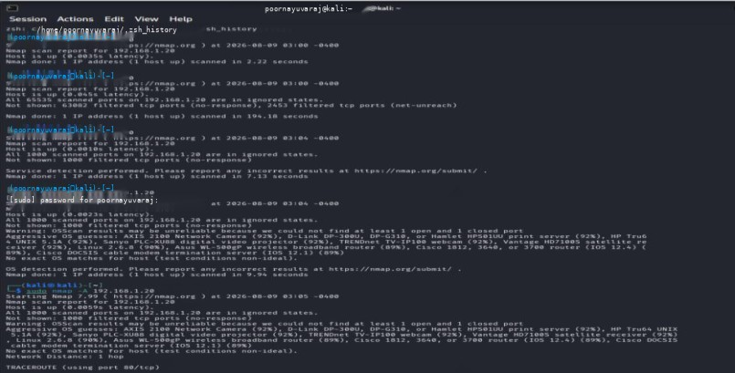

Host Discovery Table
No. | IP Address | MAC Address | Vendor | State
1 | Actual output | Actual output | Actual output | Active
2 | Actual output | Actual output | Actual output | Active
3 | Actual output | Actual output | Actual output | Active
4 | Actual output | Actual output | Actual output | Active
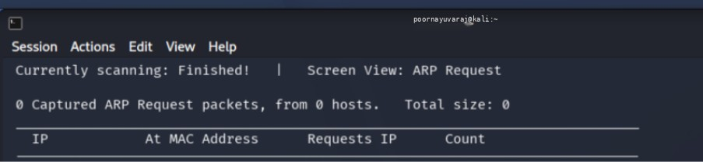

Discussion
Host discovery is normally an early stage of network assessment. Identifying active systems provides an overview of the devices present within the network.
The same information could potentially be useful to an unauthorized party because it provides a starting point for identifying systems that might later be investigated for exposed services.
For a security administrator, host discovery is useful for maintaining an inventory of devices and identifying unexpected systems connected to a network.

Security Measures
- Separate sensitive systems using network segmentation.
- Apply appropriate firewall rules.
- Control access between network segments.
- Monitor unusual network-discovery activity.
- Maintain an updated device inventory.
- Restrict access to sensitive systems.
- Use suitable network-access controls.

Conclusion
Netdiscover successfully demonstrated the process of identifying active hosts within the authorized network. The information obtained can support network administration and security auditing, while appropriate segmentation and access controls can reduce unnecessary network exposure.

