**Task 1.2 (SQL-Oracle)**

**STAGE -1:**

1.**Construct and ER-Diagram for the above-mentioned Requirement:**

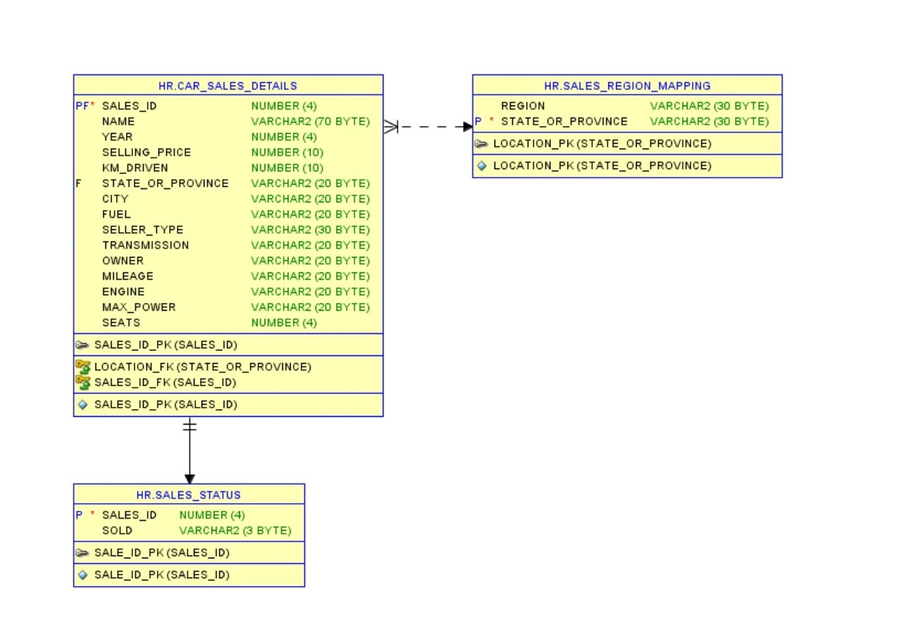

**2**.**Construct Tables as per the ER-Diagram:**

**CREATE DATABASE Cars_Sales;**

**CREATE TABLE CARDATA**

(

SALES_ID  NUMBER(38)

NAME VARCHAR2(128 BYTE)

YEAR NUMBER(38)

SELLING_PRICE NUMBER(38)

KM_DRIVEN NUMBER(38)

STATE_OR_PROVINCE VARCHAR2(26 BYTE)

CITY VARCHAR2(26 BYTE)

FUEL VARCHAR2(26 BYTE)

SELLER_TYPE VARCHAR2(26 BYTE)

TRANSMISSION VARCHAR2(26 BYTE)

OWNER VARCHAR2(26 BYTE)

MILEAGE VARCHAR2(26 BYTE)

ENGINE VARCHAR2(26 BYTE)

MAX_POWER VARCHAR2(26 BYTE)

SEATS NUMBER(38)

PRIMARY KEY (SALES_ID)

FOREIGN KEY (STATE_OR_PROVINCE)

REFERNENCES  STATE(STATE_OR_PROVINCE)

);

**CREATE TABLE SALES**

(

SALES_ID NUMBER(38)

SOLD VARCHAR(26 BYTE)

FOREIGN KEY (SALES_ID)

REFERENCES  CARDATA(SALES_ID)

);

**CREATE TABLE STATEREGION**(

REGION VARCHAR(26 BYTE)

STATE_OR_PROVINCE VARCHAR2(26 BYTE)

PRIMARY KEY (STATE_OR_PROVINCE)

);

**3.Identify the relationships between tables and use appropriate standards for the same where applicable**

The CARDATA table contains all the necessary information about the cars that are to be sold

The SALES table contains the information regarding the sales of the car from the CARDATA table. There is a relationship between SALES_ID in both the tables. There is a one to one relationship between these tables

The STATEREGION table contains the state or province details as well as the region to which the state or province belongs. The STATE_OR_PROVINCE is a primary key in the table. This primary key value is used in the CARDATA table to identify the state or province the car belongs to. There is one to one relationship between these tables.

**4.Insert the appropriate data into the identified tables from the sample dataset provided.**

INSERT INTO CARDATA VALUES(1,  ’Maruti Swift Dzire VDI’,  2014,450000,145500,‘District of Columbia’, ‘Washington’, ‘Diesel’,  ‘Individual’,  ‘Manual’, ‘First Owner’, ‘23.4 kmpl’,  ‘ 1248 CC’ ,’74 bhp’ ,5);

**STEP 1:**

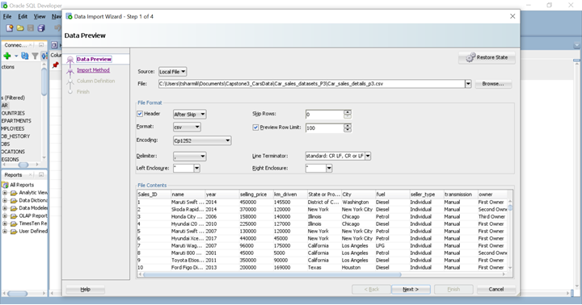

**STEP 2:**

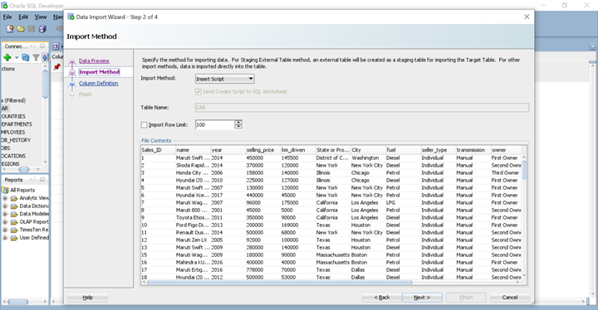

**STEP 3**:

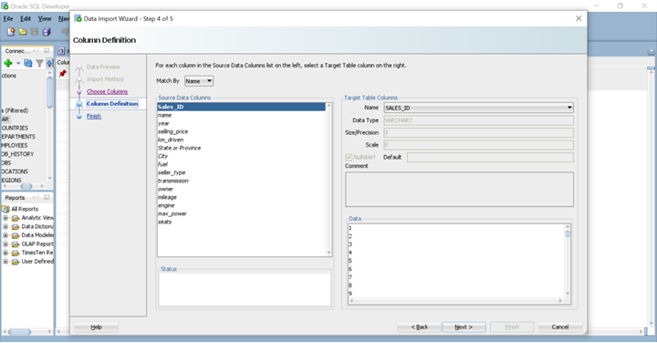

**STEP 4**:

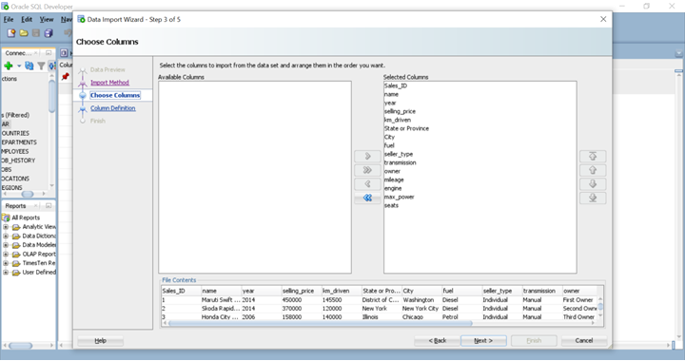

**STEP 5**:

DISPLAYING THE DATA FROM THE CSV FILES INTO THE TABLE.

DISPLAYING VALUES FROM CARDATA TABLE:

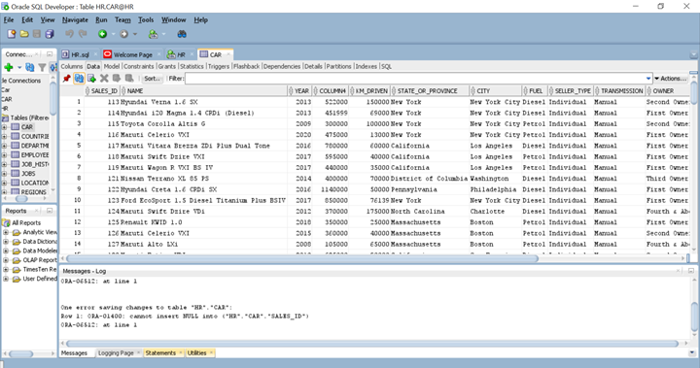

IMPORTING DATA INTO STATEREGION TABLES:

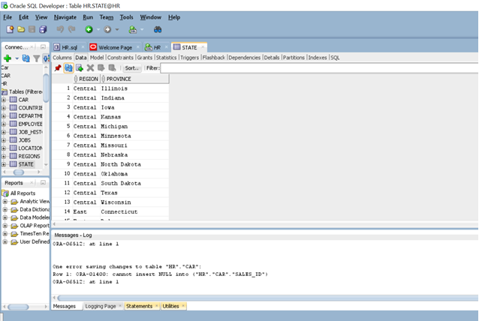

IMPORTING VALUES INTO SALES TABLE:

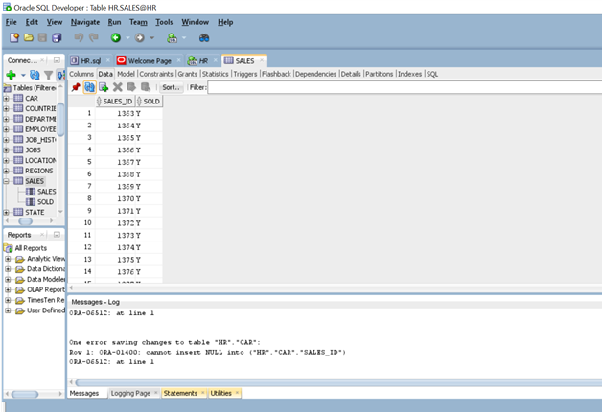

**STAGE -2:**

Generate Info of the cars which is of the type first owner and the year of car purchase is between 2016-2020 and the number of kms driven is less than 80,000

select * from cardata

where  owner='First Owner'

and year in(2016,2017,2018,2019,2020)  #year between 2016 and 2020

and km_driven<80000;

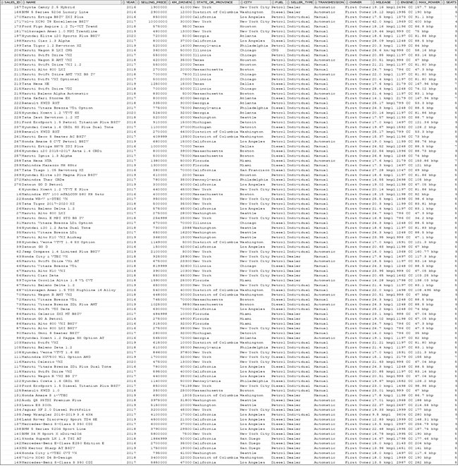

Generate Info of all the cars  whose average mileage is around 25 kmpl and year of car purchase is between 2018-2020 which has minimum seating of 4-5 and fuel type is diesel.

select * from cardata

where mileage between '25 kmpl' and '25.9 kmpl'

and year in(2018,2019,2020)

and seats in(4,5)

and fuel='Diesel';

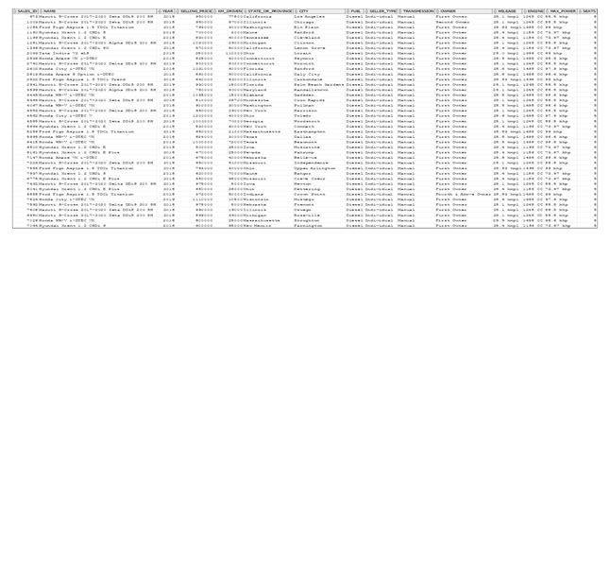

Generate Info of all the cars which are not sold, and seller-type is individual or dealer and also which has been used for less than 60000 kms and year of car purchase is 2014-2020.

select * from cardata

inner join sales

on cardata.sales_id=sales.sales_id

where cardata.seller_type in('Dealer','Individual')

and cardata.year in(2014,2015,2016,2017,2018,2019,2020)

and cardata.km_driven<60000

and sales.sold='N';

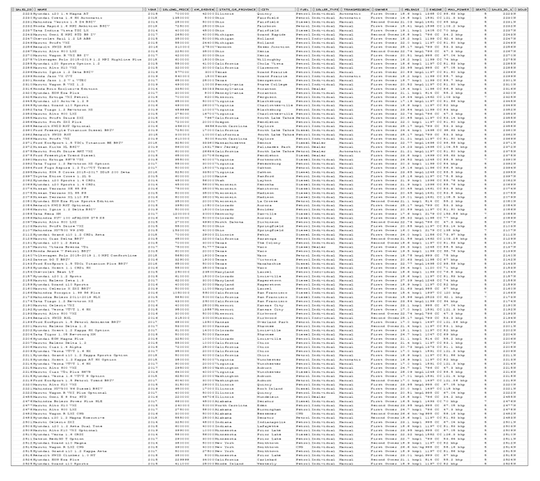

Generate Info of all the cars which are manual and automatic whose mileage ranges between 20-25kmpl approximately and also which is within these cities(Washington, New York City,Chicago,Los Angeles).

select * from cardata

where Transmission in('Automatic','Manual')

and city in('Washington','New York City','Chicago','Los Angeles')

and mileage between '20 kmpl' and '25 kmpl';

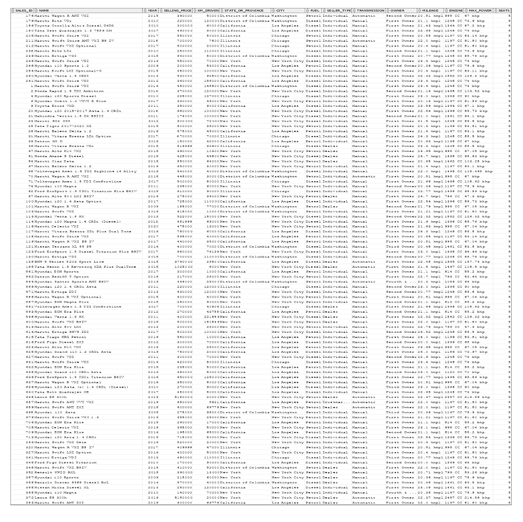

Generate Info of all the  cars  which belong to honda category could be either first owner and second owner and also fuel type is petrol and average mileage should be 25kmpl and which are not sold and and seating arrangement should be minimum 4.

select * from cardata

inner join sales

on cardata.sales_id=sales.sales_id

where cardata.name like'%Honda%'

and cardata.owner in('First Owner','Second Owner')

and cardata.fuel='Petrol'

and cardata.mileage between '25 kmpl' and '25.9 kmpl'

and cardata.seats>=4

and sales.sold='N';

No Records to Display