ARCHITECTURE:

The basic architecture of the project is as shown in the figure below.

- User connects to the server on which the website Traveleria is hosted.
- User gives query by selecting appropriate options as country, city and date.
- The queries are processed in the server by php pages.
- php pages contact webservers (eg virtualtourist.com, besttimetogo.com etc..) to extract required information.
- The extracted information is stored in database for caching.
- The result (webpages and information) is given to the user through interactive user interface using CSS, javascript and HTML.

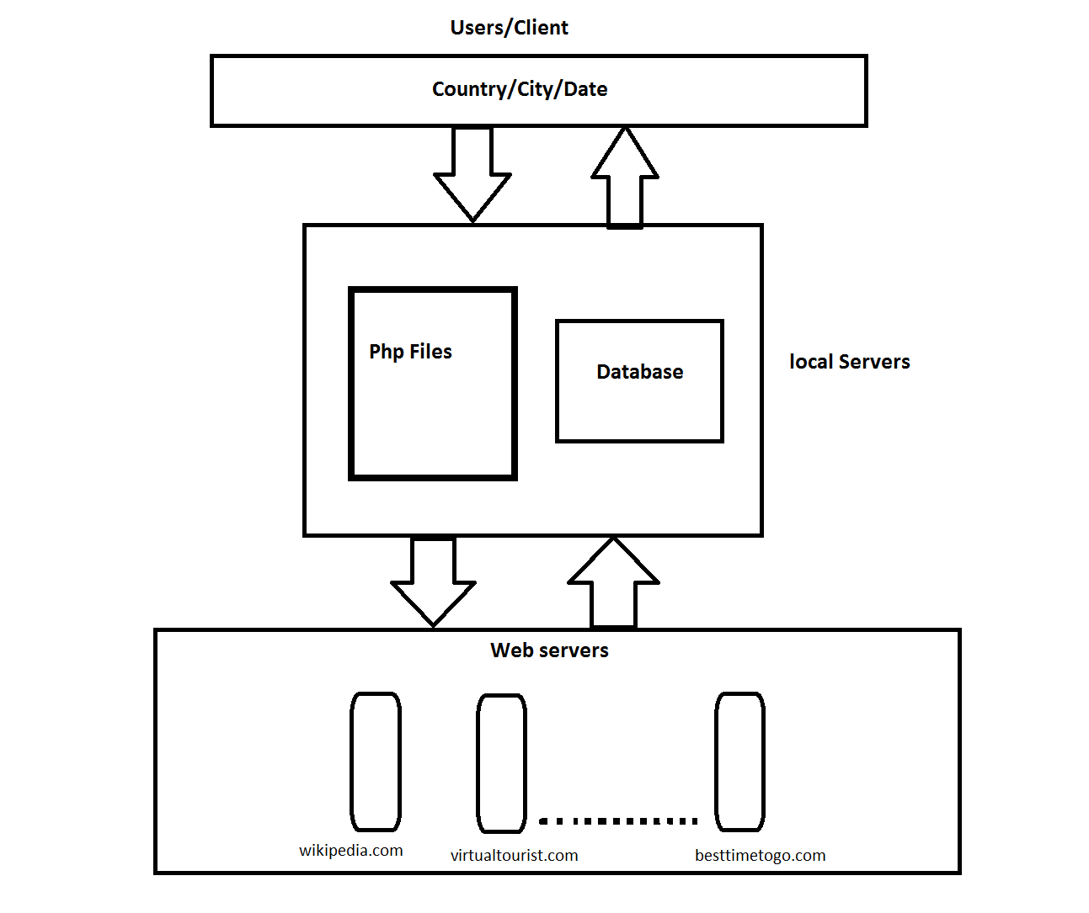

USER INTERFACE:

