Output :
Some of the basic features, which are helpful for travel, that are provided by the website :

- Customs Duty: Customs is an authority or agency in a country that checks the flow of goods including animals, transports, personal effects and hazardous items in and out of a country. This helps users to carry only permitted goods

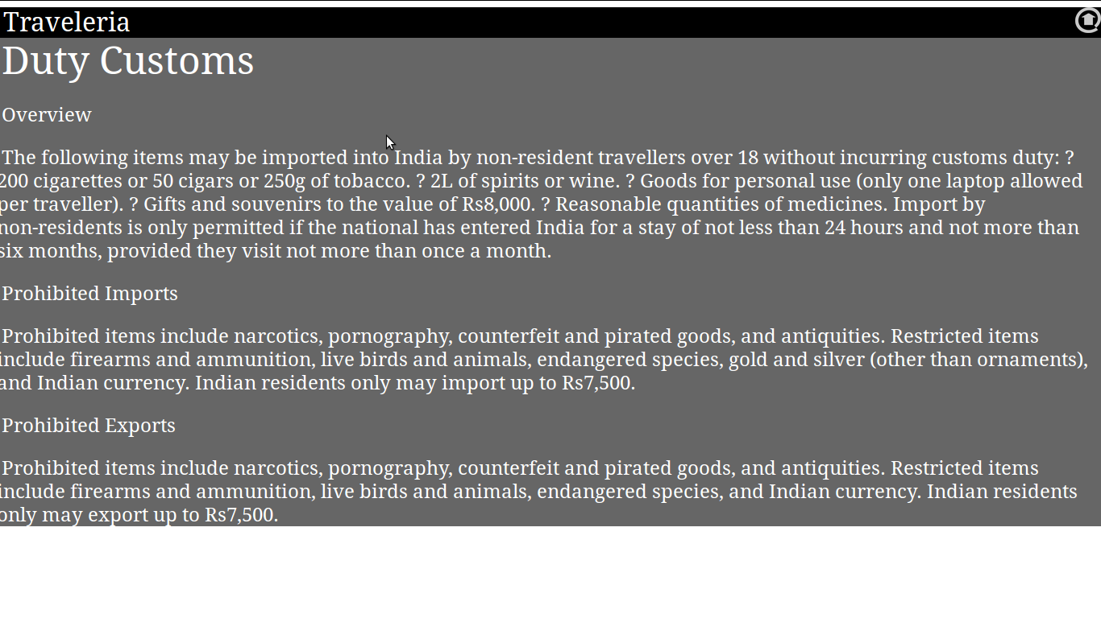

- Tourist Scams: Common scams in a place is given so that the users can avoid such scams

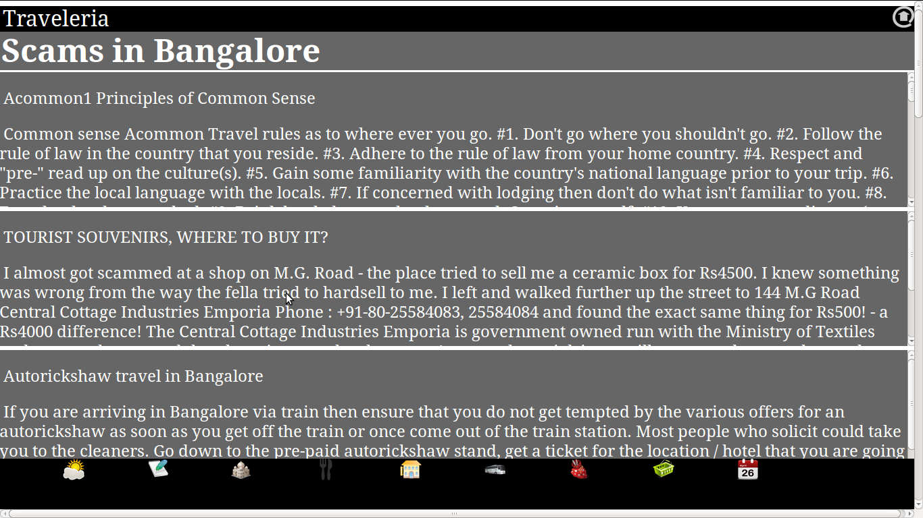

- Restaurants: List of famous local restaurants are given so that the travelers can try local food.

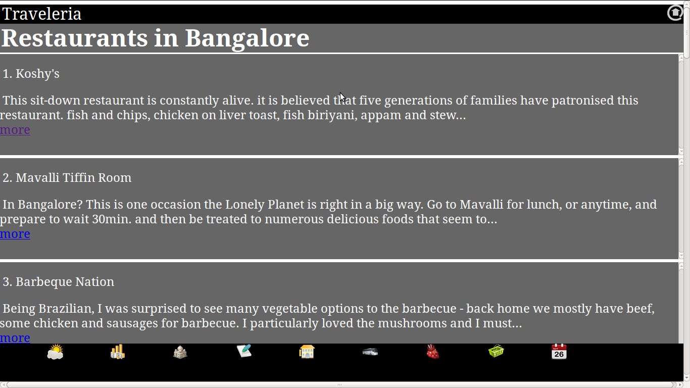

`

- Hotels: List of famous hotels where travelers can stay

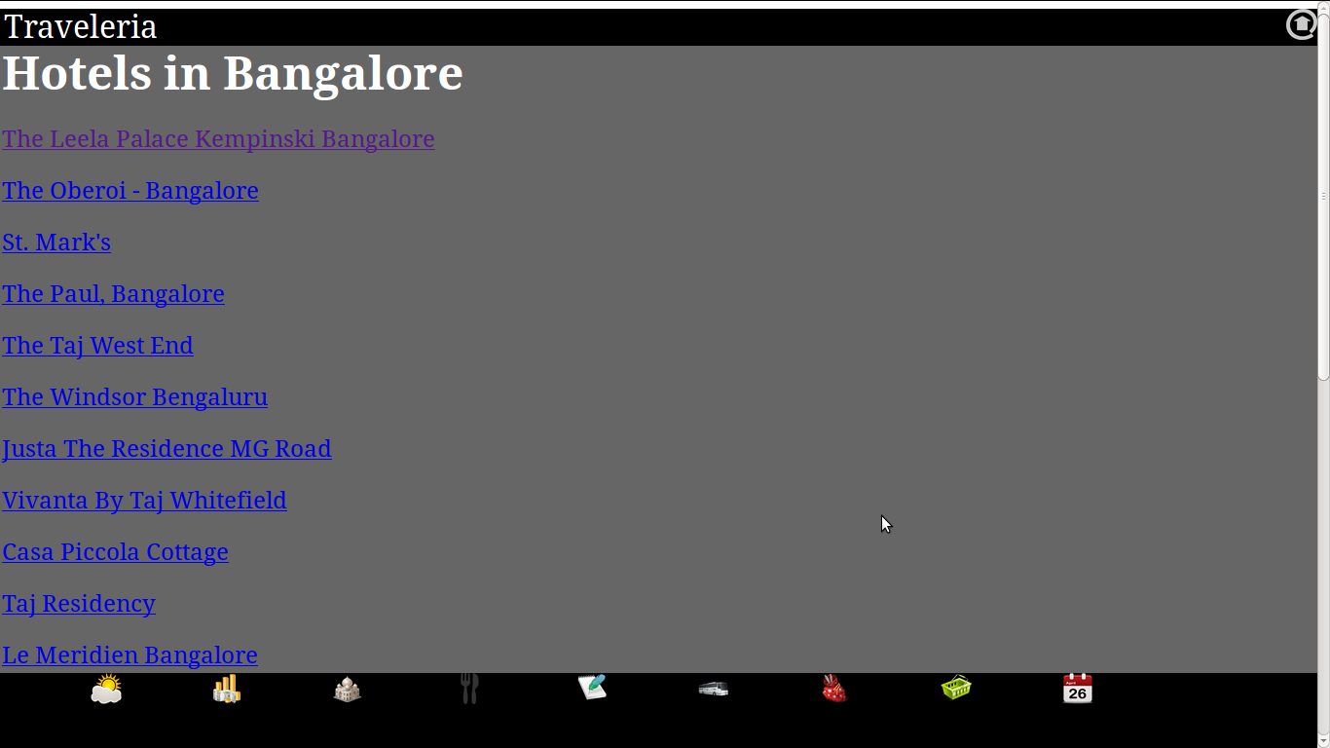

- Means of transport: Best means of transport of a place is provided so that travelers can go to in and around places with comfort.

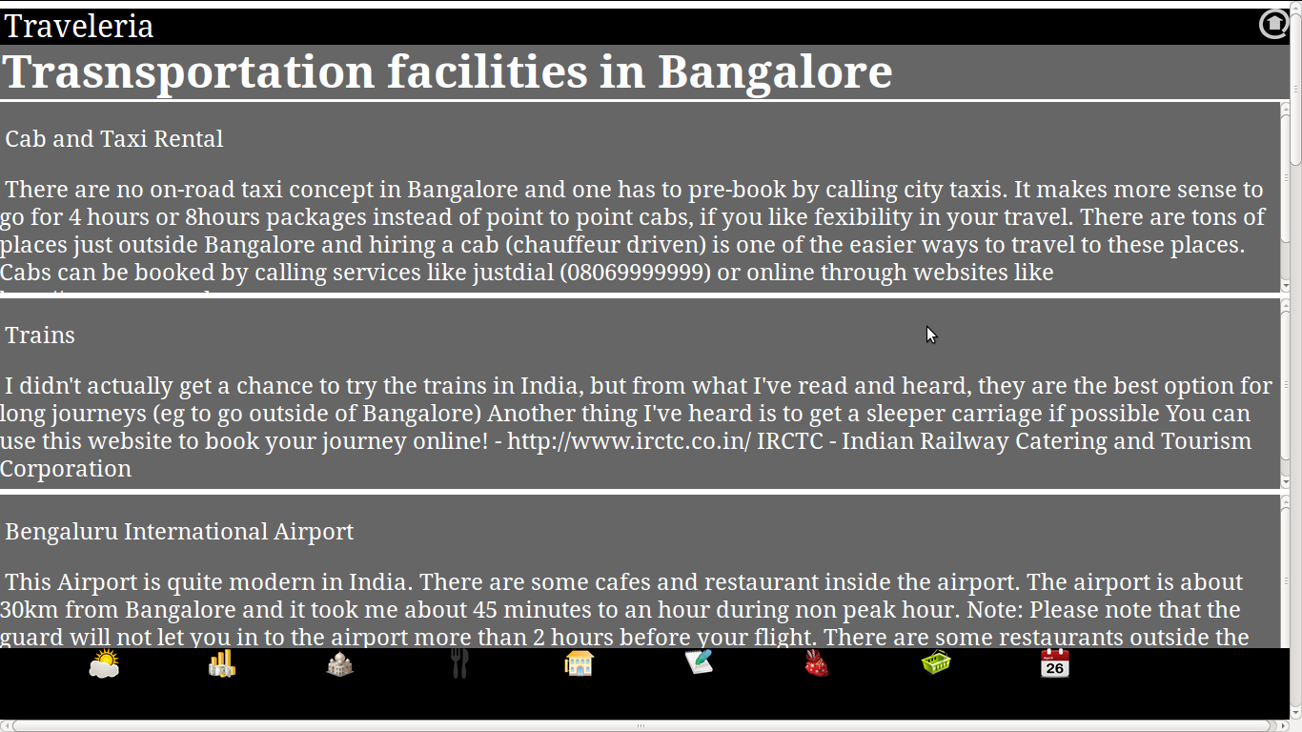

- Happening events: Happening events of a place is provided so that travelers can participate.

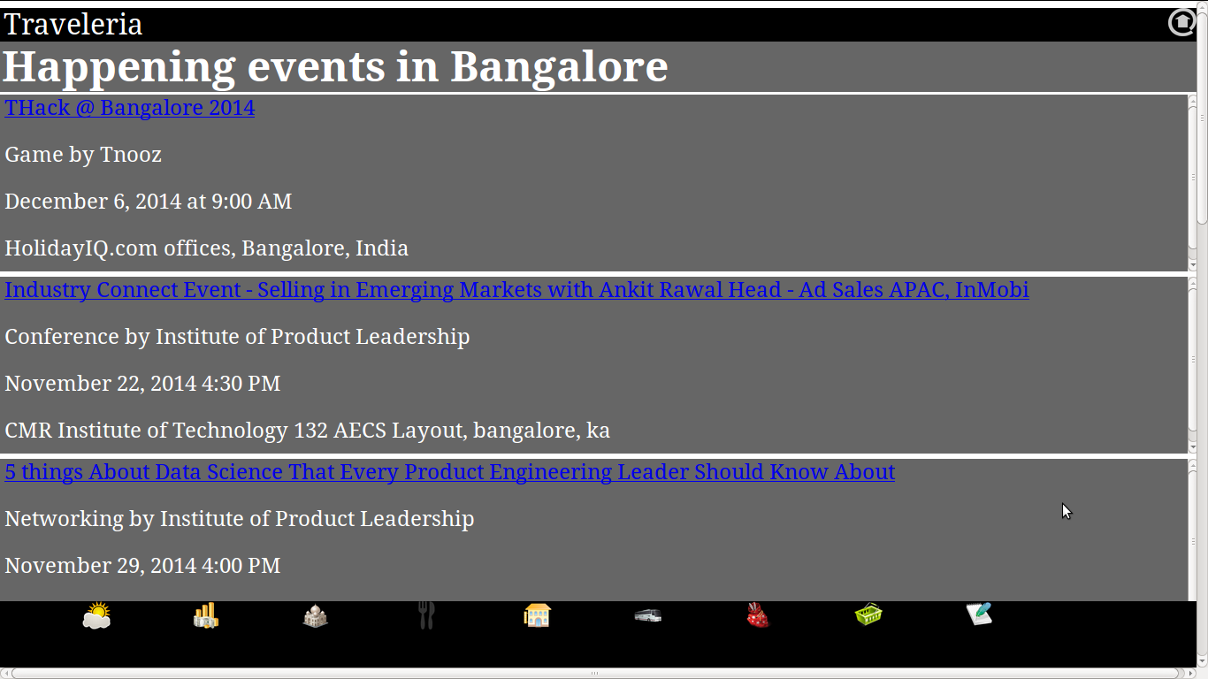

- Places in and around: Famous places that can be visited in and around a place is given.

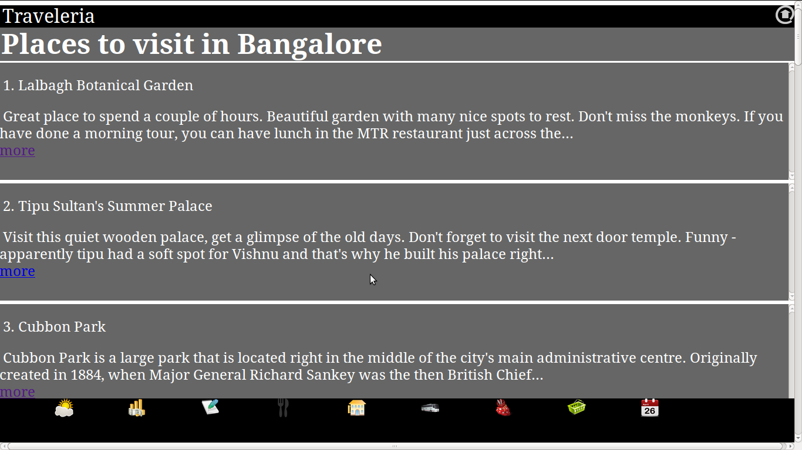

- Description and images: Description and images of a place is given.
- Best time to go: Best months in which a traveler can visit a place is given.

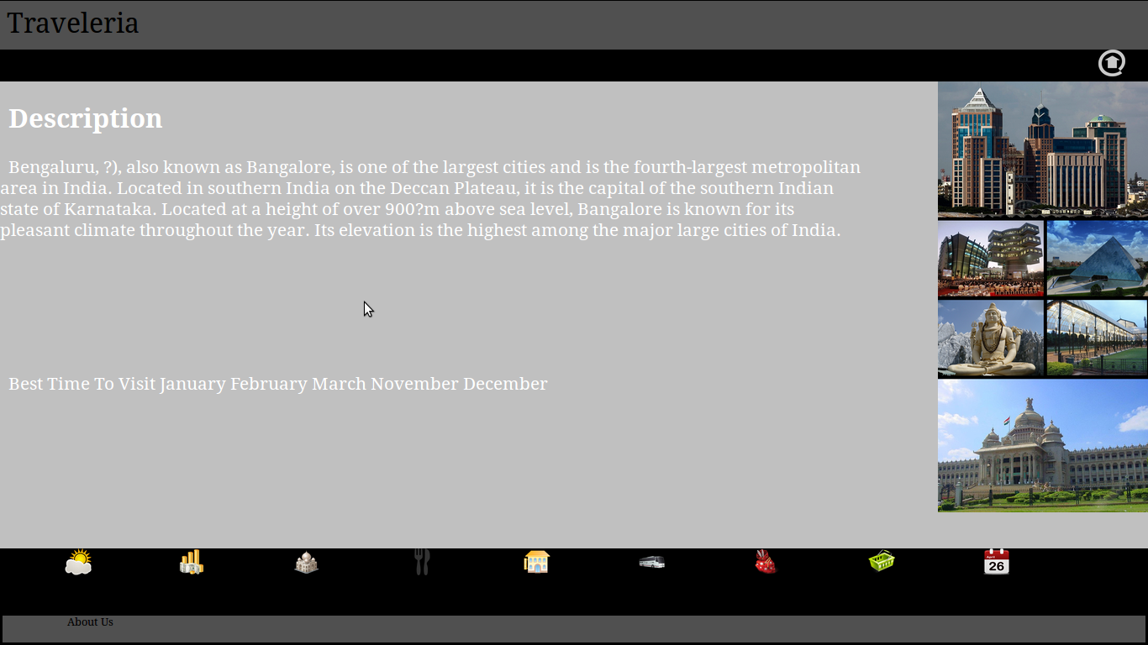

- Weather: Maximum and minimum temperatures and forecast of 5 weeks of a place is provided which helps travelers to plan their site seeing easy.

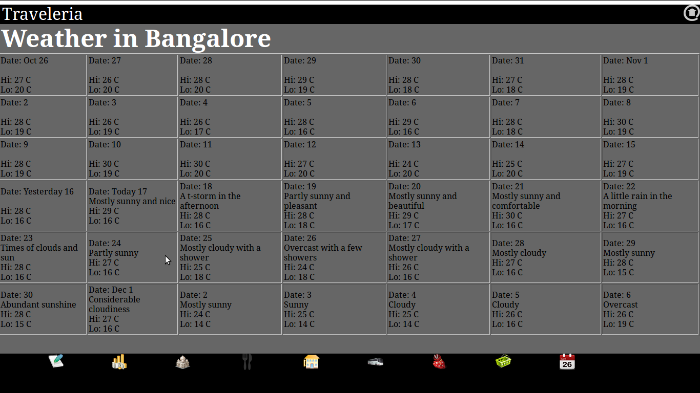

- Shopping: List of famous shopping malls, places and markets is provided.

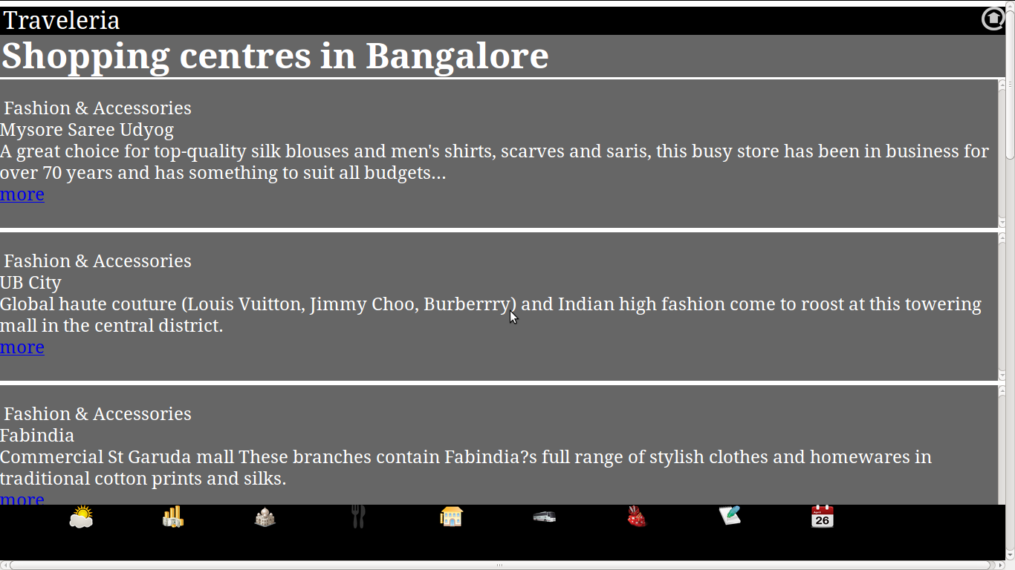

- Local Customs: List of Local customs and traditions of a place is provided.

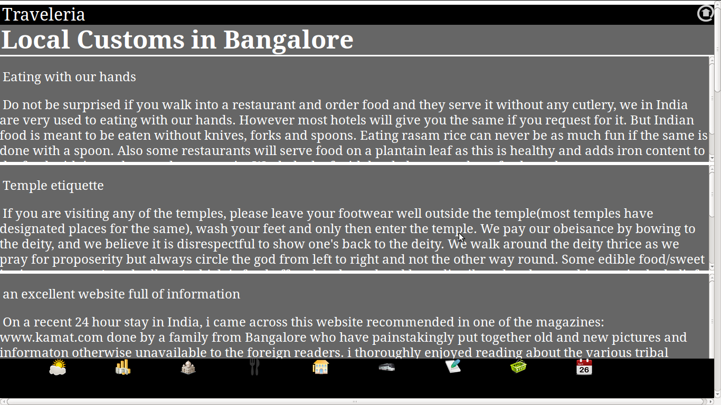

  - ARCHITECTURE:

The basic architecture of the project is as shown in Fig 3.2.1.

- User connects to the server on which the website Traveleria is hosted.
- User gives query by selecting appropriate options as country, city and date.
- The queries are processed in the server by php pages.
- php pages contact webservers (eg virtualtourist.com, besttimetogo.com etc..) to extract required information.
- The extracted information is stored in database for caching.
- The result (webpages and information) is given to the user through interactive user interface using CSS, javascript and HTML.

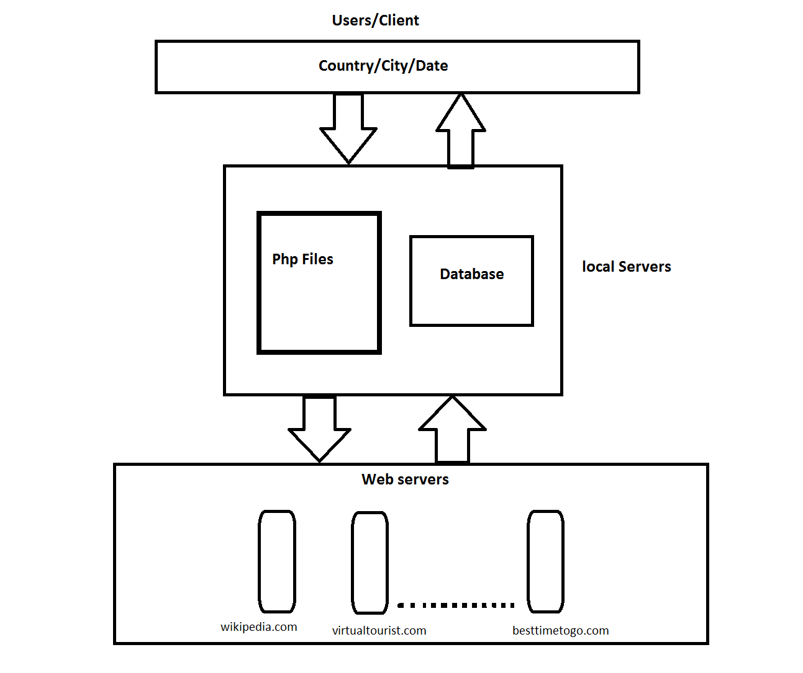
Fig 4.1 ARCHITECTURE

  - USER INTERFACE:

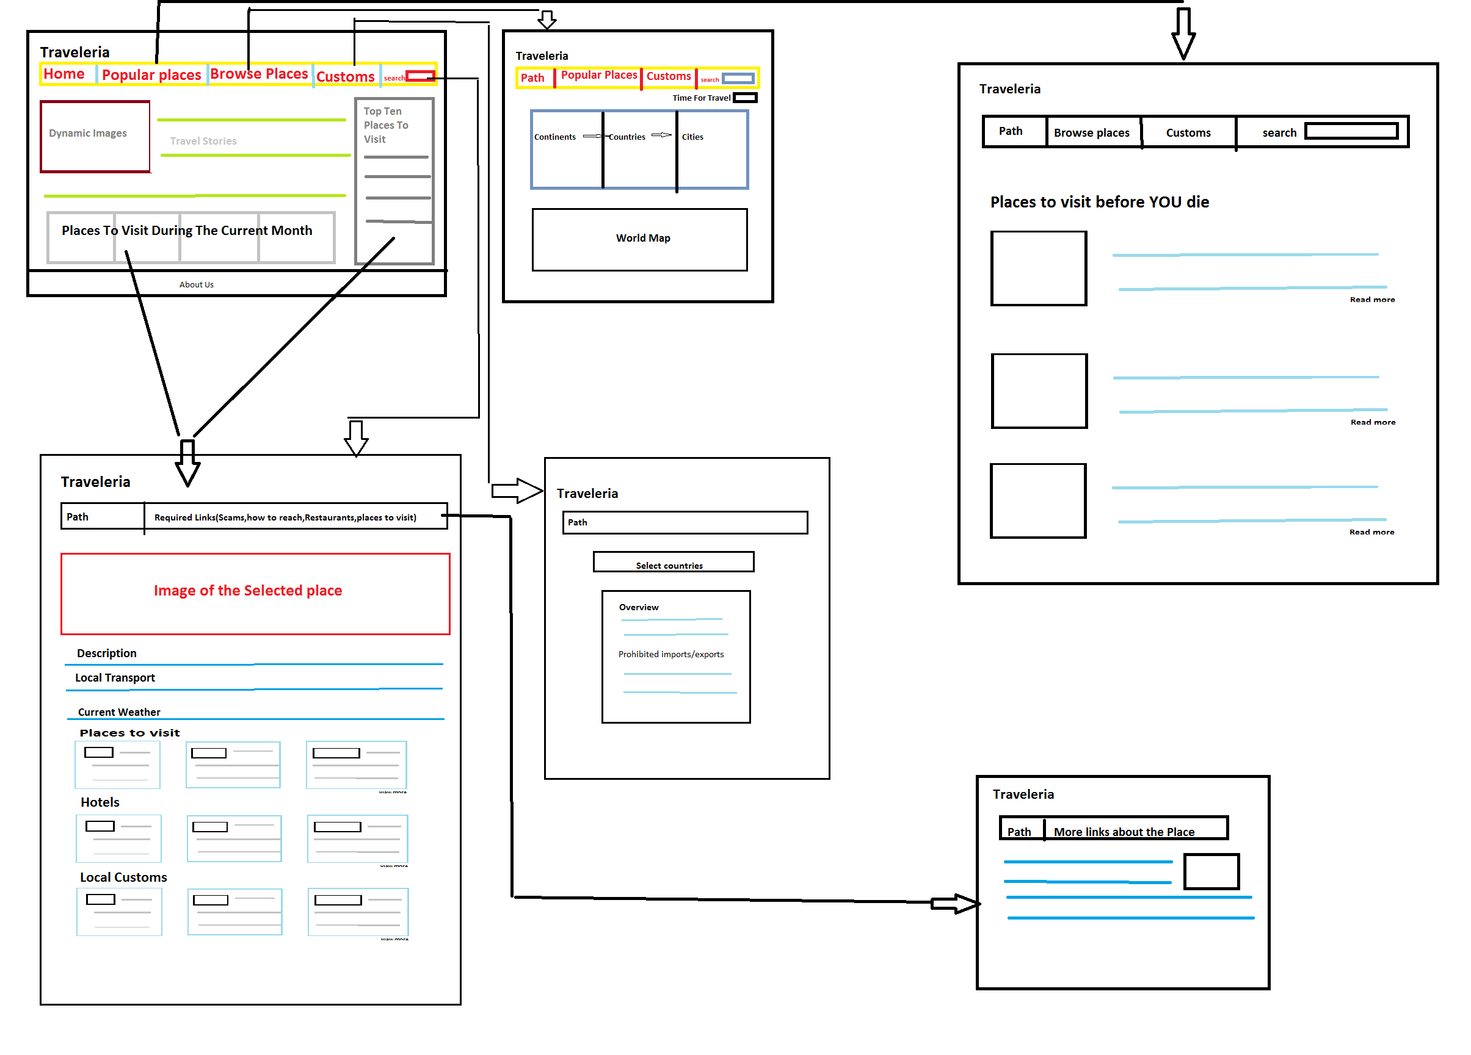
Fig 4.2 USER INTERFACE

- CONCLUSION:

From this project we learn the importance of travel and the need for every person to travel. Also, we learn that there are tons of bytes of information and data extraction plays a major role in extracting such data and putting it to good use. Traveleria website is a one-stop website for all required information for travel. Instead of browsing through many websites and finding pieces of information in each website, users can browse Traveleria and find all the pieces of information that they want at a single place.

- FUTURE ENHANCEMENT:

This project has a wide range of applications and hence scope for improvement is high. Some of the future enhancements of the project are :

- Information about places all around the world can be provided.
- Interface can be made interactive and user friendly.
- Time taken for loading data can be reduced.
- Use multithreading to support many users.

- BIBLIOGRAPHY:

Jsoup tutorial http://jsoup.org/cookbook/
php tutorial http://www.w3schools.com/php/
php tutorial http://php.net/downloads.php
CSS tutorial http://www.w3schools.com/css/
CSS tutorial http://www.csstutorial.net/
HTML tutorial http://www.tutorialspoint.com/html/
javascript tutorial http://www.codecademy.com/en/tracks/javascript

