Flask_api server Troubleshoot  
  
location: /home/ubuntu/edge-server  
logs: /home/ubuntu/edge-server/logs/api.log

tail -f /home/ubuntu/edge-server/logs/api.log   
  
start/stop/status - check   
  
sudo systemctl stop api_server

sudo systemctl start api_server

sudo systemctl status api_server  
  
  
  
Flask_api server logs we see for post from edge device.  
  
  
  
  
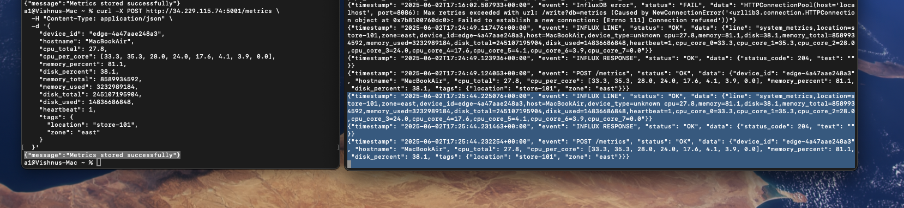

{"timestamp": "2025-06-02T17:25:44.225076+00:00", "event": "INFLUX LINE", "status": "OK", "data": {"line": "system_metrics,location=store-101,zone=east,device_id=edge-4a47aae248a3,host=MacBookAir,device_type=unknown cpu=27.8,memory=81.1,disk=38.1,memory_total=8589934592,memory_used=3232989184,disk_total=245107195904,disk_used=14836686848,heartbeat=1,cpu_core_0=33.3,cpu_core_1=35.3,cpu_core_2=28.0,cpu_core_3=24.0,cpu_core_4=17.6,cpu_core_5=4.1,cpu_core_6=3.9,cpu_core_7=0.0"}}

{"timestamp": "2025-06-02T17:25:44.231463+00:00", "event": "INFLUX RESPONSE", "status": "OK", "data": {"status_code": 204, "text": ""}}

{"timestamp": "2025-06-02T17:25:44.232254+00:00", "event": "POST /metrics", "status": "OK", "data": {"device_id": "edge-4a47aae248a3", "hostname": "MacBookAir", "cpu_total": 27.8, "cpu_per_core": [33.3, 35.3, 28.0, 24.0, 17.6, 4.1, 3.9, 0.0], "memory_percent": 81.1, "disk_percent": 38.1, "tags": {"location": "store-101", "zone": "east"}}}

If the InfluxDB is down we get this error “{"error":"Failed to reach InfluxDB"}

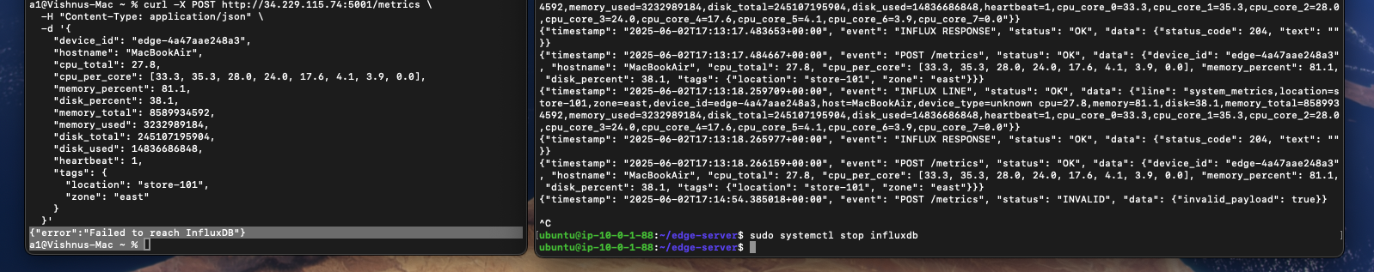  
  
if its up we see {"message":"Metrics stored successfully"}

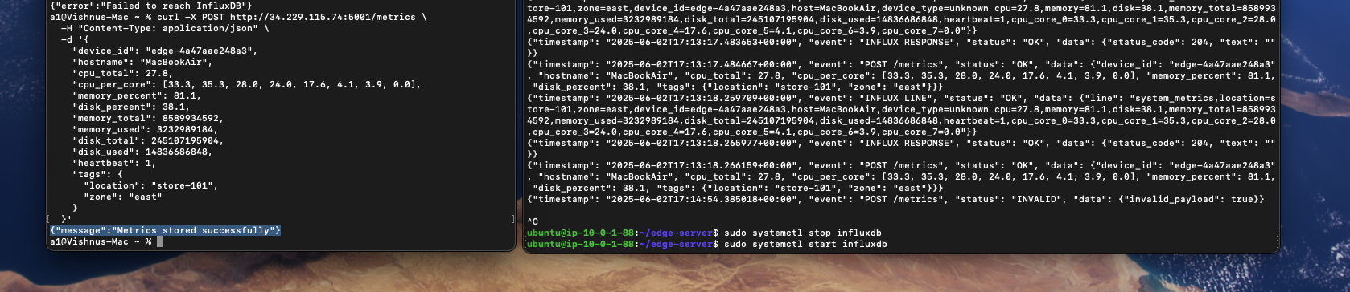

From edge device if its sending the metrics we see this error for the influxDB or the api server is stopped.   
  
  
{"timestamp": "2025-06-02T17:34:58.033780+00:00", "event": "InfluxDB error", "status": "FAIL", "data": "HTTPConnectionPool(host='localhost', port=8086): Max retries exceeded with url: /write?db=metrics (Caused by NewConnectionError('<urllib3.connection.HTTPConnection object at 0x7b810070bdf0>: Failed to establish a new connection: [Errno 111] Connection refused'))"}

We can troubleshoot the error like this identifying its influx issue.  
  
  
we see this log at the edge-device logs as we enables 3 retries  
  
this is for api_server issue

[edge-4a47aae248a3] Metrics collected at 2025-06-02T17:41:20.367836+00:00

[ERROR] 2025-06-02T17:41:20.409992+00:00: Cloud push attempt 1 failed: HTTPConnectionPool(host='34.229.115.74', port=5001): Max retries exceeded with url: /metrics (Caused by NewConnectionError('<urllib3.connection.HTTPConnection object at 0x102681cd0>: Failed to establish a new connection: [Errno 61] Connection refused'))

[ERROR] 2025-06-02T17:41:22.459507+00:00: Cloud push attempt 2 failed: HTTPConnectionPool(host='34.229.115.74', port=5001): Max retries exceeded with url: /metrics (Caused by NewConnectionError('<urllib3.connection.HTTPConnection object at 0x1026823f0>: Failed to establish a new connection: [Errno 61] Connection refused'))

[ERROR] 2025-06-02T17:41:26.498968+00:00: Cloud push attempt 3 failed: HTTPConnectionPool(host='34.229.115.74', port=5001): Max retries exceeded with url: /metrics (Caused by NewConnectionError('<urllib3.connection.HTTPConnection object at 0x10263b530>: Failed to establish a new connection: [Errno 61] Connection refused'))

[ERROR] 2025-06-02T17:41:26.499108+00:00: All cloud push attempts failed

^CTraceback (most recent call last):   
  
this is for InfluxDB issue

{"timestamp": "2025-06-02T17:34:51.583277+00:00", "device_id": "edge-4a47aae248a3", "level": "INFO", "device_type": "edge-node", "metrics": {"timestamp": "2025-06-02T17:34:50.576508+00:00", "hostname": "Vishnus-Mac.local", "cpu_total": 15.7, "cpu_per_core": [31.4, 26.0, 24.0, 24.0, 0.0, 0.0, 0.0, 0.0], "memory_percent": 80.7, "memory_used": 3010101248, "memory_total": 8589934592, "disk_percent": 38.5, "disk_used": 14836686848, "disk_total": 245107195904, "heartbeat": 1}, "tags": {"location": "store-101", "zone": "east"}}

{"timestamp": "2025-06-02T17:34:51.682385+00:00", "device_id": "edge-4a47aae248a3", "level": "ERROR", "message": "Cloud push attempt 1 failed: 500 Server Error: INTERNAL SERVER ERROR for url: http://34.229.115.74:5001/metrics"}

{"timestamp": "2025-06-02T17:34:53.782047+00:00", "device_id": "edge-4a47aae248a3", "level": "ERROR", "message": "Cloud push attempt 2 failed: 500 Server Error: INTERNAL SERVER ERROR for url: http://34.229.115.74:5001/metrics"}

{"timestamp": "2025-06-02T17:34:57.896067+00:00", "device_id": "edge-4a47aae248a3", "level": "ERROR", "message": "Cloud push attempt 3 failed: 500 Server Error: INTERNAL SERVER ERROR for url: http://34.229.115.74:5001/metrics"}

{"timestamp": "2025-06-02T17:34:57.896656+00:00", "device_id": "edge-4a47aae248a3", "level": "ERROR", "message": "All cloud push attempts failed"}