InFLuxDB  
  
sudo systemctl status influxdb

Should say active (running)

If not, run: sudo systemctl start influxdb

sudo journalctl -u influxdb -n 100 --no-pager  
  
  
To access Influx   
  
on linux just type - influx

SHOW DATABASES;

USE metrics;

SHOW MEASUREMENTS;

SELECT * FROM system_metrics ORDER BY time DESC LIMIT 5;  
  
  
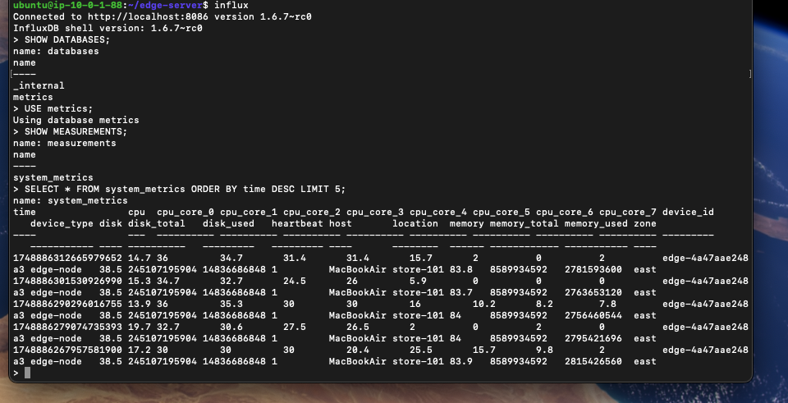

If you see your data coming in, InfluxDB is receiving metrics correctly.

To check disk usage   
  
  
sudo du -sh /var/lib/influxdb  
  
status - curl -I http://localhost:8086/ping