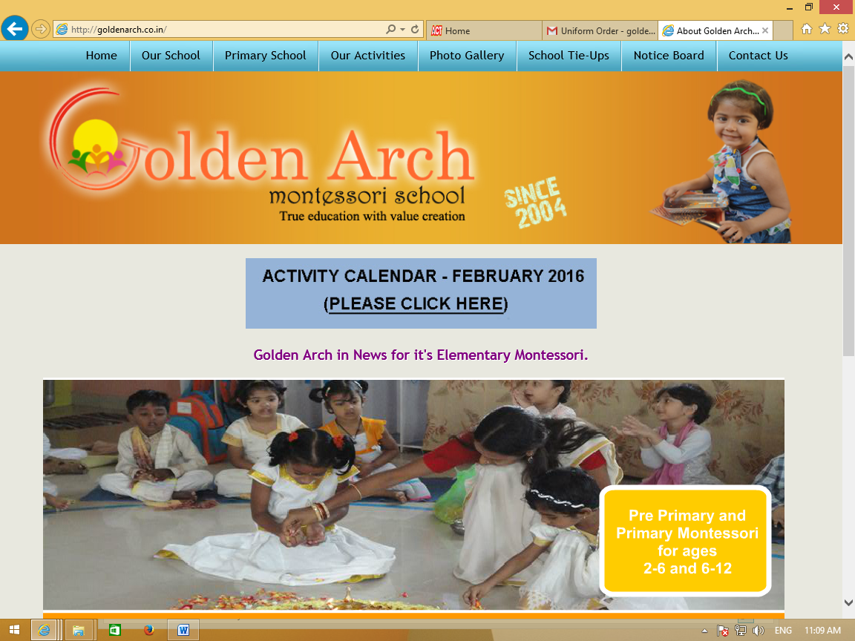

**Activities for July’16**

**Theme for the month: Strokes of Colour!!**

**Theme Activities..**

**Week 1- Introducing Primary colours**

Children should come in the respective colour code:

Tuesday – 5th July – Red

Thursday – 7th July- Blue

Friday – 8th July - Yellow.

**Week 2- Introducing Secondary colours**

Children should come in the respective colour code:

Tuesday –12th July - Orange

Wednesday – 13th July -Purple.

Thursday -14th July - Pink.

**Week 3: Scrap book activity.**

**Week 4 Activity : Show and Tell**

27th Wednesday - Child to bring any favourite object of their favourite colour and talk about it.

**(Please Note - All theme activities listed above are only for Pre primary and not for elementary children)**

**Parent as the Child – A Workshop**

Saturday 16th of July –This will be a workshop to introduce the Montessori method to the parents. Seize the opportunity to understand the style of working at Golden Arch. Be your child and don’t miss this experience of working like your child!

Please note the following slots, choose one of them and book your slots at the office or call on PH – 7022502244 before 14th of July.

9.30 to 10.30 am

11.00 to 12.oo noon

12.30 pm to 1.30 pm

All NEW parents of Pre Primary are welcome for the session

Please note – This workshop is only for parents.

**Celebrations**

July 29th: Colour Carnival – For all children including elementary

Children need to come in multi coloured dress and accessories. Child with maximum number of colours will be the Star of the Carnival.

Boys ! Come on ! you can beat the girls.

Parents can witness the ‘Colour exhibit’ that children have crafted during the month.

Please also send few flowers of different colours and any one fruit on 29th.(Children will use them for decoration)

**List of Holidays**

**6th /7th/8th July ,as declared later : Holiday for Ramzan**

**Note:** Please send children in school T shirt on every Friday unless the dress code is specified.