**Task 1**

1. **Class : class is a blueprint for creating objects.**

**Define a class that represents an entity**

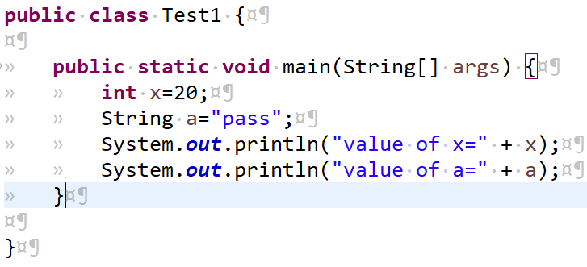

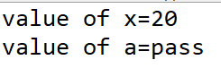

1. **Object: an object is an instance of a class using the car class , create an object and see its properties.**

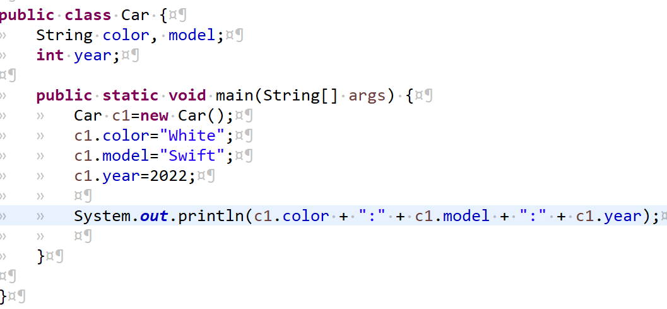

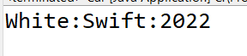

1. **Variable: a variable to store data for use in a program. Variable can be defined in classes or methods.**

**Instance variable: declared in class area.**

**Local variables: declared in any method or block .**

**Class variables (static keyword is used) and declared in class area.**

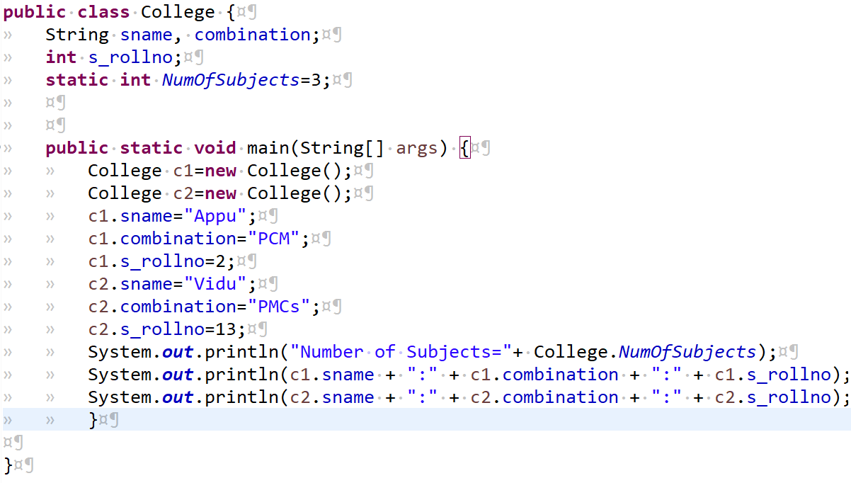

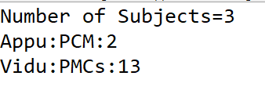

1. **Datatypes: they define the type of data a variable can hold. Here are few examples:**

**Primitive datatypes: int , float, double, Boolean, char .**

**Non – primitive datatypes: String, Arrays, Classes.**

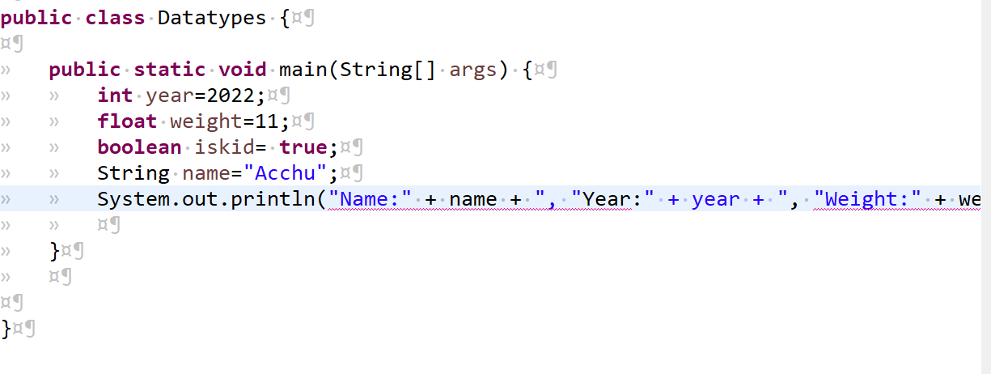

**Task 2**

**Create classes college, student and create multiple objects using the classes.**

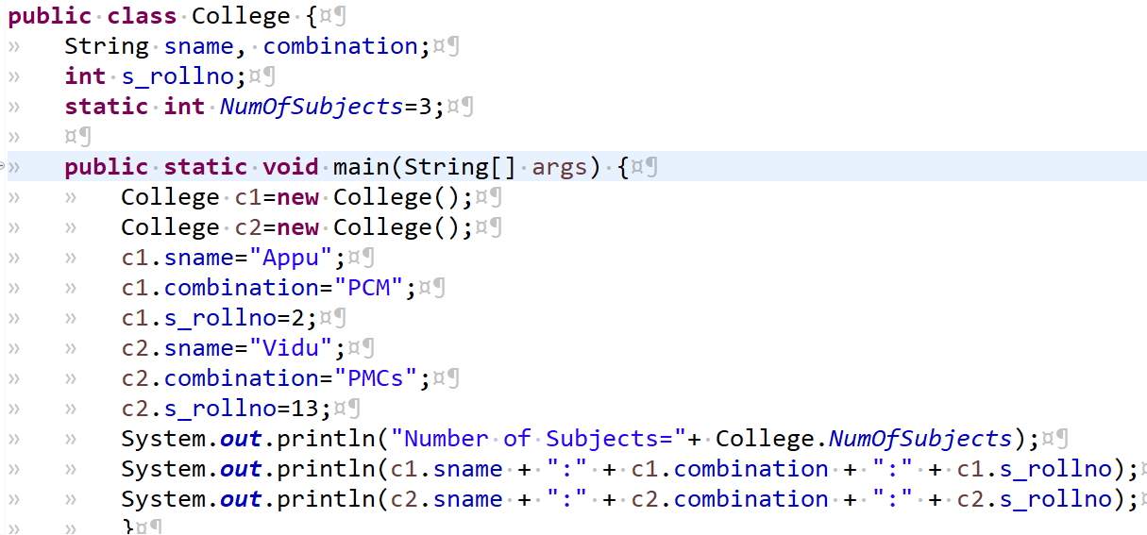

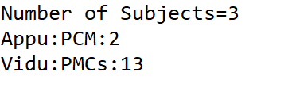

**Ex:**



