**WEEK3-HANDS ON**

**Spring Core and Maven**

1. **Exercise 1: Configuring a Basic Spring Application**

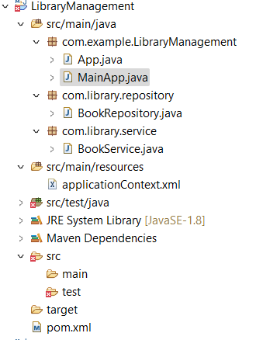

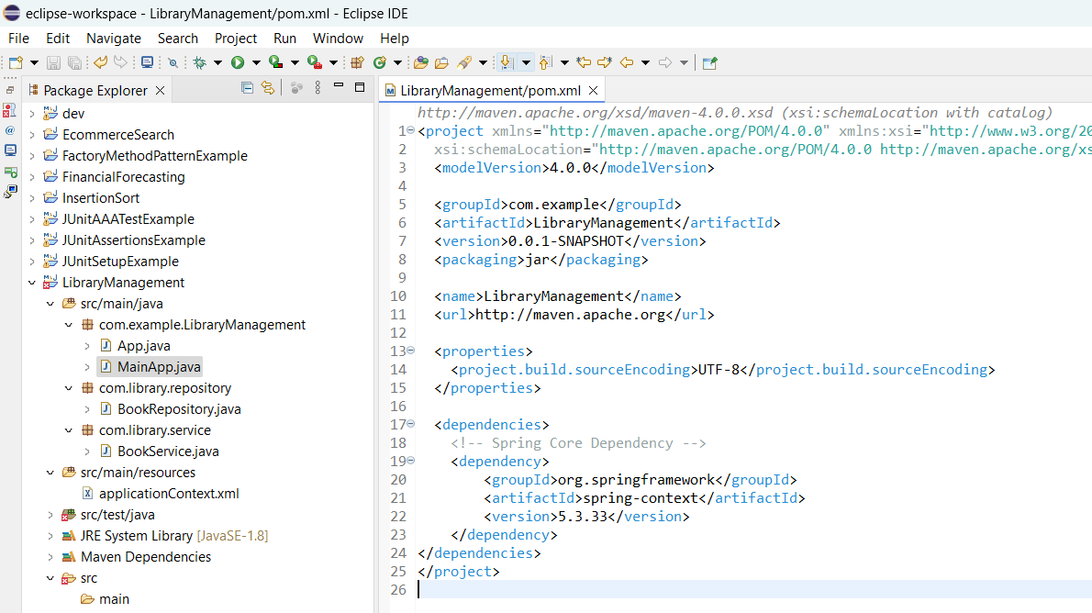

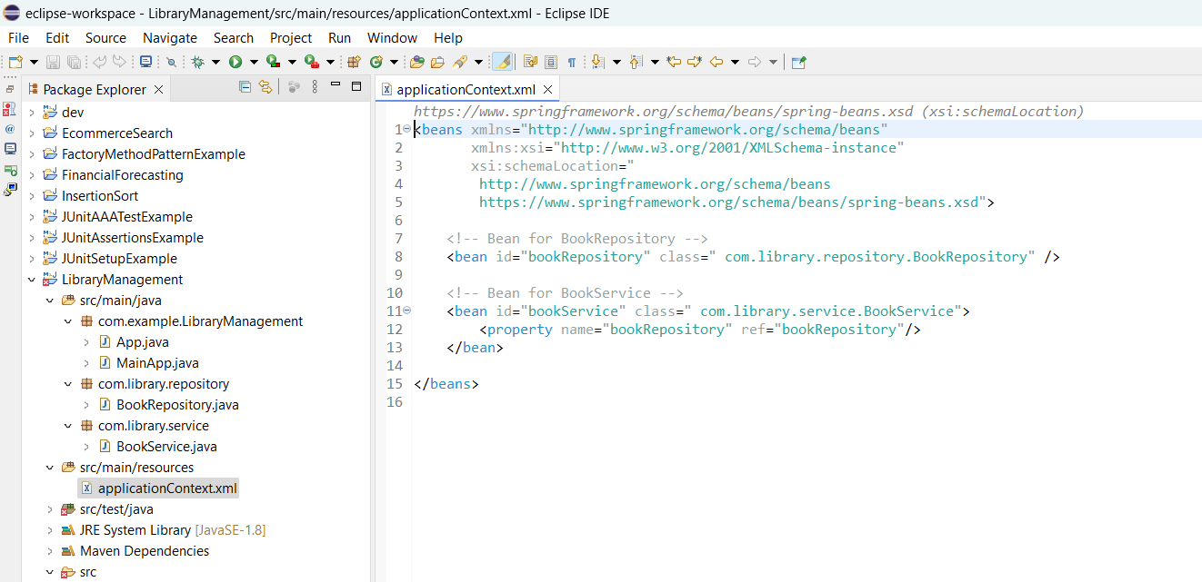

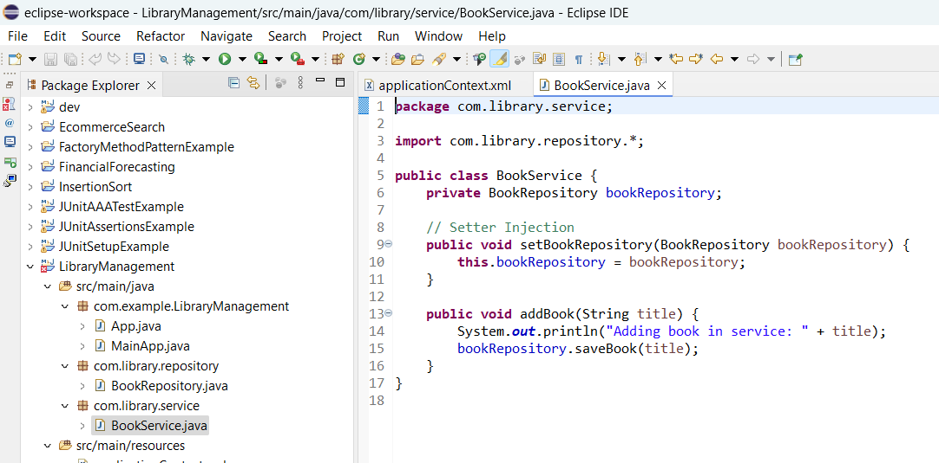

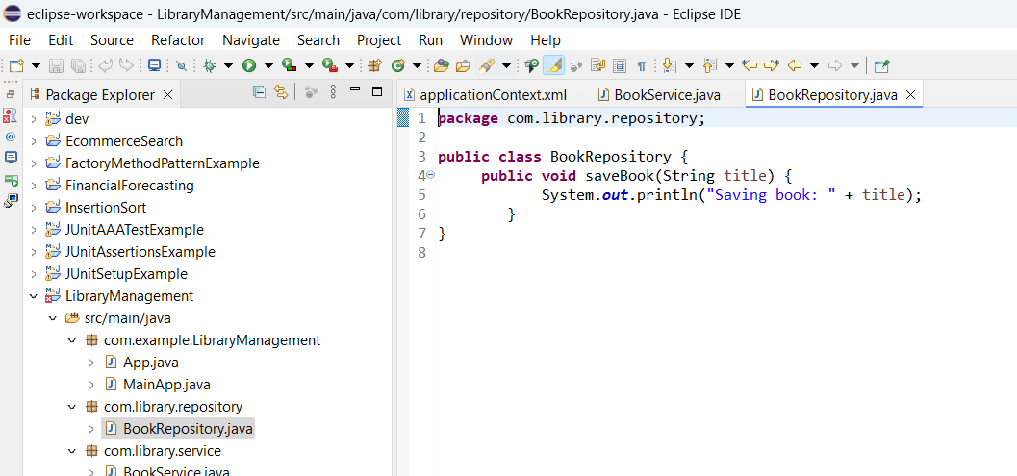

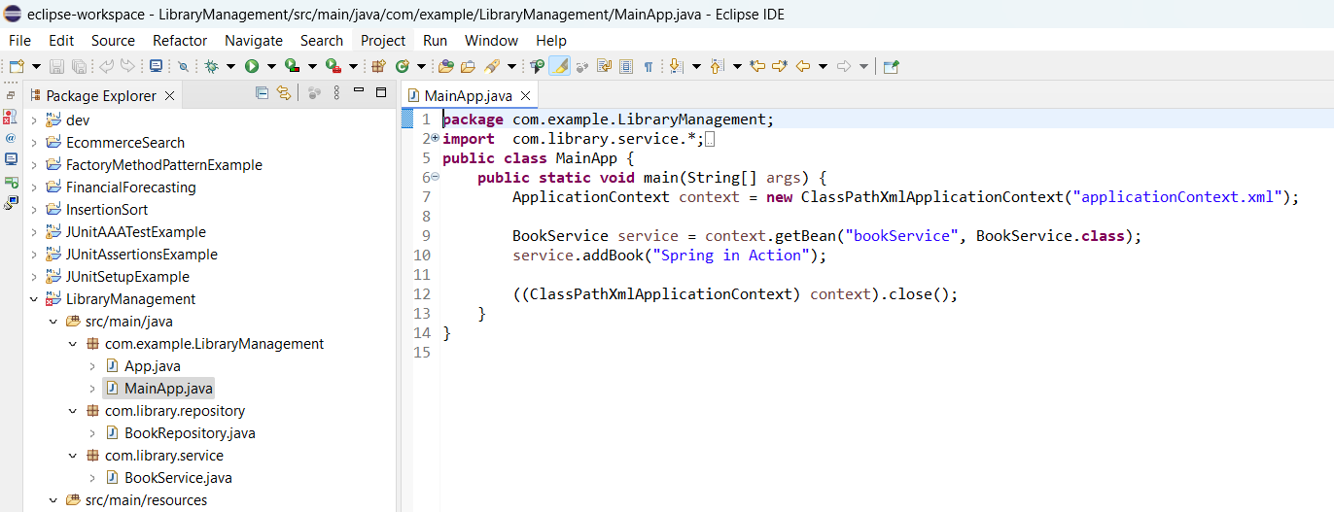

**OUTPUT:**

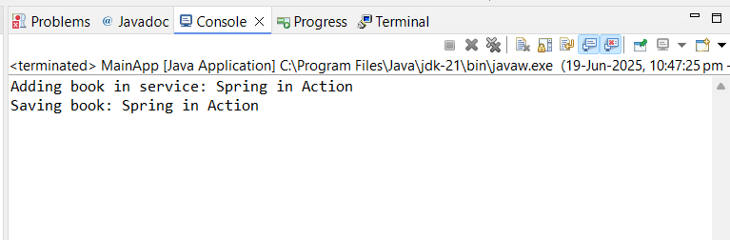

1. **Exercise 2: Implementing Dependency Injection**

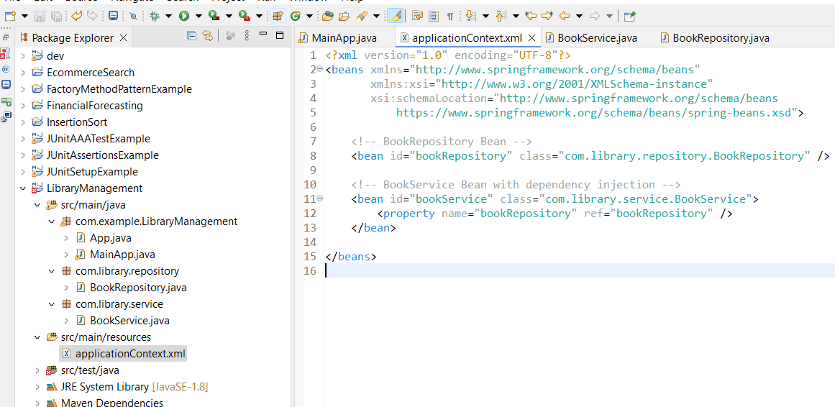

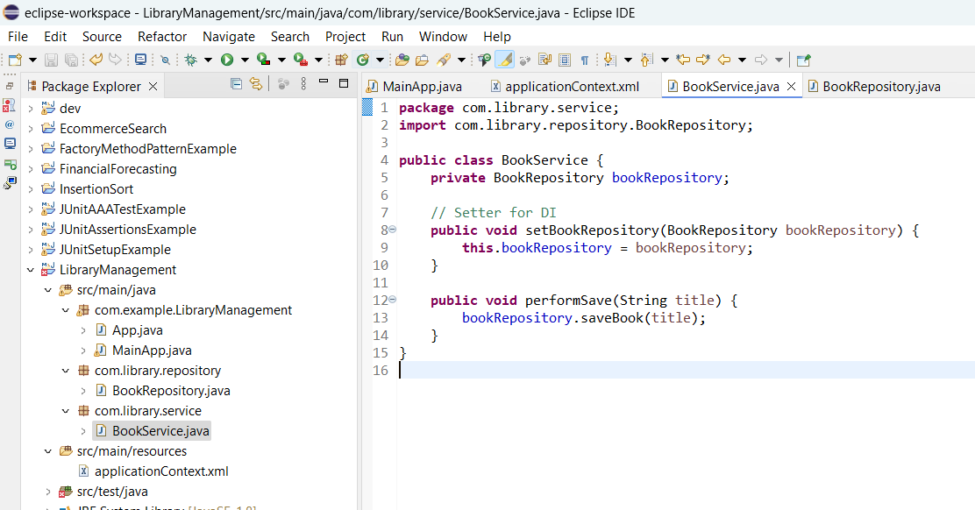

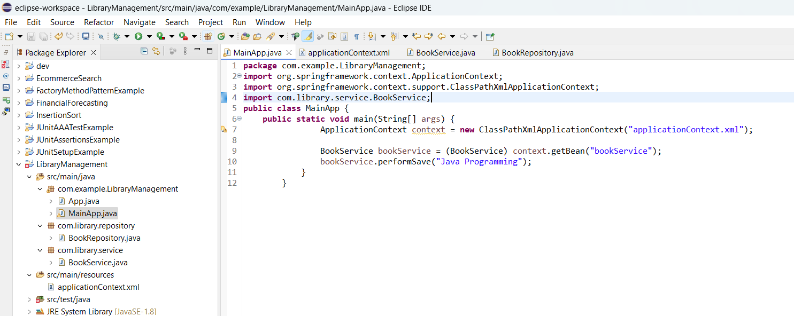

**OUTPUT:**

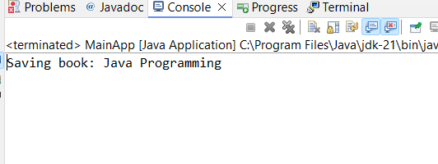

1. **Exercise 4: Creating and Configuring a Maven Project**

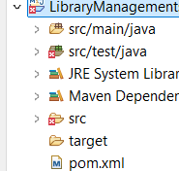

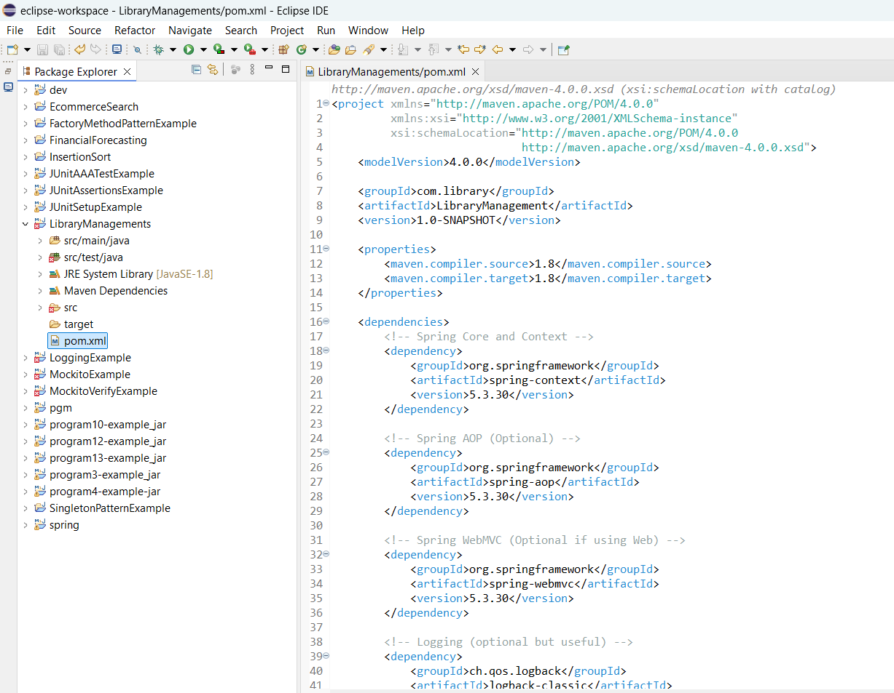

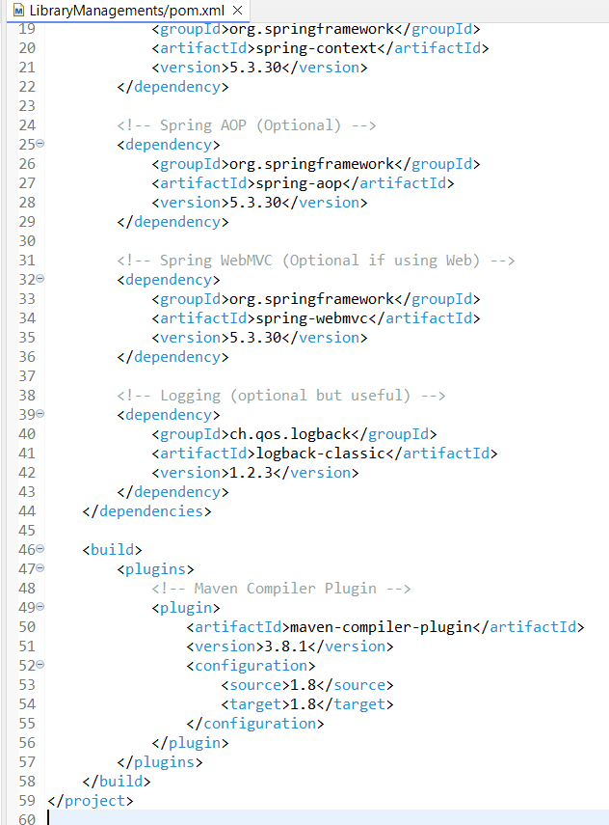

**Spring Data JPA with Spring Boot, Hibernate**

1. **Spring Data JPA - Quick Example**

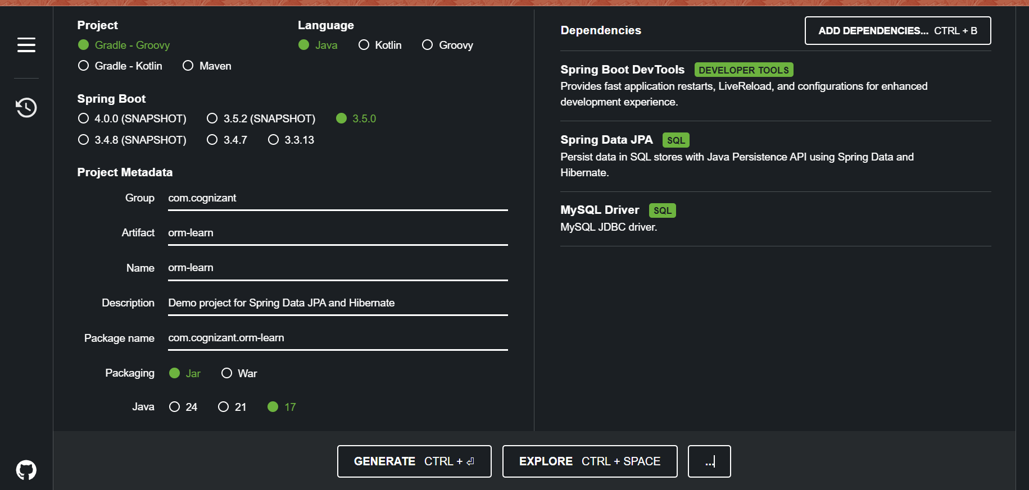

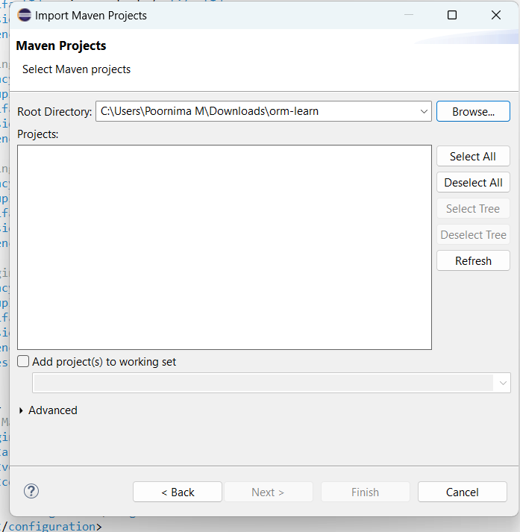

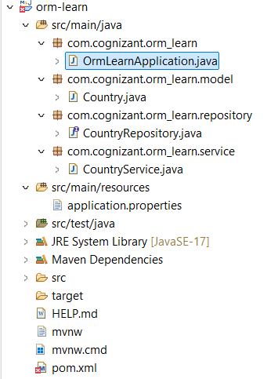

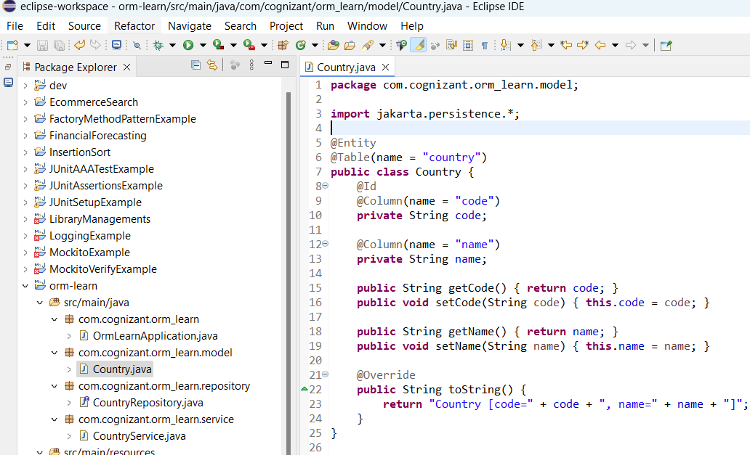

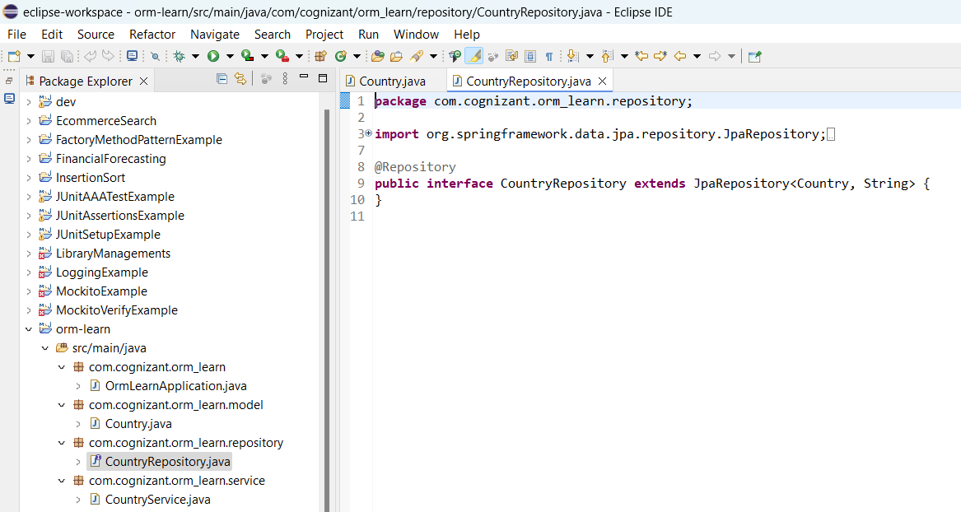

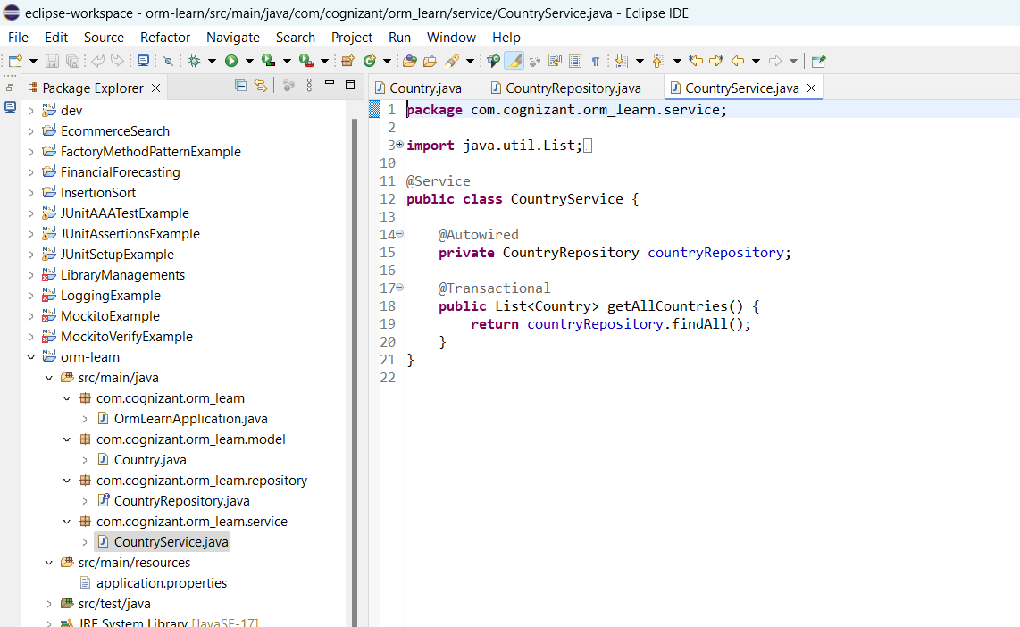

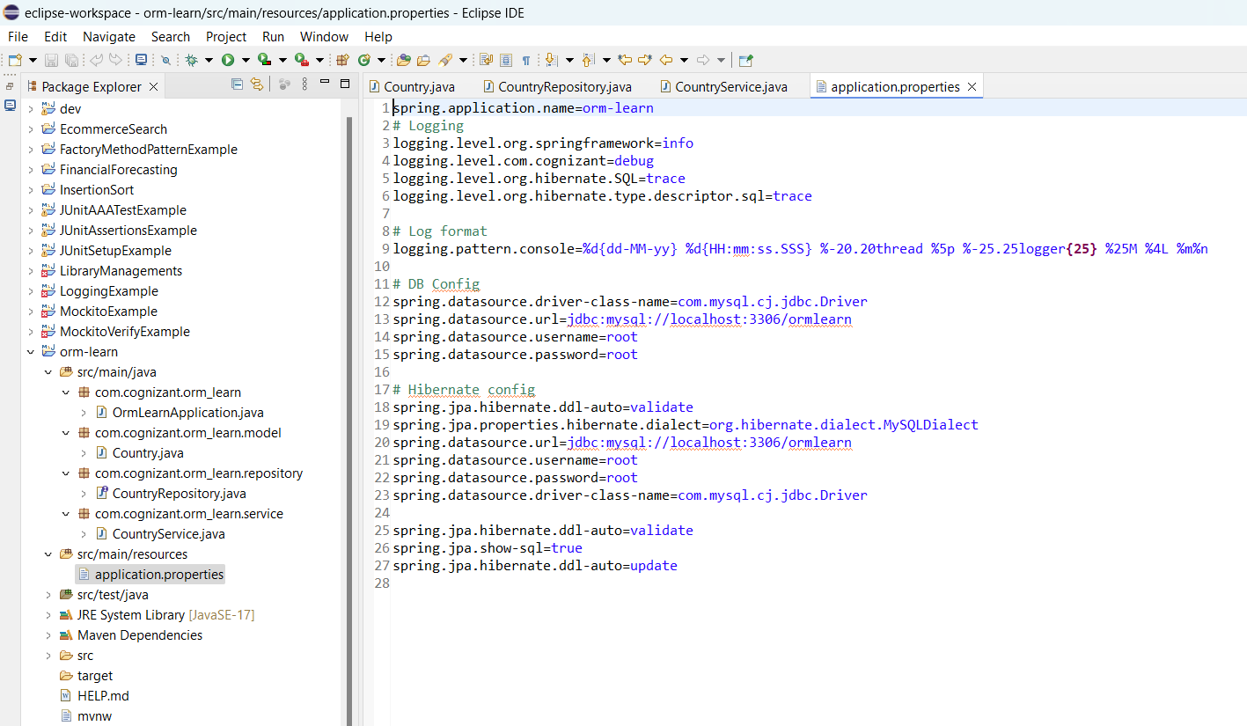

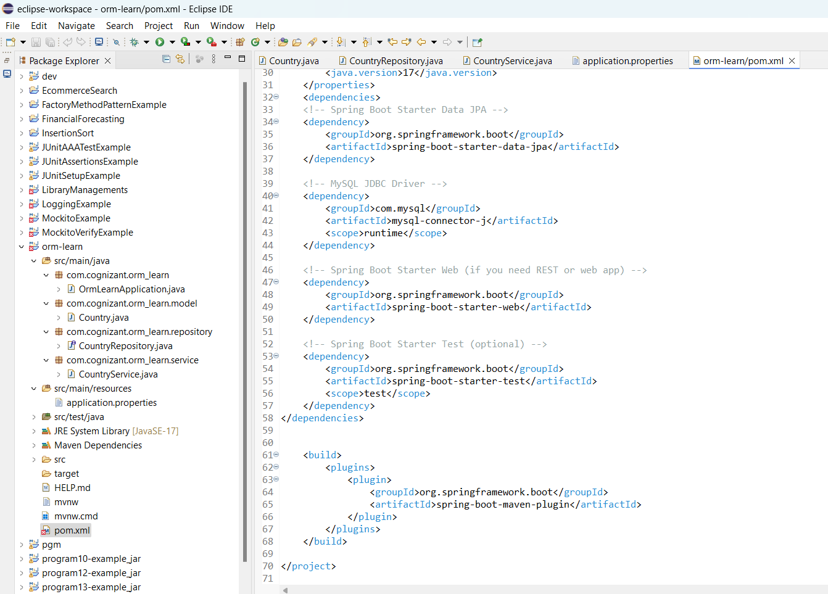

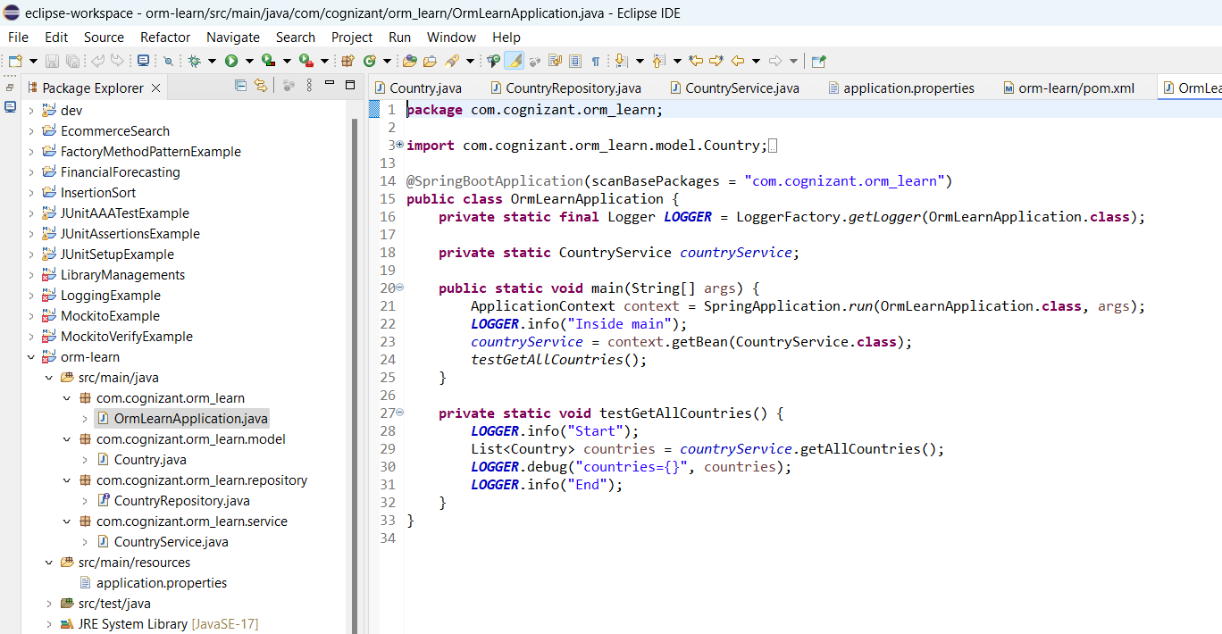

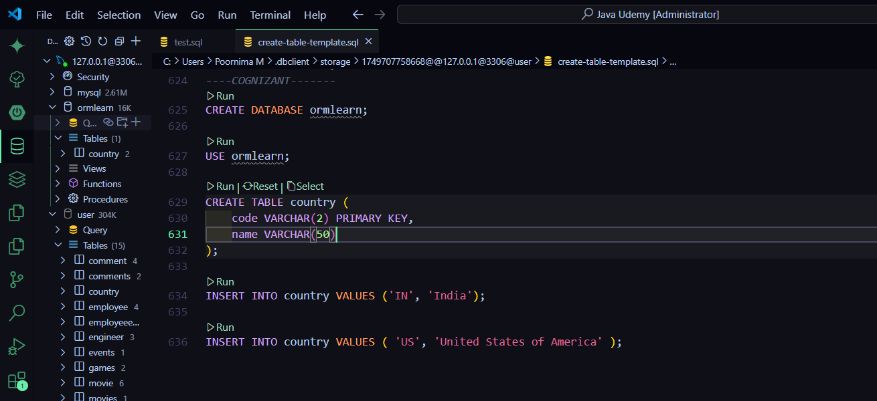

**OUTPUT:**

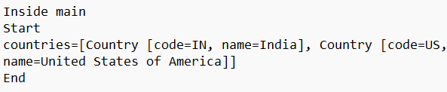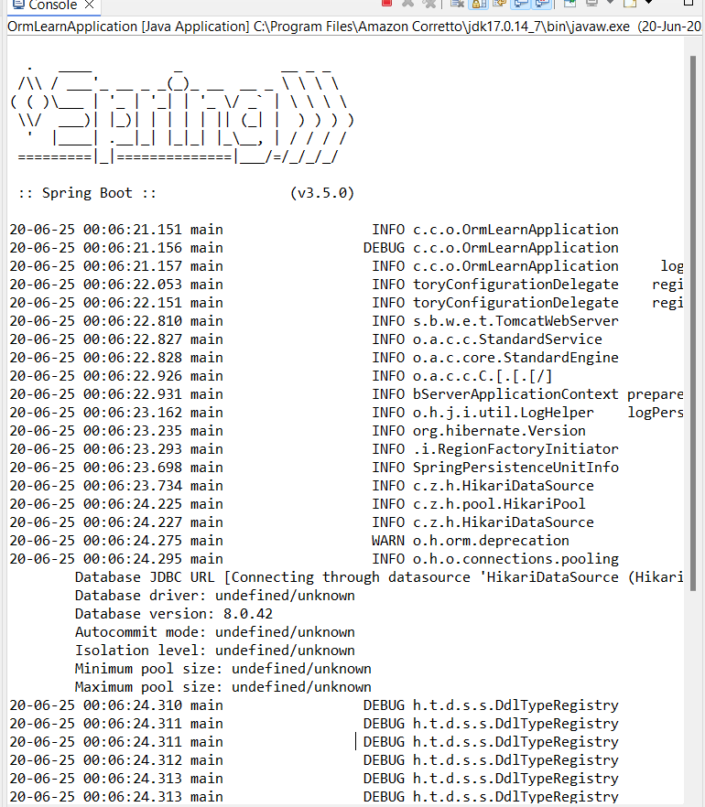

1. **Difference between JPA, Hibernate and Spring Data JPA**

Java Persistence API (JPA)

• JSR 338 Specification for persisting, reading and managing data from Java objects

• Does not contain concrete implementation of the specification

• Hibernate is one of the implementation of JPA

Hibernate

• ORM Tool that implements JPA

Spring Data JPA

• Does not have JPA implementation, but reduces boiler plate code

• This is another level of abstraction over JPA implementation provider like Hibernate

• Manages transactions

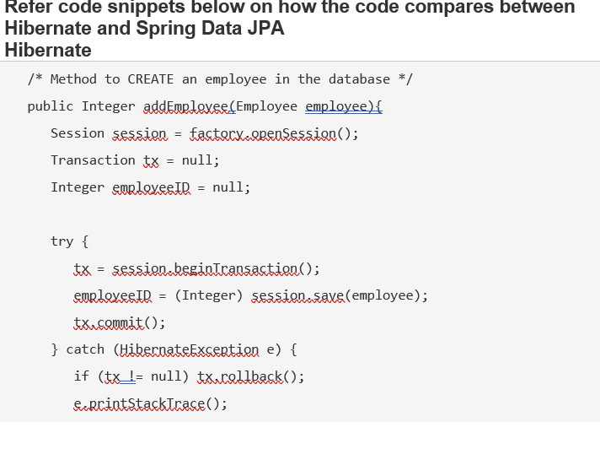

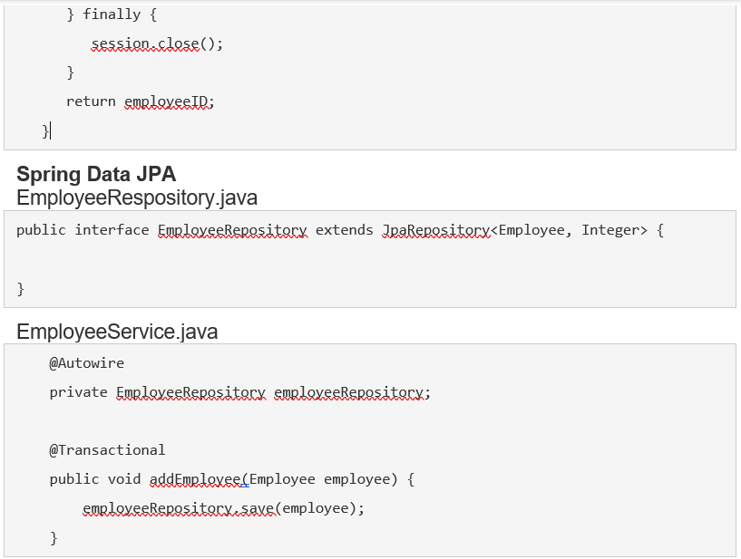

**OUTPUT:**

