BUCKMAN DIGITAL WATER
Monthly Cooling Water Performance Report
Candler Hospital Savannah GA (US)
Reporting Month: August 2026
Customer / Site | System | Controller | Prepared For
Candler Hospital Savannah GA (US) | Cooling Tower | 84253F5FB67B, 84253FAB8C75 | Monthly Performance Review

This report summarises corrosion control, scale control, microbial control, water efficiency, product efficiency, and proactive system support for Candler Hospital Savannah GA (US), August 2026, using controller setpoints, telemetry KPIs, field data, and service note records.

Prepared By | Prepared Date | Report Status
Buckman Digital Water | 09 September 2026 | Draft

Executive Summary
System Health Check
Corrosion Control
Status: Excellent
During the reporting period, the system remained under good control. The mild steel and copper corrosion rates averaged 0.95 mpy and 0.09 mpy, respectively, both of which are well within the recommended limits of <5 mpy and <0.5 mpy.
Scale Control
Status: Acceptable
Traced Product was within the recommended range for 45.3% of the reporting month. Polymer consumption rate averaged 41.6% and increased from 41.6% at the start of the month to 44.8% at the end of the month. Conductivity was within the recommended range for 5.4% of the reporting month. End-of-month Traced Product was 89.3% higher than the setpoint, and conductivity was also not maintained, so the product trend should be treated as conductivity-related until cycles, blowdown, makeup, or dilution behavior is corrected.
Microbial Control
Status: Acceptable
Insufficient ORP spike was observed during oxidizing biocide application, so oxidizing biocide feed response should be reviewed during the upcoming service visit. FRC and dip-slide will be analysed in the upcoming visit to ensure good microbial control.
Water Efficiency
Status: Excellent
MU Conductivity | Target COC | Actual COC | Deviation | Status
300.0 µS/cm | 2.0 | 2.23 | 11.5% | Excellent

Water efficiency was Critical. Conductivity averaged 668.76 uS/cm against the 570.00-630.00 uS/cm Controller Setpoint range, with only 5.4% of readings in range. Conductivity increased from about 633.9 uS/cm early in the month to 703.6 uS/cm later in the month, indicating high cycles, reduced blowdown, evaporation concentration, or concentrated makeup conditions need review.
Product Efficiency
Status: Acceptable
Product efficiency needs attention because Traced Product averaged 53.22 ppm against the 30.00 ppm setpoint and the 28.00-32.00 ppm control range. Because conductivity was also high and not maintained, product control should be reviewed together with cycles, blowdown, makeup, and dilution behavior before changing feed settings.
Proactive System Support
No service notes were recorded for the August reporting period. Recommended follow-up: Confirm inhibitor residual, inspect for deposit activity, and compare corrosion movement with ORP and product trends. Traced Product deviation remained at about 87.1% in the last 7 days, so correct the conductivity trend by checking cycles, blowdown, makeup, and dilution behavior before changing feed settings. Check FRC during the upcoming service visit to confirm oxidizing biocide residual. Measure dip-slide CFU during the upcoming service visit to confirm microbial control. Verify phosphate and silica residuals during the next service visit.

Performance Summary
Controller Setpoints are used as control limits below. % In Range is calculated from the full reporting month telemetry.
Parameter | Context Point | Average | Std Dev | Min | Max | Lower Limit | Upper Limit | % In Range | Status
Corrosion – MS (MPY) | ACM Skid | 0.948 | 0.469 | 0.161 | 1.782 | 0.00 | 3.00 | 100.0% | ✓ Excellent
Corrosion – Cu (MPY) | ACM Skid | 0.088 | 0.050 | 0.017 | 0.260 | 0.00 | 0.50 | 100.0% | ✓ Excellent
Traced Product (ppm) | ACM Skid | 53.221 | 22.283 | 27.924 | 85.742 | 28.0 | 32.0 | 45.3% | ⚠ Acceptable
Conductivity (µS/cm) | ACM Skid | 668.760 | 230.617 | 316.970 | 1038.476 | 570 | 630 | 5.4% | ✗ Critical
pH | ACM Skid | 8.729 | 0.115 | 8.403 | 8.947 | 7.50 | 10.00 | 100.0% | ℹ Info
ORP (mV) | ACM Skid | 225.316 | 87.630 | 108.154 | 378.485 | – | – | – | See chart
Turbidity (NTU) | ACM Skid | 14.865 | 15.800 | 0.000 | 49.475 | – | 75.0 | – | ℹ Info
Cell Fouling (%) | ACM Skid | 6.463 | 6.921 | 0.000 | 15.558 | – | 30.0 | – | ℹ Info
FRC | Field Data | Not avail. | – | – | – | – | – | – | ⚠ Check

Charts and Comments
Corrosion Rate
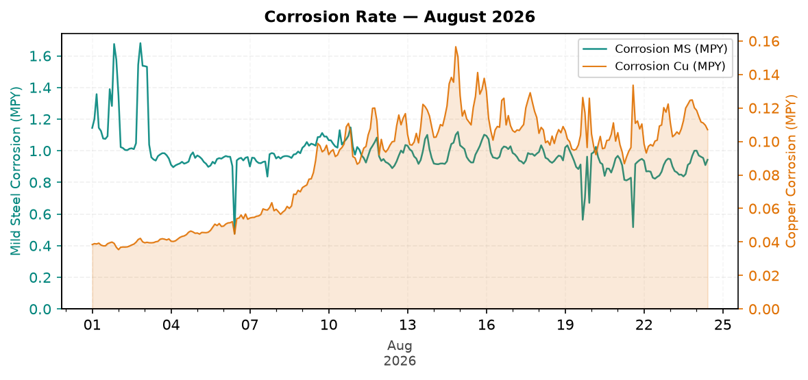
Figure 1: Corrosion Rate — August 2026
Comment: Pattern: corrosion control is increasing, but remains good against the target.
Mild steel corrosion decreased across the month, while copper corrosion increased across the month.
MS was within the 3.0 MPY target, and Cu was within the 0.5 MPY target.
Likely reason: corrosion is still protected, but increasing movement should be checked against product and ORP trends.
Traced Product Control Trend
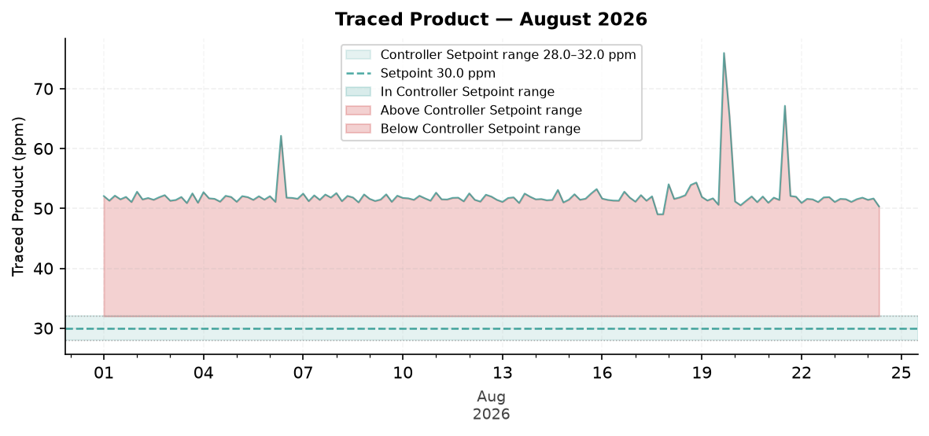
Figure 2: Traced Product — August 2026
Comment: Pattern: Traced Product is still not maintained at the end of the month.
The last 7 days still show about 87.1% deviation from setpoint, indicating the issue is still present.
The Traced Product average was above the configured range. The monthly in-range performance was 45.3%.
Likely reason: the Traced Product trend is related to the high conductivity trend; reduced blowdown, higher cycles, or concentration effects are pushing both up.
ORP vs Copper Corrosion Rate
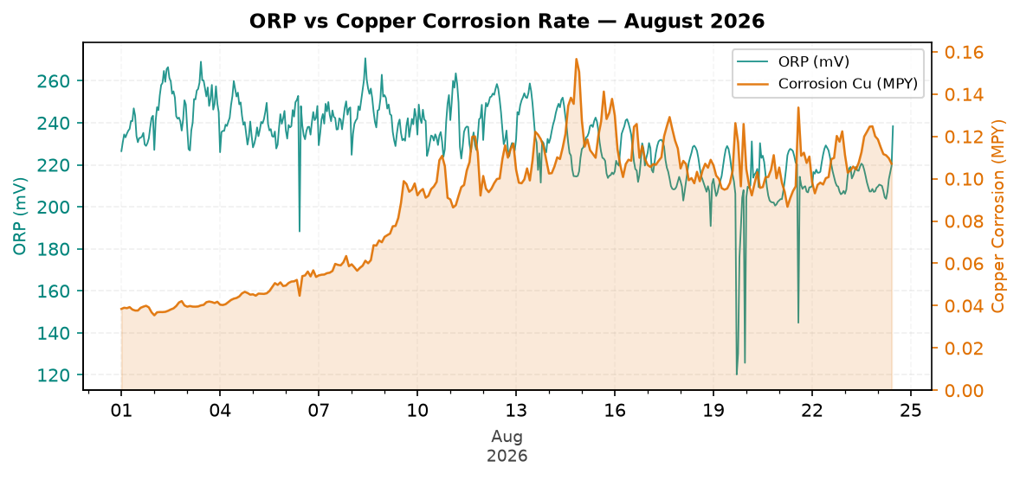
Figure 3: ORP vs Copper Corrosion Rate — August 2026
Comment: Pattern: ORP response is decreasing across the month.
ORP showed a visible spike response pattern during the month without relying on absolute ORP values.
Copper corrosion increased across the month while the ORP pattern changed.
Likely reason: biocide response is present and corrosion inhibitor is preventing a copper upset.
Oxidizing Biocide Pump Relay vs Copper Corrosion
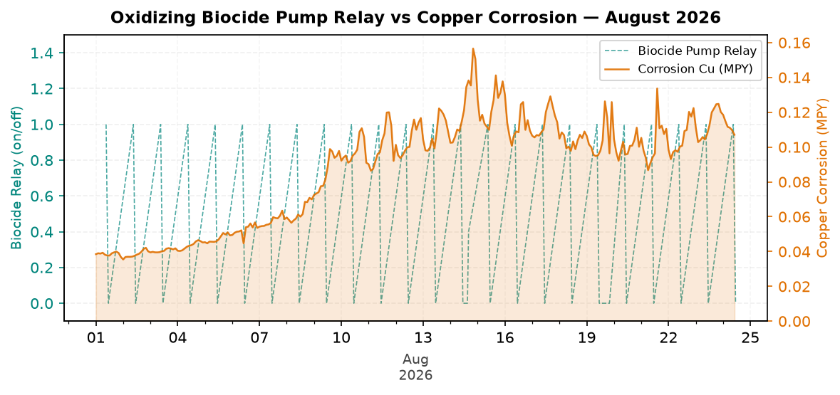
Figure 4: Oxidizing Biocide Pump Relay vs Copper Corrosion — August 2026
Comment: Pattern: biocide feed versus copper corrosion is increasing, but remains good against the target.
Biocide relay activity was present in the monthly trend.
Relay activity decreased across the month when the month is split into early and late periods.
Likely reason: relay feed timing is adequate and copper corrosion remains protected.
Electrode Conductivity
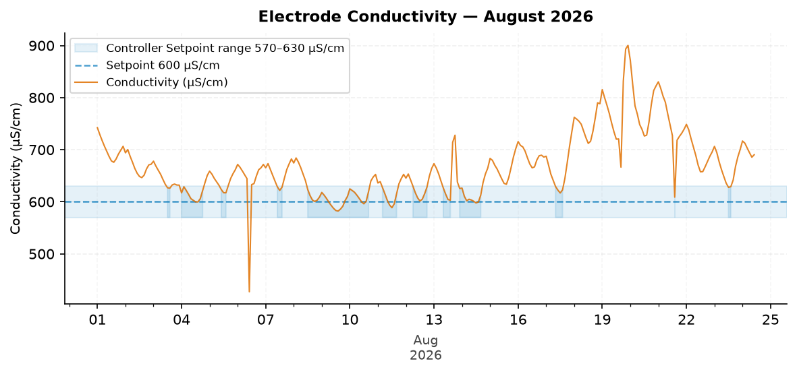
Figure 5: Electrode Conductivity — August 2026
Comment: Pattern: conductivity is increasing and needs attention against the target.
The trend moved from about 633.9 µS/cm at the start to 703.6 µS/cm at the end.
The conductivity average was above the configured range. The monthly in-range performance was 5.4%.
Likely reason: reduced blowdown, higher cycles, evaporation concentration, or concentrated makeup is raising conductivity.

Closing Summary
Overall August performance for Candler main showed Excellent corrosion control and Acceptable microbial control, while conductivity and Traced Product control require follow-up. The primary action is to correct the high conductivity trend first because the Traced Product deviation is linked with conductivity behavior. After cycles and blowdown control are stabilized, product residual and polymer efficiency should be verified during the next service visit.

