BUCKMAN DIGITAL WATER
Monthly Cooling Water Performance Report
Flowserve US Raleigh NC (US)
Reporting Month: August 2026
Customer / Site | System | Controller | Prepared For
Flowserve US Raleigh NC (US) | Cooling Tower | 84253F5EE1C9 | Monthly Performance Review

This report summarises corrosion control, scale control, microbial control, water efficiency, product efficiency, and proactive system support for Flowserve US Raleigh NC (US), August 2026, using controller setpoints, telemetry KPIs, field data, and service note records.

Prepared By | Prepared Date | Report Status
Buckman Digital Water | 08 September 2026 | Draft

Executive Summary
System Health Check
Corrosion Control
Status: Excellent
During the reporting period, the system remained under good control. The mild steel and copper corrosion rates averaged 0.61 mpy and 0.02 mpy, respectively, both of which are well within the recommended limits of <5 mpy and <0.5 mpy.
Scale Control
Status: Acceptable
Traced Product was within the recommended range for 29.9% of the reporting month. Polymer consumption rate averaged 62.5% and increased from 60.2% at the start of the month to 65.6% at the end of the month. Conductivity was within the recommended range for 13.2% of the reporting month. End-of-month Traced Product was 7.0% higher than the setpoint, and conductivity was also not maintained, so the product trend should be treated as conductivity-related until cycles, blowdown, makeup, or dilution behavior is corrected. Conductivity was below its setpoint configuration range for most of the same period, so water loss, dilution, or blowdown/makeup behavior should be inspected during the upcoming service visit. Because polymer consumption increased by more than 5%, phosphate residual will be checked during the upcoming service visit.
Microbial Control
Status: Acceptable
Insufficient ORP spike was observed during oxidizing biocide application, so oxidizing biocide feed response should be reviewed during the upcoming service visit. FRC and dip-slide will be analysed in the upcoming visit to ensure good microbial control.
Water Efficiency
Makeup water conductivity is not available for this site. Actual cycles of concentration cannot be calculated. Makeup conductivity should be captured at the next service visit.
Water efficiency was Critical. Conductivity averaged 891.67 uS/cm against the 930.00-970.00 uS/cm Controller Setpoint range, with only 13.2% of readings in range. Conductivity stayed below the configured range and moved slightly from about 889.4 uS/cm early to 893.9 uS/cm later in the month. Makeup conductivity was not available, so actual cycles of concentration could not be calculated; dilution, water loss, excess blowdown, or makeup changes should be reviewed.
Product Efficiency
Status: Acceptable
Product efficiency needs attention because Traced Product averaged 90.26 ppm against the 85.00 ppm setpoint and the 82.00-88.00 ppm control range, with only 29.9% of readings in range. Because conductivity was also not maintained, product-control review should first be tied to conductivity, blowdown, makeup, dilution, or water-loss behavior before changing feed settings.
Proactive System Support
No service notes were recorded for the August reporting period. Recommended follow-up: Confirm inhibitor residual, inspect for deposit activity, and compare corrosion movement with ORP and product trends. Traced Product was not maintained while conductivity was also not maintained, so treat the product issue as conductivity-related and check cycles, blowdown, makeup, and dilution behavior first. Capture makeup water conductivity during the next service visit so actual cycles of concentration can be verified. Check FRC during the upcoming service visit to confirm oxidizing biocide residual. Measure dip-slide CFU during the upcoming service visit to confirm microbial control. Verify phosphate and silica residuals during the next service visit.

Performance Summary
Controller Setpoints are used as control limits below. % In Range is calculated from the full reporting month telemetry.
Parameter | Context Point | Average | Std Dev | Min | Max | Lower Limit | Upper Limit | % In Range | Status
Corrosion – MS (MPY) | ACM Skid | 0.612 | 0.220 | 0.249 | 1.924 | 0.00 | 3.00 | 100.0% | ✓ Excellent
Corrosion – Cu (MPY) | ACM Skid | 0.020 | 0.010 | 0.000 | 0.092 | 0.00 | 0.50 | 100.0% | ✓ Excellent
Traced Product (ppm) | ACM Skid | 90.262 | 8.982 | 75.095 | 303.263 | 82.0 | 88.0 | 29.9% | ⚠ Acceptable
Conductivity (µS/cm) | ACM Skid | 891.668 | 36.697 | 570.220 | 967.757 | 930 | 970 | 13.2% | ✗ Critical
pH | ACM Skid | 8.835 | 0.151 | 8.412 | 9.055 | 7.50 | 10.00 | 100.0% | ℹ Info
ORP (mV) | ACM Skid | 525.698 | 106.369 | 59.013 | 715.000 | – | – | – | See chart
Turbidity (NTU) | ACM Skid | 5.754 | 0.592 | 3.150 | 6.947 | – | 75.0 | – | ℹ Info
Cell Fouling (%) | ACM Skid | 20.467 | 2.009 | 17.086 | 25.674 | – | 30.0 | – | ℹ Info
FRC | Field Data | Not avail. | – | – | – | – | – | – | ⚠ Check

Charts and Comments
Corrosion Rate
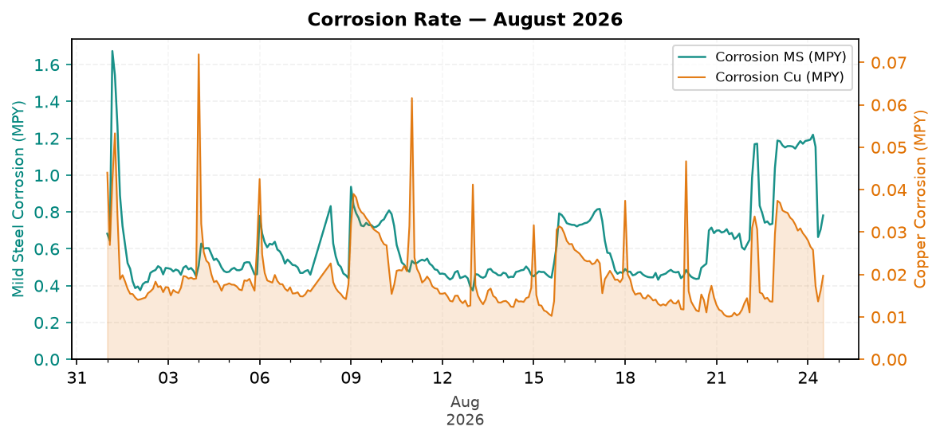
Figure 1: Corrosion Rate — August 2026
Comment: Pattern: corrosion control is increasing, but remains good against the target.
Mild steel corrosion increased across the month, while copper corrosion decreased across the month.
MS was within the 3.0 MPY target, and Cu was within the 0.5 MPY target.
Likely reason: corrosion is still protected, but increasing movement should be checked against product and ORP trends.
Traced Product Control Trend
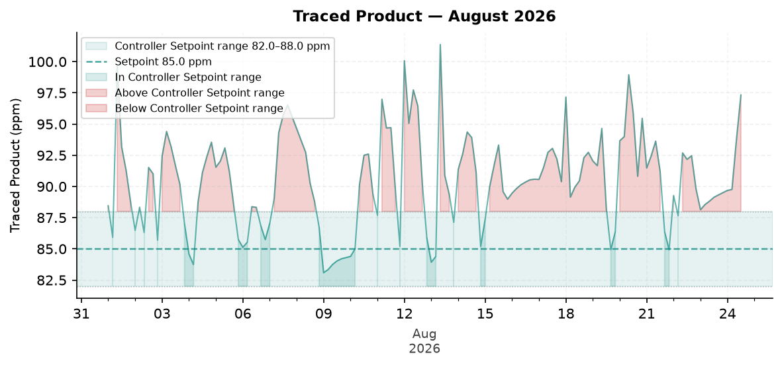
Figure 2: Traced Product — August 2026
Comment: Pattern: Traced Product is still not maintained at the end of the month.
The trend moved from about 89.6 ppm at the start to 90.9 ppm at the end.
The Traced Product average was above the configured range. The monthly in-range performance was 29.9%.
Likely reason: conductivity was not maintained, so the Traced Product variation should be tied to conductivity control before assigning another cause.
ORP vs Copper Corrosion Rate
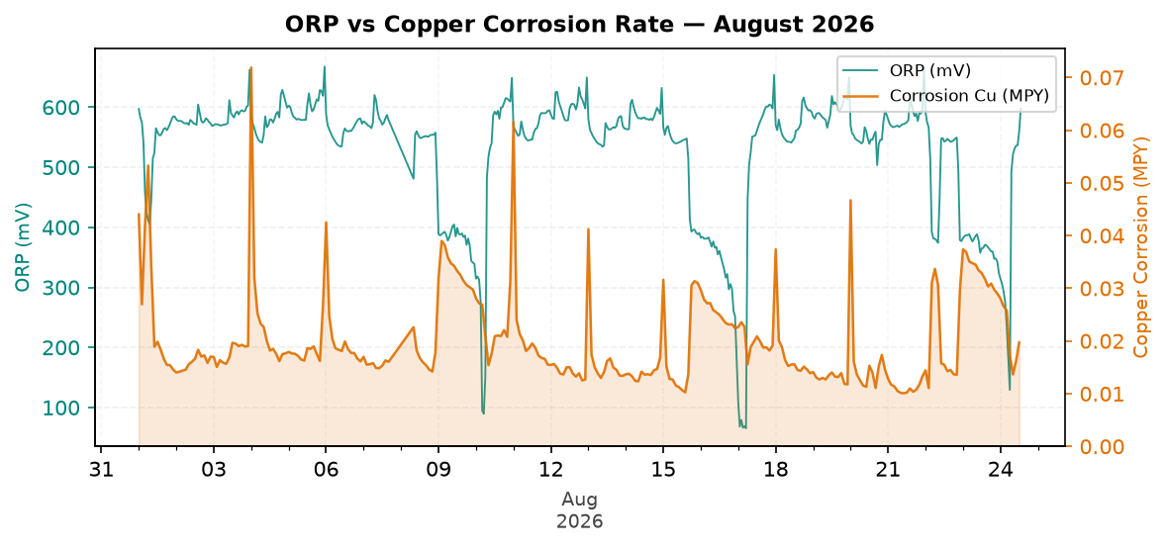
Figure 3: ORP vs Copper Corrosion Rate — August 2026
Comment: Pattern: ORP response is decreasing across the month.
ORP did not show a strong spike response pattern during the month without relying on absolute ORP values.
Copper corrosion decreased across the month while the ORP pattern changed.
Likely reason: biocide feed timing, relay operation, oxidizer inventory, or field FRC residual should be checked.
Oxidizing Biocide Pump Relay vs Copper Corrosion
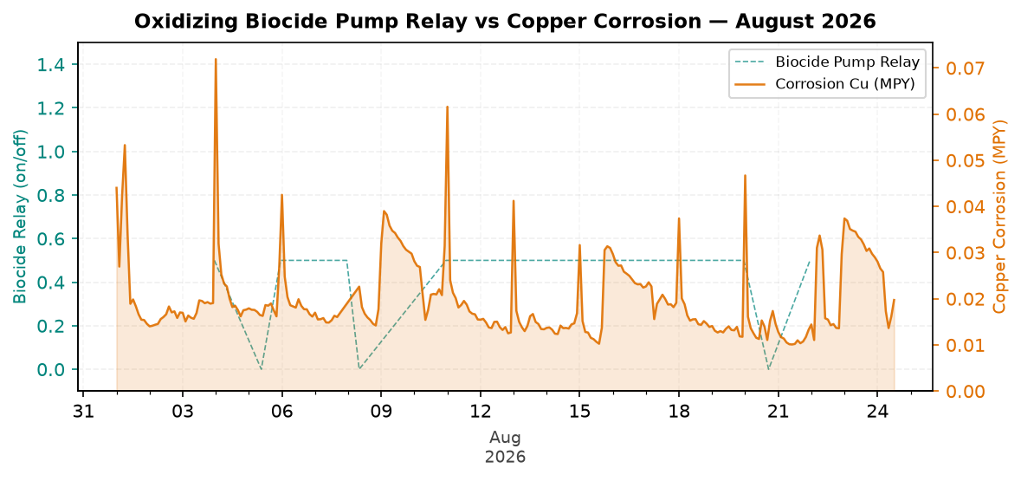
Figure 4: Oxidizing Biocide Pump Relay vs Copper Corrosion — August 2026
Comment: Pattern: biocide feed versus copper corrosion is decreasing, but remains good against the target.
Biocide relay activity was present in the monthly trend.
Relay activity increased across the month when the month is split into early and late periods.
Likely reason: relay feed timing is adequate and copper corrosion remains protected.
Electrode Conductivity
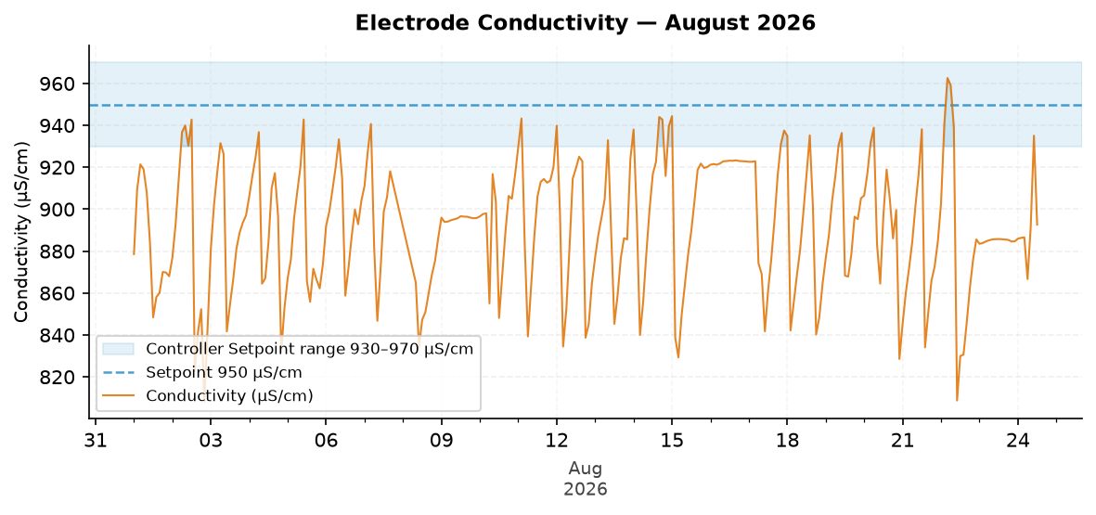
Figure 5: Electrode Conductivity — August 2026
Comment: Pattern: conductivity is stable and needs attention against the target.
The trend moved from about 889.4 µS/cm at the start to 893.9 µS/cm at the end.
The conductivity average was below the configured range. The monthly in-range performance was 13.2%.
Likely reason: dilution, water loss, excess blowdown, or makeup changes are keeping conductivity low.

Closing Summary
Overall August performance for Flowserve showed Excellent corrosion control and Acceptable microbial control, while water efficiency and Traced Product consistency need follow-up. The primary action is to investigate low conductivity and possible dilution, excess blowdown, makeup change, or water loss, then confirm product residual response after conductivity control is stabilized.

