BUCKMAN DIGITAL WATER
Monthly Cooling Water Performance Report
St. Joseph's Hospital Savannah GA (US)
Reporting Month: August 2026
Customer / Site | System | Controller | Prepared For
St. Joseph's Hospital Savannah GA (US) | Cooling Tower | 84253FAB8CC5 | Monthly Performance Review

This report summarises corrosion control, scale control, microbial control, water efficiency, product efficiency, and proactive system support for St. Joseph's Hospital Savannah GA (US), August 2026, using controller setpoints, telemetry KPIs, field data, and service note records.

Prepared By | Prepared Date | Report Status
Buckman Digital Water | 24 August 2026 | Draft

Executive Summary
System Health Check
Corrosion Control
Status: Excellent
The average mild steel corrosion rate was 0.1007 MPY against the target of within 3.0 MPY, and the average copper corrosion rate was 0.0509 MPY against the target of within 0.5 MPY. Status: Excellent. Corrosion control was Excellent because both metals remained well below their target limits during the August reporting period. Mild steel and copper corrosion both decreased across the month, indicating inhibitor residual and operating chemistry kept corrosion protected.
Scale Control
Status: Acceptable
Status: Acceptable. Traced Product was within the Controller Setpoint control range for 52.9% of the reporting month. Polymer consumption rate averaged 75.7% and decreased from 77.6% at the start of the month to 75.3% at the end of the month. End-of-month Traced Product was 5.1% higher than the setpoint, so the pump stroke will be reduced during the upcoming service visit. Conductivity remained stable and maintained within its setpoint configuration range, so the Traced Product deviation is not linked to water loss or dilution and should be addressed through product control optimisation.
Microbial Control
Status: Acceptable
FRC data was not available in the field data for this reporting period and will be checked during the upcoming service visit. The August service note reported low ORP and a negative probe reading, with a recommendation to inspect the probe and check for blockage in the system. ORP did not show a strong spike response pattern, but biocide relay activity was present, supporting an Acceptable microbial control status pending field FRC and dip-slide confirmation.
Dip-slide analysis reported 7 CFU/mL, indicating excellent microbial control.
Water Efficiency
Status: Excellent
MU Conductivity | Target COC | Actual COC | Deviation | Status
224.4 µS/cm | 2.67 | 2.66 | 0.6% | Excellent

Water efficiency was Excellent. Conductivity averaged 596.12 uS/cm against the 570.00-630.00 uS/cm Controller Setpoint range, with 78.8% of readings in range. Conductivity remained stable from about 597.7 uS/cm early in the month to 594.5 uS/cm later in the month. Makeup and blowdown control appear balanced, so tower cycles remained steady.
Product Efficiency
Status: Acceptable
Product efficiency needs continued attention because Traced Product was within the Controller Setpoint range for 52.9% of the reporting month. Polymer consumption rate averaged 75.7%, so phosphate, silica, and product residuals should be verified during the next service visit. Because conductivity was maintained, the product-control review should focus on residual confirmation, pump delivery, fluorometer calibration, and control optimisation rather than water loss.
Proactive System Support
The August service note documented low ORP and a negative probe reading, with a recommendation to inspect the probe and check for blockage in the system. Recommended follow-up: Traced Product was not maintained, so review product feed delivery, pump stroke, inventory, and fluorometer calibration. Check FRC during the upcoming service visit to confirm oxidizing biocide residual. Verify phosphate and silica residuals against the polymer consumption trend during the next service visit.

Performance Summary
Controller Setpoints are used as control limits below. % In Range is calculated from the full reporting month telemetry.
Parameter | Context Point | Average | Std Dev | Min | Max | Lower Limit | Upper Limit | % In Range | Status
Corrosion – MS (MPY) | ACM Skid | 0.101 | 0.012 | 0.100 | 0.326 | 0.00 | 3.00 | 100.0% | ✓ Excellent
Corrosion – Cu (MPY) | ACM Skid | 0.051 | 0.048 | 0.000 | 0.478 | 0.00 | 0.50 | 100.0% | ✓ Excellent
Traced Product (ppm) | ACM Skid | 45.115 | 3.414 | 39.905 | 100.317 | 40.9 | 45.1 | 52.9% | ⚠ Acceptable
Conductivity (µS/cm) | ACM Skid | 596.115 | 23.463 | 495.878 | 684.975 | 570 | 630 | 78.8% | ✓ Excellent
pH | ACM Skid | 9.301 | 0.037 | 9.101 | 9.398 | 7.50 | 10.00 | 100.0% | ℹ Info
ORP (mV) | ACM Skid | 42.501 | 63.463 | -418.219 | 212.546 | – | – | – | See chart
Turbidity (NTU) | ACM Skid | 0.114 | 1.230 | 0.000 | 23.572 | – | 75.0 | – | ℹ Info
Cell Fouling (%) | ACM Skid | 2.979 | 2.065 | 0.609 | 17.275 | – | 30.0 | – | ℹ Info
FRC | Field Data | Not avail. | – | – | – | – | – | – | ⚠ Check

Charts and Comments
Corrosion Rate
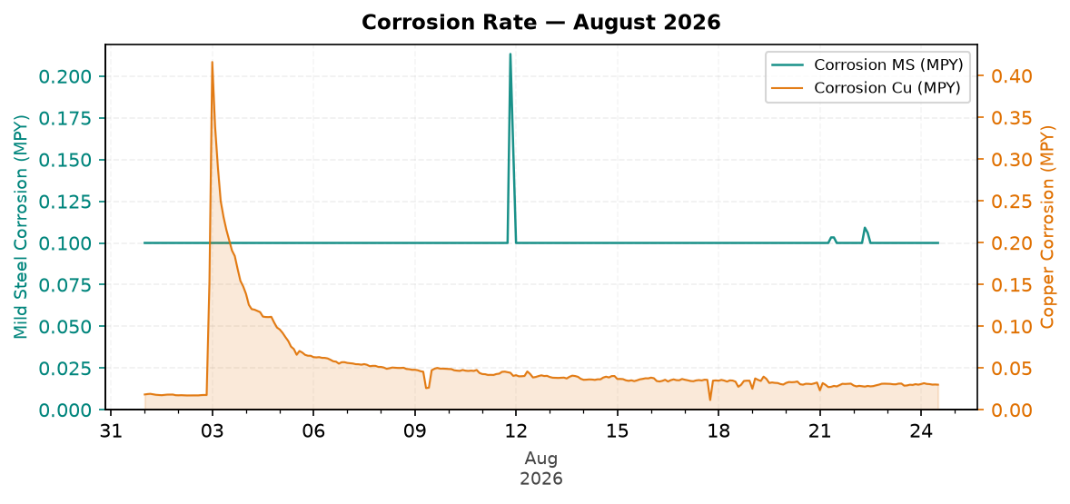
Figure 1: Corrosion Rate — August 2026
Comment: Pattern: corrosion control is decreasing, but remains good against the target.
Mild steel corrosion decreased across the month, while copper corrosion decreased across the month.
MS was within the 3.0 MPY target, and Cu was within the 0.5 MPY target.
Likely reason: inhibitor residual and operating chemistry are keeping corrosion protected.
Traced Product Control Trend
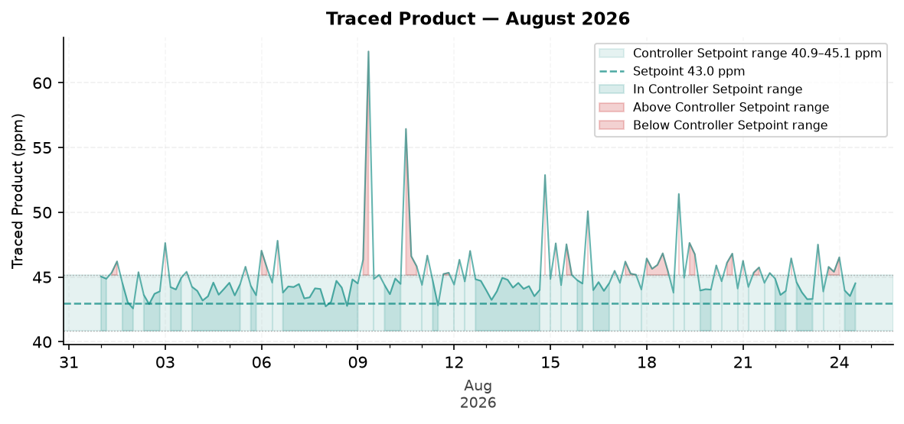
Figure 2: Traced Product — August 2026
Comment: Pattern: Traced Product is still not maintained at the end of the month.
The trend moved from about 45.0 ppm at the start to 45.2 ppm at the end.
The Traced Product average was within the configured range. The monthly in-range performance was 52.9%.
Likely reason: chemical feed and tower cycles are balanced, so scale control remains steady.
ORP vs Copper Corrosion Rate
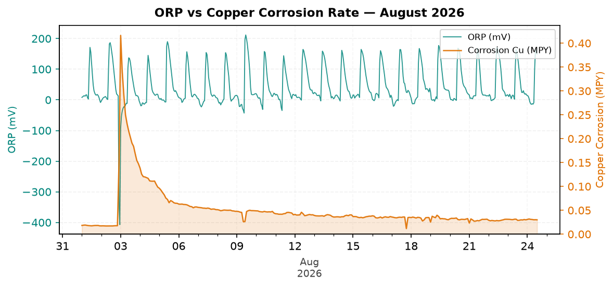
Figure 3: ORP vs Copper Corrosion Rate — August 2026
Comment: Pattern: ORP response is increasing across the month.
ORP did not show a strong spike response pattern during the month without relying on absolute ORP values.
Copper corrosion decreased across the month while the ORP pattern changed.
Likely reason: biocide feed timing, relay operation, oxidizer inventory, or field FRC residual should be checked.
Oxidizing Biocide Pump Relay vs Copper Corrosion
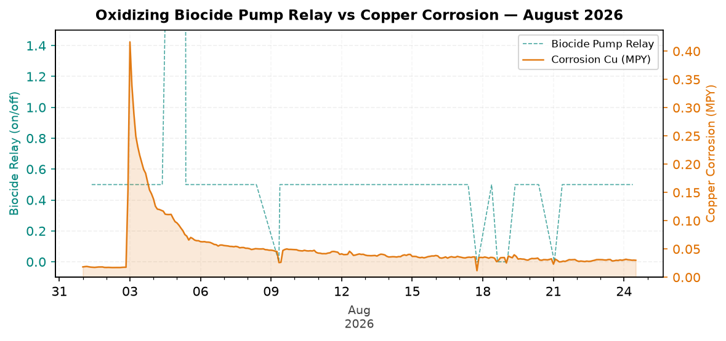
Figure 4: Oxidizing Biocide Pump Relay vs Copper Corrosion — August 2026
Comment: Pattern: biocide feed versus copper corrosion is decreasing, but remains good against the target.
Biocide relay activity was present in the monthly trend.
Relay activity decreased across the month when the month is split into early and late periods.
Likely reason: relay feed timing is adequate and copper corrosion remains protected.
Electrode Conductivity
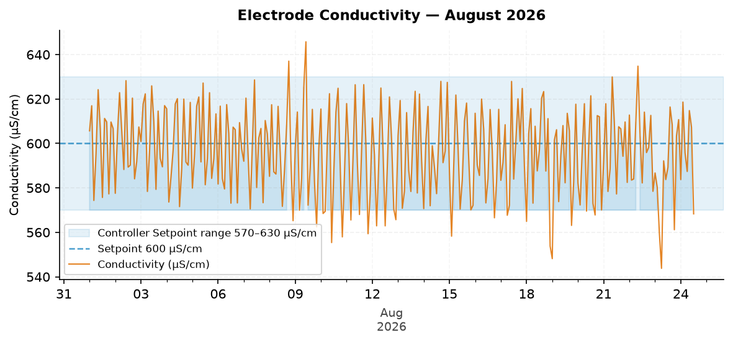
Figure 5: Electrode Conductivity — August 2026
Comment: Pattern: conductivity remains good and stable across the month.
The trend moved from about 597.7 µS/cm at the start to 594.5 µS/cm at the end.
The conductivity average was within the configured range. The monthly in-range performance was 78.8%.
Likely reason: makeup and blowdown control are balanced, so tower cycles remained steady.

Closing Summary
Overall August performance for St. Joseph showed Excellent corrosion control and water efficiency, with Acceptable scale and microbial control. The main follow-up items are to inspect the ORP probe and possible blockage, confirm FRC and dip-slide results, and continue improving Traced Product consistency while conductivity remains stable.

