BUCKMAN DIGITAL WATER
Monthly Cooling Water Performance Report
St. Joseph's Hospital Savannah GA (US)
Reporting Month: July 2026
Customer / Site | System | Controller | Prepared For
St. Joseph's Hospital Savannah GA (US) | Cooling Tower | 84253FAB8CC5 | Monthly Performance Review

This report summarises corrosion control, scale control, microbial control, water efficiency, product efficiency, and proactive system support for St. Joseph's Hospital Savannah GA (US), July 2026, using controller setpoints, telemetry KPIs, field data, and service note records.

Prepared By | Prepared Date | Report Status
Buckman Digital Water | 21 September 2026 | Draft

Executive Summary
System Health Check
Corrosion Control
Status: Excellent
During the reporting period, the system remained under good control. The mild steel and copper corrosion rates averaged 0.10 mpy and 0.02 mpy, respectively, both of which are well within the recommended limits of <5 mpy and <0.5 mpy.
Scale Control
Status: Acceptable
Traced Product was within the recommended range for 47.9% of the reporting month. Polymer consumption rate averaged 83.9% and decreased from 88.3% at the start of the month to 77.8% at the end of the month. Conductivity was within the recommended range for 83.7% of the reporting month. The product was higher than target during the initial part of the month and moved closer to the control band later, but end-of-month control was 49.9% within range, so it is not yet consistently maintained well. The end-of-month traced product deviation from setpoint is minimal, so the control logic will be optimised. Conductivity remained stable and maintained within its setpoint configuration range, so the Traced Product deviation is not linked to water loss or dilution and should be addressed through product control optimisation.
Microbial Control
Status: Acceptable
ORP spike response of at least 50 mV was observed at least two times per week during oxidizing biocide application, indicating good microbial dosage. FRC and dip-slide will be analysed in the upcoming visit to ensure good microbial control.
Water Efficiency
Status: Excellent
MU Conductivity | Target COC | Actual COC | Deviation | Status
224.4 µS/cm | 2.67 | 2.66 | 0.4% | Excellent

Water efficiency was Excellent. Conductivity averaged 597.64 uS/cm against the 570-630 uS/cm Controller Setpoint range, with 83.7% of readings in range. Makeup conductivity was 224.4 uS/cm, target COC was 2.67, and actual COC was 2.66, giving only 0.4% deviation from target.
Product Efficiency
Status: Acceptable
Product efficiency needs continued attention because Traced Product was within the Controller Setpoint range for only 47.9% of the reporting month. Feed control logic should be optimised and product control should be verified during the upcoming service visit.
Proactive System Support
The July service note documented low ORP related to a clogged sample line, plus a recommendation to inspect the dosing pump, probe, onsite inventory, FRC level, and pH probe. Recommended follow-up: Traced Product was not maintained while conductivity was maintained, so verify product inventory, pump prime, feed delivery, and fluorometer calibration. Check FRC during the upcoming service visit to confirm oxidizing biocide residual. Measure dip-slide CFU during the upcoming service visit to confirm microbial control. Verify phosphate and silica residuals during the next service visit.

Performance Summary
Controller Setpoints are used as control limits below. % In Range is calculated from the full reporting month telemetry.
Parameter | Context Point | Average | Std Dev | Min | Max | Lower Limit | Upper Limit | % In Range | Status
Corrosion – MS (MPY) | ACM Skid | 0.100 | 0.000 | 0.100 | 0.100 | 0.00 | 3.00 | 100.0% | ✓ Excellent
Corrosion – Cu (MPY) | ACM Skid | 0.021 | 0.002 | 0.000 | 0.026 | 0.00 | 0.50 | 100.0% | ✓ Excellent
Traced Product (ppm) | ACM Skid | 45.658 | 4.287 | 39.315 | 68.553 | 40.9 | 45.1 | 47.9% | ⚠ Acceptable
Conductivity (µS/cm) | ACM Skid | 597.635 | 22.753 | 467.688 | 662.806 | 570 | 630 | 83.7% | ✓ Excellent
pH | ACM Skid | 9.284 | 0.039 | 9.119 | 9.376 | 7.50 | 10.00 | 100.0% | ℹ Info
ORP (mV) | ACM Skid | 38.306 | 50.107 | -31.119 | 266.546 | – | – | – | See chart
Turbidity (NTU) | ACM Skid | 0.005 | 0.194 | 0.000 | 7.829 | – | 75.0 | – | ℹ Info
Cell Fouling (%) | ACM Skid | 3.659 | 1.216 | 1.236 | 16.780 | – | 30.0 | – | ℹ Info
FRC | Field Data | Not avail. | – | – | – | – | – | – | ⚠ Check

Charts and Comments
Corrosion Rate
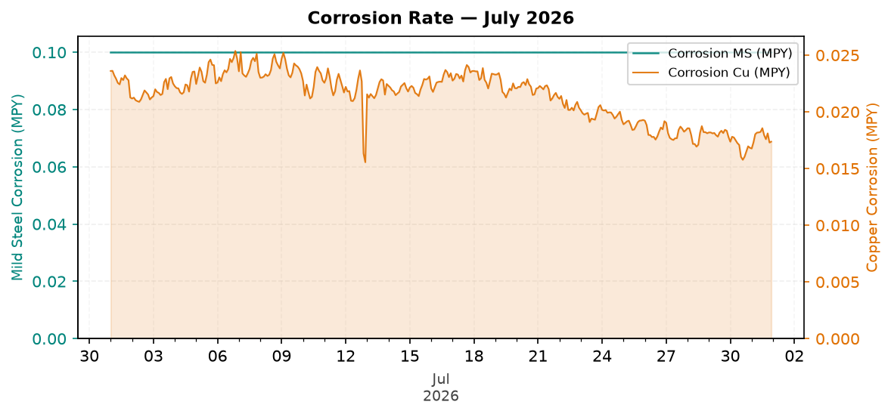
Figure 1: Corrosion Rate — July 2026
Comment: Pattern: corrosion control is decreasing, but remains good against the target.
Mild steel corrosion remained broadly stable across the month, while copper corrosion decreased across the month.
MS was within the 3.0 MPY target, and Cu was within the 0.5 MPY target.
Likely reason: inhibitor residual and operating chemistry are keeping corrosion protected.
Traced Product Control Trend
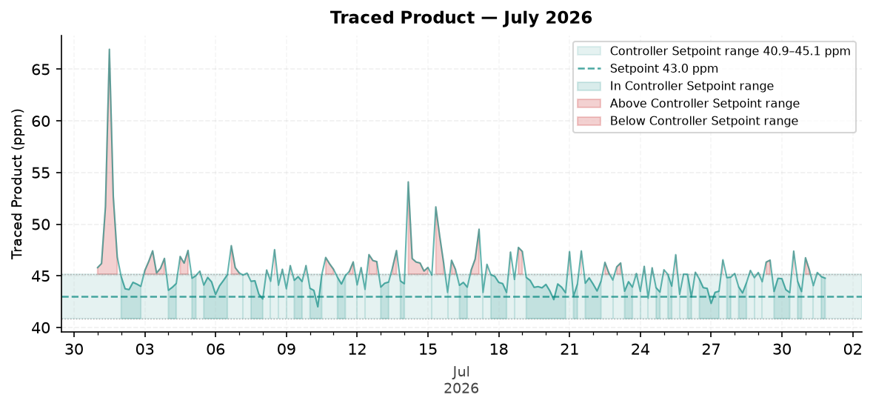
Figure 2: Traced Product — July 2026
Comment: Pattern: Traced Product is still not maintained at the end of the month.
The trend moved from about 46.5 ppm at the start to 44.8 ppm at the end.
The Traced Product average was above the configured range. The monthly in-range performance was 47.9%.
Likely reason: feed is recovering from overfeed; review pump stroke or calibration if it does not return to range.
ORP vs Copper Corrosion Rate
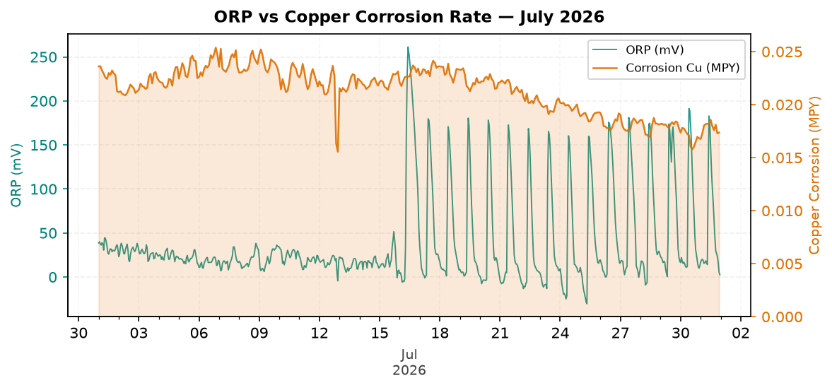
Figure 3: ORP vs Copper Corrosion Rate — July 2026
Comment: Pattern: ORP response is increasing across the month.
ORP showed a visible spike response pattern during the month without relying on absolute ORP values.
Copper corrosion decreased across the month while the ORP pattern changed.
Likely reason: biocide response is present and corrosion inhibitor is preventing a copper upset.
Oxidizing Biocide Pump Relay vs Copper Corrosion
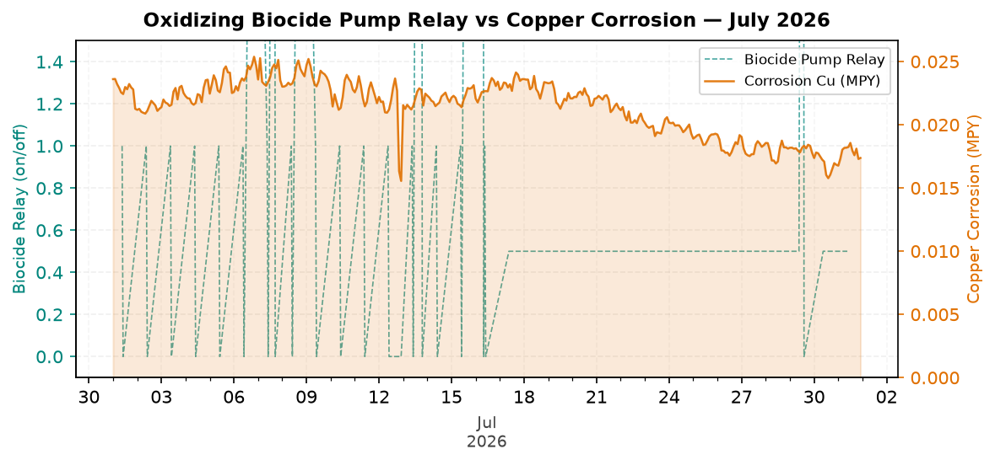
Figure 4: Oxidizing Biocide Pump Relay vs Copper Corrosion — July 2026
Comment: Pattern: biocide feed versus copper corrosion is decreasing, but remains good against the target.
Biocide relay activity was present in the monthly trend.
Relay activity increased across the month when the month is split into early and late periods.
Likely reason: relay feed timing is adequate and copper corrosion remains protected.
Electrode Conductivity
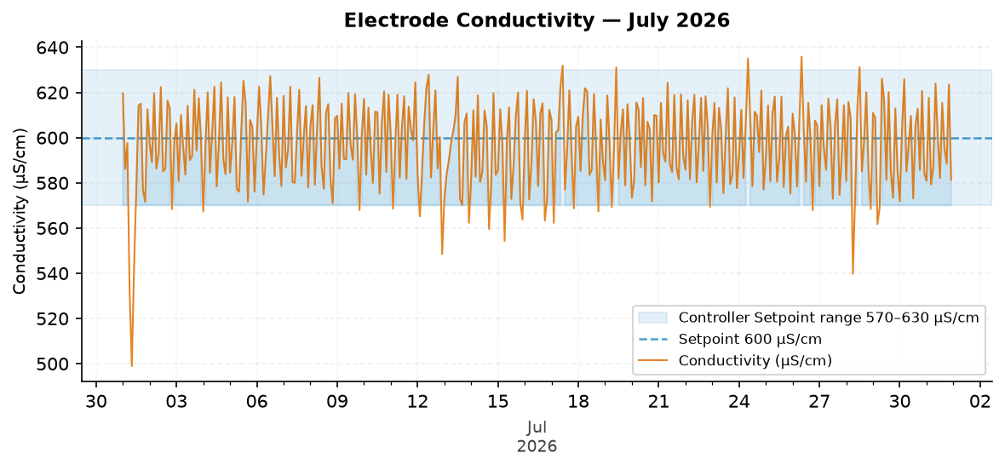
Figure 5: Electrode Conductivity — July 2026
Comment: Pattern: conductivity remains good and stable across the month.
The trend moved from about 596.3 µS/cm at the start to 599.0 µS/cm at the end.
The conductivity average was within the configured range. The monthly in-range performance was 83.7%.
Likely reason: makeup and blowdown control are balanced, so tower cycles remained steady.

Closing Summary
Overall July performance was strong for corrosion control and water efficiency, with conductivity and COC maintained close to target. The main follow-up items are to confirm ORP/FRC recovery after the sample-line service and continue improving Traced Product control until end-of-month performance is consistently maintained.

