BUCKMAN DIGITAL WATER
Monthly Cooling Water Performance Report
Synthomer Chester SC (US)
Reporting Month: August 2026
Customer / Site | System | Controller | Prepared For
Synthomer Chester SC (US) | Cooling Tower | 84253f5ee2c1 | Monthly Performance Review

This report summarises corrosion control, scale control, microbial control, water efficiency, product efficiency, and proactive system support for Synthomer Chester SC (US), August 2026, using controller setpoints, telemetry KPIs, field data, and service note records.

Prepared By | Prepared Date | Report Status
Buckman Digital Water | 22 September 2026 | Draft

Executive Summary
System Health Check
Corrosion Control
Status: Excellent
During the reporting period, the system remained under good control. The mild steel and copper corrosion rates averaged 0.56 mpy and 0.45 mpy, respectively, both of which are well within the recommended limits of <5 mpy and <0.5 mpy.
Scale Control
Status: Acceptable
Traced Product in-range performance could not be calculated for this reporting month. Polymer consumption rate averaged 11.9% and increased from 0.0% at the start of the month to 29.3% at the end of the month. Conductivity was below its setpoint configuration range for most of the same period, so water loss, dilution, or blowdown/makeup behavior should be inspected during the upcoming service visit. Because polymer consumption increased by more than 5%, phosphate residual will be checked during the upcoming service visit.
Microbial Control
Status: Acceptable
ORP spike response of at least 50 mV was observed at least two times per week during oxidizing biocide application, indicating good microbial dosage. FRC and dip-slide will be analysed in the upcoming visit to ensure good microbial control.
Water Efficiency
Status: Acceptable
MU Conductivity | Target COC | Actual COC | Deviation | Status
100.0 µS/cm | 10.0 | 9.58 | 4.2% | Acceptable

System | Current COC | Target COC | Decrease | Annual Water Loss | Estimated Cost
Cooling System | 9.58 | 10.00 | 4.2% | 24,299 gal/year | $1,214.97/year

Because current COC is more than 3% below the value-creation Target COC, estimated avoidable makeup water is 24,299 gallons per annum. At a makeup water cost of $5 per 100 gallons, the estimated annual savings opportunity is $1,214.97.
The average conductivity is 957.6 µS/cm, which is below the recommended setpoint of 1000 µS/cm. Conductivity decreased from about 964.5 µS/cm at the start of the month to 950.7 µS/cm at the end. Water loss was observed from the COC gap, but last-day conductivity averaged 993.1 µS/cm and was maintained at 1000 µS/cm setpoint (+/-3%); continue monitoring blowdown and makeup stability.
Product Efficiency
Status: Acceptable
Product efficiency needs continued monitoring because Traced Product averaged below the 100.00 ppm setpoint while increasing toward target later in the month. Verify phosphate, silica, and product residuals during the next service visit before changing pump stroke or feed logic.
Proactive System Support
Recommended follow-up: Check FRC during the upcoming service visit to confirm oxidizing biocide residual. Measure dip-slide CFU during the upcoming service visit to confirm microbial control. Verify phosphate and silica residuals during the next service visit.

Performance Summary
Controller Setpoints are used as control limits below. % In Range is calculated from the full reporting month telemetry.
Parameter | Context Point | Average | Std Dev | Min | Max | Lower Limit | Upper Limit | % In Range | Status
Corrosion – MS (MPY) | ACM Skid | 0.562 | 0.151 | 0.100 | 1.075 | 0.00 | 3.00 | 100.0% | ✓ Excellent
Corrosion – Cu (MPY) | ACM Skid | 0.451 | 0.450 | 0.051 | 2.339 | 0.00 | 0.50 | 68.9% | ✓ Excellent
Traced Product (ppm) | ACM Skid | 65.575 | 37.820 | 10.195 | 121.620 | – | – | – | ⚠ Acceptable
Conductivity (µS/cm) | ACM Skid | 957.585 | 50.324 | 776.147 | 1054.077 | – | – | – | ⚠ Acceptable
pH | ACM Skid | 9.969 | 0.092 | 9.075 | 10.244 | 7.50 | 10.00 | 62.6% | ℹ Info
ORP (mV) | ACM Skid | 539.114 | 29.202 | 493.796 | 668.612 | – | – | – | See chart
Turbidity (NTU) | ACM Skid | 10.429 | 2.991 | 3.202 | 19.520 | – | 75.0 | – | ℹ Info
Cell Fouling (%) | ACM Skid | 9.166 | 7.177 | 0.000 | 30.391 | – | 30.0 | – | ℹ Info

Charts and Comments
Corrosion Rate
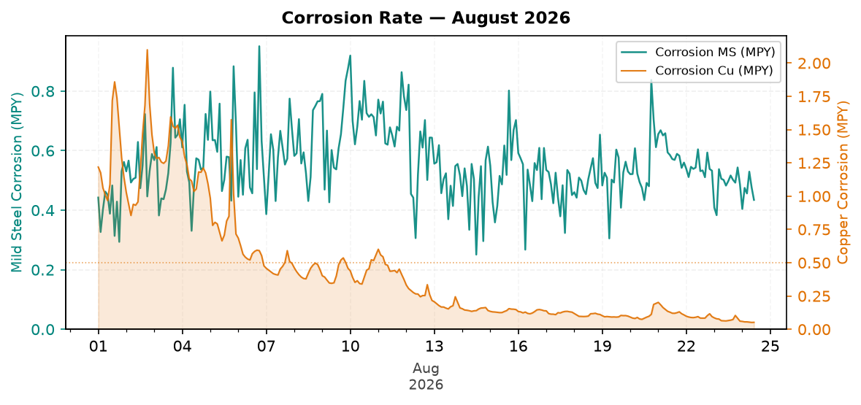
Figure 1: Corrosion Rate — August 2026
Comment: During the reporting period, the system remained under good control. The mild steel and copper corrosion rates averaged 0.56 mpy and 0.45 mpy, respectively, both of which are well within the recommended limits of <5 mpy and <0.5 mpy.
Traced Product Control Trend
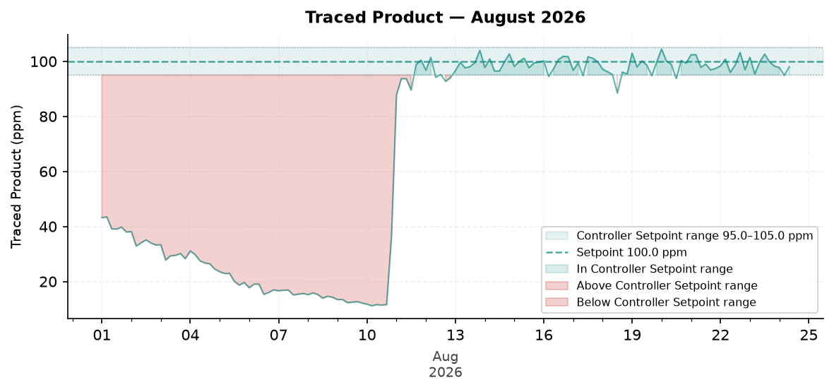
Figure 2: Traced Product — August 2026
Comment: The Traced Product level was maintained below the setpoint until 10 August 2026. Later, the Traced Product level was well maintained at the setpoint of 100.0 ppm. The low Traced Product during the first 10 days can be due to lack of inventory, dosing pump lost prime, or a leak in the pump discharge line.
ORP vs Copper Corrosion Rate
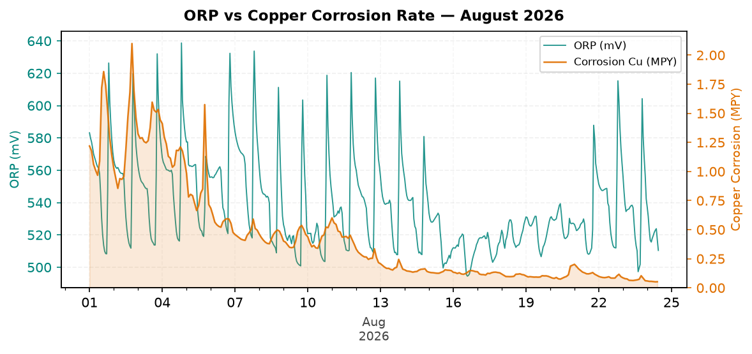
Figure 3: ORP vs Copper Corrosion Rate — August 2026
Comment: ORP did not show more than 50 mV spikes at least three times during the week from 15 August 2026 to 21 August 2026; no slug dosage of biocide is observed during this period. This could be due to lack of inventory, dosing pump lost prime, or a leak in the pump discharge line.
Copper corrosion was above the recommended limit of 0.5 mpy from 01 August 2026 to 06 August 2026.
Traced Product was low during the high copper corrosion period, indicating possible lack of inventory.
Electrode Conductivity
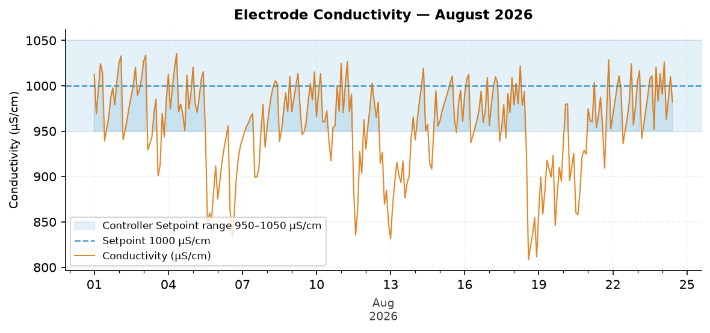
Figure 4: Electrode Conductivity — August 2026
Comment: Pattern: conductivity is decreasing and needs attention against the target.
The trend moved from about 964.5 µS/cm at the start to 950.7 µS/cm at the end.
The conductivity average could not be compared with a configured range. The monthly in-range performance was N/A.
Likely reason: increased makeup, dilution, water loss, or blowdown activity caused the downward movement.
Traced Product vs Cell Fouling
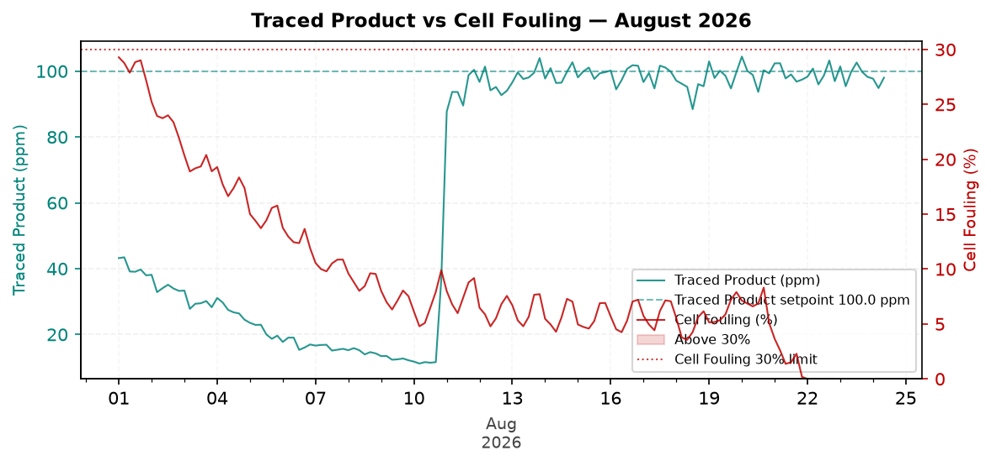
Figure 5: Traced Product vs Cell Fouling — August 2026
Comment: Pattern: cell fouling is decreasing and needs attention against the target.
Cell fouling averaged 9.2% and peaked at 30.4% during the month.
Traced Product increased across the month while cell fouling decreased across the month.
Cell fouling exceeded the 30% limit, so the fluorometer cell should be inspected and cleaned, and sample flow should be confirmed during the next service visit.

Closing Summary
Overall August performance for Synthomer showed Excellent corrosion control and Acceptable microbial and water-efficiency performance. The main follow-up is to confirm product residual recovery toward setpoint and validate field residuals because SCC did not provide lower and upper control limits for percent-in-range calculation. Continued review of conductivity, FRC, dip-slide CFU, phosphate, and silica residuals is recommended during the next service visit.

