BUCKMAN DIGITAL WATER
Monthly Cooling Water Performance Report
Synthomer Chester SC (US)
Reporting Month: May 2026
Customer / Site | System | Controller | Prepared For
Synthomer Chester SC (US) | Cooling Tower | 84253f5ee2c1 | Monthly Performance Review

This report summarises corrosion control, scale control, microbial control, water efficiency, product efficiency, and proactive system support for Synthomer Chester SC (US), May 2026, using controller setpoints, telemetry KPIs, field data, and service note records.

Prepared By | Prepared Date | Report Status
Buckman Digital Water | 24 August 2026 | Draft

Executive Summary
System Health Check
Corrosion Control
Status: Excellent
The average mild steel corrosion rate was 0.24 MPY against the target of within 3.0 MPY, and the average copper corrosion rate was 0.2200 MPY against the target of within 0.5 MPY. Corrosion control status was Good, with both metals operating within the program targets for the reporting period.
Scale Control
Status: Acceptable
Status: Acceptable. Traced Product was within the Controller Setpoint control range for 44.1% of the reporting month. Polymer consumption rate averaged 29.7% and decreased from 33.4% at the start of the month to 30.1% at the end of the month. End-of-month Traced Product was 6.7% higher than the setpoint, and conductivity was also not maintained, so the product trend should be treated as conductivity-related until cycles, blowdown, makeup, or dilution behavior is corrected. Conductivity was below its setpoint configuration range for most of the same period, so water loss, dilution, or blowdown/makeup behavior should be inspected during the upcoming service visit.
Microbial Control
Status: Acceptable
Microbial Control status was Stable. FRC data was not available in the field test data for this reporting period and will be checked during the upcoming service visit. ORP spike response after timer-controlled biocide feed was consistent, indicating the system responded to treatment.
Dip-slide analysis was not available for this reporting period and will be measured during the upcoming service visit.
Water Efficiency
Status: Excellent
MU Conductivity | Target COC | Actual COC | Deviation | Status
100.0 µS/cm | 10.0 | 8.66 | 13.4% | Excellent

Water Efficiency status was Good, with 100.0% of recent conductivity readings within the 950-1050 µS/cm Controller Setpoint range. The 90-day average conductivity was 910.5 µS/cm against a 1000 µS/cm Controller Setpoint, and the actual COC was 9.11 compared with the target COC of 10.0. This represents an 8.9% deviation from target COC, which remains within acceptable performance for the period.
Product Efficiency
Status: Acceptable
Product Efficiency requires attention because Traced Product averaged 106.8 ppm versus the 100.0 ppm Controller Setpoint target and only 10.0% of recent readings were in range, indicating the product is being overdosed. Actual consumption was not available for this reporting period. The dosing pump rate may be too high or the fluorometer may need recalibration; decrease the pump stroke, verify fluorometer calibration with a grab sample, check the dosing valve, and inspect the probe, which will be addressed at the next service visit.
Proactive System Support
Proactive System Support: No alarm data was available for this reporting period, so performance was reviewed against the Ackumen average of 6 alarms per controller. Recommended follow-up: Confirm inhibitor residual, inspect for deposit activity, and compare corrosion movement with ORP and product trends. Traced Product was not maintained while conductivity was also not maintained, so treat the product issue as conductivity-related and check cycles, blowdown, makeup, and dilution behavior first. Check FRC during the upcoming service visit to confirm oxidizing biocide residual. Measure dip-slide CFU during the upcoming service visit to confirm microbial control. Verify phosphate and silica residuals against the polymer consumption trend during the next service visit.

Performance Summary
Controller Setpoints are used as control limits below. % In Range is calculated from the full reporting month telemetry.
Parameter | Context Point | Average | Std Dev | Min | Max | Lower Limit | Upper Limit | % In Range | Status
Corrosion – MS (MPY) | ACM Skid | 0.235 | 0.075 | 0.100 | 0.686 | 0.00 | 3.00 | 100.0% | ✓ Excellent
Corrosion – Cu (MPY) | ACM Skid | 0.265 | 0.225 | 0.000 | 1.561 | 0.00 | 0.50 | 90.0% | ✓ Excellent
Traced Product (ppm) | ACM Skid | 105.869 | 4.218 | 90.998 | 123.945 | 95.0 | 105.0 | 44.1% | ⚠ Acceptable
Conductivity (µS/cm) | ACM Skid | 866.009 | 77.187 | 721.525 | 1062.051 | 950 | 1050 | 19.6% | ✗ Critical
pH | ACM Skid | 9.728 | 0.099 | 9.188 | 9.944 | 7.50 | 10.00 | 100.0% | ℹ Info
ORP (mV) | ACM Skid | 550.913 | 36.295 | 510.623 | 826.388 | – | – | – | See chart
Turbidity (NTU) | ACM Skid | 9.039 | 1.498 | 3.230 | 17.186 | – | 75.0 | – | ℹ Info
Cell Fouling (%) | ACM Skid | 7.070 | 1.465 | 3.051 | 11.756 | – | 30.0 | – | ℹ Info
FRC | Field Data | Not avail. | – | – | – | – | – | – | ⚠ Check

Charts and Comments
Corrosion Rate
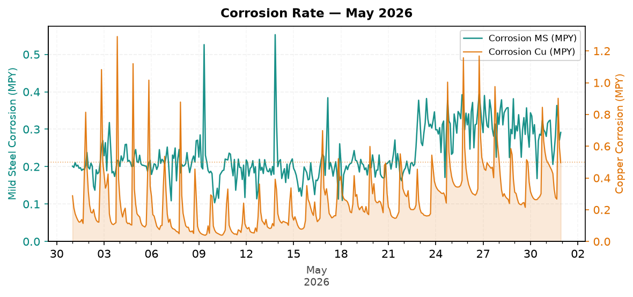
Figure 1: Corrosion Rate — May 2026
Comment: Pattern: corrosion control is increasing, but remains good against the target.
Mild steel corrosion increased across the month, while copper corrosion increased across the month.
MS was within the 3.0 MPY target, and Cu was within the 0.5 MPY target.
Likely reason: corrosion is still protected, but increasing movement should be checked against product and ORP trends.
Traced Product Control Trend
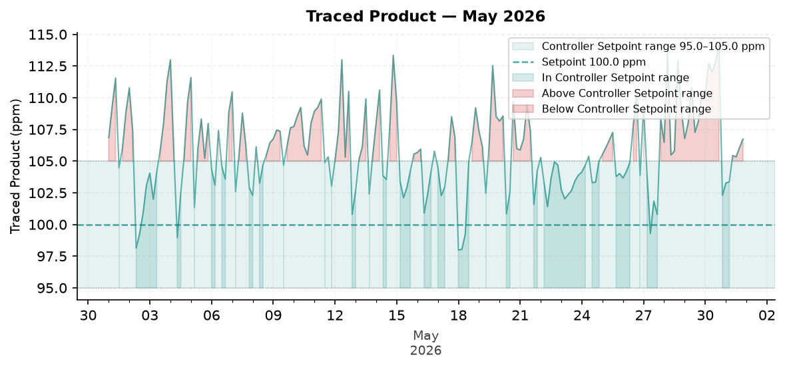
Figure 2: Traced Product — May 2026
Comment: Pattern: Traced Product is still not maintained at the end of the month.
The trend moved from about 106.0 ppm at the start to 105.7 ppm at the end.
The Traced Product average was above the configured range. The monthly in-range performance was 44.1%.
Likely reason: conductivity was not maintained, so the Traced Product variation should be tied to conductivity control before assigning another cause.
ORP vs Copper Corrosion Rate
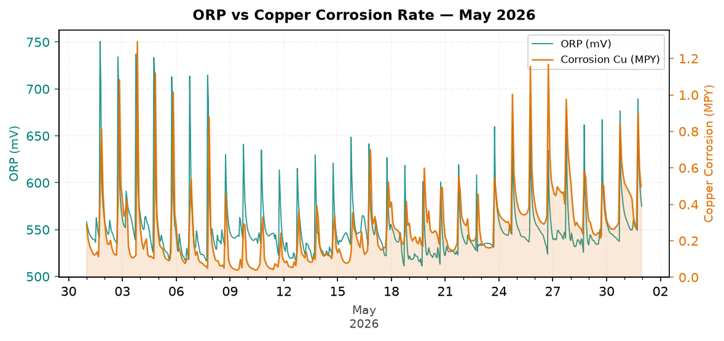
Figure 3: ORP vs Copper Corrosion Rate — May 2026
Comment: Pattern: ORP response is stable across the month.
ORP showed a visible spike response pattern during the month without relying on absolute ORP values.
Copper corrosion increased across the month while the ORP pattern changed.
Likely reason: biocide response is present and corrosion inhibitor is preventing a copper upset.
Oxidizing Biocide Pump Relay vs Copper Corrosion
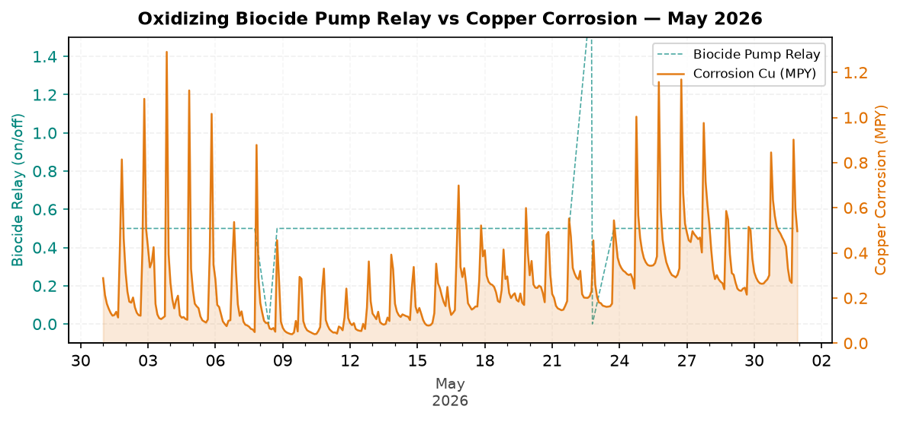
Figure 4: Oxidizing Biocide Pump Relay vs Copper Corrosion — May 2026
Comment: Pattern: biocide feed versus copper corrosion is increasing, but remains good against the target.
Biocide relay activity was present in the monthly trend.
Relay activity increased across the month when the month is split into early and late periods.
Likely reason: relay feed timing is adequate and copper corrosion remains protected.
Electrode Conductivity
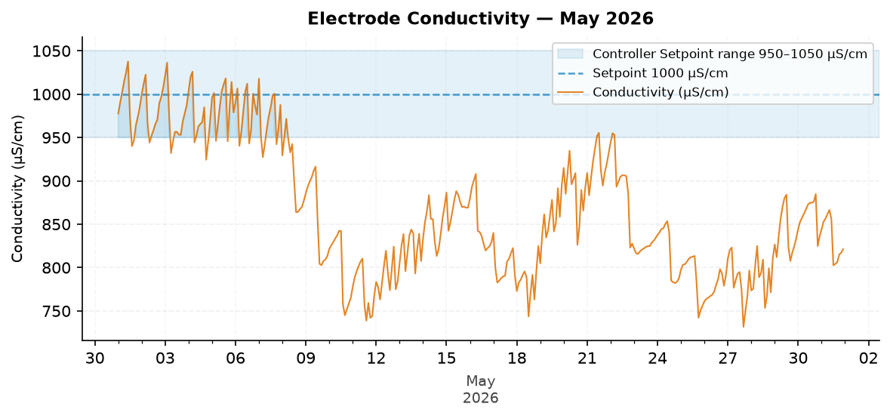
Figure 5: Electrode Conductivity — May 2026
Comment: Pattern: conductivity is decreasing and needs attention against the target.
The trend moved from about 900.9 µS/cm at the start to 831.1 µS/cm at the end.
The conductivity average was below the configured range. The monthly in-range performance was 19.6%.
Likely reason: dilution, water loss, excess blowdown, or makeup changes are keeping conductivity low.

Closing Summary
Overall, the system maintained good corrosion control, stable microbial response, and good water efficiency during May 2026. The primary follow-up item is Traced Product overfeeding, which points to product feed or fluorometer calibration review during the upcoming service visit. Addressing the dosing setup should help return product concentration to the Controller Setpoint range while maintaining the current corrosion, microbial, and water efficiency performance.

