BUCKMAN DIGITAL WATER
Monthly Cooling Water Performance Report
Flowserve US Raleigh NC (US)
Reporting Month: August 2026
Customer / Site | System | Controller | Prepared For
Flowserve US Raleigh NC (US) | Cooling Tower | 84253F5EE1C9 | Monthly Performance Review

This report summarises corrosion control, scale control, microbial control, water efficiency, product efficiency, and proactive system support for Flowserve US Raleigh NC (US), August 2026, using controller setpoints, telemetry KPIs, field data, and service note records.

Prepared By | Prepared Date | Report Status
Buckman Digital Water | 23 September 2026 | Draft

Executive Summary
System Health Check
Corrosion Control
Status: Excellent
During the reporting period, the system remained under good control. The mild steel and copper corrosion rates averaged 0.61 mpy and 0.02 mpy, respectively, both of which are well within the recommended limits of <5 mpy and <0.5 mpy.
Scale Control
Status: Acceptable
Traced Product was within the recommended range for 29.9% of the reporting month. Polymer consumption rate averaged 62.5% and increased from 60.2% at the start of the month to 65.6% at the end of the month. Conductivity was within the recommended range for 13.2% of the reporting month. End-of-month Traced Product was 7.0% higher than the setpoint, and conductivity was also not maintained, so the product trend should be treated as conductivity-related until cycles, blowdown, makeup, or dilution behavior is corrected. Conductivity was below its setpoint configuration range for most of the same period, so water loss, dilution, or blowdown/makeup behavior should be inspected during the upcoming service visit. Because polymer consumption increased by more than 5%, phosphate residual will be checked during the upcoming service visit.
Microbial Control
Status: Acceptable
ORP spike response of at least 50 mV was observed at least two times per week during oxidizing biocide application, indicating good microbial dosage. FRC and dip-slide will be analysed in the upcoming visit to ensure good microbial control.
Water Efficiency
Status: Critical
Makeup water conductivity is not available for this site. Actual cycles of concentration cannot be calculated. Makeup conductivity should be captured at the next service visit.
The average conductivity is 891.7 µS/cm, which is below the recommended setpoint range of 930-970 µS/cm. Conductivity remained broadly stable from about 889.4 µS/cm at the start of the month to 893.9 µS/cm at the end. Recommendation: dilution, water loss, excess blowdown, or makeup changes are keeping conductivity low.
Product Efficiency
Status: Acceptable
Product efficiency needs attention because Traced Product averaged 90.26 ppm against the 85.00 ppm setpoint and the 82.00-88.00 ppm control range, with only 29.9% of readings in range. Because conductivity was also not maintained, product-control review should first be tied to conductivity, blowdown, makeup, dilution, or water-loss behavior before changing feed settings.
The target consumption rate is 4.6 pounds/month whereas current consumption rate is 4.9 pounds. Target and current consumption match for this reporting period.
Proactive System Support
Recommended follow-up: Confirm inhibitor residual, inspect for deposit activity, and compare corrosion movement with ORP and product trends. Traced Product was not maintained while conductivity was also not maintained, so treat the product issue as conductivity-related and check cycles, blowdown, makeup, and dilution behavior first. Capture makeup water conductivity during the next service visit so actual cycles of concentration can be verified. Check FRC during the upcoming service visit to confirm oxidizing biocide residual. Measure dip-slide CFU during the upcoming service visit to confirm microbial control. Verify phosphate and silica residuals during the next service visit.

Performance Summary
Controller Setpoints are used as control limits below. % In Range is calculated from the full reporting month telemetry.
Parameter | Context Point | Average | Lower Limit | Upper Limit | % In Range | Status
Corrosion – MS (MPY) | ACM Skid | 0.612 | 0.00 | 3.00 | 100.0% | ✓ Excellent
Corrosion – Cu (MPY) | ACM Skid | 0.020 | 0.00 | 0.50 | 100.0% | ✓ Excellent
Traced Product (ppm) | ACM Skid | 90.262 | 82.0 | 88.0 | 29.9% | ⚠ Acceptable
Conductivity (µS/cm) | ACM Skid | 891.668 | 930 | 970 | 13.2% | ✗ Critical
pH | ACM Skid | 8.835 | 7.50 | 10.00 | 100.0% | ✓ Excellent
Turbidity (NTU) | ACM Skid | 5.754 | 0.0 | 75.0 | 100.0% | ✓ Excellent
Cell Fouling (%) | ACM Skid | 20.467 | 0.0 | 30.0 | 100.0% | ✓ Excellent

Charts and Comments
Corrosion Rate
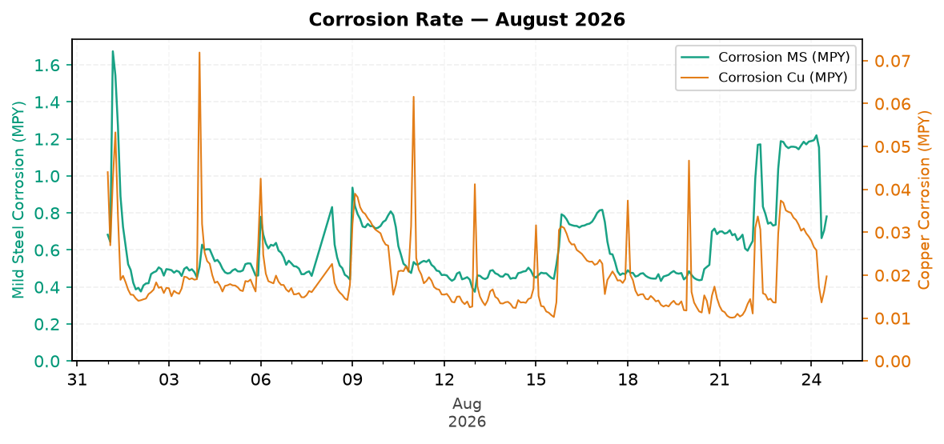
Figure 1: Corrosion Rate — August 2026
Comment: During the reporting period, the system remained under good control. The mild steel and copper corrosion rates averaged 0.61 mpy and 0.02 mpy, respectively, both of which are well within the recommended limits of <5 mpy and <0.5 mpy.
Traced Product Control Trend
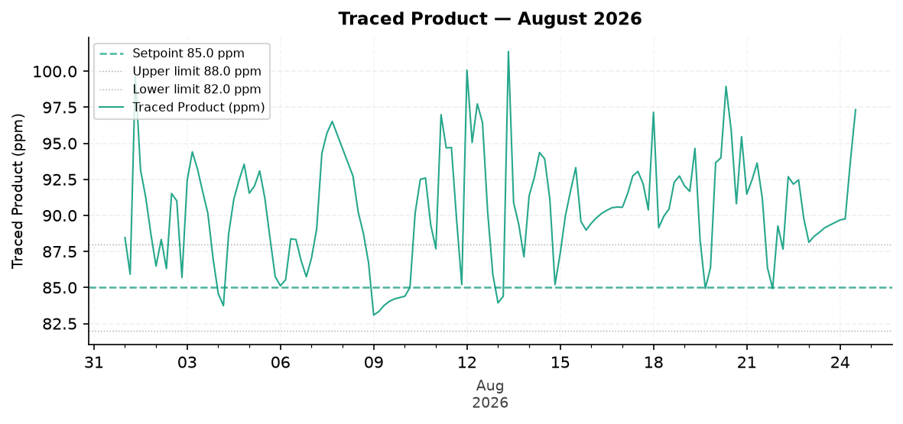
Figure 2: Traced Product — August 2026
Comment: Traced Product was maintained within the setpoint range of 82.0-88.0 ppm only 29.9% of the time.
The trend moved from about 89.6 ppm at the start to 90.9 ppm at the end.
Likely reason: conductivity was not maintained, so the Traced Product variation should be tied to conductivity control before assigning another cause.
ORP vs Copper Corrosion Rate
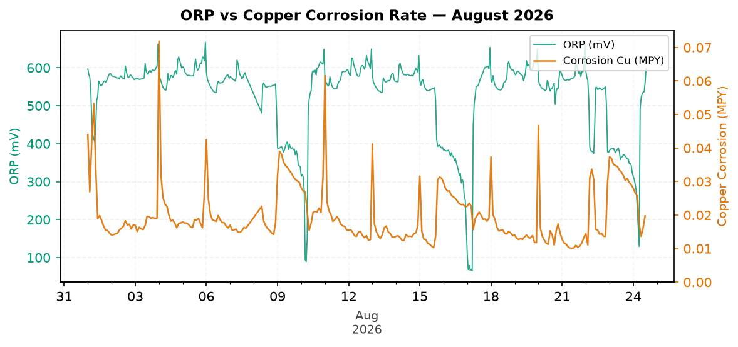
Figure 3: ORP vs Copper Corrosion Rate — August 2026
Comment: ORP did not show more than 50 mV spikes at least three times during the week from 01 August 2026 to 07 August 2026; no slug dosage of biocide is observed during this period. This could be due to lack of inventory, dosing pump lost prime, or a leak in the pump discharge line.
Copper corrosion remained within the recommended limit of 0.5 mpy.
Electrode Conductivity
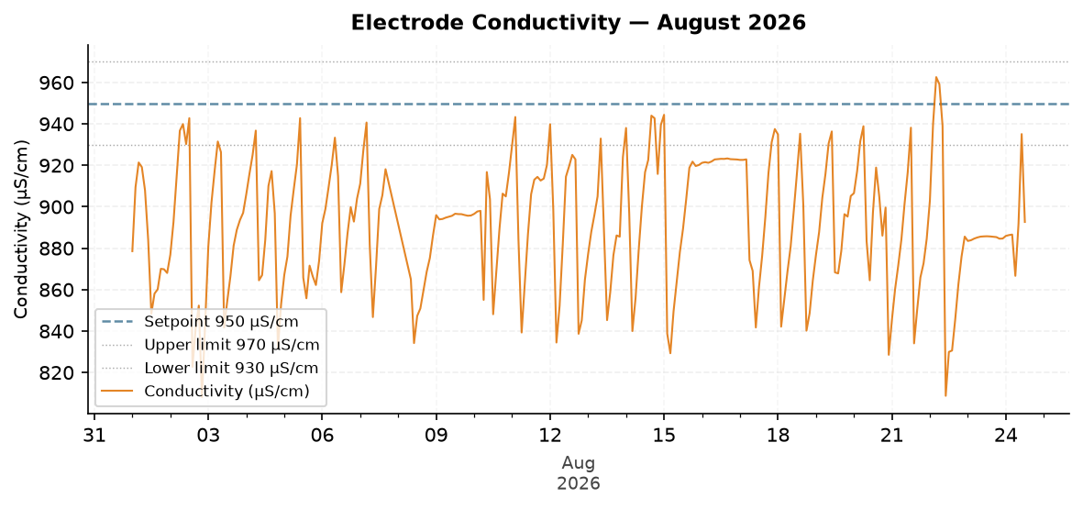
Figure 4: Electrode Conductivity — August 2026
Comment: The average conductivity is 891.7 µS/cm, which is below the recommended setpoint range of 930-970 µS/cm. Conductivity remained broadly stable from about 889.4 µS/cm at the start of the month to 893.9 µS/cm at the end. Recommendation: dilution, water loss, excess blowdown, or makeup changes are keeping conductivity low.

Closing Summary
Overall August performance for Flowserve showed Excellent corrosion control and Acceptable microbial control, while water efficiency and Traced Product consistency need follow-up. The primary action is to investigate low conductivity and possible dilution, excess blowdown, makeup change, or water loss, then confirm product residual response after conductivity control is stabilized.

