BUCKMAN DIGITAL WATER
Monthly Cooling Water Performance Report
Flowserve US Raleigh NC (US)
Reporting Month: July 2026
Customer / Site | System | Controller | Prepared For
Flowserve US Raleigh NC (US) | Cooling Tower | 84253F5EE1C9 | Monthly Performance Review

This report summarises corrosion control, scale control, microbial control, water efficiency, product efficiency, and proactive system support for Flowserve US Raleigh NC (US), July 2026, using controller setpoints, telemetry KPIs, field data, and service note records.

Prepared By | Prepared Date | Report Status
Buckman Digital Water | 06 August 2026 | Draft

Executive Summary
System Health Check
Corrosion Control
Status: Excellent
The average mild steel corrosion rate was 1.10 MPY against the target of within 3.0 MPY, and the average copper corrosion rate was 0.0250 MPY against the target of within 0.5 MPY. Both corrosion indicators were maintained within the required control targets for the July reporting period, supporting excellent asset preservation for the cooling water system.
Scale Control
Status: Acceptable
Traced Product averaged 91.9 ppm against the SCC target range of 82.0-88.0 ppm, with 41.3% of July readings maintained within range. Observation: Traced Product was above the programmed control band for much of the month, indicating scale control needs attention even though part of the month was within range. Conductivity was below its SCC range for most of the same period, which points to water balance or dilution conditions as a likely contributor rather than a simple overfeed condition alone. Recommendation: verify fluorometer calibration, review product feed settings, check pump rate, and inspect water balance and blowdown/makeup behavior during the upcoming service visit.
Microbial Control
Status: Acceptable
FRC data was not available in the MDE data for this reporting period and will be checked during the upcoming service visit. ORP spike response after biocide feed was consistent, indicating the slug dosage of biocide is successful.
Dip-slide analysis was not available for this reporting period and will be measured during the upcoming service visit.
Water Efficiency
Makeup water conductivity is not available for this site. Actual cycles of concentration cannot be calculated. Makeup conductivity should be captured at the next service visit.
Conductivity averaged 890.6 uS/cm against the SCC range of 930-970 uS/cm, with 20.2% of July readings maintained within range. Makeup conductivity was not available, so current COC and target COC could not be calculated; this will be reviewed when makeup conductivity data is available. Because conductivity was below the control range for much of the period, possible water loss, makeup/blowdown behavior, or dilution should be inspected during the upcoming service visit.
Product Efficiency
Status: Acceptable
Traced Product was 41.3% within the SCC control range, and actual product consumption data was not available for direct comparison with target consumption. Product efficiency should be reviewed by checking calibration, feed settings, and pump operation, then comparing actual consumption once usage data is available.
Proactive System Support
No service notes were recorded for this reporting period. The main proactive follow-up items are to verify Traced Product feed and fluorometer calibration, review conductivity control and water balance, and collect FRC during the next service visit.

Performance Summary
Controller Setpoints are used as control limits below. % In Range is calculated from the full reporting month telemetry.
Parameter | Context Point | Average | Std Dev | Min | Max | Lower Limit | Upper Limit | % In Range | Status
Corrosion – MS (MPY) | ACM Skid | 1.102 | 0.688 | 0.247 | 2.818 | 0.00 | 3.00 | 100.0% | ✓ Excellent
Corrosion – Cu (MPY) | ACM Skid | 0.025 | 0.143 | 0.010 | 3.308 | 0.00 | 0.50 | 99.8% | ✓ Excellent
Traced Product (ppm) | ACM Skid | 91.921 | 10.177 | 78.792 | 274.838 | 82.0 | 88.0 | 41.3% | ⚠ Acceptable
Conductivity (µS/cm) | ACM Skid | 890.606 | 44.201 | 453.220 | 988.564 | 930 | 970 | 20.2% | ✗ Critical
pH | ACM Skid | 8.455 | 0.256 | 7.458 | 8.914 | 7.50 | 10.00 | 100.0% | ℹ Info
ORP (mV) | ACM Skid | 549.451 | 152.851 | 78.917 | 819.747 | – | – | – | See chart
Turbidity (NTU) | ACM Skid | 3.160 | 1.191 | 1.643 | 38.197 | – | 75.0 | – | ℹ Info
Cell Fouling (%) | ACM Skid | 15.129 | 3.677 | 10.370 | 23.008 | – | 30.0 | – | ℹ Info
FRC | Field Data | Not avail. | – | – | – | – | – | – | ⚠ Check

Charts and Comments
Corrosion Rate
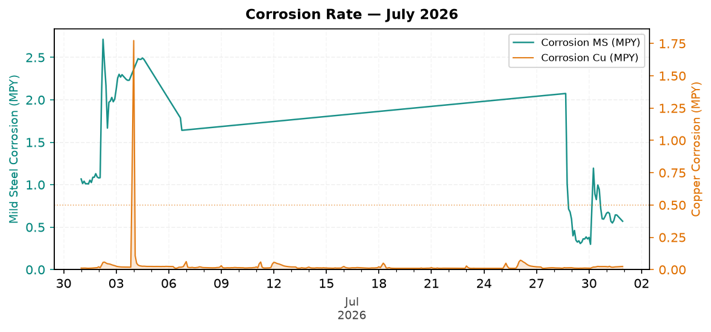
Figure 1: Corrosion Rate — July 2026
Comment: The corrosion trend remained controlled overall, with recent mild steel and copper readings staying comfortably within the required limits.
Traced Product Control Trend
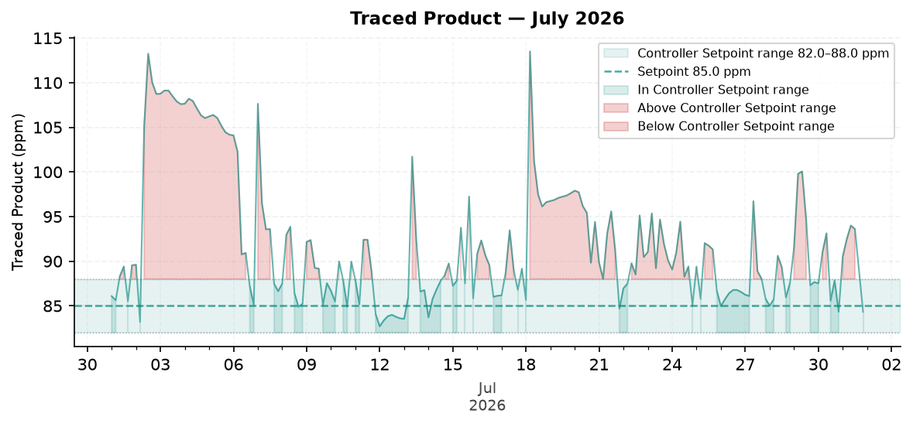
Figure 2: Traced Product — July 2026
Comment: The Traced Product trend spent part of July within range but remained above the SCC control band often enough to require continued review.
ORP vs Copper Corrosion Rate
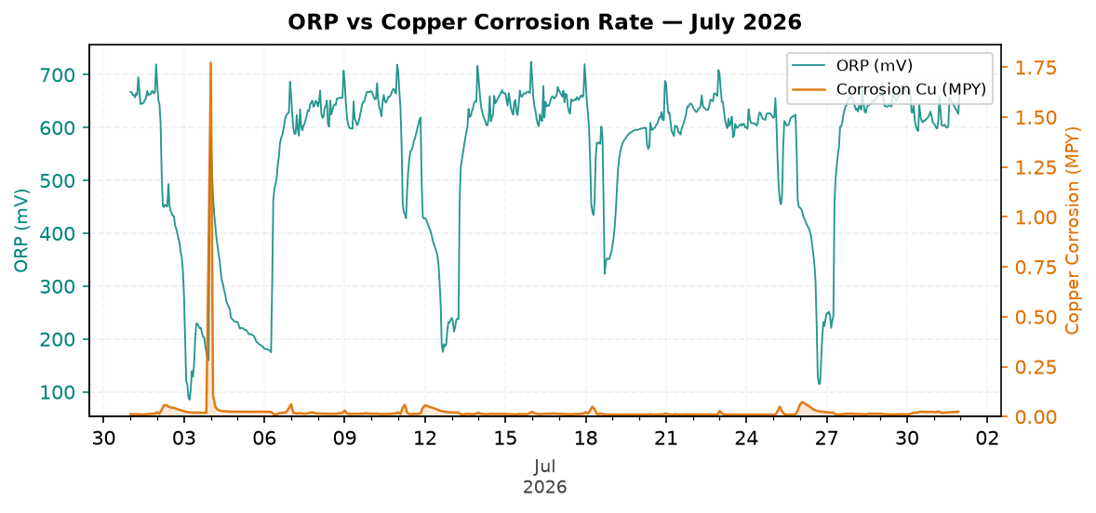
Figure 3: ORP vs Copper Corrosion Rate — July 2026
Comment: The ORP response showed treatment activity without requiring absolute ORP values to be reported in the narrative.
Oxidizing Biocide Pump Relay vs Copper Corrosion
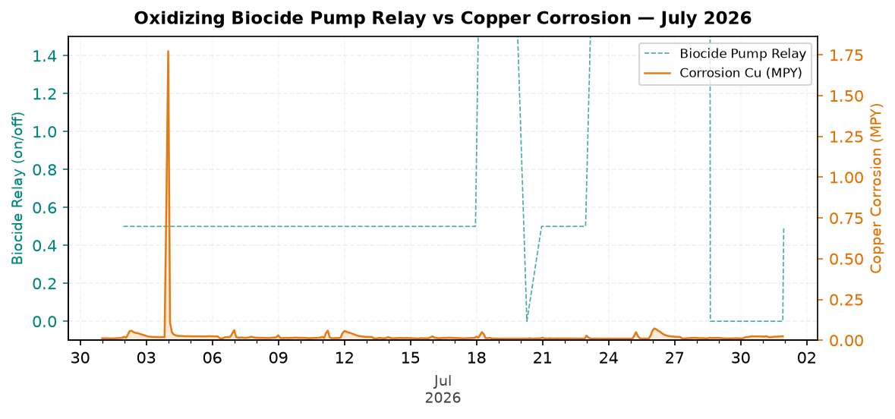
Figure 4: Oxidizing Biocide Pump Relay vs Copper Corrosion — July 2026
Electrode Conductivity
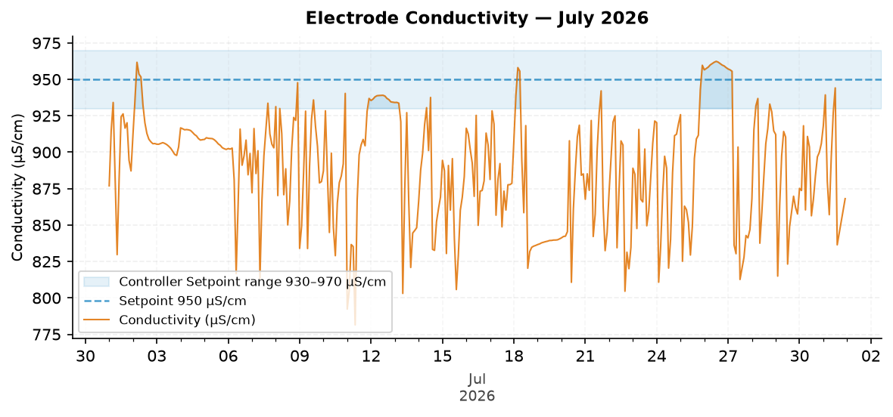
Figure 5: Electrode Conductivity — July 2026
Comment: The conductivity trend was below the SCC range for much of the recent period but moved closer to the control band near the end of the month.

Closing Summary
Flowserve US Raleigh NC maintained good corrosion control during July 2026, while scale control and product efficiency should continue to be reviewed because Traced Product was above the SCC range for part of the month. Conductivity control requires attention due to low in-range performance, and FRC should be measured during the upcoming service visit to confirm microbial control.

