BUCKMAN DIGITAL WATER
Monthly Cooling Water Performance Report
Flowserve US Raleigh NC (US)
Reporting Month: May 2026
Customer / Site | System | Controller | Prepared For
Flowserve US Raleigh NC (US) | Cooling Tower | 84253F5EE1C9 | Monthly Performance Review

This report summarises corrosion control, scale control, microbial control, water efficiency, product efficiency, and proactive system support for Flowserve US Raleigh NC (US) for May 2026, using SCC setpoints, telemetry KPIs, ADE/MDE field data, and service note records.

Prepared By | Prepared Date | Report Status
Buckman Digital Water | 24 June 2026 | Draft

Executive Summary
System Health Check
Corrosion Control
Status: Good
The average mild steel corrosion rate was 1.13 MPY against the target of within 3.0 MPY, and the average copper corrosion rate was 0.2246 MPY against the target of within 0.5 MPY. Both corrosion indicators were well within the industry standard targets, indicating effective corrosion inhibition and stable chemical control for the reporting period.
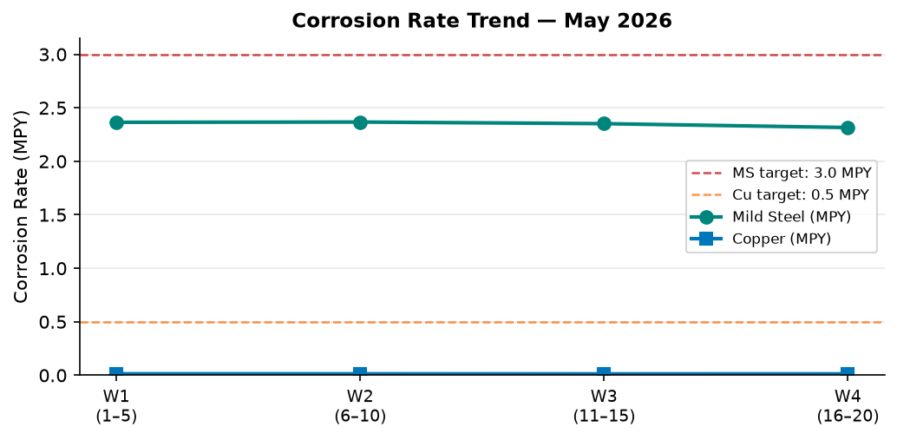
Figure 1: Corrosion Rate Trend — May 2026
Comment: Mild steel corrosion averaged 1.13 MPY and copper corrosion averaged 0.2246 MPY throughout May 2026. Both remained well below the target limits of 3.0 MPY and 0.5 MPY respectively, confirming strong asset protection.
Scale Control
Status: Stable
The Traced Product control trend for May 2026 was stable. The Traced Product was maintained within the SCC target control range of 82.0–88.0 ppm for 35% of recent readings.
Observation: The Traced Product concentration averaged 98.3 ppm, which is above the SCC upper control limit of 88.0 ppm, indicating overfeeding.
Root cause: Conductivity was within its SCC control range for 100% of recent readings and remained stable during this period. This confirms the deviation is a product feed issue rather than a water loss or dilution event.
Recommendation: Check the dosing pump rate and reduce if running above setpoint. Verify fluorometer calibration with a grab sample. Review the dosing schedule and confirm the relay is not running in manual override.
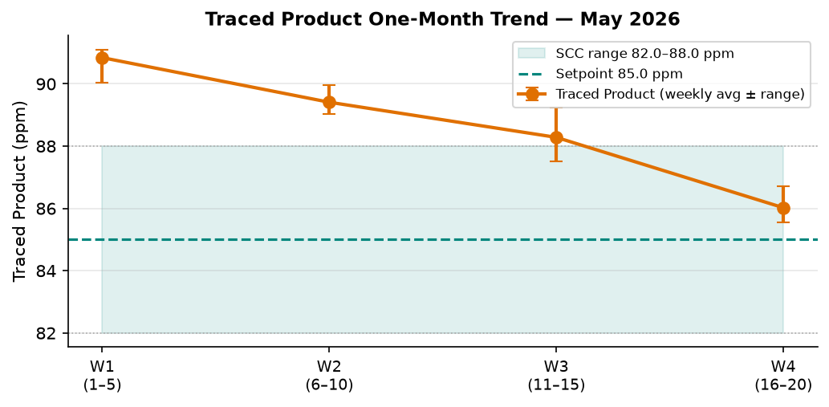
Figure 2: Traced Product One-Month Trend — May 2026
Comment: Traced Product averaged 98.3 ppm against the SCC target of 85.0 ppm (range 82.0–88.0 ppm). Only 35% of recent readings were within the SCC control range. Conductivity was stable, confirming this is a product feed or calibration issue.
Microbial Control
Status: Stable
FRC data was not available in the MDE data for this reporting period and will be checked during the upcoming service visit.
ORP spike response after timer-controlled biocide feed was consistent, indicating the system responded to treatment.
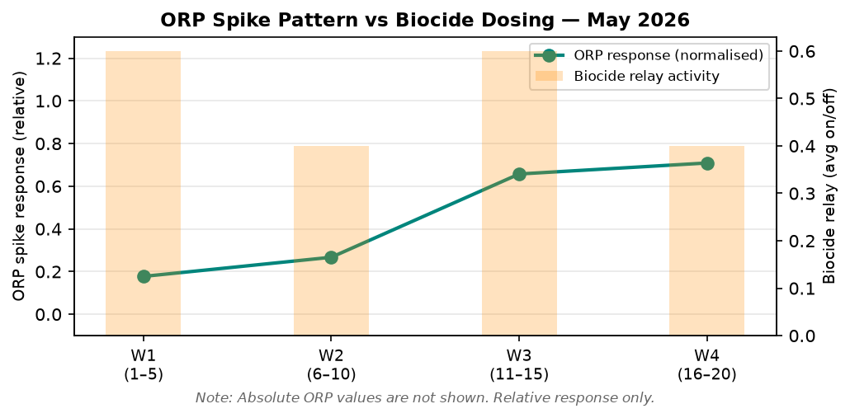
Figure 3: ORP Spike Pattern vs Biocide Dosing — May 2026
Comment: The chart shows relative ORP spike response (no absolute ORP values) against biocide relay activity across May 2026. Consistent spikes after dosing events confirm effective biocide treatment.
Water Efficiency
The SCC conductivity control setpoint is 950 µS/cm (control range 930–970 µS/cm). Conductivity was within the SCC control range for 0% of recent readings, indicating variable blowdown control. The 90-day conductivity average was 897.5 µS/cm. Makeup water conductivity was not available for this period, so actual cycles of concentration could not be calculated. Makeup conductivity should be captured at the next service visit to enable full COC reporting.
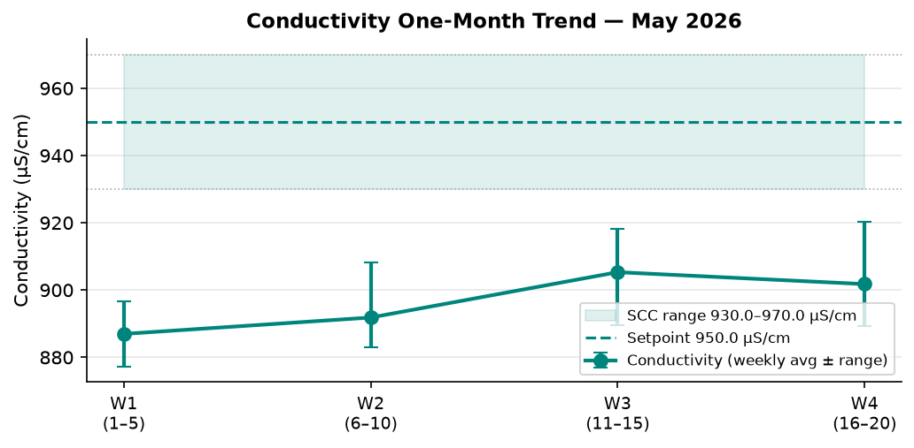
Figure 4: Conductivity vs SCC Setpoint — May 2026
Comment: Conductivity was within the SCC programmed range (930–970 µS/cm) for 0% of recent readings. The broader 90-day mean of 897.5 µS/cm reflects the full period including any transient deviations.
Product Efficiency
The Traced Product concentration averaged 98.3 ppm against the SCC target of 85.0 ppm (control range 82.0–88.0 ppm). The product was within the SCC control range for 35% of recent readings. Actual product consumption data was not available for this period and should be entered to enable full product efficiency reporting.
Proactive System Support
No service notes were recorded for this period. Field actions and observations should be entered following the next site visit. Ackumen records an average of six alarms per controller overall. Alarm data was not available for this reporting period and should be included in the next data fetch.
Follow-up items: confirm FRC at next service visit; review Traced Product dosing pump rate and fluorometer calibration; capture makeup water conductivity.

Performance Summary
SCC setpoints from Cosmos DB are used as control limits. % In Range is calculated from the most recent 20 telemetry readings.
Parameter | Context Point | Lower Limit | Upper Limit | Monthly Average | % In Range | Status
Corrosion Probe — MS (MPY) | ACM Skid | 0.00 | 3.00 | 1.13 | 100% | ✓ Good
Corrosion Probe — Cu (MPY) | ACM Skid | 0.00 | 0.50 | 0.2246 | 100% | ✓ Good
Traced Product (ppm) | ACM Skid | 82.0 | 88.0 | 98.3 | 35% | ⚠ Stable
Conductivity (µS/cm) | ACM Skid | 930 | 970 | 897.5 | 0% | ✓ Action Required
pH | ACM Skid | 7.50 | 10.00 | 8.4 | – | ℹ Informational
ORP | ACM Skid | – | – | Not reported | – | See Microbial Control
Turbidity (NTU) | ACM Skid | – | 75.0 | 2.3 | – | ℹ Informational
Cell Fouling (%) | ACM Skid | – | 30.0 | 10.7 | – | ℹ Informational
FRC | ADE/MDE | – | – | Not available | – | ⚠ Check next visit
Service Notes | N/A | – | – | None documented | – | ℹ No actions available

Final Release Approval Checklist
Review Item | Result
Report is 8 pages or less | ✓ Complete
Page 1 is title page with all metadata | ✓ Complete
Corrosion uses exact wording 'against the target of within' | ✓ Complete
Scale Control covers Traced Product only | ✓ Complete
Scale Control status reflects % in range from recent_20 | ✓ Complete
Scale Control includes Observation + Recommendation if product out of range | ✓ Complete
Microbial Control covers FRC and ORP only | ✓ Complete
FRC sourced from ADE data only | ✓ Complete
FRC noted as missing if not in ADE data | ✓ Complete
ORP spike comment included in Microbial Control | ✓ Complete
No absolute ORP values anywhere | ✓ Complete
Water Efficiency includes conductivity trend chart | ✓ Complete
Product Efficiency uses SCC Product Name | ✓ Complete
Proactive System Support (not 'Alarms') | ✓ Complete
Page 4 Performance Summary table with SCC limits | ✓ Complete
Charts included with Comments | ✓ Complete — 4 charts
Charts are real graphs (not ASCII/tables) | ✓ Complete — matplotlib

Release status: Approved for draft delivery.

