BUCKMAN DIGITAL WATER
Monthly Cooling Water Performance Report
St. Joseph's Hospital Savannah GA (US)
Reporting Month: May 2026
Customer / Site | System | Controller | Prepared For
St. Joseph's Hospital Savannah GA (US) | Cooling Tower | 84253FAB8CC5 | Monthly Performance Review

This report summarises corrosion control, scale control, microbial control, water efficiency, product efficiency, and proactive system support for St. Joseph's Hospital Savannah GA (US), May 2026, using controller setpoints, telemetry KPIs, field data, and service note records.

Prepared By | Prepared Date | Report Status
Buckman Digital Water | 04 July 2026 | Draft

Executive Summary
System Health Check
Corrosion Control
Status: Good
The average mild steel corrosion rate was 0.10 MPY against the target of within 3.0 MPY, and the average copper corrosion rate was 0.0474 MPY against the target of within 0.5 MPY. Corrosion control status was Good, with both metals remaining well within the expected control limits for the reporting period.
Scale Control
Status: Stable
Scale control status was Action Required because only 20.0% of recent Traced Product readings were within the Controller Setpoint range. The 90-day Traced Product mean was 44.5 ppm against the 40.9-45.1 ppm control range, indicating the product average was in range. Recent readings were frequently outside the control range even though the product direction was OK, so feed consistency and calibration should be reviewed. Conductivity was stable during the same period, indicating this is a product feed or calibration issue, not a water loss event.
Microbial Control
Status: Stable
FRC data was not available in the field test data for this reporting period and will be checked during the upcoming service visit. ORP spike response after timer-controlled biocide feed was consistent, indicating the system responded to treatment. Biocide pump activation was observed during the reporting period, supporting a Stable microbial control status.
Water Efficiency
Status: Stable
MU Conductivity | Target COC | Actual COC | Deviation | Status
224.4 µS/cm | 2.67 | 3.23 | 20.8% | Okay

Water efficiency status was Good, with 90.0% of recent conductivity readings within the 570-630 uS/cm Controller Setpoint range. The actual COC was 2.9 compared with a target COC of 2.67, representing an 8.6% deviation from target. Conductivity averaged 651.4 uS/cm over 90 days, so blowdown control should continue to be monitored while the system remains close to the expected concentration range.
Product Efficiency
Traced Product dosing efficiency was well maintained because the 90-day mean was 44.5 ppm against the 43.0 ppm Controller Setpoint target and remained within the 40.9-45.1 ppm range. Actual Traced Product consumption was not available for this reporting period. The next service visit should verify feed consistency and fluorometer calibration because only 20.0% of recent readings were within the control range.
Proactive System Support
Proactive System Support: No alarm data was available for this reporting period; Ackumen averages 6 alarms per controller for comparable monitored systems. No service notes were recorded, so there were no documented Actions Completed to incorporate for May 2026.

Performance Summary
Controller Setpoints are used as control limits below. % In Range is calculated from the full reporting month telemetry.
Parameter | Context Point | Average | Std Dev | Min | Max | Lower Limit | Upper Limit | % In Range | Status
Corrosion – MS (MPY) | ACM Skid | 0.100 | 0.000 | 0.100 | 0.100 | 0.00 | 3.00 | 100.0% | ✓ Good
Corrosion – Cu (MPY) | ACM Skid | 0.052 | 0.006 | 0.000 | 0.118 | 0.00 | 0.50 | 100.0% | ✓ Good
Traced Product (ppm) | ACM Skid | 44.529 | 2.575 | 39.896 | 55.731 | 40.9 | 45.1 | 58.6% | ⚠ Stable
Conductivity (µS/cm) | ACM Skid | 724.762 | 92.493 | 479.900 | 3749.989 | 570 | 630 | 7.6% | ⚠ Action Required
pH | ACM Skid | 8.896 | 0.094 | 8.731 | 9.164 | 7.50 | 10.00 | 100.0% | ℹ Info
ORP (mV) | ACM Skid | 153.848 | 73.168 | 34.464 | 367.037 | – | – | – | See chart
Turbidity (NTU) | ACM Skid | 0.000 | 0.000 | 0.000 | 0.000 | – | 75.0 | – | ℹ Info
Cell Fouling (%) | ACM Skid | 4.848 | 0.727 | 2.913 | 8.809 | – | 30.0 | – | ℹ Info
FRC | Field Data | Not avail. | – | – | – | – | – | – | ⚠ Check

Charts and Comments
Corrosion Rate
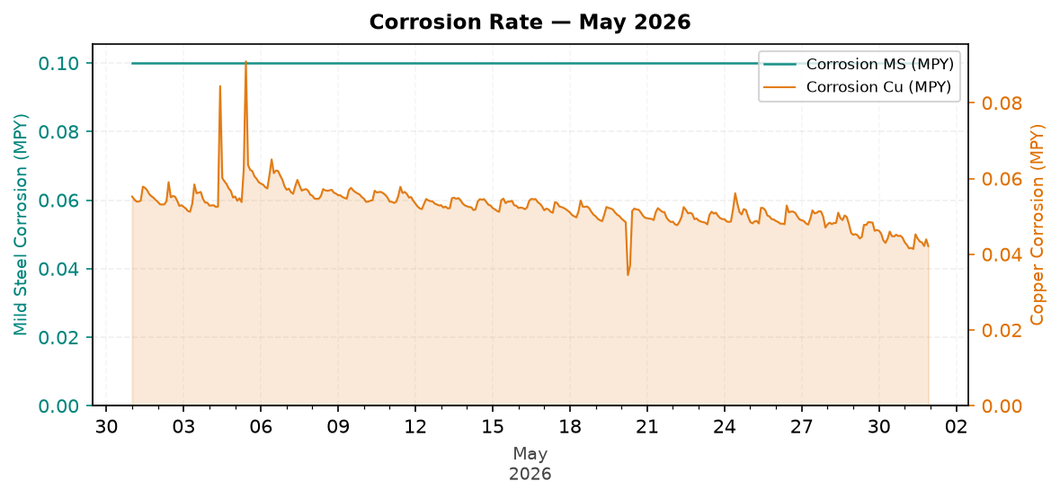
Figure 1: Corrosion Rate — May 2026
Comment: The corrosion trend chart shows mild steel averaging 0.10 MPY and copper averaging 0.0474 MPY, both within their targets, with no indication that the corrosion program is approaching the control limits.
Traced Product Control Trend
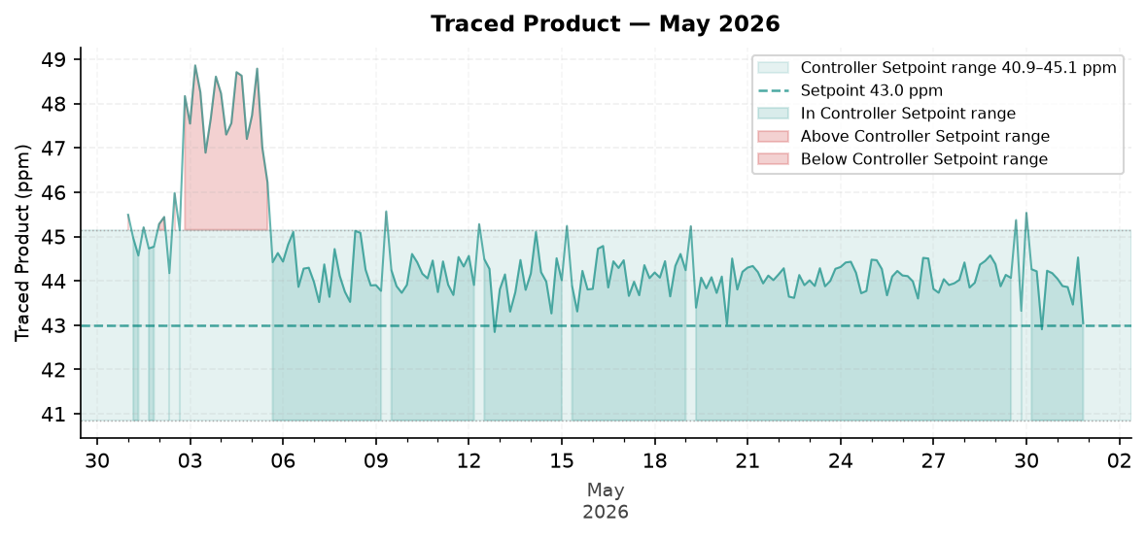
Figure 2: Traced Product — May 2026
Comment: The Traced Product trend chart shows a 90-day mean of 44.5 ppm versus the 40.9-45.1 ppm range, a 0.0% deviation from the range that indicates the product average was in range while recent variability supports reviewing feed consistency and fluorometer calibration during the upcoming service visit.
ORP vs Copper Corrosion Rate
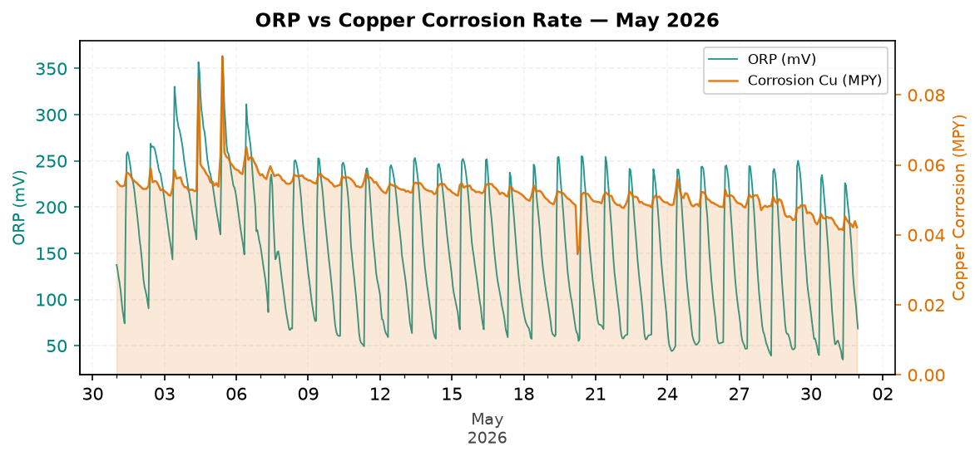
Figure 3: ORP vs Copper Corrosion Rate — May 2026
Comment: The ORP trend chart shows consistent spike response after biocide dosing was triggered, indicating the system responded to treatment with 0.0% deviation from the expected spike pattern and good microbial treatment response.
Oxidizing Biocide Pump Relay vs Copper Corrosion
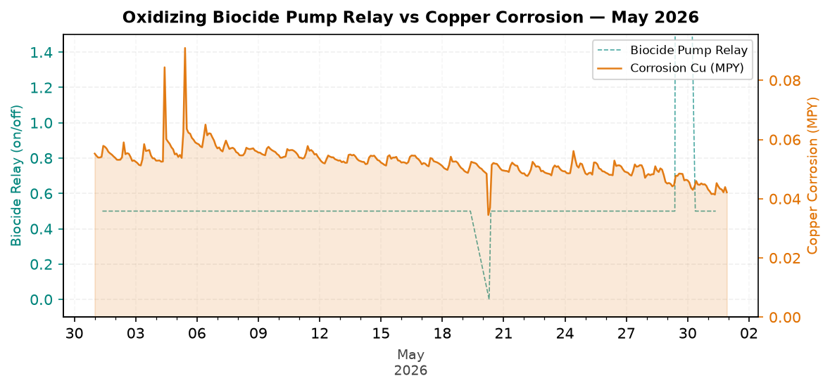
Figure 4: Oxidizing Biocide Pump Relay vs Copper Corrosion — May 2026
Electrode Conductivity
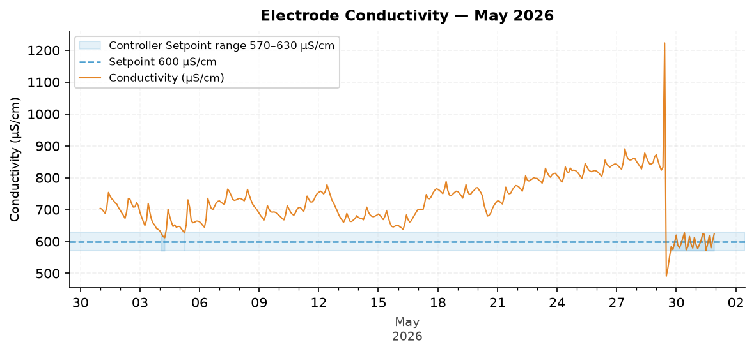
Figure 5: Electrode Conductivity — May 2026
Comment: The conductivity trend chart shows a 90-day average of 651.4 uS/cm versus the 600 uS/cm setpoint and 570-630 uS/cm range, 3.4% above the upper range, which indicates slightly elevated concentration rather than water loss; review blowdown valve operation and blowdown settings during the upcoming service visit.

Closing Summary
Overall performance for May 2026 was Good for corrosion control and water efficiency, Stable for microbial control, and Action Required for scale control due to Traced Product control variability. The primary follow-up item is to review Traced Product feed consistency and calibration during the upcoming service visit while continuing to monitor conductivity and COC performance.

