CHAPTER 1: INTRODUCTION
Introduction to Internship
An internship is an essential part of academic learning that provides practical exposure to real-world industry environments. It helps bridge the gap between theoretical knowledge and practical application, enabling students to develop technical and professional skills required for their careers.
I undertook my internship at DREGAL, where I worked in an offline mode environment. The internship focused on Full Stack Web Development using the MERN stack, along with strengthening core programming and database concepts. During this period, I gained hands-on experience in technologies such as MongoDB, Express.js, React.js, and Node.js, and worked on building a real-time eCommerce web application.
The internship provided an opportunity to understand how modern web applications are developed, how frontend and backend systems interact through APIs, and how databases are managed efficiently. It also helped me improve my problem-solving abilities, debugging skills, and teamwork experience while working on real-world projects.
Overall, this internship played a significant role in enhancing my technical knowledge and preparing me for a professional career in the IT industry.
Objective
The primary objective of this internship is to gain practical knowledge and hands-on experience in Full Stack Web Development using the MERN stack. It aims to bridge the gap between academic learning and real-world application by exposing students to industry-level tools and technologies.
The internship focuses on developing skills in frontend and backend development, understanding how web applications function end-to-end, and learning how to design and integrate RESTful APIs. It also aims to build a strong foundation in database management using MongoDB and improve problem-solving and debugging abilities.
Another key objective is to understand the workflow of real-time projects, including user authentication, payment integration (Razorpay), API communication using Axios, and deployment of applications. Additionally, the internship encourages teamwork, communication skills, and familiarity with professional development practices.
SCOPE OF THE INTERNSHIP
The primary objective of this internship is to gain practical knowledge and hands-on experience in Full Stack Web Development using the MERN stack. It aims to bridge the gap between academic learning and real-world application by exposing students to industry-level tools and technologies.
The internship focuses on developing skills in frontend and backend development, understanding how web applications function end-to-end, and learning how to design and integrate RESTful APIs. It also aims to build a strong foundation in database management using MongoDB and improve problem-solving and debugging abilities.
Another key objective is to understand the workflow of real-time projects, including user authentication, payment integration (Razorpay), API communication using Axios, and deployment of applications. Additionally, the internship encourages teamwork, communication skills, and familiarity with professional development practices.
IMPORTANCE OF THE INTERNSHIP
The internship plays a crucial role in bridging the gap between academic knowledge and practical industry experience. It provides an opportunity to apply theoretical concepts in real-world scenarios, helping in better understanding of how technologies are used in professional environments.
Through this internship, I gained hands-on experience in MERN stack development, which is widely used in modern web applications. It helped me understand the complete development process, including frontend design, backend logic, database management, and API integration.
The internship also enhanced my ability to work on real-time projects, such as developing an eCommerce application with features like user authentication, payment integration, and admin management. This experience improved my problem-solving, debugging, and analytical skills.

CHAPTER 2: ORGANIZATION PROFILE
OVERVIEW OF THE COMPANY
DREGAL is an emerging IT training and development organization located in Mangalore. The company focuses on providing industry-oriented training and internship opportunities to students and graduates in the field of software development and modern technologies.
DREGAL aims to bridge the gap between academic learning and industry requirements by offering hands-on training in areas such as Full Stack Web Development, programming fundamentals, and database management.
The company provides guidance in technologies like MERN stack (MongoDB, Express.js, React.js, Node.js), along with tools and frameworks used in the software industry. It also supports students in developing problem-solving skills, understanding project workflows, and gaining exposure to professional development practices.
VISSION AND MISSION
Vision
To become a leading training and development organization that empowers students with industry-relevant skills and prepares them to excel in the field of information technology and software development.
Mission
- To provide high-quality, practical training in modern technologies such as Full Stack Web Development
- To bridge the gap between academic knowledge and industry requirements through real-time project experience
- To enhance students’ technical, analytical, and problem-solving skills
- To create career-ready professionals by offering hands-on learning and internship opportunities
- To promote continuous learning, innovation, and professional growth among students

SERVICES / PRODUCTS OFFERED
DREGAL primarily focuses on providing training, development, and internship services in the field of information technology. The key services offered by the company include:
- Technical Training Programs
Offers training in modern technologies such as MERN Stack (MongoDB, Express.js, React.js, Node.js), programming fundamentals, and database management.
- Full Stack Web Development
Development of dynamic and responsive web applications using frontend and backend technologies.
- Database Management Services
Training and support in handling databases like MongoDB, including data storage, retrieval, and management.
- API Development and Integration
Building and integrating RESTful APIs for communication between frontend and backend systems.
- Deployment and Maintenance
Guidance on deploying web applications and maintaining them in a production environment.
ORGANIZATIONAL STRUCTURE
DREGAL follows a structured and collaborative organizational model to ensure effective training, development, and project execution. The organization is divided into different roles and responsibilities to maintain smooth workflow and coordination.
TECHNOLOGIES USED IN THE COMPANY
- Frontend: React.js, HTML, CSS, and JavaScript
- Backend: Node.js and Express.js
- Database: MongoDB
- API Communication: Axios
- Authentication & Email Services: Node mailer
- Payment Integration: Razorpay
- Development Tools: VS Code, Git, and GitHub
- Deployment Platforms: Render, Netlify
CHAPTER 3: PROBLEM STATEMENT
DESCRIPTION OF THE PROBLEM ADDRESSED DURING THE INTERNSHIP
During the internship, the primary problem addressed was the development of a real-time eCommerce web application that efficiently manages user interactions, product handling, and online transactions. The challenge was to design and implement a system that provides a smooth and secure shopping experience for users while ensuring proper data management and system performance.
One of the key problems was enabling seamless communication between the frontend and backend, ensuring that user actions such as registration, login, product selection, and cart updates are processed accurately through APIs. Another major challenge was implementing secure user authentication, including OTP verification using email services.
The project also addressed the complexity of managing dynamic data, such as product details, user information, and order processing, using a database like MongoDB. Integrating a reliable payment gateway (Razorpay) for handling secure online transactions was another important aspect.
NEED FOR THE SYSTE/APPLICATION
In today’s digital era, online shopping has become an essential part of daily life, creating a strong demand for efficient and user-friendly eCommerce platforms. The need for this system arises from the requirement to provide users with a convenient way to browse, select, and purchase products from anywhere at any time.
The application is designed to overcome limitations of traditional shopping methods by offering features such as online product browsing, secure user authentication, cart management, and digital payments. It ensures a seamless shopping experience through smooth interaction between frontend and backend systems.
Additionally, there is a need for efficient data management, where product details, user information, and order history can be stored and retrieved effectively using databases like MongoDB. The system also addresses the requirement for secure transactions through payment gateway integration such as Razorpay.
LIMITATIN OF EXISTING SYSTEM
Lack of Convenience
Traditional systems require physical presence, making shopping time-consuming and less flexible.
Limited Accessibility
Users cannot access products or services anytime and from anywhere, reducing overall usability.
Manual Data Management
Maintaining product details, user information, and orders manually increases the chances of errors and inefficiency.
CHAPTER 4: SOFTWARE REQUIREMENT SPECIFICATION ANALYSIS
INTRODUCTION
The Software Requirement Specification (SRS) is a detailed document that describes the functional and non-functional requirements of a system. It serves as a blueprint for the development of the application and provides a clear understanding of how the system should operate
This SRS document outlines the requirements for the development of a MERN-based eCommerce web application inspired by the FirstCry platform. The system is designed to provide users with a seamless online shopping experience, including features such as user authentication, product browsing, cart management, and secure payment processing.
The purpose of this document is to define the system’s behavior, functionalities, and constraints in a structured manner. It acts as a reference for developers, testers, and stakeholders to ensure that the application is developed according to specified requirements.

SCOPE
The scope of this Software Requirement Specification (SRS) covers the development of a full-stack eCommerce web application using the MERN stack (MongoDB, Express.js, React.js, Node.js). The application is designed to provide a complete online shopping platform with both user and admin functionalities.
The system allows users to register and log in using OTP verification, browse products, view product details, add items to the cart, and complete purchases through a secure Razorpay payment gateway. It ensures smooth interaction between the frontend and backend using RESTful APIs and Axios.
From the administrative perspective, the system provides an admin dashboard to manage products, users, and orders efficiently. The admin can perform operations such as adding, updating, and deleting products, as well as monitoring user activities and order status.
Purpose
The purpose of this Software Requirement Specification (SRS) document is to provide a detailed description of the requirements for developing a MERN-based eCommerce web application. It defines the system’s functionalities, performance expectations, and constraints to ensure a clear understanding of how the application should be designed and implemented.
This document serves as a reference for developers, testers, and stakeholders by outlining the complete behavior of the system, including user authentication, product management, cart operations, order processing, and payment integration using Razorpay.
The SRS aims to ensure that all components of the application are developed in a structured and systematic manner, reducing ambiguity and improving communication among team members. It also helps in maintaining consistency throughout the development lifecycle and ensures that the final product meets user requirements and industry standards.
Functional Requirements
1. User Registration and Authentication
- The system should allow users to register using email.
- The system should implement OTP verification using Nodemailer for secure authentication.
- The system should allow users to log in and log out securely.
2. User Management
- The system should store and manage user profile information.
- The system should allow users to update their profile details.
3. Product Management
- The system should display a list of available products.
- The system should allow users to view detailed product information.
- The admin should be able to add, update, and delete products.
4. Search and Filtering
- The system should allow users to search for products.
- The system should provide filtering options based on categories or price.
5. Cart Management
- The system should allow users to add products to the cart.
- The system should allow users to update quantity or remove items from the cart.
- The system should display the total price of items in the cart.
6. Order Management
- The system should allow users to place orders.
- The system should store order details and history.
- The admin should be able to view and manage all orders.
7. Payment Integration
- The system should integrate Razorpay for secure online payments.
- The system should confirm successful or failed transactions.
8. Admin Dashboard
- The system should provide a secure admin login.
- The admin should manage users, products, and orders through the dashboard.
9. API Communication
- The system should use RESTful APIs for communication between frontend and backend.
- The system should use Axios for handling API requests and responses.
10. Error Handling and Validation
- The system should validate user inputs.
- The system should display appropriate error messages for invalid actions
NON-FUNCTIONAL REQUIREMENTS
1. Performance Requirements
- The system should respond to user requests within a few seconds.
- It should handle multiple users simultaneously without significant performance degradation.
2. Security Requirements
- The system should ensure secure user authentication using OTP verification.
- Sensitive data such as user details and payment information should be protected.
- Secure communication should be maintained between frontend and backend.
3. Usability Requirements
- The application should have a user-friendly and intuitive interface.
- It should be easy to navigate for users of all experience levels.
- The design should be responsive and accessible across different devices.
4. Reliability Requirements
- The system should function consistently without failures.
- It should handle errors gracefully and provide proper feedback to users.
5. Scalability Requirements
- The system should be able to handle increasing numbers of users and data.
- It should support future enhancements and additional features.
FEASIBILITY STUDY
1. Technical Feasibility
The proposed system is technically feasible as it uses modern and widely adopted technologies such as MongoDB, Express.js, React.js, and Node.js (MERN stack). These technologies are well-supported, scalable, and suitable for developing dynamic web applications.
The required development tools such as VS Code, Git, and deployment platforms (Render/Netlify) are easily accessible. The system does not require high-end hardware, making it feasible to develop and deploy. Additionally, sufficient learning resources and community support are available, which makes implementation manageable.
2. Economical Feasibility
The system is economically feasible as it involves minimal cost. Most of the technologies and tools used, including the MERN stack, are open-source and free to use.
Development can be carried out using existing systems without requiring expensive infrastructure. Deployment platforms also offer free tiers, reducing overall costs. Hence, the project can be completed within a limited budget.
3. Operational Feasibility
The system is operationally feasible as it is designed to be user-friendly and easy to operate. Users can easily navigate through the application for browsing products, adding items to the cart, and making purchases.
REQUIREMENT ANALYSIS
Requirement analysis is the process of identifying, gathering, and analyzing the needs and expectations of users to develop an effective system. It helps in understanding what the application should do and how it should perform.
The system requires a user-friendly interface where users can easily register, log in using OTP verification, browse products, and make purchases. It also requires efficient frontend and backend integration using APIs to ensure smooth communication between different components of the application.
From a functional perspective, the system must support features such as product management, cart operations, order processing, and secure payment integration using Razorpay. It should also provide an admin dashboard for managing products, users, and orders.
From a technical perspective, the system requires the use of React.js for frontend development, Node.js and Express.js for backend services, and MongoDB for database management. Tools like Axios are needed for API communication, and Nodemailer is required for implementing OTP-based authentication.
MODULES DESCRIPTION
1. User Module
This module handles user-related functionalities such as registration, login, and authentication using OTP verification (Nodemailer). It manages user profiles, stores user details, and allows users to securely access the application. It also maintains user-related data such as order history and personal information.
2. Product Module
The Product Module manages all product-related operations. It allows users to view product listings, detailed descriptions, prices, and images. The admin can add, update, and delete products. This module interacts with MongoDB to store and retrieve product data efficiently.
3. Cart Module
The Cart Module enables users to add products to their cart, update quantities, and remove items. It calculates the total cost of items and prepares the data for the checkout process. This module ensures a smooth shopping experience.
4. Order Module
This module handles order placement and management. It stores order details, processes user purchases, and maintains order history. It also allows users and admins to track order status.
5. Payment Module
The Payment Module integrates the Razorpay payment gateway to facilitate secure online transactions. It handles payment processing, verifies transactions, and updates order status based on payment success or failure.
6. Admin Module
The Admin Module provides a dashboard for managing the entire application. It allows the admin to manage users, products, and orders. The admin can monitor activities, update product details, and ensure smooth system operation.
7. API Integration Module
This module manages communication between the frontend and backend using RESTful APIs and Axios. It ensures efficient data exchange and smooth functionality across the application.
CHAPTER 5: SYSTEM DESIGN
System design is a crucial phase in the software development process where the overall architecture and structure of the system are defined. It involves designing the system components, their interactions, and the data flow to ensure efficient and reliable application performance.
The proposed system is a MERN-based eCommerce web application designed to provide a seamless online shopping experience. The system follows a client-server architecture, where the frontend is developed using React.js and the backend is built using Node.js and Express.js. These components communicate through RESTful APIs, with Axios used for handling HTTP requests.
The system design also includes the use of MongoDB as the database for storing user information, product details, and order data. Additional integrations such as Nodemailer for OTP-based authentication and Razorpay for secure payment processing are incorporated into the design.
The design ensures modularity by dividing the application into different components such as user, product, cart, order, and admin modules. This modular approach improves maintainability, scalability, and overall system efficiency.

SCOPE
The scope of the system design defines the overall structure and boundaries of the MERN-based eCommerce web application. It focuses on designing an efficient and scalable architecture that supports both frontend and backend functionalities.
The system design covers the development of a client-server architecture, where the frontend is built using React.js to provide an interactive user interface, and the backend is developed using Node.js and Express.js to handle business logic and API services. Communication between these components is achieved through RESTful APIs using Axios.
The scope includes the design of various modules such as User, Product, Cart, Order, Payment, and Admin modules, ensuring proper interaction and data flow between them. It also involves designing the database structure using MongoDB for efficient storage and retrieval of user data, product details, and transaction records.
PURPOSE
The purpose of the system design is to provide a structured framework for developing the MERN-based eCommerce web application. It defines how different components of the system are organized and how they interact to achieve the desired functionality.
The system design aims to ensure efficient communication between the frontend (React.js) and backend (Node.js and Express.js) through well-defined RESTful APIs. It also outlines the design of the MongoDB database for effective storage and management of user data, product information, and order details.
Additionally, the purpose of the design is to incorporate essential features such as user authentication using OTP (Nodemailer), secure payment integration using Razorpay, and a centralized admin dashboard for system management.
The design focuses on achieving key qualities such as scalability, security, performance, and maintainability, ensuring that the application can handle real-world usage efficiently.

SYSTEM ARCHITECTURE
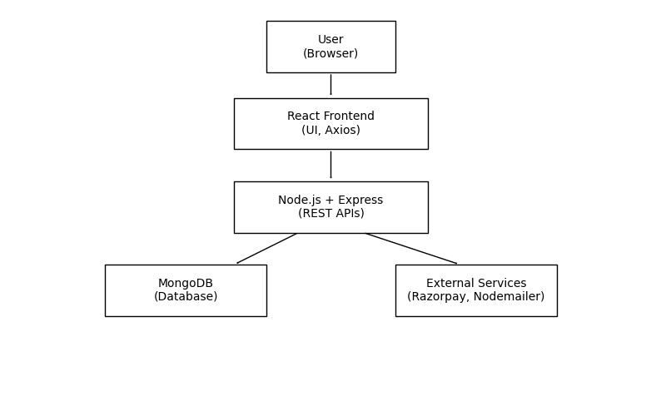
USER INTERFACE DESIGN
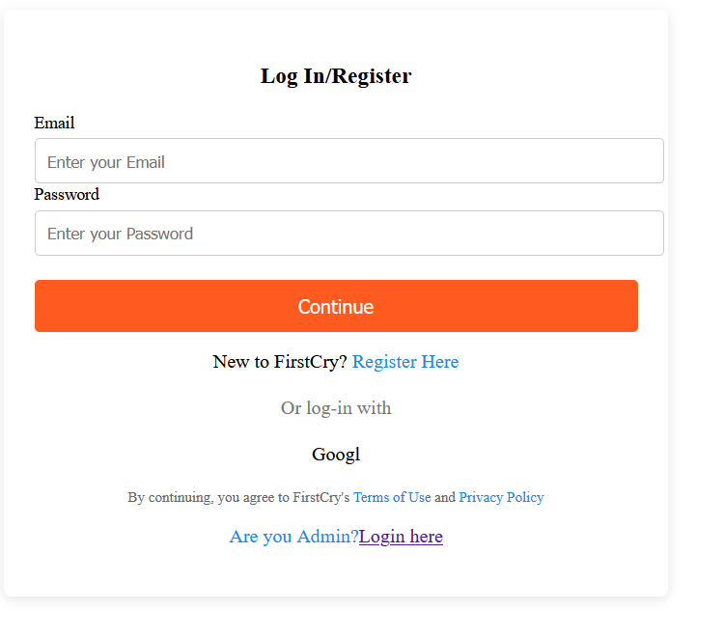

DATA FLOW DIAGRAM

CHAPTER 6: DETAILED DESIGN
INTRODUCTION
The detailed design phase focuses on the internal structure of the system and provides a comprehensive description of how each component is implemented. It translates the system architecture and high-level design into specific modules, data structures, algorithms, and interfaces required for development.
For the MERN-based eCommerce web application, the detailed design defines how the frontend, backend, and database interact to perform various operations. The frontend, developed using React.js, is designed with reusable components to ensure modularity and maintainability. The backend, built using Node.js and Express.js, handles business logic, API development, and integration with external services.
The design also includes the structure of the MongoDB database, defining collections such as users, products, carts, and orders. Each module—such as user authentication, product management, cart operations, payment processing, and admin control—is designed with clear responsibilities and data flow. The detailed design provides a clear blueprint for developers to implement the system efficiently, ensuring scalability, security, and maintainability of the application.
SCOPE
The scope of the detailed design defines the internal working and implementation details of the MERN-based eCommerce web application. It focuses on how each module of the system is structured, how components interact, and how data flows within the application.
The detailed design covers the implementation of all major modules, including User, Product, Cart, Order, Payment, and Admin modules. It specifies how the frontend components are designed using React.js, including reusable UI components, state management, and user interactions.
On the backend, the scope includes the design of RESTful APIs using Node.js and Express.js, handling business logic, request processing, and server-side validation. It also defines how MongoDB is structured to store and manage data such as user details, product information, cart items, and order records.
The scope further includes integration of external services such as Nodemailer for OTP-based authentication and Razorpay for secure payment processing. It also addresses aspects like error handling, data validation, and API communication using Axios.
PURPOSE
The purpose of the detailed design is to provide a comprehensive and structured description of how the MERN-based eCommerce web application is implemented at a technical level. It serves as a blueprint that guides developers in building each component of the system accurately and efficiently.
This phase defines the internal logic of the application, including the design of frontend components using React.js, backend services using Node.js and Express.js, and the structure of the MongoDB database. It ensures that all modules—such as user authentication, product management, cart operations, order processing, payment integration, and admin functionalities—are clearly specified and properly organized.
The detailed design also focuses on defining API endpoints, data flow, validation mechanisms, and error handling processes. It includes integration of external services like Nodemailer for OTP verification and Razorpay for secure transactions.
Additionally, the purpose is to ensure that the system is scalable, maintainable, secure, and efficient, while reducing development errors and improving overall system quality.

UML DIAGRAM
USE CASE DIAGRAM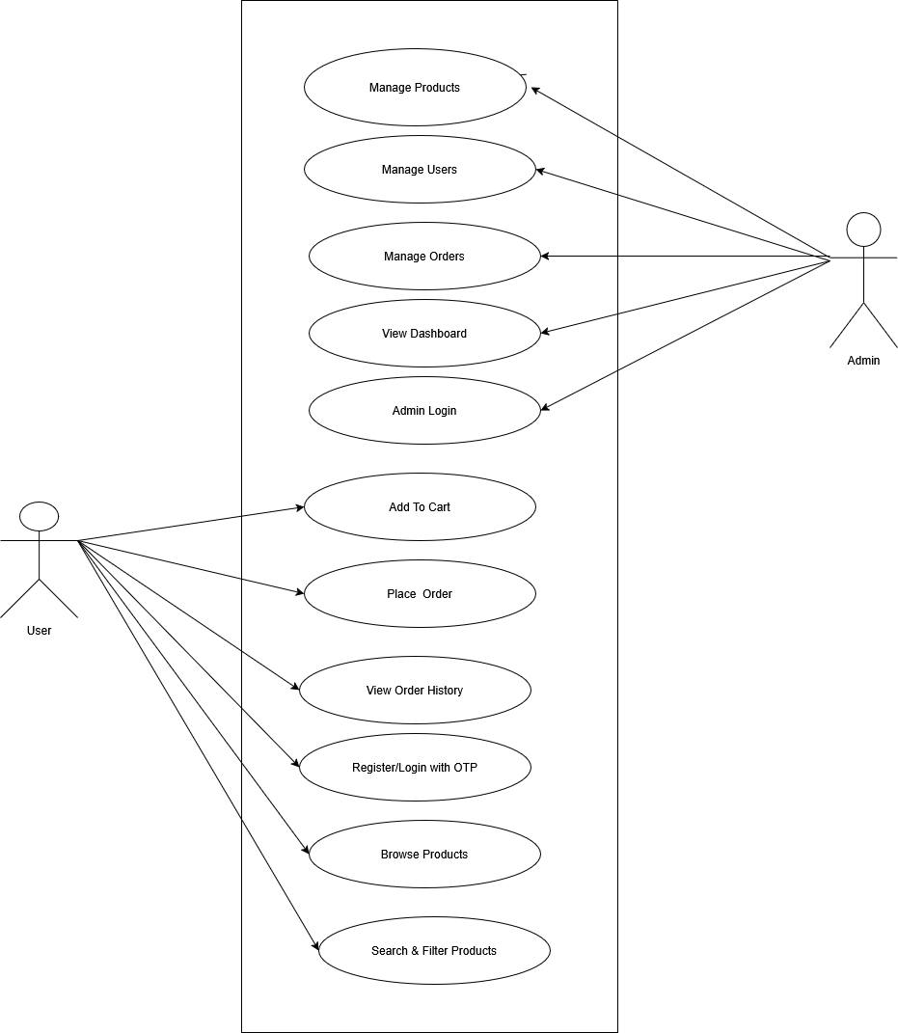

SEQUENCE DIAGRAM
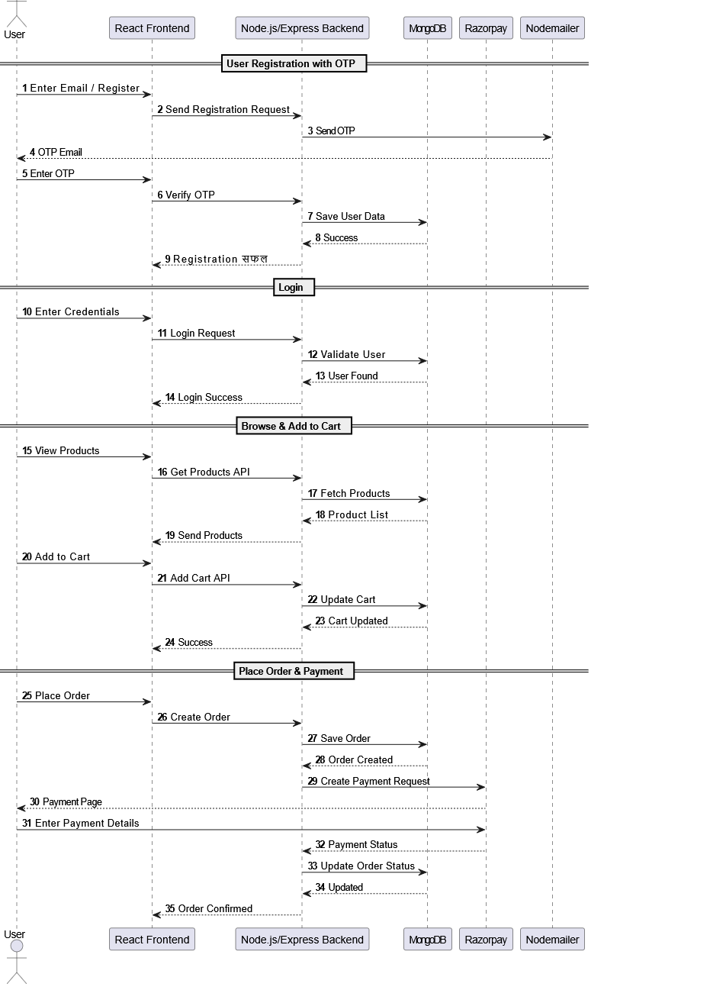

ACTIVITY DIAGRAM
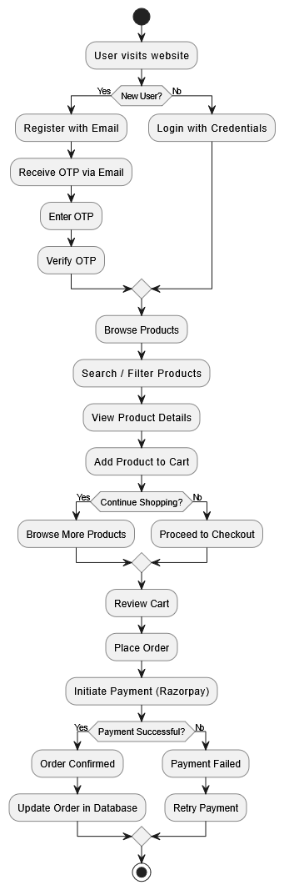

DATAFLOW DIAGRAM : OVERALL SYSTEM INTERACTION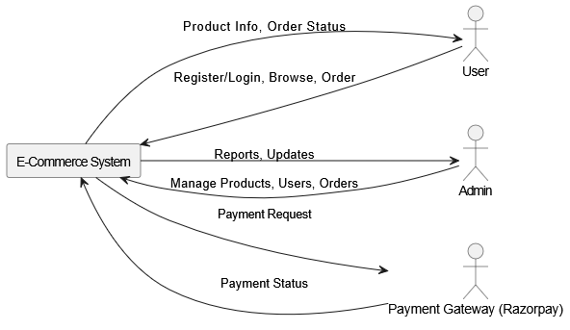
CHAPTER 7 : IMPLEMENTATION
DEVELOPMENT ENVIORNMENT
The development environment consists of the hardware and software tools used to build and run the application.
Hardware Requirements
- System: Laptop/Desktop
- Processor: Intel i3 or above
- RAM: Minimum 4 GB (8 GB recommended)
- Storage: 256 GB or more
- Storage: 256 GB or more
Software Requirements
- Operating System: Windows / Linux / macOS
- Code Editor: Visual Studio Code
- Frontend Technologies: React.js, HTML, CSS, JavaScript
- Backend Technologies: Node.js, Express.js
- Database: MongoDB
- API Communication: Axios
- Authentication: Nodemailer (OTP verification)
- Payment Gateway: Razorpay
Development Tools
- Version Control: Git & GitHub
- Package Manager: npm (Node Package Manager)
- Browser: Google Chrome (for testing and debugging)
- Deployment Platforms: Render, Netlify, or Vercel
CHAPTER 8 : TESTING
The FirstCry e-commerce project was thoroughly tested to ensure that all functionalities work correctly and the system performs reliably under different conditions. The testing phase covered both frontend and backend components of the MERN stack application. On the backend side, APIs built using Node.js and Express were tested using Postman to verify correct responses for user registration, login, OTP verification, product management, cart operations, and order processing. Each API was checked for proper status codes, data validation, and error handling. MongoDB database operations were also tested to confirm that data is being stored, updated, and retrieved correctly without inconsistencies. On the frontend side, the React application was tested to ensure that all components render properly and interact smoothly with backend services. User actions such as signing up, logging in, adding products to the cart, and placing orders were tested to confirm seamless integration between frontend and backend.
Integration testing was performed to verify the communication between different modules of the system, ensuring that the user authentication flow, product browsing, cart management, and checkout process work together without errors. Functional testing confirmed that each feature meets the required specifications, including OTP-based authentication, secure login system, product display, and order placement functionality. The system was also tested for usability to ensure that the user interface is simple, responsive, and easy to navigate across different devices. Performance testing was carried out by observing API response times and page loading speed, which showed that the application responds efficiently under normal usage conditions. Security testing ensured that sensitive user data such as passwords are encrypted and protected, and unauthorized access to protected routes is prevented using proper authentication mechanisms. Overall, the testing phase confirmed that the FirstCry e-commerce project is stable, functional, and ready for deployment with minimal errors and a smooth user experience.
TESTING OBJECTIVES
The main objective of testing in the FirstCry e-commerce project is to ensure that the developed system is reliable, functional, secure, and meets all the specified user requirements. Testing aims to identify and fix errors or bugs in the application before deployment so that the final product delivers a smooth and error-free user experience. It verifies that all features such as user registration, OTP verification, login, product browsing, cart management, and order placement work correctly and interact properly between frontend and backend components. Another important objective is to check the accuracy of data handling between the React frontend, Node.js/Express backend, and MongoDB database to ensure consistency and integrity of information. Testing also focuses on validating system performance by ensuring that the application responds efficiently to user requests without delays or failures. In addition, it ensures security by verifying that sensitive data like passwords are encrypted and that unauthorized users cannot access protected routes. Usability is also an important objective, making sure that the interface is user-friendly, responsive, and easy to navigate. Overall, the objective of testing is to deliver a stable, secure, and high-quality e-commerce application that satisfies user expectations and business requirements.
UNIT TESTING
TEST CASE | INPUT DESCRIPTION | EXPECTED OUTPUT | OBSERVED RESULT
1 | Valid name, email, phone, password | Successful registration | Pass
2 | Existing email | Prevent duplicate user creation | Pass
3 | Invalid email format | Error message: Invalid email format | Pass
4 | Empty password field | Validation message: Password is required | Pass

User Login Test Cases
TEST CASE | Input Description | Expected Output | Observed Result
1 | Valid email and password | Login successful | Pass
2 | Incorrect password | Error: Invalid credentials | Pass
3 | Unregistered email | Error: User not found | Pass
4 | Empty input fields | Validation message: Please enter credentials | Pass
5 | Valid credentials | Redirect to home/dashboard | Pass

OTP VERIFICATION TEST CASES
Test cases | Input Description | Expected Output | Observed Result
1 | Correct OTP | OTP verified successfully | Pass
2 | Incorrect OTP | Error: Invalid OTP | Pass
3 | Expired OTP | Error: OTP expired | Pass
4 | Empty OTP field | Validation message: Enter OTP | Pass
5 | Resend OTP request | New OTP sent successfully | Pass

CART MODULE TEST CASES
Test cases | Input Description | Expected Output | Observed Result
1 | Add product to cart | Product added successfully | Pass
2 | Remove product from cart | Product removed successfully | Pass
3 | View cart items | Cart items displayed | Pass
4 | Empty cart | Message: Cart is empty | Pass
5 | Add same product again | Quantity updated | Pass

ORDER / CHECKOUT TEST CASES
Test cases | Input Description | Expected output | Observed Result
1 | Valid checkout details | Order placed successfully | Pass
2 | Empty address field | Validation error | Pass
3 | Payment success | Order confirmation generated | Pass
4 | Payment failure | Order failed message | Pass
5 | Order history request | Previous orders displayed | Pass

CHAPTER 9 : RESULTS AND DISCUSSION
OUTPUT SCREENSHOT
PERFORMANCE ANALYSIS

CHAPTER 10 : CHALLENGES FACED
TECHNICAL CHALLENGES
During the development of the FirstCry e-commerce project, several technical challenges were encountered while working with the MERN stack. One of the major challenges was handling the integration between the frontend (React) and backend (Node.js/Express). Ensuring smooth API communication required proper configuration of CORS policies and consistent handling of request and response formats. Another challenge was managing authentication and security, especially during user registration and OTP verification, where proper validation and error handling were essential to prevent invalid or duplicate user entries.
Database management using MongoDB also presented challenges, particularly in maintaining data consistency between user, product, cart, and order collections. Designing efficient schemas and ensuring correct relationships between them required careful planning. Additionally, handling asynchronous operations in Node.js, such as database queries and API calls, sometimes led to unexpected errors like undefined responses or delayed data rendering in the frontend.
On the frontend side, managing state in React for features like cart updates and user sessions was challenging, especially when multiple components needed to share data. Performance optimization and ensuring smooth UI rendering while fetching data from the backend also required attention. Debugging network errors, such as Axios errors and server response failures, took additional effort during development.
LEARNING DIFFICULTIES
During the development of the FirstCry e-commerce project using the MERN stack, several learning difficulties were encountered, especially while working with new technologies and integrating different modules. One of the main difficulties was understanding the complete flow of the MERN architecture, particularly how React (frontend) communicates with Node.js and Express (backend) and how data is stored and retrieved from MongoDB. Initially, managing API requests and responses was confusing, especially while handling asynchronous operations and debugging errors like network failures or incorrect data responses.
Another learning difficulty was implementing authentication and security features such as user registration, login, and OTP verification. Understanding token-based authentication, password hashing, and validation logic required additional effort and practice. Working with OTP generation and email service integration also posed challenges, as ensuring reliable delivery and correct verification flow was complex at the beginning.
In React, managing state across multiple components, especially for cart functionality and user sessions, was initially difficult. Proper handling of props, hooks, and state updates required practice to avoid data inconsistencies in the UI. Additionally, working with MongoDB schema design and relationships between collections like users, products, cart, and orders required a clear understanding of database structure and normalization concepts.
Debugging errors across the full stack was also a significant learning challenge, as issues could arise from frontend, backend, or database layers. However, through continuous learning, practice, and problem-solving, these difficulties were gradually overcome, leading to better understanding and successful completion of the project.
SOLUTION ADOPTED
During the development of the FirstCry e-commerce project, the challenges and learning difficulties were effectively resolved by adopting systematic solutions and best practices in MERN stack development. To handle integration issues between the frontend and backend, proper API structuring was implemented using Express routes, and CORS configuration was correctly set up to allow smooth communication between React and Node.js. Postman was extensively used to test each API independently before connecting it to the frontend, which helped in identifying and fixing errors early.
For authentication and security-related challenges, password hashing using bcrypt and structured validation checks were implemented to ensure secure user data handling. OTP-based verification was improved by properly integrating email services and handling expiration logic to ensure secure and reliable authentication. Token-based authentication (such as JWT, if used in your project) was applied to manage user sessions securely.
In the frontend, React state management issues were resolved by using appropriate hooks such as useState and useEffect, and by lifting state up where necessary to maintain consistency across components like product listings and cart functionality. This ensured smooth data flow and accurate UI updates.
Database-related challenges were addressed by carefully designing MongoDB schemas for users, products, cart, and orders, ensuring proper relationships and efficient querying. Indexing and structured schema design helped in improving data retrieval performance.
Debugging across the full stack was managed by following a step-by-step approach—testing backend APIs first, then frontend integration, and finally end-to-end system testing. Console logging, error handling middleware, and careful monitoring of network requests helped in quickly identifying issues.
Overall, adopting modular development, continuous testing, and incremental debugging significantly improved the stability and performance of the FirstCry e-commerce application.
CHAPTER 11 : CONCLUSION AND FUTURE
SUMMARY OF INTERNSHIP EXPERIENCE
The internship experience gained during the development of the FirstCry e-commerce project was highly valuable and practical. It provided hands-on exposure to full-stack web development using the MERN stack, which includes MongoDB, Express.js, React.js, and Node.js. Throughout the internship, real-world development practices such as API creation, frontend-backend integration, database management, authentication, and deployment handling were learned and implemented.
Working on this project helped in understanding the complete lifecycle of a web application, starting from requirement analysis, system design, development, testing, and debugging. Practical experience was gained in building user modules like registration, login, OTP verification, product browsing, cart management, and order placement. It also improved problem-solving skills by handling real-time issues such as API errors, database inconsistencies, and UI state management problems.
In addition to technical skills, the internship also helped in improving time management, logical thinking, and debugging techniques. Overall, it was a strong learning experience that bridged the gap between theoretical knowledge and real-world application development.
SKILLS GAINED
During the development of the FirstCry e-commerce project, several technical and non-technical skills were developed and strengthened. This project provided practical exposure to full-stack web development using the MERN stack, which helped in understanding how modern web applications are built and deployed.
On the technical side, strong knowledge was gained in frontend development using React.js, including component creation, state management using hooks, routing, and building responsive user interfaces. In the backend, experience was gained in Node.js and Express.js, particularly in creating RESTful APIs, handling requests and responses, and implementing middleware for authentication and error handling. Working with MongoDB improved understanding of database design, schema creation, and performing CRUD operations efficiently.
In addition, skills in API integration were developed by connecting frontend and backend systems and ensuring smooth data flow between them. Experience with tools like Postman helped in testing APIs independently before integration. The project also improved knowledge of authentication and security concepts, including password hashing, OTP verification, and protected routes.
Problem-solving and debugging skills were significantly enhanced while resolving errors related to network requests, database issues, and UI rendering problems. The project also helped improve logical thinking, analytical ability, and time management skills, which are essential for real-world software development.
Overall, this project contributed to building confidence in developing complete full-stack applications and prepared for real-world software development environments.
FUTURE IMPROVEMENTS TO THE SYSTEM
The FirstCry e-commerce project can be further enhanced to improve its functionality, performance, and user experience. One of the major future improvements is the integration of advanced payment gateways such as Razorpay, Stripe, or PayPal to enable secure and seamless online transactions. Currently, the system can be upgraded to support multiple payment methods including UPI, cards, and net banking for better convenience.
Another important improvement is the addition of an AI-based recommendation system, which suggests products to users based on their browsing history, previous purchases, and preferences. This would significantly enhance user engagement and increase sales. The system can also be improved by implementing a wishlist feature, allowing users to save products for future purchase.
An order tracking system can be introduced to provide real-time updates on product delivery status, improving transparency and customer satisfaction. Additionally, adding a product review and rating system will help users make better purchasing decisions and increase trust in the platform.
From an administrative perspective, an advanced admin dashboard with analytics can be developed to monitor sales, user activity, and product performance using charts and graphs. This will help in better business decision-making.
Further improvements can also include mobile application development using React Native or Flutter, making the platform accessible to mobile users. Deployment can be enhanced using cloud services like AWS, Azure, or Docker for better scalability, performance, and reliability.
Overall, these future enhancements will transform the current system into a more advanced, scalable, and industry-level e-commerce platform.

REFERENCES
1. Books
- A. S. Tanenbaum, Computer Networks, Pearson Education.
- David Flanagan, JavaScript: The Definitive Guide, O’Reilly Media.
- M. N. Huxley, Full Stack Web Development with MERN, Packt Publishing.
- Brad Traversy, Modern Full Stack Development, Self-learning Guide.
- Robin Nixon, Learning PHP, MySQL & JavaScript, O’Reilly Media (for web fundamentals reference).
2. Websites
- https://react.dev – React Official Documentation
- https://nodejs.org – Node.js Official Documentation
- https://expressjs.com – Express.js Framework Guide
- https://www.mongodb.com/docs – MongoDB Official Documentation
- https://www.w3schools.com – Web Development Tutorials
- https://stackoverflow.com – Programming Problem Solving Platform
- https://developer.mozilla.org – MDN Web Docs (JavaScript, HTML, CSS reference)

3. Research Papers / Articles
- IEEE Paper: “A Study on MERN Stack Architecture for Web Applications”
- IEEE Paper: “Secure Authentication Mechanisms in Web Applications using JWT”
- Research Article: “Performance Optimization Techniques in Full Stack Web Development”
- Journal Paper: “E-commerce System Design and Implementation using Modern Web Technologies”
- Article: “Scalable Web Application Development using Node.js and React.js”

