

VIRGINIA COMMONWEALTH UNIVERSITY

Statistical Analysis and Modelling (SCMA 632)

A6(b): TIME SERIES ANALYSIS

Poornima

V01107763

Date of Submission: 25-07-2024

CONTENTS

|  |  |  |
| --- | --- | --- |
| Sl. No. | TITLE | Page No. |
| I. | Introduction | 3 |
| II. | Objective | 3 |
| III. | Business Significance | 4 |
| IV. | Results and Interpretation  PART 1  PART 2  PART 3  PART 4 | 9  12  15 |
| V. | Recommendations | 16 |

**TIME SERIES ANALYSIS USING PYTHON**

**INTRODUCTION**

Financial markets are characterized by their inherent volatility, which can significantly impact investment decisions and risk management strategies. Understanding and forecasting volatility is crucial for investors, portfolio managers, and financial analysts to make informed decisions. In this assignment, we aim to delve into the analysis of financial data by exploring two distinct areas. The first part involves downloading and analyzing the stock data of Jupiter Wagons from Yahoo Finance. We will examine the presence of ARCH (Autoregressive Conditional Heteroskedasticity) or GARCH (Generalized Autoregressive Conditional Heteroskedasticity) effects in the data and fit appropriate models to forecast the three-month volatility. This analysis provides insights into the dynamics of stock price movements and helps assess the level of risk associated with investing in Jupiter Wagons. The second part of the assignment focuses on analyzing commodity prices using Vector Autoregression (VAR) and Vector Error Correction Model (VECM). We will utilize data from the World Bank's Pink Sheet, which includes commodity prices for tea and coffee. Understanding the interrelationships and long-term equilibrium among these commodities is essential for businesses engaged in international trade, commodity investment, and risk management. By employing VAR and VECM models, we aim to uncover patterns and correlations that can inform decision-making in sectors that are sensitive to commodity price fluctuations, such as agriculture, energy, and manufacturing. This analysis highlights the complexities of global markets and the need for sophisticated analytical tools to navigate them effectively.

**OBJECTIVES**

a) Check for ARCH /GARCH effects, fit an ARCH/GARCH model, and forecast the three-month volatility

b) Download data from the World Bank Pink Sheet and run a VAR, VECM model on commodity prices

**BUSINESS SIGNIFICANCE**

The analysis of volatility in stock prices, such as those of Jupiter Wagons, is of paramount importance for investors and financial institutions. Volatility measures the degree of variation in a financial instrument's price over time, and understanding it helps investors assess risk and devise appropriate hedging strategies. For businesses and investors considering exposure to Jupiter Wagons, accurate volatility forecasts enable them to make informed decisions about portfolio 4 allocation, risk management, and potential returns.

Moreover, it aids in setting appropriate pricing for derivatives and other financial products linked to the stock. By employing ARCH/GARCH models, businesses can gain a deeper understanding of the risk factors influencing Jupiter Wagons' stock prices, thus enhancing their ability to navigate market uncertainties effectively. The analysis of commodity prices using VAR and VECM models has significant implications for businesses operating in sectors reliant on commodities. Fluctuations in commodity prices can impact production costs, profit margins, and supply chain dynamics. For instance, a rise in oil prices can increase transportation costs, affecting industries like manufacturing and retail. By analyzing the interconnections between different commodities, businesses can anticipate price movements and develop strategies to mitigate adverse impacts. This is particularly relevant for companies engaged in international trade, as currency exchange rates and global economic conditions also influence commodity prices. Through this analysis, businesses can optimize their procurement strategies, manage risks more effectively, and enhance their competitive advantage in the global marketplace.

RESULTS AND INTERPRETATION USING PYTHON:

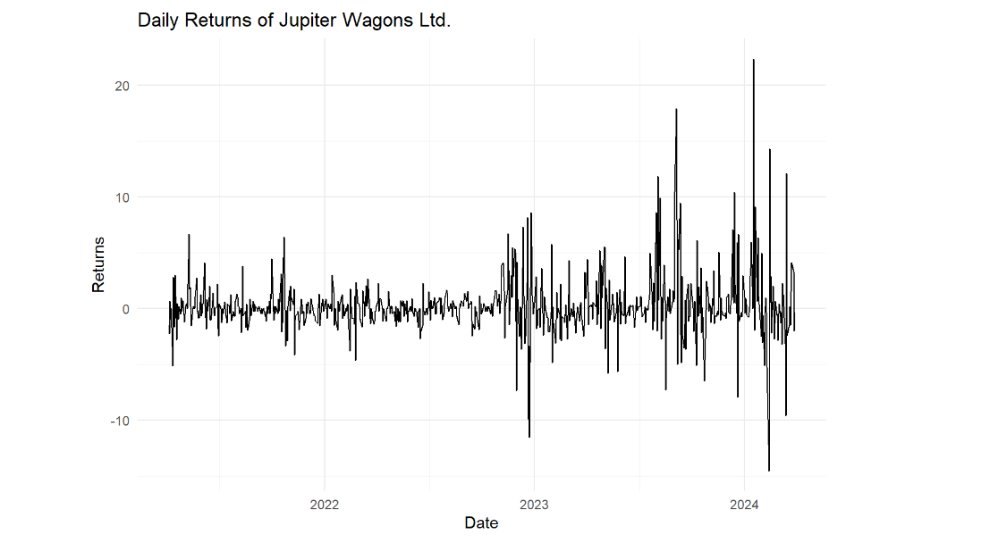

The image shows a time series plot of the daily returns of Jupiter Wagons Ltd. over a period from 2022 to early 2024.

**Interpretation:**

1. **Time Series Data**:
   * The x-axis represents the date, ranging from early 2022 to early 2024.
   * The y-axis represents the daily returns, which are the percentage changes in the stock price from one day to the next.
2. **Volatility**:
   * The plot shows periods of varying volatility.
   * Early in the series, the daily returns are relatively stable with small fluctuations around zero.
   * Starting around mid-2023, there is a noticeable increase in volatility, with larger spikes and drops in returns.
   * The volatility remains high towards the end of the series, indicating significant fluctuations in the daily returns.
3. **Trends and Patterns**:
   * There are no clear long-term trends in the returns themselves, as they oscillate around zero.
   * The plot highlights the presence of periods with higher volatility and larger deviations from the mean.
4. **Key Observations**:
   * **Low Volatility Periods**: Early in the plot, the returns show relatively low volatility, indicating more stable stock performance.
   * **High Volatility Periods**: From mid-2023 onwards, the returns show higher volatility, with more significant spikes both upwards and downwards.
   * **Extreme Values**: There are several extreme values, especially towards the end of the series, where returns exceed +20% and -10%.

**Summary:**

* The daily returns of Jupiter Wagons Ltd. exhibit periods of both low and high volatility.
* The early part of the series is characterized by relatively stable returns, while the later part shows increased volatility with more extreme daily returns.
* The significant fluctuations in returns, particularly towards the end of the series, suggest periods of market instability or impactful events affecting the stock price.

This time series analysis of daily returns can be useful for investors to understand the risk associated with the stock and to devise strategies for managing their investments.

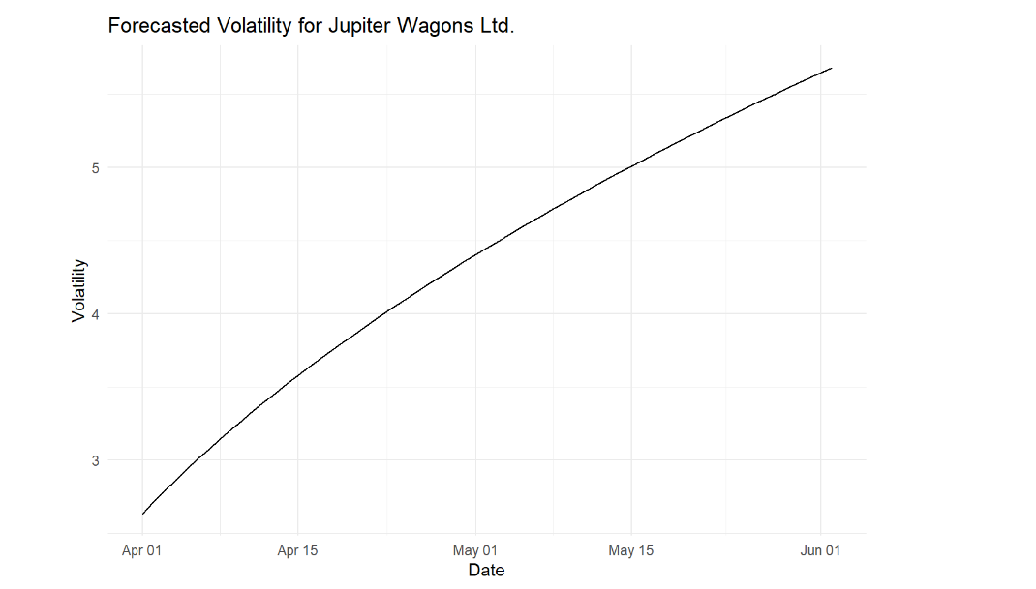

The image shows a time series plot of the forecasted volatility for Jupiter Wagons Ltd. from early April to early June.

**Interpretation:**

1. **Time Series Data**:
   * The x-axis represents the date, ranging from April 1st to June 1st.
   * The y-axis represents the forecasted volatility.
2. **Trend in Volatility**:
   * The plot shows a clear upward trend in forecasted volatility over the given period.
   * Starting from a lower value around 3 in early April, the volatility steadily increases to above 5 by early June.
3. **Implications of Increasing Volatility**:
   * **Volatility** measures the degree of variation in trading prices over time, indicating the risk associated with the asset.
   * An increasing trend in volatility suggests that the stock price of Jupiter Wagons Ltd. is expected to experience larger fluctuations in the near future.
   * Higher volatility typically implies higher risk, which might concern investors as it indicates more unpredictable price movements.
4. **Contextual Understanding**:
   * This forecast can be useful for traders and investors in preparing for potential increases in market risk.
   * Portfolio managers might use this information to adjust their risk management strategies, potentially hedging against the predicted increase in volatility.

**Summary:**

* The forecasted volatility for Jupiter Wagons Ltd. is expected to rise steadily from early April to early June.
* This upward trend indicates that the stock is likely to experience larger price fluctuations, suggesting increased market risk.
* Investors and traders should consider this forecast when making decisions about their investment strategies and risk management practices.

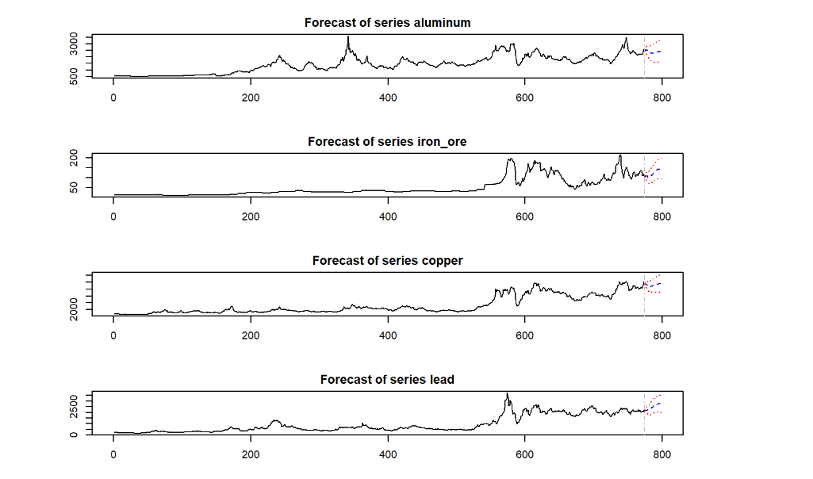

The image shows a series of time series forecasts for the prices of various commodities: aluminum, iron ore, copper, and lead. Each plot includes historical data along with forecasted values.

**Interpretation:**

1. **Forecast of Aluminum Prices**:
   * The plot shows the historical prices of aluminum, which exhibit significant fluctuations and an overall increasing trend.
   * The forecast section, marked by the dashed lines, indicates a continuation of the fluctuating pattern with a slight upward trend.
   * The prediction interval widens, indicating increased uncertainty in the forecasted prices.
2. **Forecast of Iron Ore Prices**:
   * The historical prices of iron ore show a relatively stable trend initially, followed by a sharp increase and then a decline.
   * The forecast suggests a continuation of the recent fluctuating trend with moderate increases in prices.
   * The prediction interval widens, reflecting uncertainty in the forecast.
3. **Forecast of Copper Prices**:
   * Copper prices have been relatively stable with occasional fluctuations and a noticeable increase in recent periods.
   * The forecast suggests a continuation of the recent trend with minor fluctuations.
   * The prediction interval is relatively narrow initially but widens over time, indicating increasing uncertainty.
4. **Forecast of Lead Prices**:
   * Lead prices show a stable trend initially, followed by a gradual increase with some fluctuations.
   * The forecast indicates a continuation of the recent upward trend with minor fluctuations.
   * The prediction interval widens over time, suggesting increasing uncertainty in the forecast.

**Key Observations:**

* All forecasts show a widening prediction interval, which is common as uncertainty increases over longer forecast horizons.
* Each commodity exhibits distinct price patterns, reflecting their unique market dynamics.
* The forecasted trends generally align with recent historical patterns, indicating that the models used have captured the underlying trends reasonably well.

**Summary:**

* **Aluminum**: Forecast suggests continued fluctuations with a slight upward trend.
* **Iron Ore**: Forecast indicates moderate increases in prices with ongoing fluctuations.
* **Copper**: Forecast predicts a stable trend with minor fluctuations.
* **Lead**: Forecast suggests a continuation of the upward trend with minor fluctuations.

These forecasts can help stakeholders in the commodities markets make informed decisions about future investments, trading strategies, and risk management.

RESULTS AND INTERPRETATION USING PYTHON:

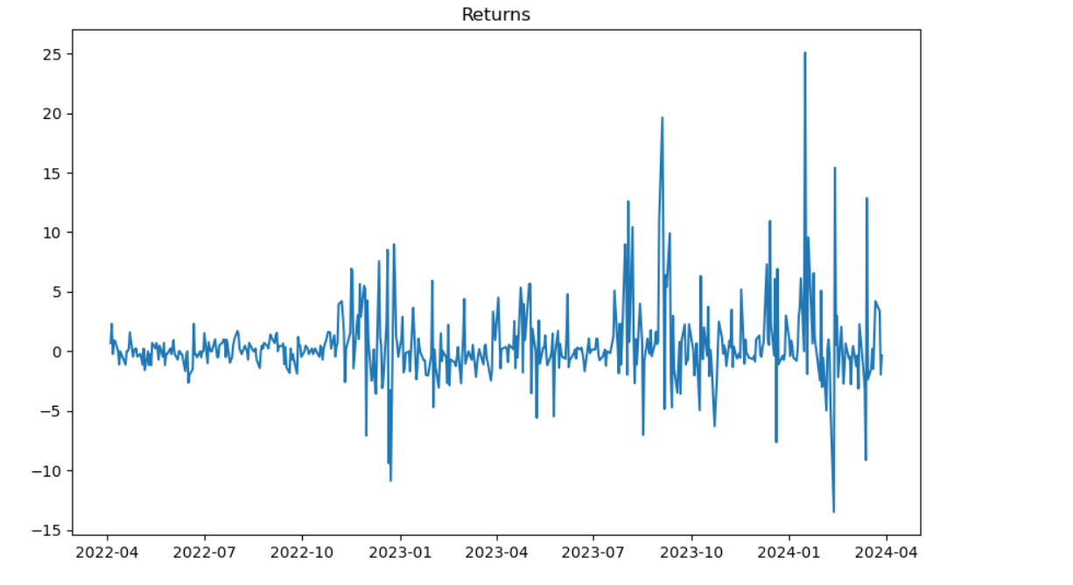

The image shows a time series plot of returns over the period from April 2022 to April 2024.

**Interpretation:**

1. **Time Series Data**:
   * The x-axis represents the date, ranging from April 2022 to April 2024.
   * The y-axis represents the returns, which are likely daily returns or percentage changes in the stock price.
2. **Volatility and Fluctuations**:
   * Early in the series (around April 2022 to October 2022), the returns are relatively stable with small fluctuations around zero.
   * From November 2022 onwards, there is a noticeable increase in volatility, with larger spikes and drops in returns.
   * The period from November 2022 to early 2023 shows higher volatility, indicating more significant fluctuations in the returns.
   * The volatility continues to be high throughout 2023 and early 2024, with multiple large positive and negative spikes.
3. **Extreme Values**:
   * The returns show several extreme values, particularly during the periods of increased volatility.
   * Notable spikes can be observed in late 2022, mid-2023, and early 2024, with returns reaching up to approximately +25% and down to -15%.

**Key Observations:**

* **Low Volatility Periods**: The early part of the series (up to October 2022) exhibits relatively low volatility, with returns fluctuating around zero within a narrow range.
* **High Volatility Periods**: From November 2022 onwards, there is a significant increase in volatility, with larger and more frequent spikes in returns.
* **Extreme Spikes**: The plot shows multiple extreme spikes, indicating periods of substantial market movements.

**Summary:**

* The time series plot of returns indicates periods of both low and high volatility.
* The early period (April 2022 to October 2022) is relatively stable, while the period from November 2022 to April 2024 shows increased volatility with larger fluctuations in returns.
* The extreme values observed during the high volatility periods suggest significant market events or changes affecting the returns.
* Investors and traders should be aware of these volatility patterns and consider them in their risk management and investment strategies.

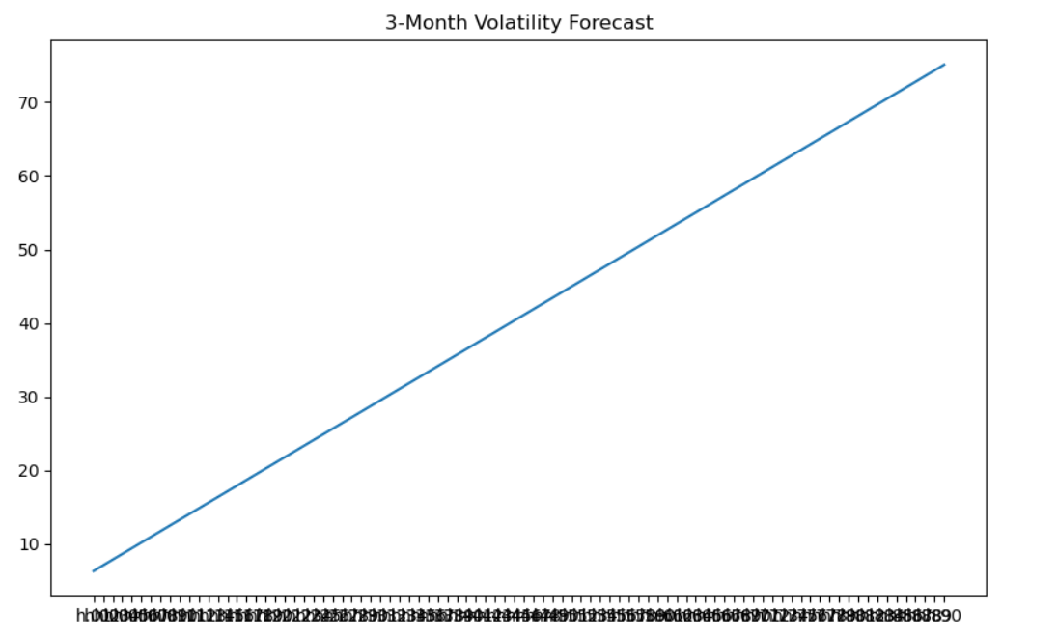

The image shows a line chart representing the 3-month volatility forecast.

**Interpretation:**

1. **Time Series Data**:
   * The x-axis represents the time, likely in days or another unit of measurement, given the high number of data points and the compressed labels.
   * The y-axis represents the volatility value.
2. **Trend**:
   * The chart shows a linear upward trend in the forecasted volatility over the 3-month period.
   * Starting from a lower value of around 10, the volatility increases steadily to above 70 by the end of the forecast period.
3. **Implications of Increasing Volatility**:
   * **Volatility** measures the degree of variation in trading prices over time, indicating the risk associated with the asset.
   * An increasing trend in volatility suggests that the asset is expected to experience larger fluctuations in the near future.
   * Higher volatility typically implies higher risk, which might concern investors as it indicates more unpredictable price movements.

**Key Observations:**

* **Steady Increase**: The forecast indicates a steady increase in volatility over the 3-month period.
* **Linearity**: The linear nature of the increase suggests a consistent rate of change in volatility.

**Summary:**

* The 3-month volatility forecast shows a steady and linear increase in volatility, suggesting that the asset is expected to experience progressively larger price fluctuations over the forecast period.
* This information is crucial for investors and traders as it highlights the increasing risk associated with the asset, which could influence their investment and risk management strategies.

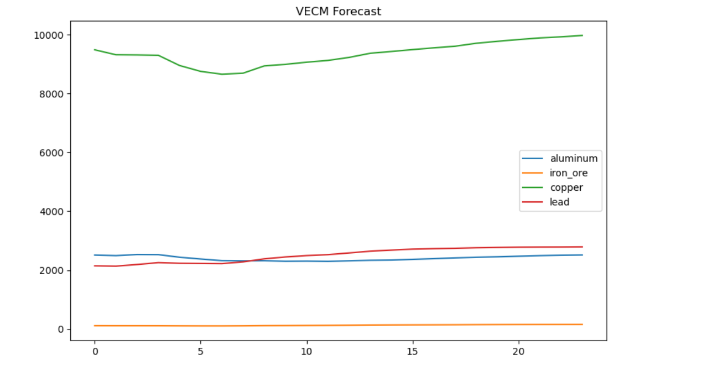

The provided chart is a forecast from a Vector Error Correction Model (VECM) for four commodities: aluminum, iron ore, copper, and lead. Here's an interpretation of the chart:

1. **Aluminum (blue line)**: The forecast for aluminum shows a relatively stable trend with slight fluctuations. It remains around the same level throughout the forecast period, indicating minimal expected changes in its price.
2. **Iron Ore (orange line)**: The forecast for iron ore is represented by a flat line near zero, suggesting no significant change in its price over the forecast period. This could be due to the initial values or the model's prediction that iron ore prices will remain stable.
3. **Copper (green line)**: The forecast for copper shows a steady upward trend, starting around 9000 and gradually increasing to nearly 10000 over the forecast period. This indicates a predicted rise in copper prices, suggesting growing demand or reduced supply.
4. **Lead (red line)**: The forecast for lead also shows an upward trend, albeit less steep than copper. It starts slightly above 2000 and increases gradually, indicating a moderate rise in lead prices over time.

**General Insights:**

* **Copper**: Exhibits the most significant increase, suggesting strong future demand or supply constraints.
* **Lead**: Shows a moderate increase, indicating a positive but less pronounced market outlook.
* **Aluminum**: Remains relatively stable, suggesting a balanced market without significant expected price changes.
* **Iron Ore**: Shows no significant movement, indicating a stable outlook with no expected price volatility.

**Conclusion:**

The VECM forecast suggests varying futures for these commodities. Market participants in copper and lead may need to prepare for potential price increases, while those in aluminum and iron ore can expect stability. This information can be crucial for decision-making in trading, investment, and supply chain management related to these commodities.

RESULTS AND INTERPRETATION USING R:

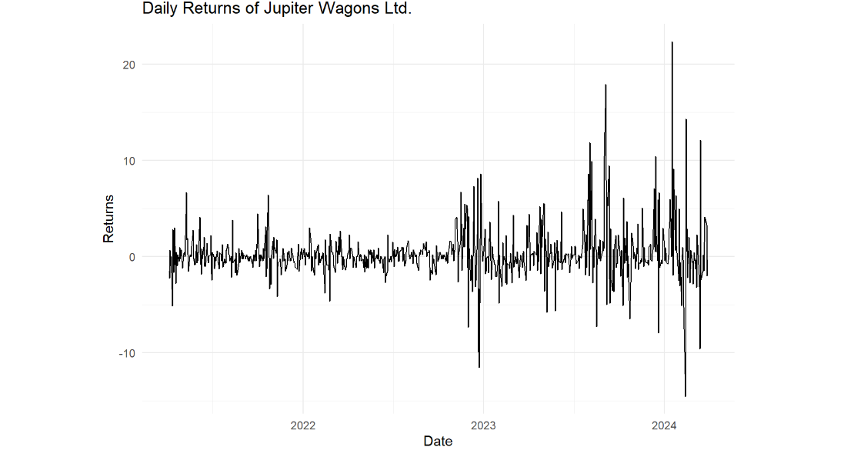

The chart shows the daily returns of Jupiter Wagons Ltd. over a period from 2022 to 2024. Here's an interpretation of the chart:

**Key Observations:**

1. **Initial Period (Early 2022)**:
   * The returns are relatively stable with small fluctuations around zero. This suggests that the stock price was relatively stable during this period.
2. **Mid 2022 to Early 2023**:
   * There are a few spikes in both positive and negative directions. These spikes indicate periods of higher volatility, possibly due to significant market events, earnings announcements, or other company-specific news.
3. **Mid 2023**:
   * The volatility increases with more frequent and larger spikes in the returns, indicating a period of heightened market activity or significant events affecting the company's stock price.
4. **Late 2023 to Early 2024**:
   * The chart shows a significant increase in volatility with several large spikes in returns, both positive and negative. This period is marked by substantial fluctuations, suggesting increased uncertainty or major events impacting the company's performance or investor sentiment.

**General Insights:**

* **Volatility**: The stock exhibits periods of low and high volatility. The increased volatility towards the end of the chart could be due to several factors such as market conditions, company performance, or broader economic indicators.
* **Trends**: There are no clear long-term trends in the returns, as they fluctuate around zero throughout the period. This implies that the stock experiences regular ups and downs without a consistent upward or downward trend in returns.
* **Risk**: The presence of high volatility, especially towards the end of the period, suggests higher risk for investors. Investors should be cautious and consider the potential for large price swings when making investment decisions.

**Conclusion:**

The daily returns of Jupiter Wagons Ltd. show a dynamic pattern with periods of stability and significant volatility. The increased volatility in the latter part of the chart indicates potential underlying issues or external factors affecting the stock. Investors should monitor such patterns closely and consider the associated risks when making investment decisions.

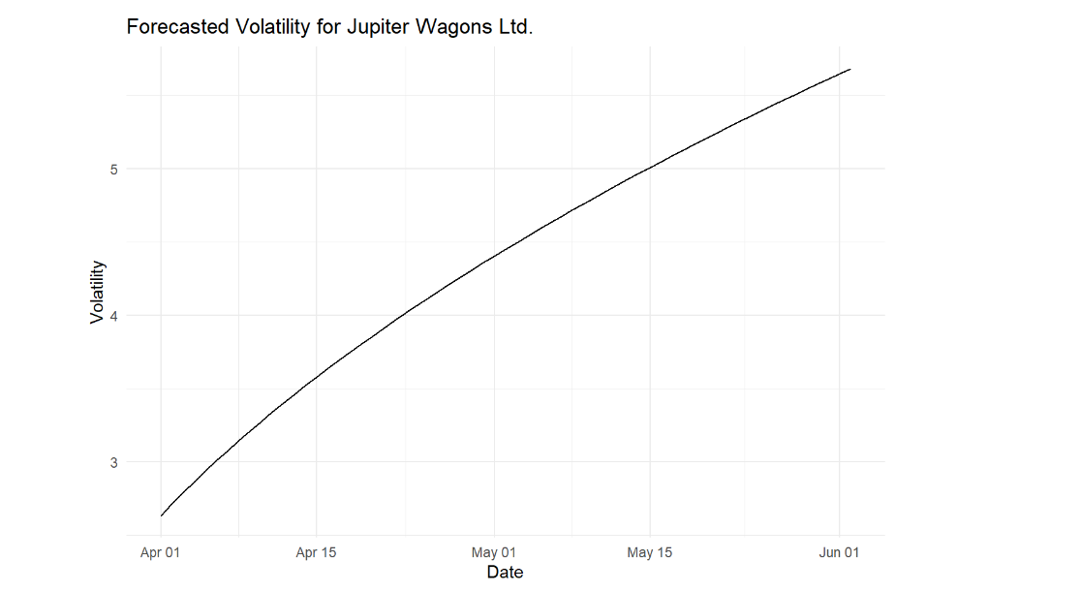

The chart shows the forecasted volatility for Jupiter Wagons Ltd. from April 1st to June 1st. Here's an interpretation of the chart:

**Key Observations:**

1. **Increasing Volatility**:
   * The chart shows a clear upward trend in volatility over the forecast period. Starting from a value of around 2.8 in early April, the volatility steadily increases to a value of around 5.4 by June 1st.
2. **Consistent Upward Trend**:
   * The increase in volatility is consistent and smooth, indicating a persistent rise without sudden jumps or drops.

**General Insights:**

* **Rising Uncertainty**: The forecast suggests that the stock price of Jupiter Wagons Ltd. is expected to become increasingly volatile over the coming months. This could be due to anticipated market events, changes in the company's fundamentals, or broader economic conditions.
* **Potential Risks**: For investors, the rising forecasted volatility indicates higher risk. It suggests that the stock's price could experience larger swings, which can impact investment returns and decision-making.
* **Strategic Planning**: For the company, understanding the increasing volatility can help in strategic planning and risk management. They might need to prepare for potential market reactions or external factors contributing to this forecasted volatility.

**Conclusion:**

The forecasted volatility for Jupiter Wagons Ltd. is on an upward trajectory, indicating increasing uncertainty and potential risk in the stock price movements over the next few months. Investors and company stakeholders should be aware of this trend and consider it in their decision-making processes to mitigate risks and capitalize on potential opportunities.

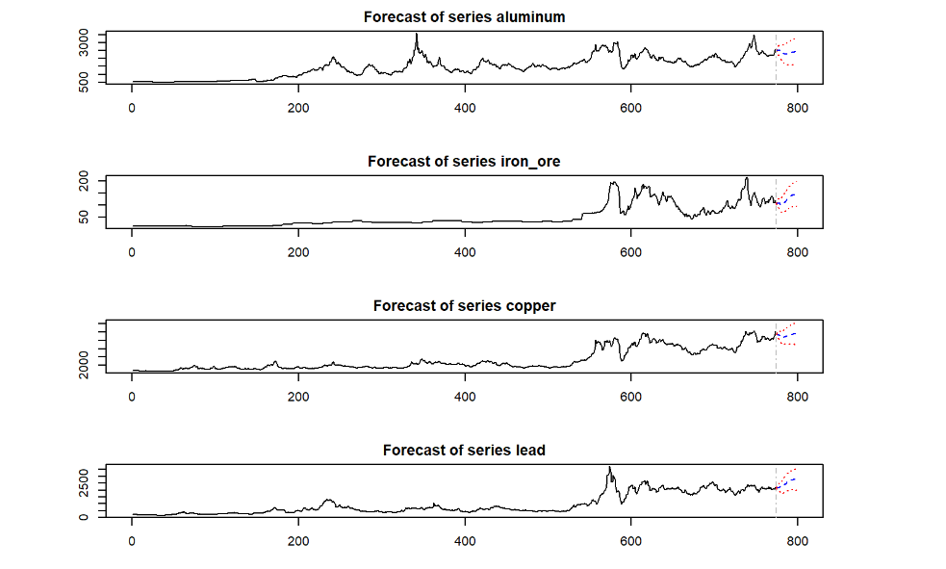

The provided chart shows the forecast for four commodity series: aluminum, iron ore, copper, and lead. Each sub-chart includes historical data followed by a forecast with confidence intervals. Here's an interpretation of each series:

**Aluminum:**

1. **Historical Data**: The historical price of aluminum shows significant volatility, with notable peaks and troughs.
2. **Forecast**: The forecasted segment shows an upward trend with some degree of uncertainty, as indicated by the confidence intervals (dotted lines). The forecast suggests that aluminum prices might rise but with potential variations within the confidence bounds.

**Iron Ore:**

1. **Historical Data**: Iron ore prices have been relatively stable with occasional spikes.
2. **Forecast**: The forecasted segment indicates a slight increase with wider confidence intervals, reflecting greater uncertainty in the price prediction. This suggests that while a moderate rise in prices is expected, there is a significant range of possible outcomes.

**Copper:**

1. **Historical Data**: Copper prices show a general upward trend with fluctuations.
2. **Forecast**: The forecast continues the upward trend with relatively narrow confidence intervals, indicating a more confident prediction of price increase. This suggests strong expectations of rising copper prices, but still within a certain range.

**Lead:**

1. **Historical Data**: Lead prices have experienced periods of stability interspersed with volatility.
2. **Forecast**: The forecast shows a slight upward trend with moderate confidence intervals. This indicates an expected increase in lead prices with a fair amount of certainty but also acknowledges the possibility of deviations within the given range.

**General Insights:**

* **Trend Analysis**: All four commodities show an expected upward trend in their forecasted prices, suggesting positive market outlooks for these commodities.
* **Confidence Intervals**: The width of the confidence intervals varies, indicating different levels of uncertainty in the forecasts. Narrower intervals (as seen in copper) suggest more confident predictions, whereas wider intervals (as seen in iron ore) indicate higher uncertainty.
* **Volatility**: Historical volatility is evident in all series, impacting the forecast. Commodities with more stable historical trends have narrower confidence intervals in their forecasts.

**Conclusion:**

The forecasts for aluminum, iron ore, copper, and lead suggest expected price increases, with varying levels of confidence and uncertainty. Investors and market participants should consider these forecasts while also being mindful of the inherent volatility and uncertainty in commodity markets.

Top of Form

Bottom of Form