### DAYANANDA SAGAR COLLEGE of ENGINEERING BANGALORE



PROJECT REPORT

ON

**“Developing Components of Fuelling Machine of PHWR”**

Submitted by

**Miss.Poornima M Chabbi(1DS15CS733)**

Department of Computer Science Engineering

DSCE, Banglore.

Under the Guidance of

**Shri Dinesh Kumar Maurya**

Fuel Handling Control Section

Reactor Control Division

Bhabha Atomic Research Centre, Mumbai



|  |  |
| --- | --- |
|  |  |

**CERTIFICATE**

**ABSTRACT**

The main objective of project is 3D modiling of Fueling Machine components of PHWR using Autodesk 3dsmax. Fuelling Machine (FM) is a complex machine used for refueling of rector channels. It consists of many mechanical components and drives (i.e. magazine assembly, Ram assembly, head assembly, support structure, Trolley and Bridge etc.). 3D models of FM components are made using 3Ds max with the help of 2D AutoCAD drawings.

3Ds Max is a 3D modeling, animation and rendering program from the Media and Entertainment division of Autodesk. Widely used in the areas of interactive games, visual effects for movies and industrial design models. The application also includes an animation module.

By using this software we created 3d models components to study the behavour of **Fueling Machine of PHWR.**

### ACKNOWLEDGEMENT

We would like to acknowledge **Bhabha Atomic Research Centre (BARC), Mumbai** for providing us the resources and support to carry out this project in its premises.

Special thanks to **Smt. Geetha S. Kumar**, Reactor Control Division, BARC for allowing us to undertake this training.

I take this opportunity to express my sincere gratitude to my guides **Shri. Dinesh Kumar Maurya** and **Shri. Anup Suryawanshi**, Bhabha Atomic Research Centre, Mumbai for having been source of consistent inspiration to work under their guidance. I would like to thank **Shri. K.P. Sarkar, Head FHCS**(Fuel Handling Control Section), for his constant encouragement and support and his keen interest during the development work.

Finally, I would like to thank all my Teachers, Friends and Family Members who have supported me throughout and enlightened me to take the right path and reach there. The days I spent in this institute will be cherished forever and also be reckoned as a guiding factor in my career.

Contents

**INTRODUCTION** 2

ORGANIZATION PROFILE 2

BHABHA ATOMIC RESEARCH CENTER 2

REACTOR CONTROL DIVISION 2

Pressurized Heavy Water Reactor(PHCS) 2

PROJECT OBJECTIVE 3

PROBLEM DEFINITION 4

Component under Observation: Fuelling Machine 4

ABOUT THE PROJECT 7

HARDWARE AND SOFTWARE SPECIFICATIONS 7

SNAPSHOTS 8

BIBLIOGRAPHY 19

# 

# **INTRODUCTION**

## ORGANIZATION PROFILE

### BHABHA ATOMIC RESEARCH CENTER

The major objective of the broad spectrum of activities at BARC is primarily to provide research and development support needed to sustain India’s nuclear power program in relation to concepts , designs, materials and safety. A versatile infrastructure of research facility and highly trained scientific and technical manpower has been developed in this technologically self-reliant nuclear research center.

REACTOR CONTROL DIVISION

The Reactor Control Division was set up to design various advanced control systems for upcoming nuclear reactors all over the country. This Division is housed inside the BARC research facility in Trombay, Mumbai and has been doing exemplary work ever since inception .The Control Systems designed basically for nuclear fuel handling Systems, handles radioactive spent fuel bundles from the reactor and all other operations are required to be done safely and remotely, as the equipment is inaccessible .

### Pressurized Heavy Water Reactor(PHWR)

Pressurized heavy water reactor (PHWR) is a nuclear power reactor, commonly using unenriched natural uranium as its fuel, that uses heavy water (deuterium oxide D2O) as its coolant and moderator. The heavy water coolant is kept under pressure, allowing it to be heated to higher temperatures without boiling, much as in a typical pressurized water reactor. While heavy water is significantly more expensive than ordinary light water, it yields greatly enhanced neutron economy, allowing the reactor to operate without fuel enrichment facilities (mitigating the additional capital cost of the heavy water) and generally enhancing the ability of the reactor to efficiently make use of alternate fuel cycles.

The work being carried out is mostly software. The hardware is being procured from outside and the hardware work involves mostly the system integration work associated with development and testing of prototype systems. However, the software development offers many challenging opportunities.

I found the working atmosphere at PHWR, very vibrant with good number of projects.

## 

## PROJECT OBJECTIVE

To develop the components of Fuel Handling Machine using 3Ds max which will be used to develop the simulation of Fuel Handling Machine.

The main objective is to show mechanical internal details of Fuel Handling Machine for training purpose. It is a part of the simulation application which shows the activities taking place in the Fueling Machine on the computer monitor so that the operator or controller can watch what is going on inside the Fueling Machin.

PROBLEM DEFINITION

Fuelling machine is a very complex machine which used to refuel the reactor whenever required. Simulation of Fuelling machine will help the operators to understand the working of the fuelling machine on the reactor. 3D models of fueling machine component help operator to visualize objects and understand them in a better way. 3D models of FM components are made using 3Ds max with the help of 2D AutoCAD drawings.

## Component under Observation: Fuelling Machine

Fuelling Machine consists of Fuelling Machine Head, Support Structure, Shielding, Trolley and Carriage. Fuelling Machine Head is pressure boundary equipment and consists of snout assembly, separator assembly, magazine assembly and ram assembly. The snout assembly is the lowermost part of the fuelling machine head. This assembly is used for clamping on to an end fitting of coolant channel making a high pressure leak tight joint. This assembly is designed based on coolant channel pitch and end fitting outside diameter. Seal plug is a part of coolant channel assembly and it is operated by the fuelling machine.

Two fuelling machine **Bridge and Carriage assemblies** are provided, one at each reactor face. As shown in Figure 5, each bridge spans the face of the reactor and supports a carriage assembly, when the carriage is in the fuelling machine vault. The carriage assembly supports a fuelling machine head. Each bridge moves vertically on two guide columns, to provide vertical motion (y-motion) of the fuelling machine head. Carriage wheels ride on rails mounted on the bridge (when in the fuelling machine vault) and on the maintenance lock tracks (when in the maintenance lock) to provide horizontal motion (x-motion) of the fuelling machine. With the bridge in its lowest position, the rails on the bridge are aligned with matching rails on the maintenance lock tracks, enabling the carriage, with the fuelling machine head, to transfer between the fuelling machine vault and the maintenance lock. Each carriage assembly consists of a drive unit assembly, and upper and lower gimbal assemblies, as shown in Figure 11. In addition to horizontal motion along the bridge and maintenance lock rails, the carriage assembly also provides fine vertical motion and motion toward and away from the reactor (z-motion) and allows a controlled amount of rotation of the head. It also provides a termination point for the catenary system. The carriage also includes clamping mechanisms, which securely anchor the carriage to the bridge rails when the fuelling machine head is clamped to a reactor end fitting, to prevent excessive loads from being applied to the end fitting by the fuelling machine head during a seismic event.

Fuelling Machine Carriage comprises of Lower Gimbal sub-assembly, Upper Gimbal sub-assembly, Top Beam, Drive plate assembly, and Trolley assembly.

**Gimbal assembly** :-Lower Gimbal sub-assembly provides the means of assembly and dis-assembly of Fuelling Machine Head to/from the Carriage. It also facilitates the ‘Y’ tilt of the Head along the horizontal trunnion axis. Support Frame with the Fuelling Machine Head is mounted in the Lower Gimbal by means of two trunnion pins fitted on either side of the Support Frame

The Upper Gimbal - Drive Plate Assembly comprises Upper Gimbal sub-assembly and Drive Plate Assembly. The Upper Gimbal sub-assembly comprises Upper Gimbal, Top Beam, ‘Z’ motion guides and actuator mechanism. The Upper Gimbal and Top Beam are welded carbon steel Structures and are precision machined.

The **Trolley assembly** comprises Main Trolley and Auxiliary Trolley. They are carbon steel structural weldments which spans between the ‘X’ Roundway Guides fitted to the underside of the Bridge Structure on both sides. They Auxiliary Trolley which carries the X-drive ball nut (9) is connected to the east end of Main Trolley through Screw Jack Assembly (10 ) A relative movement between Main Trolley and Auxiliary Trolley provides the Fine X-movement of the Carriage. The Drive Plate Assembly is connected to the Trolley Structure from below by means of 4 Drive Plate Supports Studs (2) and castle nuts (7). Machined lugs on Trolley Structure accurately position the Drive Plate during assembly. The Drive Plate Support Studs are keyed and bolted to the Main Trolley Structure by self Locking Nuts (8). This arrangement facilitates emergency detachment of Drive Plate Assembly together with Fuelling Machine Head through the Plugged access openings in the Bridge Structure and roll-on shield. The upper threaded end of these studs projects beyond the self Locking Nuts and is meant for connecting special tools to support the weight of Fuelling Machine Head Assembly during such emergency detachment operation.

**Head Antenna:-** it is a mechanical sensor. It is mounted at the front of snout assembly. Its function is to guide the fuelling machine head to end fitting of any reactor channel. Head antenna can sense +/5 mm misalignment of FM head approximately. Another special sensing arrangement is provided in front of snout assembly. This consists of four ‘L’ shaped sensing members mounted equispaced on clamping barrel by cutting slots. As misalignment is sensed by these members, motion is transferred to linear variable differential tansformers (LVDTs). Based on the LVDTs’ signals fine X and fine Y drives get actuated for proper alignment. As a preventive measure against accidental unclamping of FM head from end fitting during on power refuelling, snout emergency lock is fitted on to the snout assembly. The length of the snout assembly (along with head antenna and sensing arrangement) is 1567 mm.

# **ABOUT THE PROJECT**

This project is an effort to develop application software. It is in the field of Computer Graphics object oriented programming system.The main working of project is based on Fueling Machine.

## HARDWARE AND SOFTWARE SPECIFICATIONS

The resource used is **3Ds max** for making the use of the graphics library. By using this software, we created components to study the working of **Fueling Machine of PHWR.**

**3Ds** max **Autodesk 3ds Max**, formerly **3D Studio** and **3D Studio Max**, is a professional [3D computer graphics program](https://en.wikipedia.org/wiki/3D_computer_graphics_software) for making 3D animations, models, games and images. It is developed and produced by [Autodesk Media and Entertainment](https://en.wikipedia.org/wiki/Autodesk_Media_and_Entertainment). It has modeling capabilities and a flexible [plugin](https://en.wikipedia.org/wiki/Plug-in_(computing)) architecture and can be used on the [Microsoft Windows](https://en.wikipedia.org/wiki/Microsoft_Windows) platform. It is frequently used by [video game developers](https://en.wikipedia.org/wiki/Video_game_developer), many TV commercial studios and architectural visualization studios. It is also used for movie effects and movie pre-visualization. For its modeling and animation tools, the latest version[of 3ds Max also features [shaders](https://en.wikipedia.org/wiki/Shaders" \o "Shaders) (such as [ambient occlusion](https://en.wikipedia.org/wiki/Ambient_occlusion) and [subsurface scattering](https://en.wikipedia.org/wiki/Subsurface_scattering)), [dynamic simulation](https://en.wikipedia.org/wiki/Dynamic_simulation), [particle systems](https://en.wikipedia.org/wiki/Particle_systems), [radiosity](https://en.wikipedia.org/wiki/Radiosity_(3D_computer_graphics)" \o "Radiosity (3D computer graphics)), [normal map](https://en.wikipedia.org/wiki/Normal_mapping) creation and rendering, [global illumination](https://en.wikipedia.org/wiki/Global_illumination), a customizable [user interface](https://en.wikipedia.org/wiki/User_interface), new icons, and its own [scripting language](https://en.wikipedia.org/wiki/Scripting_language).

# SNAPSHOTS

**Bridge assembly :-**

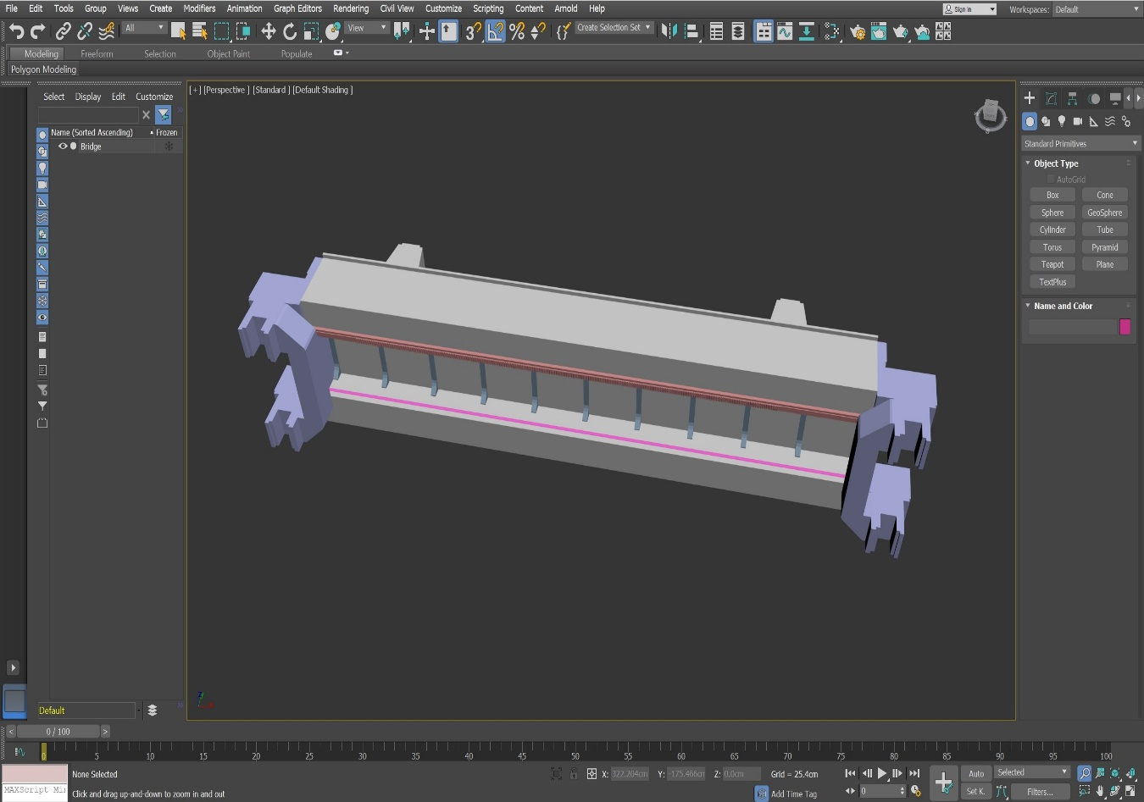

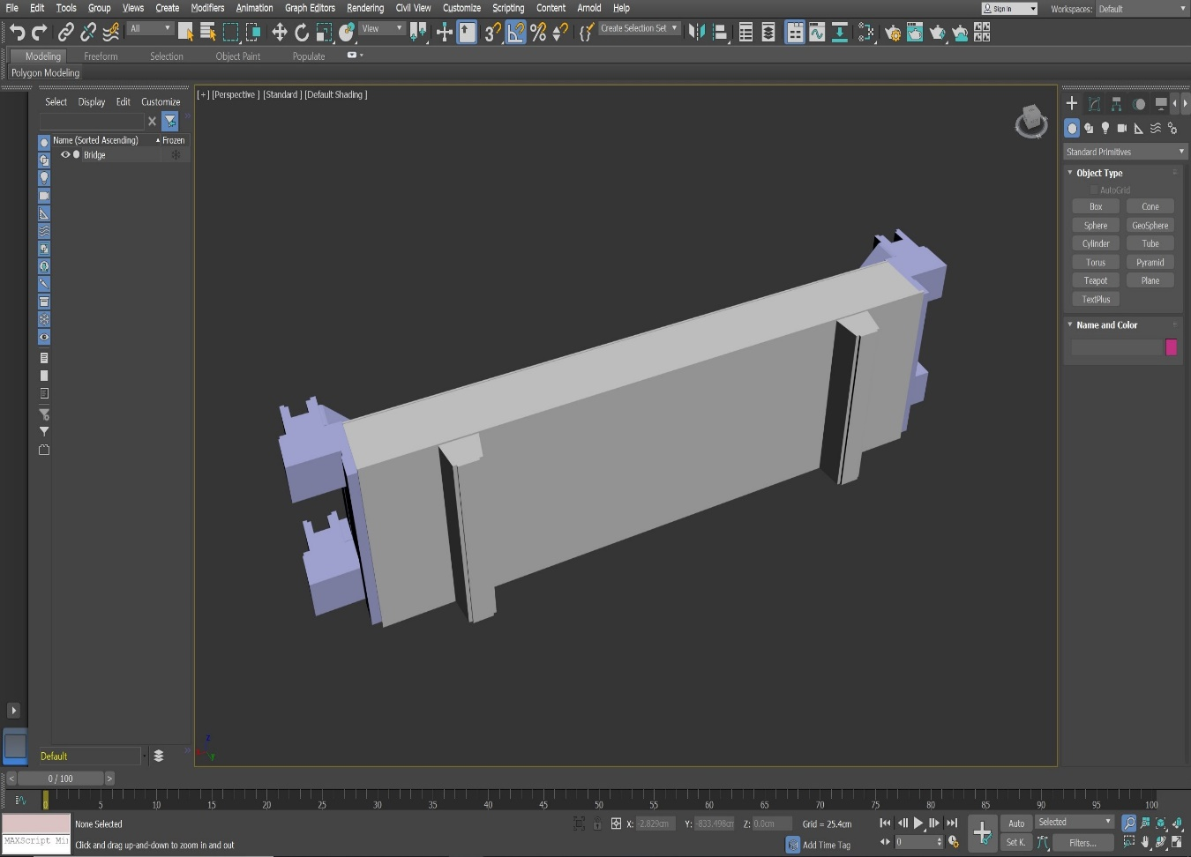

**Carriage assembly:-**

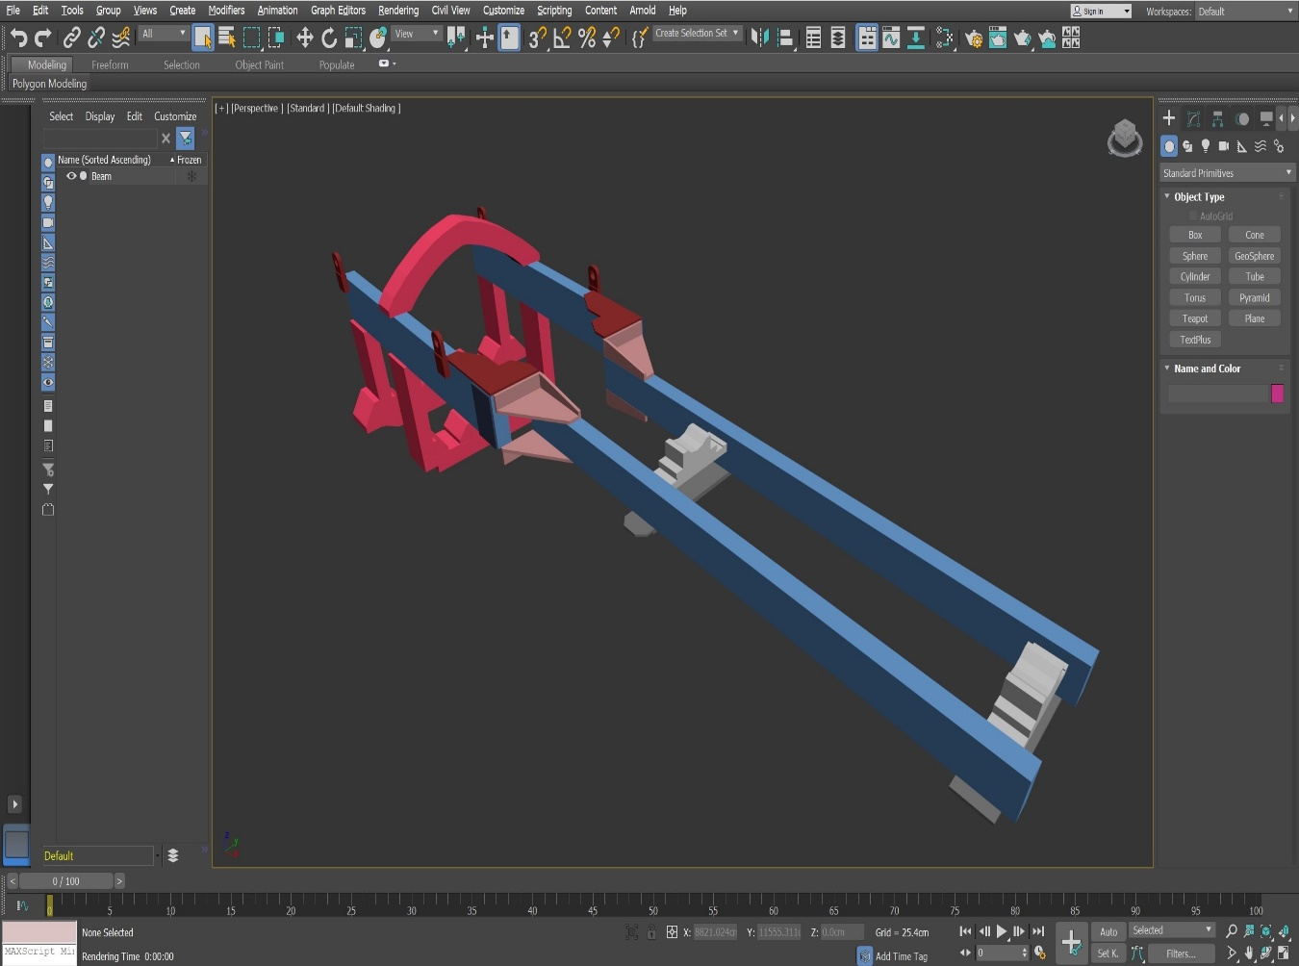

**Ram Assembly:-**

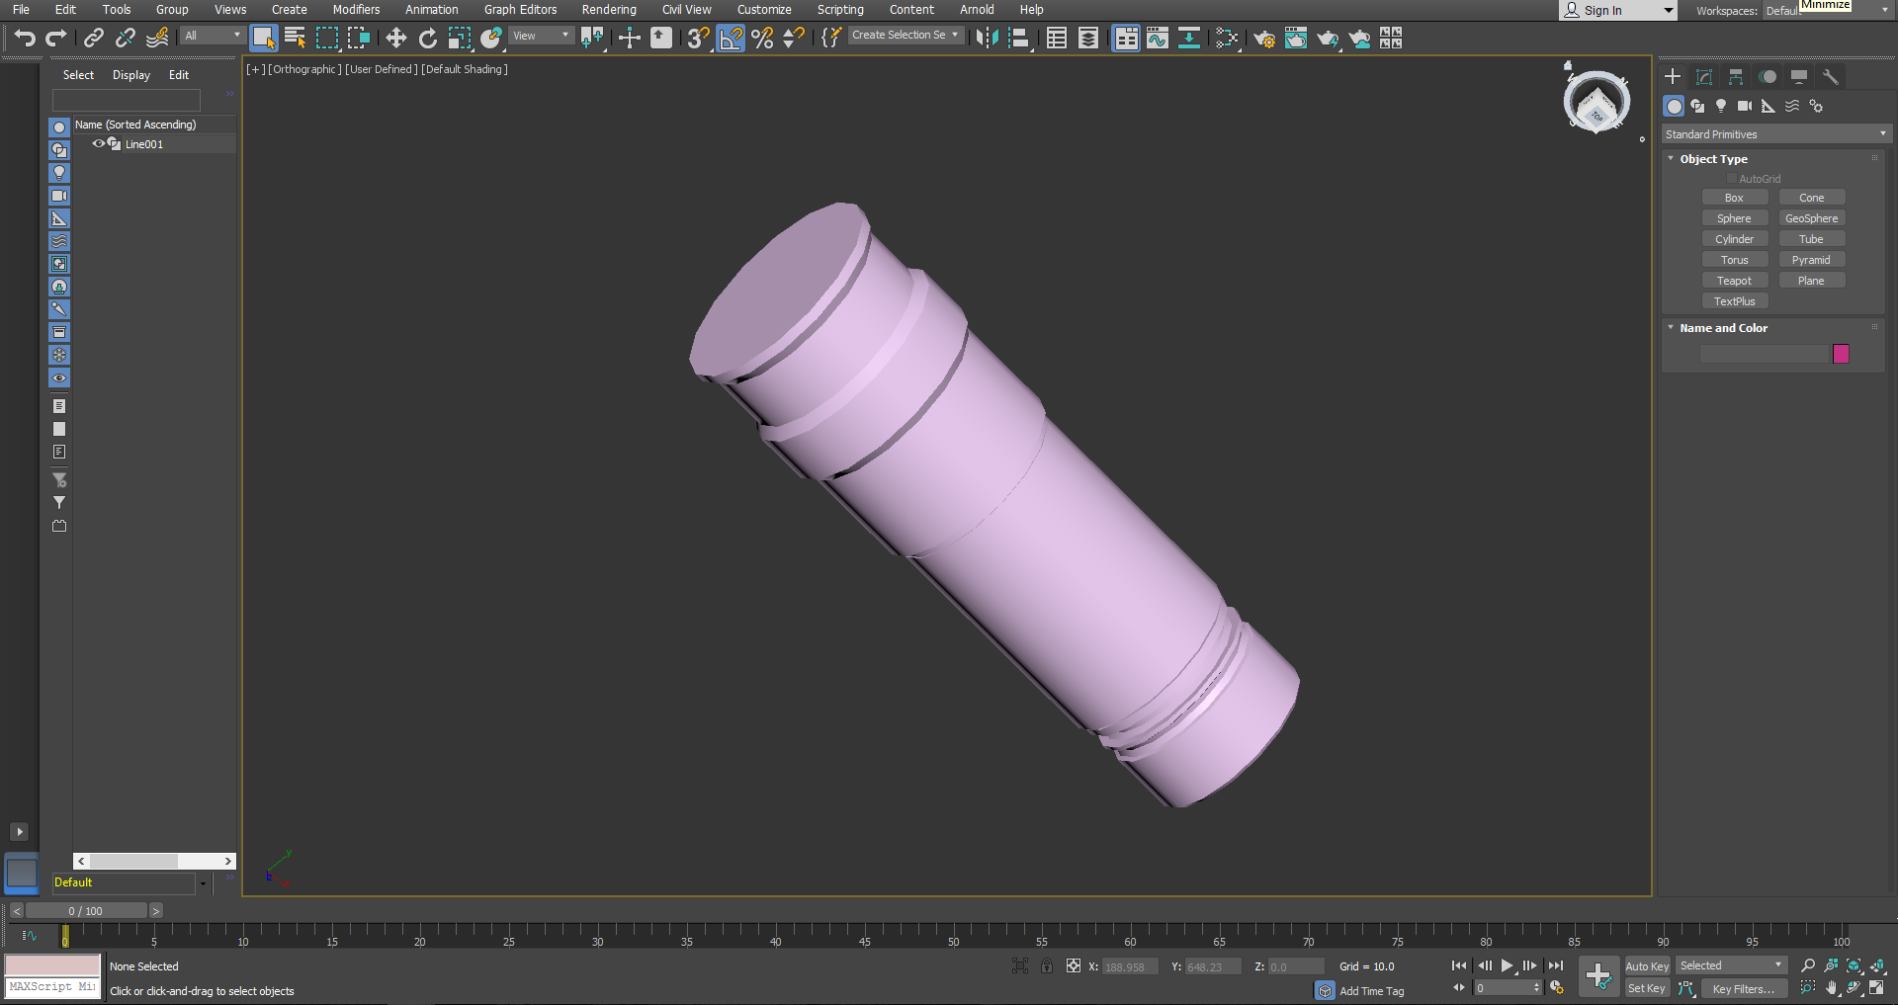

**Gimbal assembly** :-

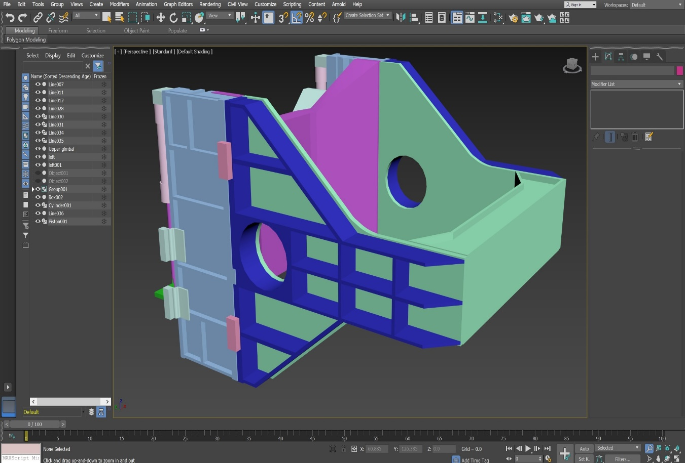

**Trolley assembly:-**

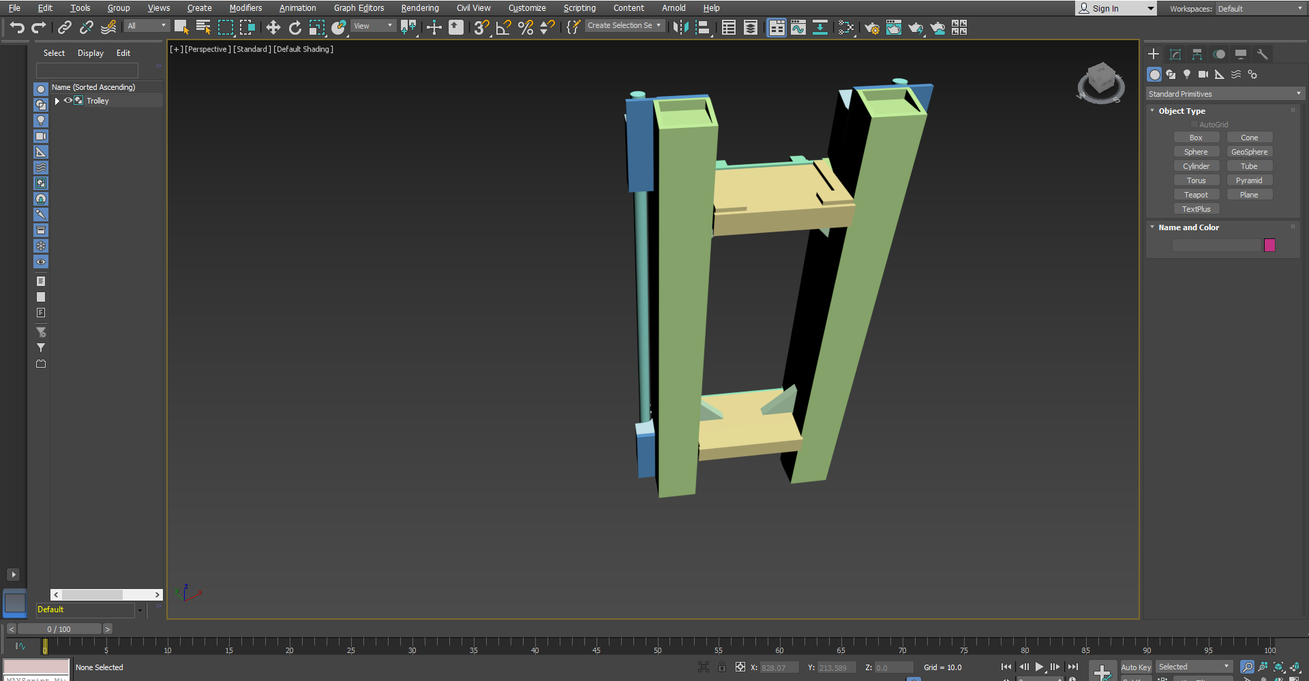

# C:\Users\Admin\AppData\Local\Microsoft\Windows\INetCacheContent.Word\trolley2.png

**Head Antenna:-**

# C:\Users\Admin\AppData\Local\Microsoft\Windows\INetCacheContent.Word\antenna head2.png

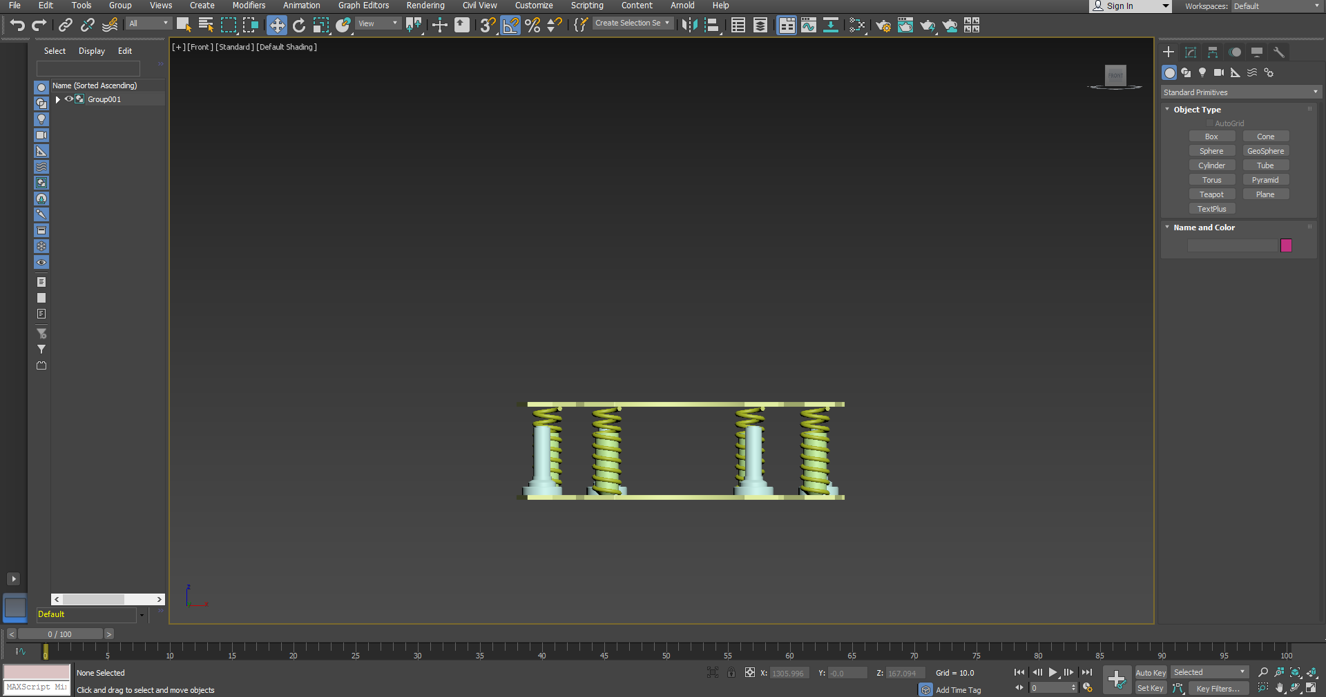

# BIBILIOGRAPHY

1. 3Ds max Tutorials from YouTube - <https://www.youtube.com/channel/UCJbPGzawDH1njbqV-D5HqKw>
2. Tutorial from AutoDesk - https://www.autodesk.in/products/3ds-max/overview