Atria Institute of Technology



**Department of Information Science and Engineering**

**Big Data Analytics (18CS72)**

**Assignment-1**

**SUBMITTED BY**

Name: Poornima Sai Talla

USN: 1AT20IS061

Section: ISE 2

Submission Date: 27/22/2023

**Course Handling Faculty Name:**

Dr. K S Ananda Kumar

Associate Professor

Dept of ISE, Atria IT.

**Table of contents**

|  |  |
| --- | --- |
| **Sl. No** | **Description** |
| 1 | 1. create an **EC2 Linux** instance in AWS Cloud /Any cloud  INSTANCE NAME - **YOUR NAME**  INSTANCE TYPE - t2.micro/any other also.  key pair name- your name  storage - 10 GB  Take the screenshot of instance running status  Mention the private IP address and Public IP address.  (Execute this program/concept and take a screenshot of the output) |
| 2 | Execute the basic Linux commands/ simple program on the instance  (Execute this program and take a screenshot of the output) |
| 3 | Create the **GitHub** Account with your credentials, Same things stored in public repository in Github. Share the assignment in github link. |

**Note:**

1. Minimum 10 Screenshots with proper explanation
2. Minimum no of pages – 10
3. Submit your Assignment soft copy (Word & PDF) to [anandakumar.ks@atria.edu](mailto:anandakumar.ks@atria.edu).

**Subject Line in mail:** Student_Name_USN_BDA_Assignment1

1. Share your assignment Github link in Assignment Document.
2. Submit Assignment on or before **27th Nov 2023.**

**Instance Creation-01**

* Log into AWS account and open the AWS Console page. In the search bar, look for EC2 instance and click on it.

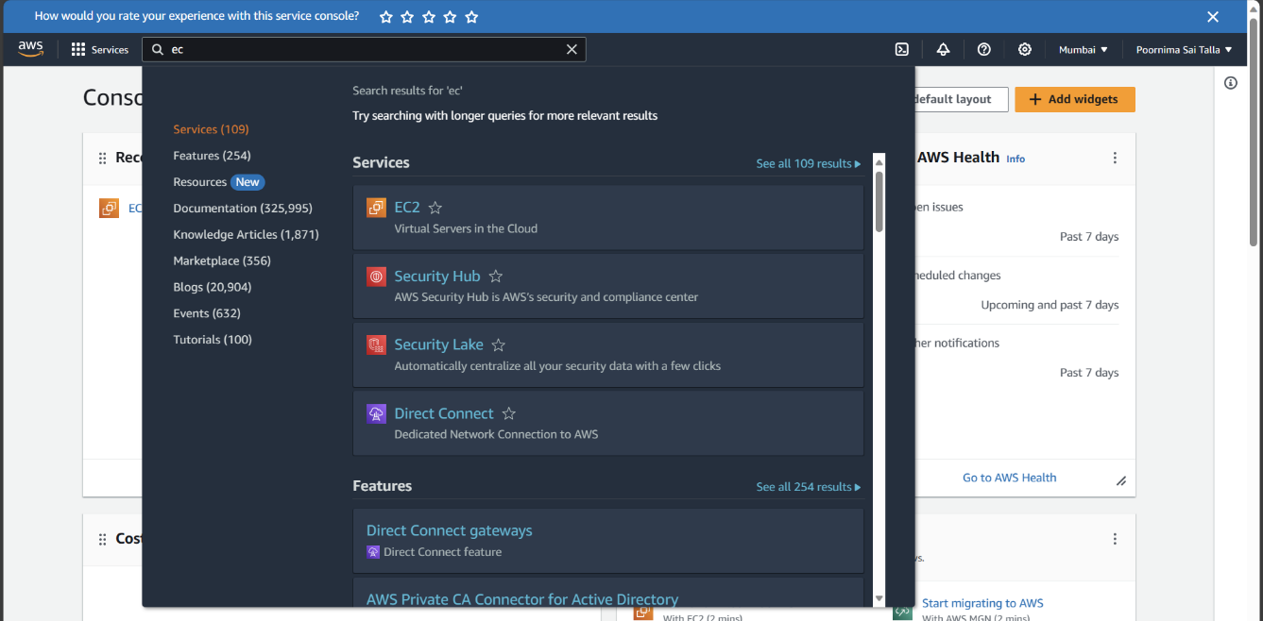

* Open the EC2 dashboard and click on “Launch Instance”

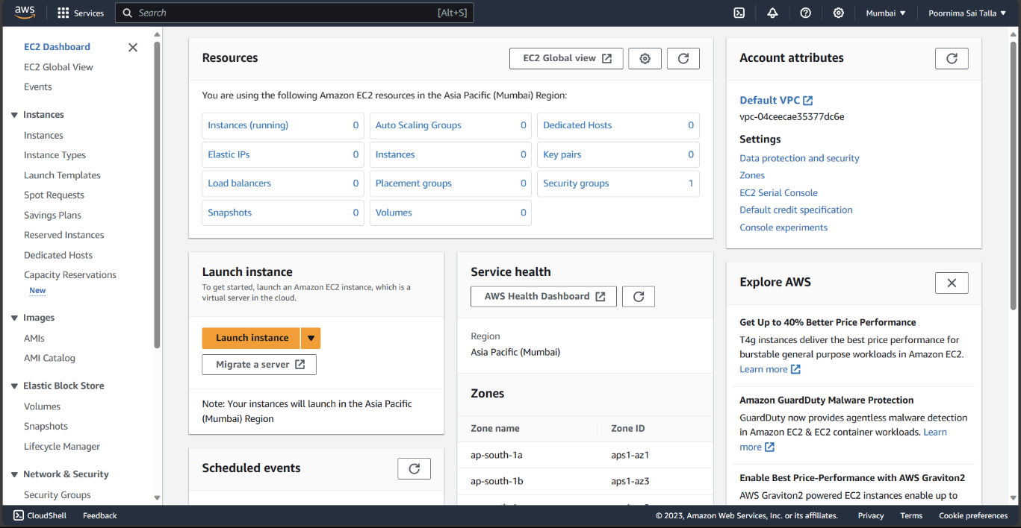

* Provide the name of the instance as “Poornima Sai Talla” and select the operating system to Amazon Linux for a Linux based OS.

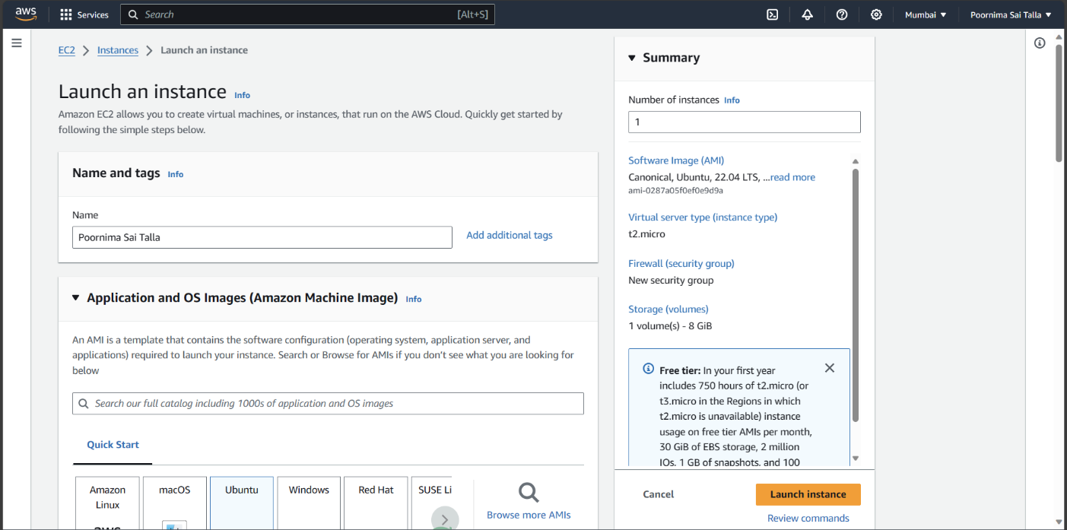

* Enter key-value pair as own name and allot the storage as 8GiB.
* Click on “Launch instance”.

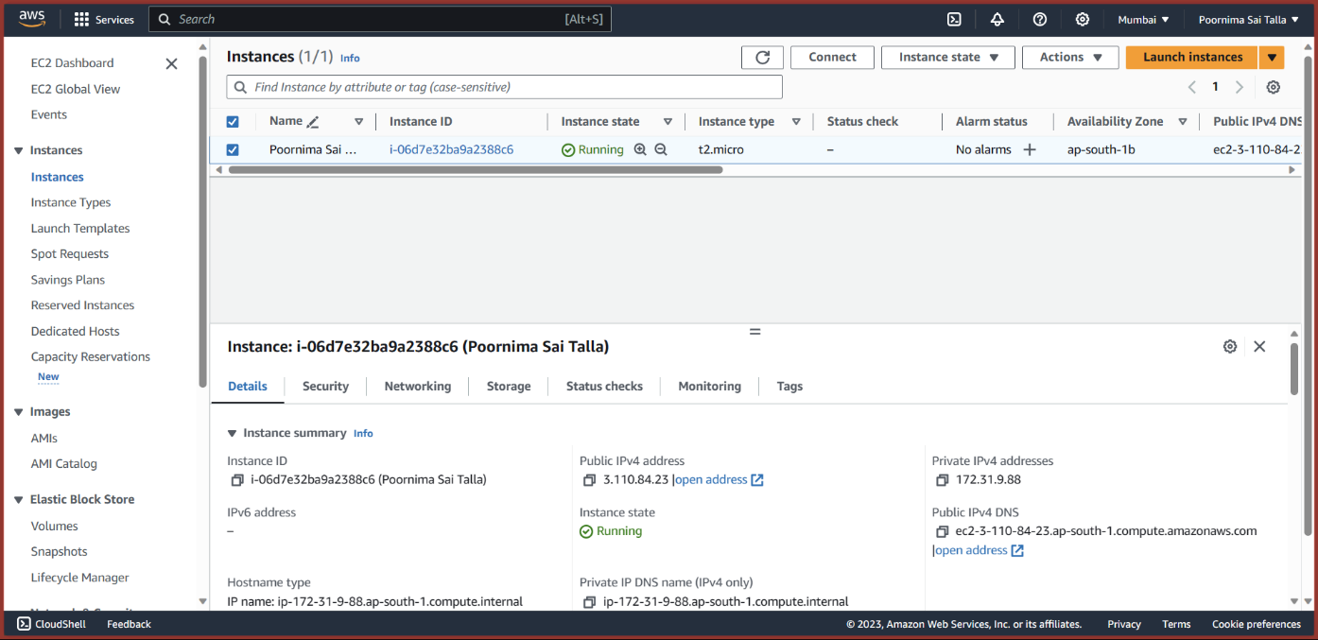

* As seen in the above screenshot, the instance is running successfully.
* The public IPv4 address is 3.110.84.23
* The private IPv4 address is 172.31.9.88

Further details about the EC2 instance created are as follows:

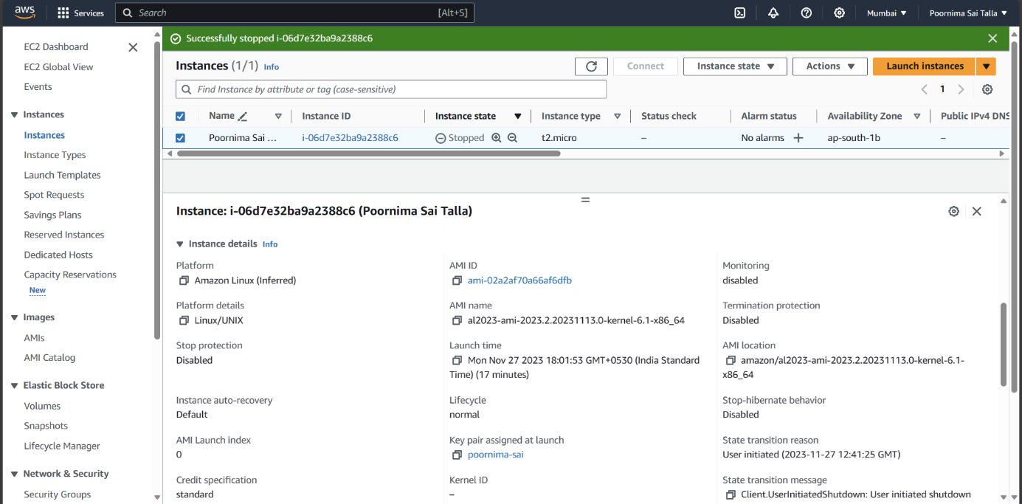

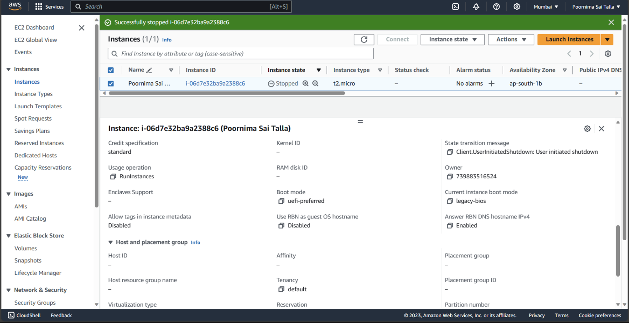

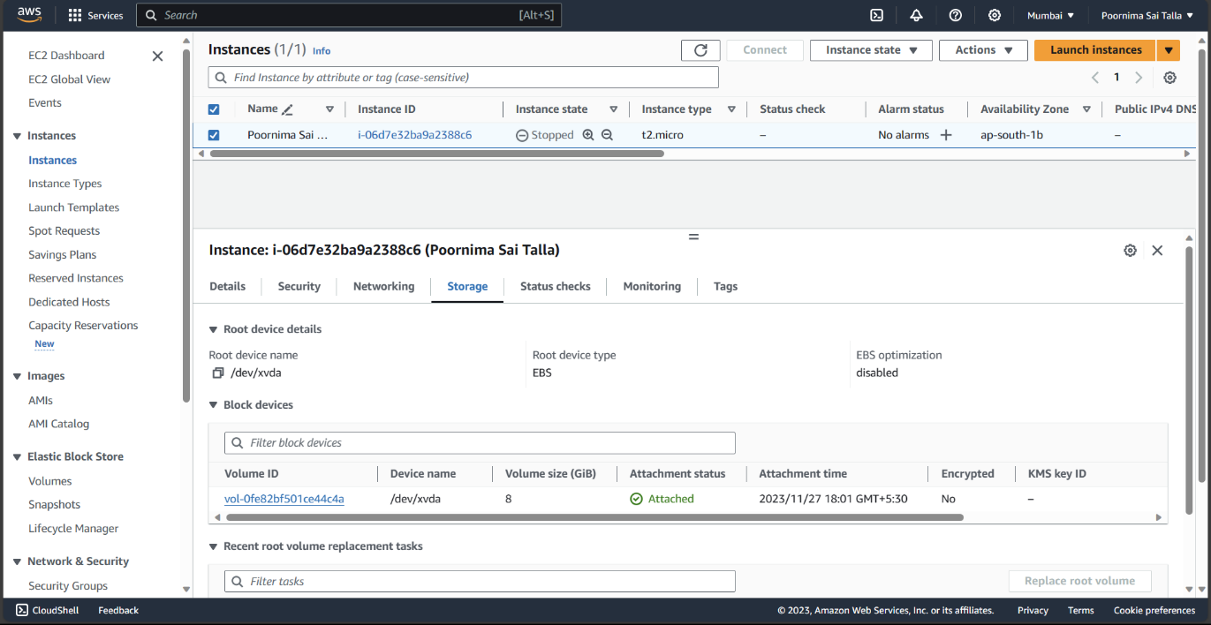

**Running sample Program on Linux Instance**

* PuTTY x86 bit installer must be installed to run the Linux commands.
* After setting up PuTTY, the host IP address must be given from the AWS console.

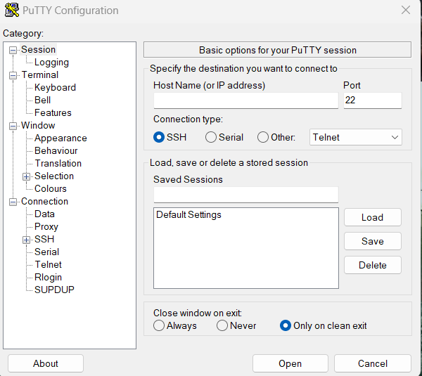

* On the left menu, under SSH, select “Auth” and under that select “Credentials” and give the username as “ec-user".
* After selecting the required options, we click on “Open”.

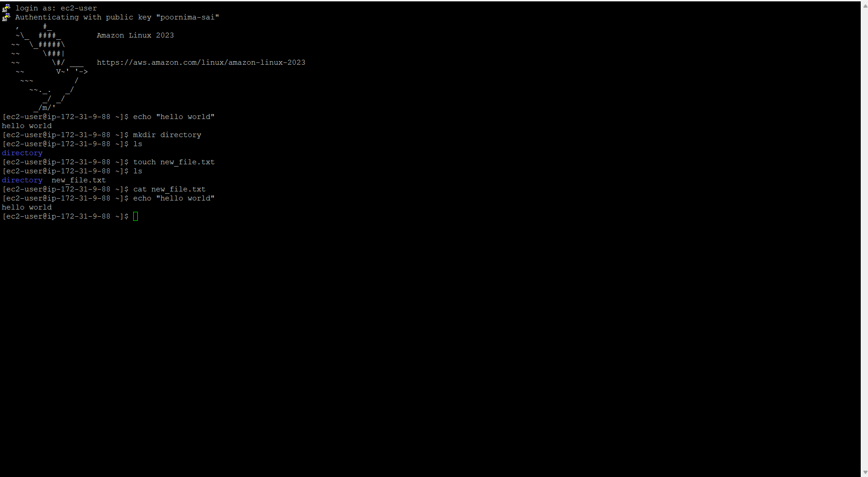

* From the image, the PuTTY console terminal is used to execute basic Linux commands.

The commands executed are as follows:

* echo “hello world”: It is used to print the string “hello world onto the terminal.
* mkdir new_directory: This command is used to create a new directory in the system.
* cat new_file.txt: This command is used to create a new file in the directory created.

**Assignment GitHub Link (**[**https://github.com/login**](https://github.com/login)**).**