Tasks
- Find the total number of insurance records.

- Retrieve the details of all smokers above age 40.
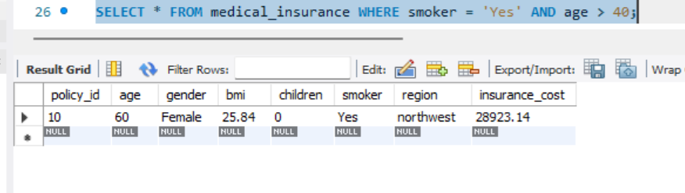

- Count how many male and female policyholders exist in the dataset.
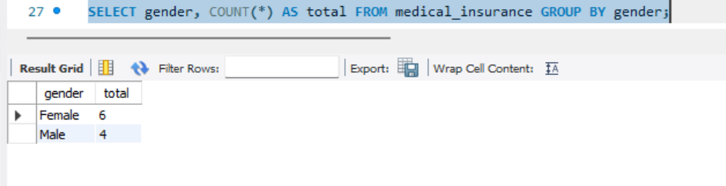
- Calculate the average insurance cost of smokers vs. non-smokers.

- Find the region with the highest average insurance cost.
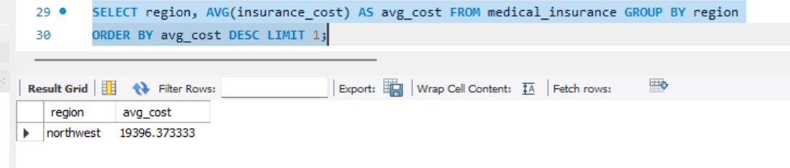
- List the top 5 policyholders who paid the highest insurance cost.
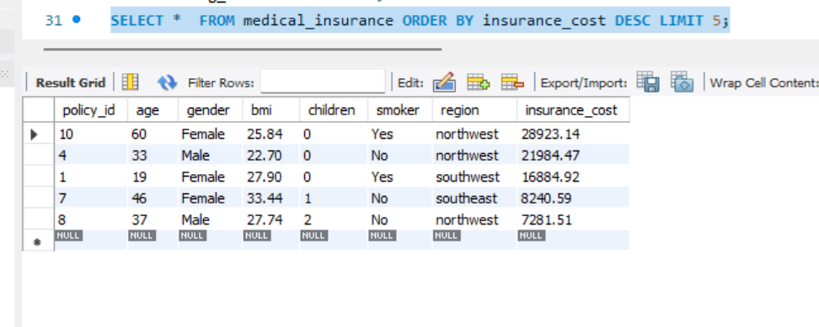
- Calculate the average insurance cost grouped by age group: Young (18–30), Middle-aged (31–50), Senior (51+).
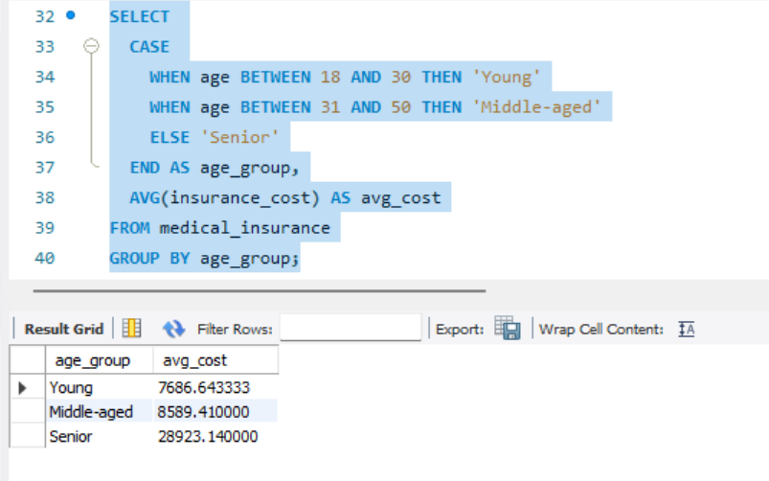
- Identify if smokers with BMI > 30 are paying significantly higher insurance than non-smokers.
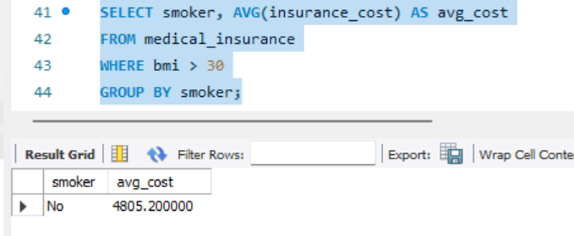
- Find the correlation-like insights (not actual correlation in SQL, but using GROUP BY) –
- Avg cost by number of children.
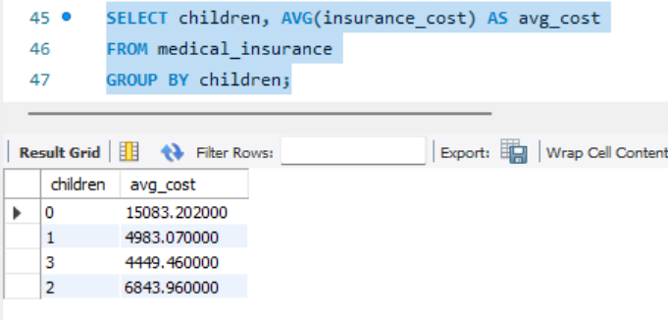
- Avg cost by gender.
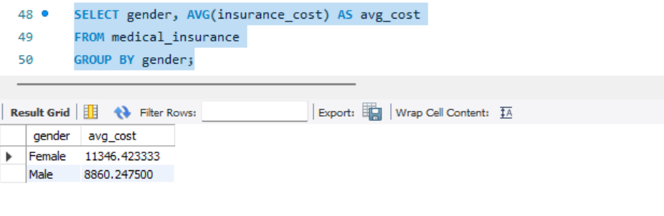
- Avg cost by region.
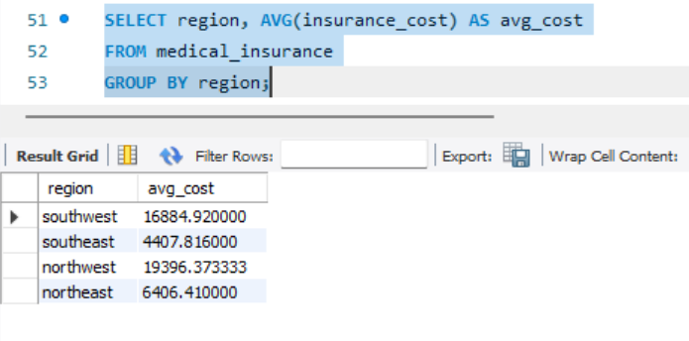

- Write a query to find the insurance cost difference between smokers and non-smokers in each region.
