Tasks
Task 1:
- Retrieve all posts along with the username of the author.
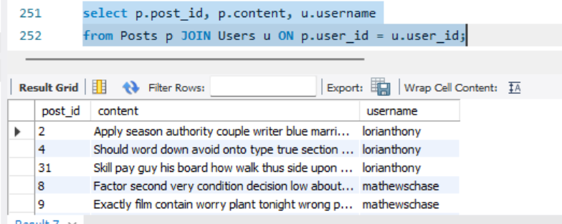
- Find all comments on each post along with the commenter’s username.
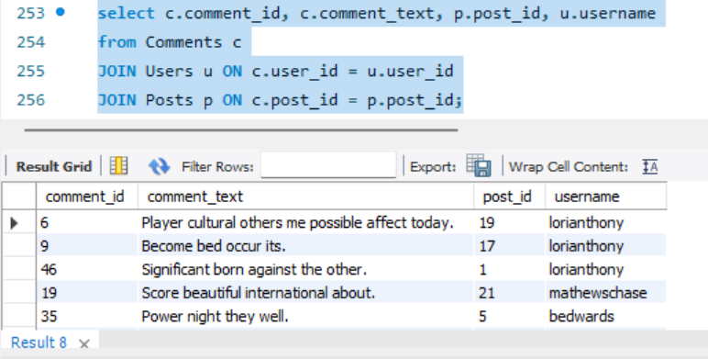
Task 2:
- Find the top 3 users with the most posts.
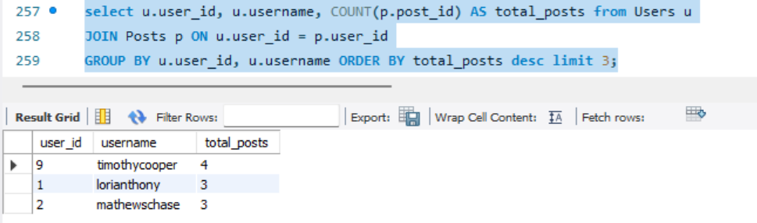
- Retrieve posts that have more likes than the average number of likes per post.
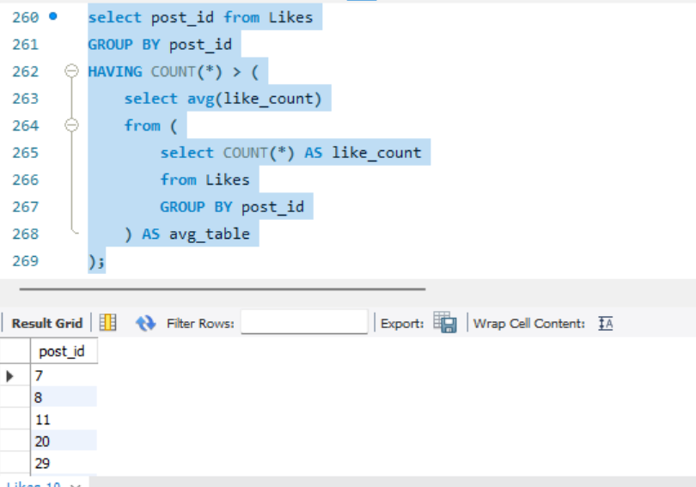
- Find users who have never posted anything but have liked posts.
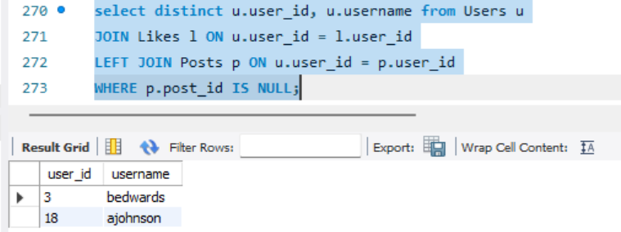
Task 3:
- Get a list of all friends of a specific user (say user_id = 3).
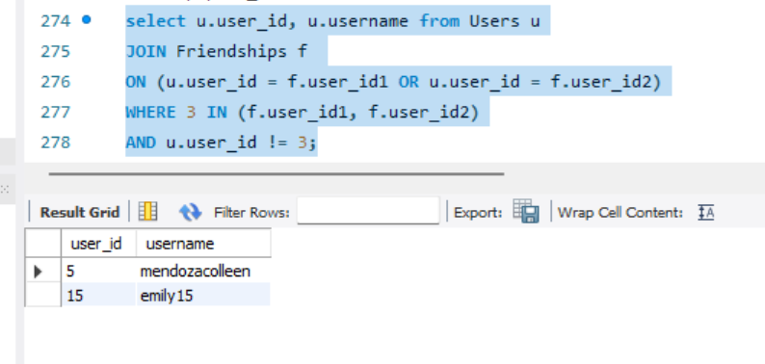
- Retrieve posts that were liked by friends of a given user (nested join scenario).
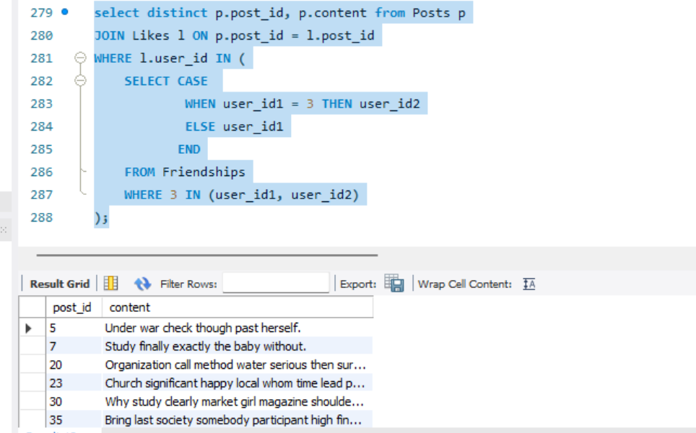
Task 4:
8. Create a stored procedure GetUserActivity(userId) that returns:
o Total posts by the user
o Total likes given by the user
o Total likes received on the user’s posts
o Total comments made by the user
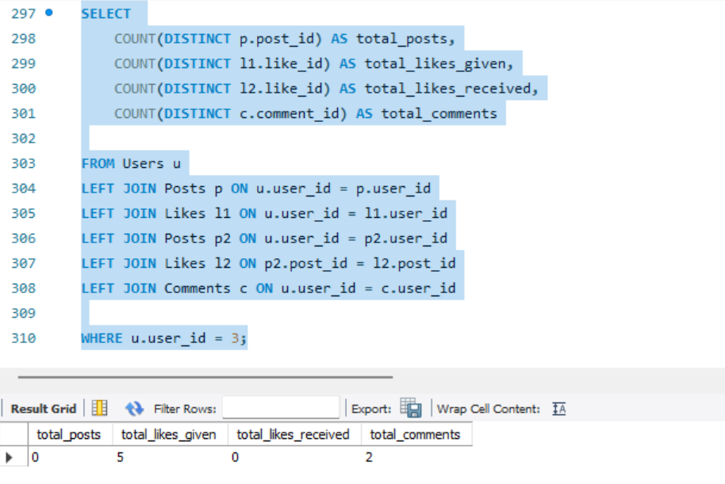
Task 5:
Challenge Query
- Find the most influential user (the user whose posts have the highest total likes + comments).
