Level 1: Very Basic
- Display all students.
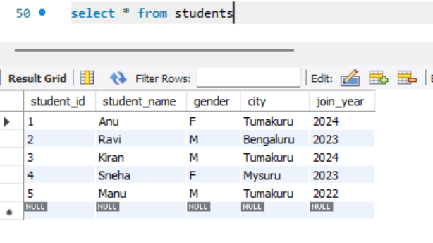
- Display only student_name and city from students table.
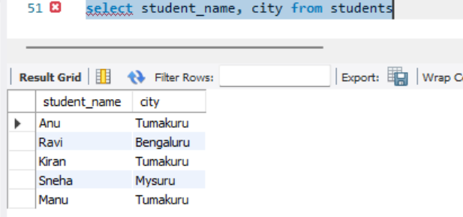
- Show all courses.
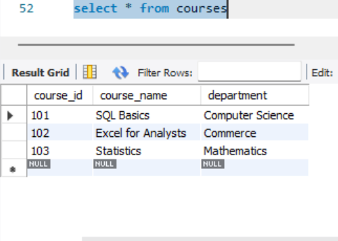
- Display students who are from Tumakuru.
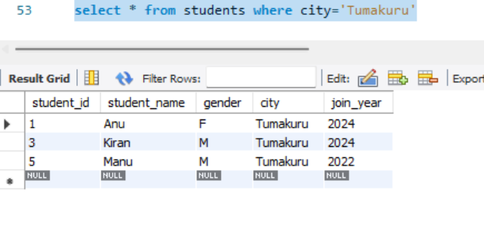
- Display students who joined in 2024.
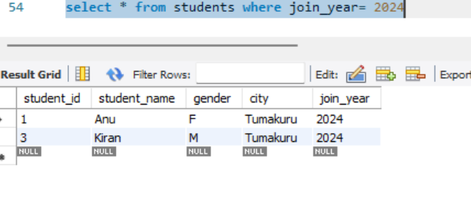
Level 2: Filtering
- Show students whose gender is F.
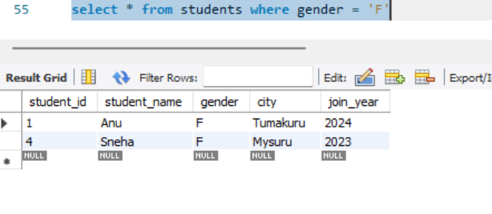
- Show marks greater than 80.
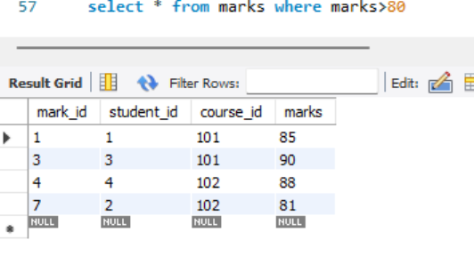
- Display course names from Commerce department.
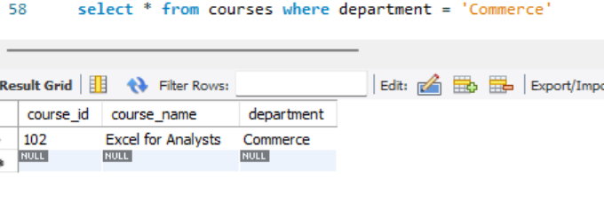
- Show students who are not from Bengaluru.
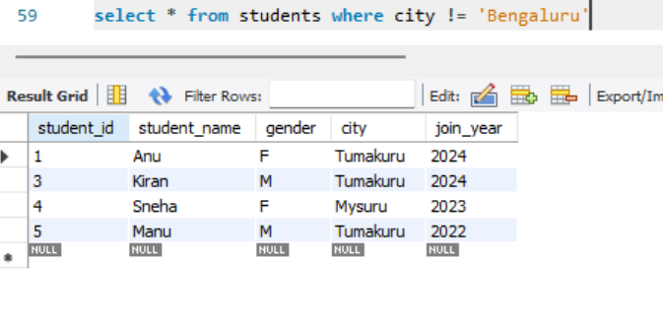
- Display marks between 70 and 90.
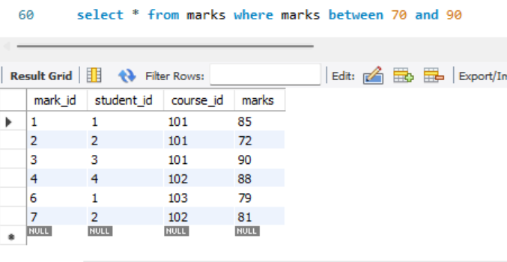

Level 3: Sorting
- Display all students ordered by student_name ascending.
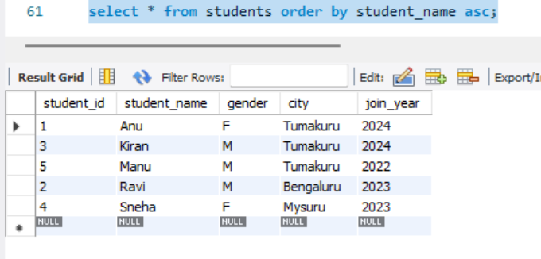
- Show marks ordered from highest to lowest.
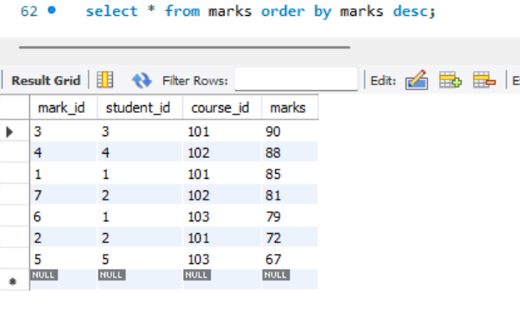

- Display students ordered by join_year descending.
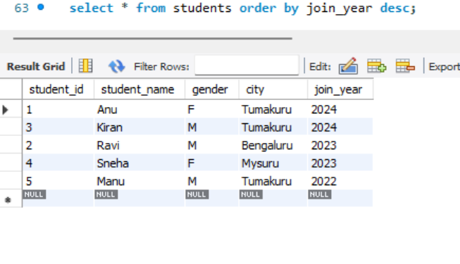
Level 4: Aggregate Basics
- Find total number of students.
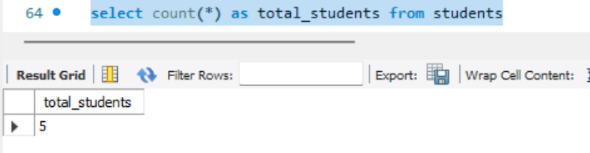
- Find average marks.
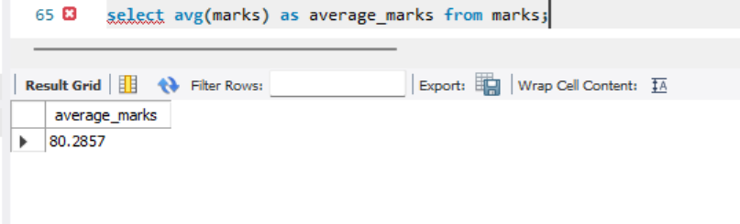
- Find highest marks.
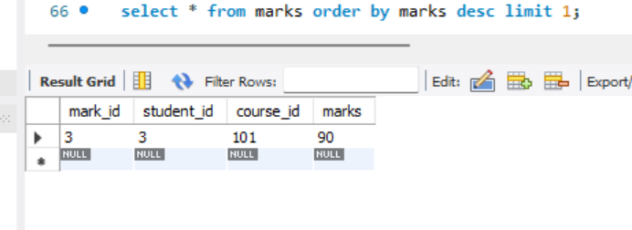
- Find lowest marks.
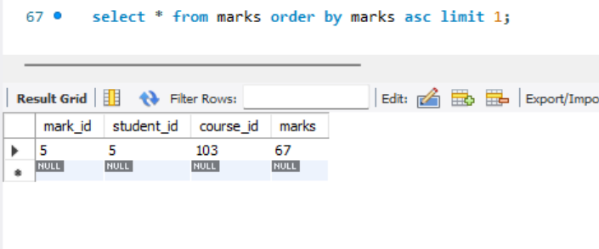
- Find total marks scored by all students.
