Day1_excel_data_analysis
I used formula to find out total revenue by Quantity*Unit price.
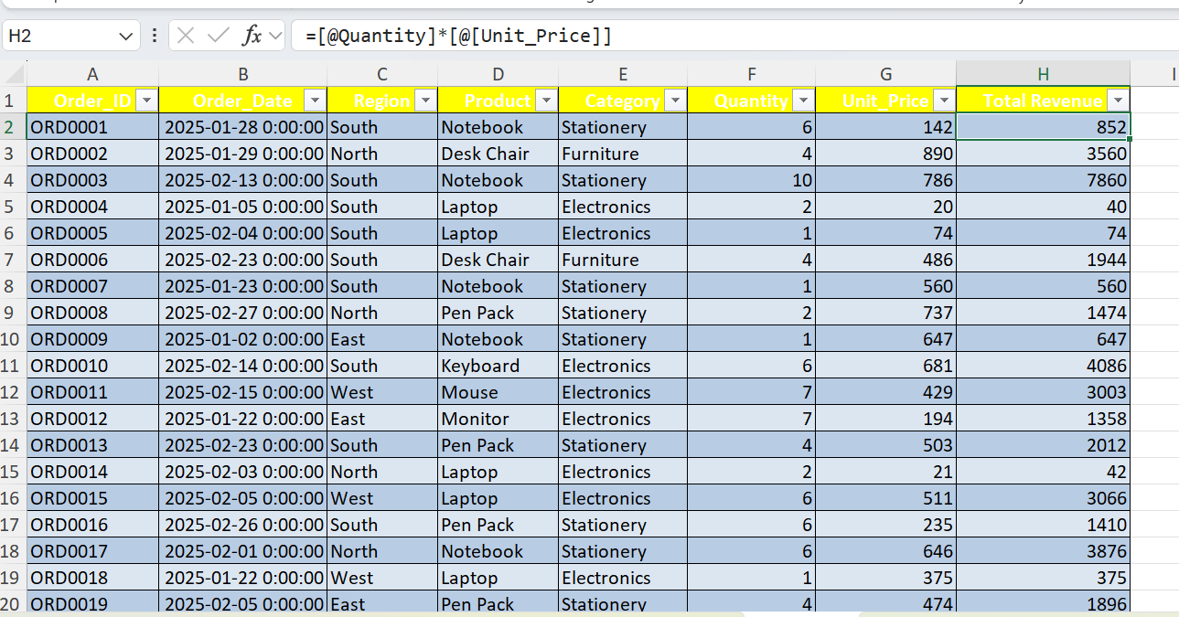

Total revenue vs Region
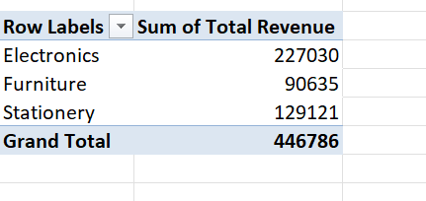
Total Revenue vs Product
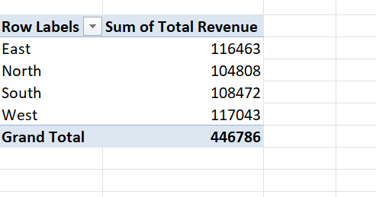
I Identify the top 5 performing products by Revenue
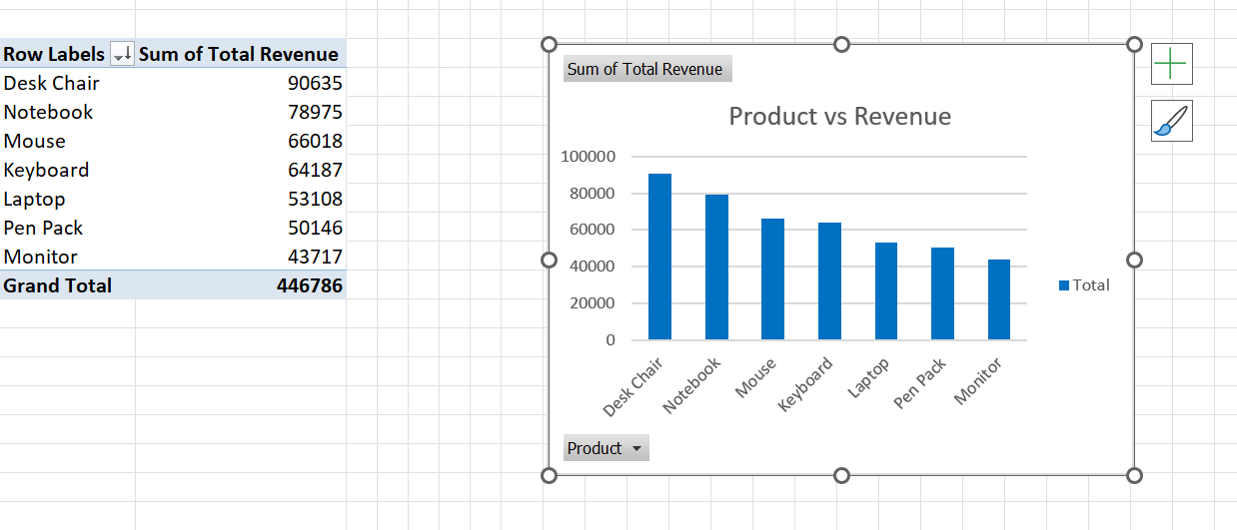
I created a chart to visualize Revenue by Region
