Task 1:
Find claims where claim amount is greater than average claim amount
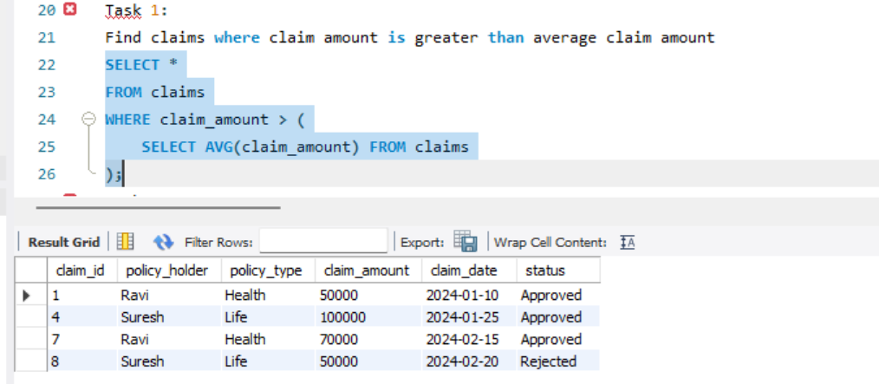
Task 2:
Find policy holders who have at least one approved claim
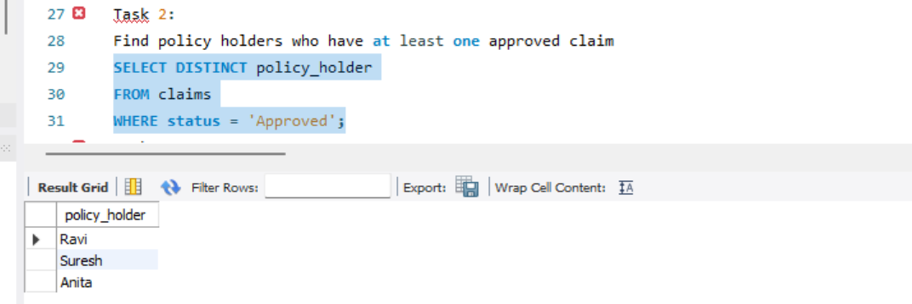
Task 3:
Find claims where claim amount is greater than that policy holder’s average claim
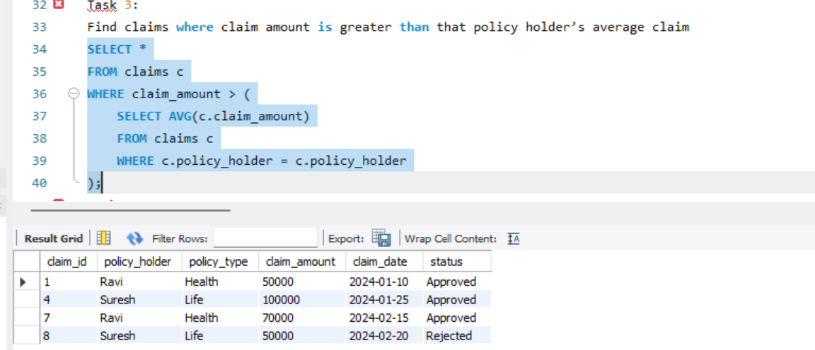
Task 4:
Display each claim along with overall average claim amount
