Day17 Tasks
Task 1: Customer Orders
Write a query to display:
• customer_name
• order_id
• amount
Include only customers who placed orders.
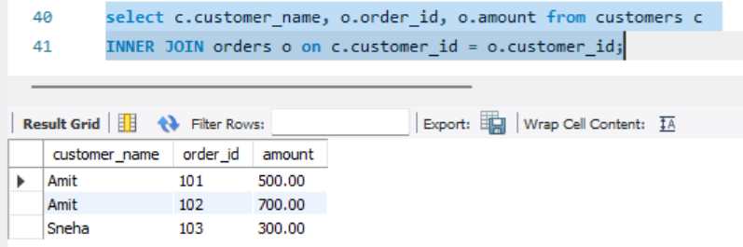
Task 2: All Customers
Write a query to display:
• all customers
• their order_id (if any)
Customers without orders should still appear.
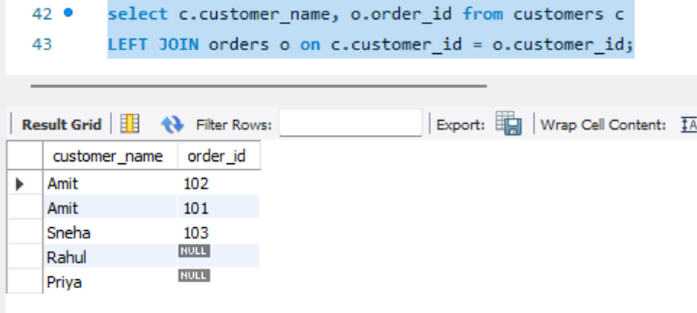
Task 3: Invalid Orders
Write a query to find:
• orders
that do NOT have a matching customer
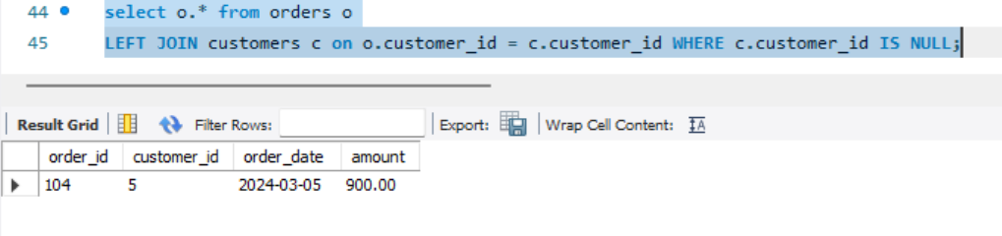
Task 4: Order Payment Status
Write a query to display:
• customer_name
• order_id
• payment_status
Include all orders, even if payment is missing.
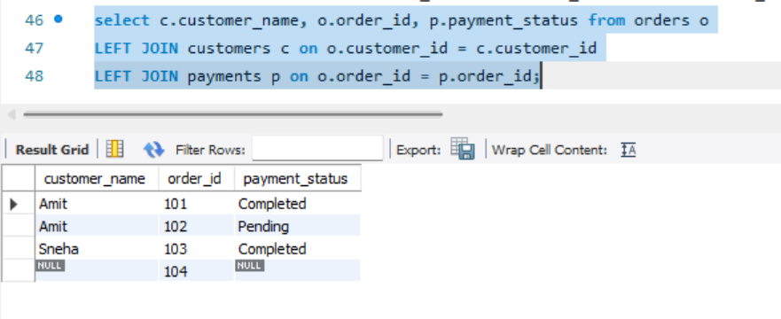
Task 5: Customers Without Orders
Find customers who have never placed an order.
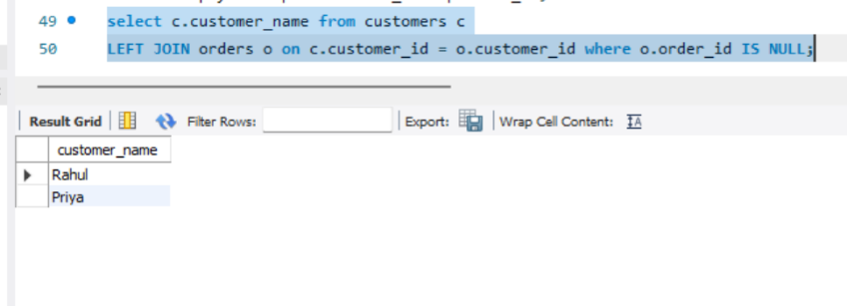
Task 6: Orders Without Payment
Find all orders that do not have a payment record.
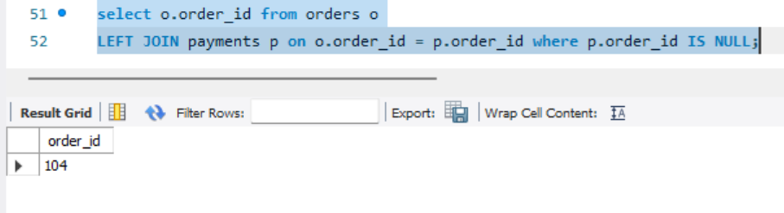
Task 7: Total Spending
Write a query to calculate:
• total amount spent by each customer
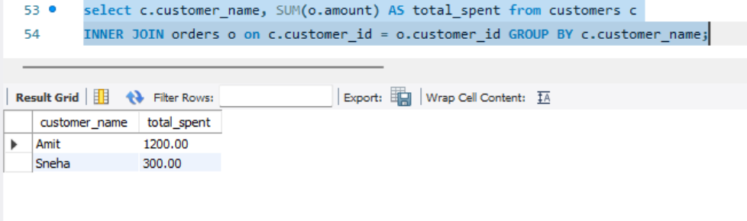
Task 8: Fully Paid Customers
Find customers whose all orders are marked as 'Completed'.
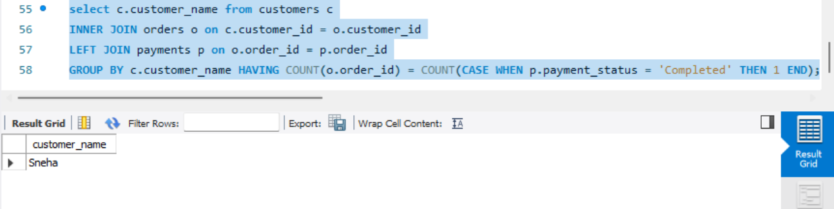
Task 9: Highest Order Per Customer
Display:
• customer_name
• highest order amount
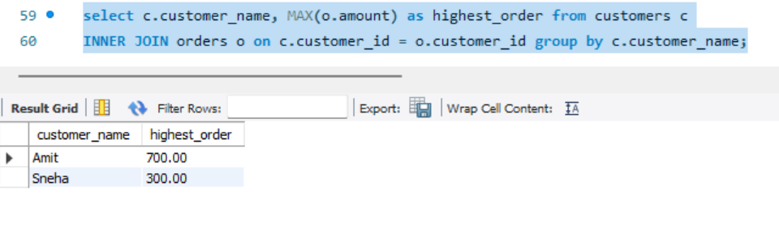
Task 10: Top Customers
Find top 2 customers based on total spending.
