Tasks
Task 1: Defect Rate per Product
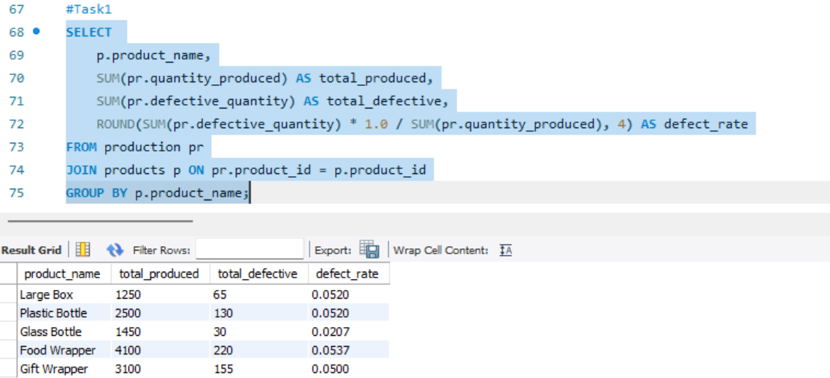

Task 2: Top Performing Product (Revenue) Find the top product by total revenue.
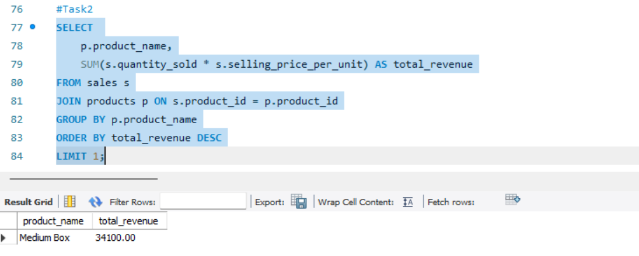

Task 3: Monthly Production Trend
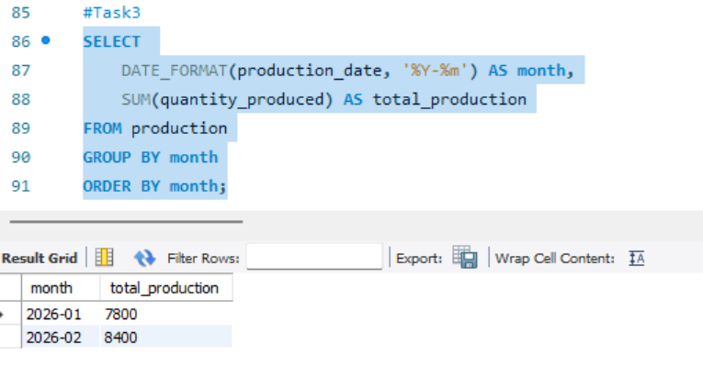

Task 4: Category-wise Profit
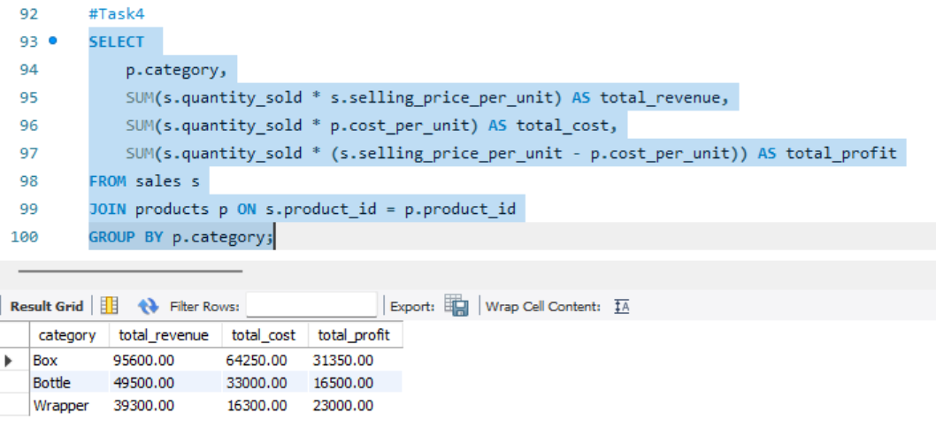

Task 5: Identify High Defect Days
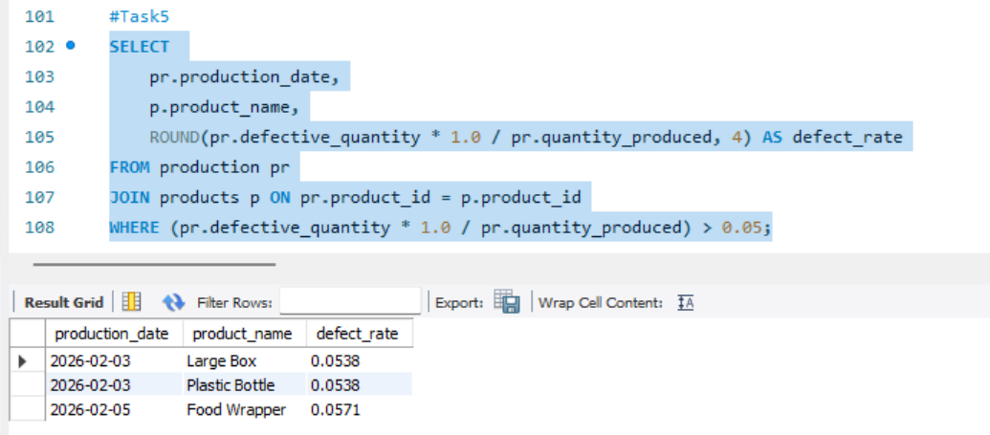

Task 6: Running Total Revenue
Calculate cumulative revenue over time.
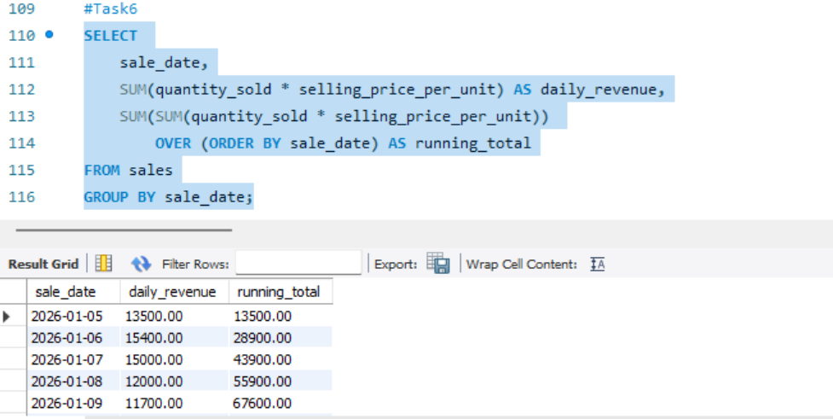

Task 7: Best Category by Profit Margin
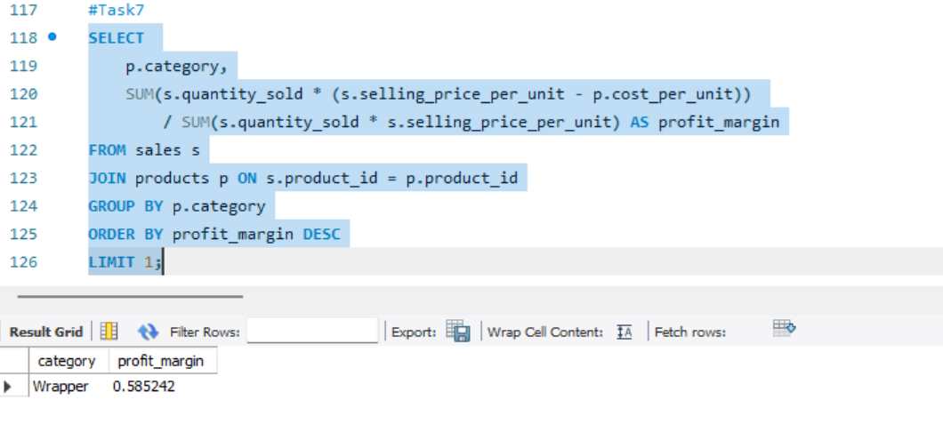

Task 8: Unsold Inventory
