*Project: Innovation For Earthquake Prediction For using Python*

*Team Member: Poornima KL*

*AI_Phase_2 Submission*

 *Definition:*

Creating an earthquake prediction system is a complex task that involves the analysis of various data sources and patterns. While Python is a suitable programming language for this, it's essential to note that earthquake prediction is still an ongoing scientific challenge, and no system can provide precise predictions. However, I can outline a basic approach using Python

Data Collection:

* Gather earthquake data from reliable sources like the USGS (United States Geological Survey) or international seismic monitoring agencies.
* Collect data on geological features, fault lines, and historical earthquake events.

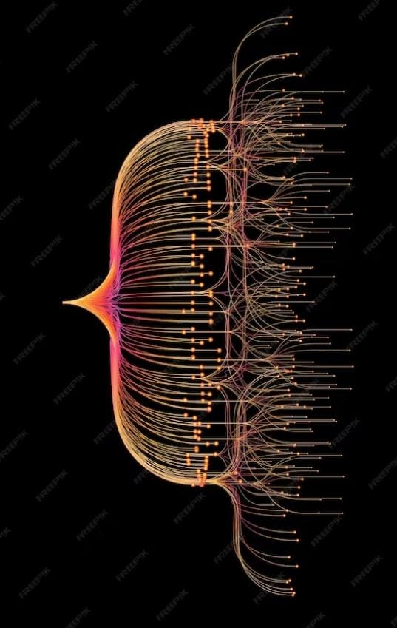Feature Engineering:

* Extract relevant features from the data, such as earthquake magnitude, depth, location, and historical seismic activity.
* Incorporate geological and environmental data like soil type, plate tectonics, and stress/strain measurements.

Data Preprocessing:

* Clean and preprocess the data, handling missing values and outliers.
* Normalize or scale numerical features to ensure they are on the same scale.

Machine Learning Models:

* Use Python libraries like scikit-learn or TensorFlow/Keras to build machine learning models.
* Experiment with various algorithms like Random Forest, Support Vector Machines, or Deep Learning models such as Neural Networks.

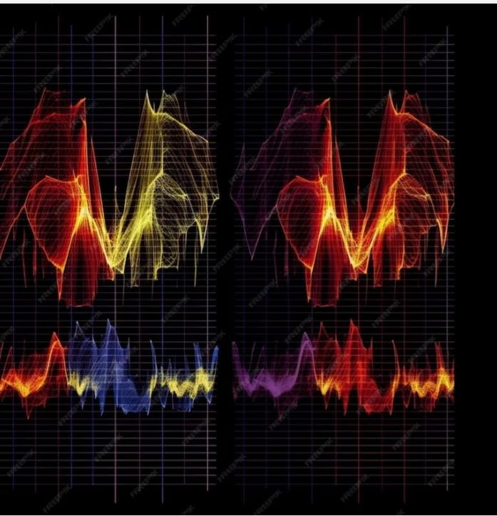Time Series Analysis:

* Consider time series analysis techniques to capture temporal patterns in seismic data.
* Techniques like autoregressive models or recurrent neural networks (RNNs) can be helpful.

Cross-Validation:

* Employ cross-validation techniques to evaluate the model's performance, ensuring it generalizes well to unseen data.

Model Evaluation:

* Use appropriate evaluation metrics such as Mean Absolute Error (MAE), Root Mean Squared Error (RMSE), or F1-score for classification tasks.

Continuous Learning:

* Update your model with new earthquake data regularly to adapt to changing patterns.

Visualization:

* Create visualizations using libraries Matplotlib or Plotly to represent earthquake data and model predictions.

Deployment:

* Develop a user-friendly interface for accessing earthquake predictions.
* Deploy the system on a server or cloud platform.
* Remember that while this approach may help identify patterns and trends in earthquake data, it cannot provide accurate short-term earthquake predictions. Earthquake prediction remains an active area of research, and it's essential to consult with experts in the field and consider ethical and safety implications when working on such projects.

Thankyou!